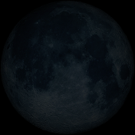
New Moon, exact at 0 degrees
Inner Moon: days 1-7, low progesterone, low estrogen, bleeding
• Visually: 345-29 degrees
• Textbook: 0-44 degrees
The ambiguous presence that brings gifts of creative potential. Now that we are in the darkest phase of the Moon cycle, the obscure vision makes for reimagining new possibilities. This phase is where we plant new seeds of intention. New Moon relates to Winter Solstice and Yule. In tantra yoga, this is the merging of Moon and Sun from third-eye to crown of the head. In and out breath unite at the crown of the head in breath pause (kumbhaka) where the magic of integration happens. In the hero’s journey, this is the call to adventure. The phase of the inner Moon cycle related with new Moon is menstruation. Low progesterone, low estrogen and bleeding is present. Take time to rest and reflect. This is a great phase for receiving dreams and insight. Use foods with higher protein that are nurturing yet easy to digest.

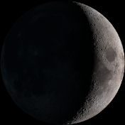
Waxing Crescent, exact at 60 degrees
Inner Moon: transition between bleeding and follicular/proliferation
• Visually: 30-74 degrees
• Textbook: 45-89 degrees
Individuality. Going extreme, leaping out, feeling a strong desire for manifesting those new Moon intentions. Feeling an extreme sense of hunger for our mission and divine guidance. Developing awareness of spiritual and sexual identity. This phase relates with Imbolc/Candlemas. In tantra yoga, this is somachara, descending course of Moon, in-breath (prana-vayu) from crown to the third-eye, relates with last quarter of daylight and the element is air. In the hero’s journey this phase is where we are feeling our desires, sensing into the intentions and meet a mentor in human, plant, animal or other than human form. In the menstrual cycle, this phase is transitional including bleeding and the building up of the uterine nest in the follicular/proliferation phase. Use clean, easy to digest food.

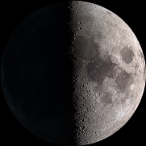
First Quarter, exact at 90 degrees
Inner Moon: days 8-14, follicular/proliferation
- Visually: 75-119 degrees
- Textbook: 90-134 degrees
The warrior experiencing tension between self and group. Concerned with justice in the organizations and groups. Relates with vernal equinox and Ostara/Easter. In tantra yoga, this is the descending in-breath (prana-vayu) from third-eye to the soft palate, relates with midday and the element is fire. In the hero’s journey, we are taking inspired action, feeling tension and resistance in group efforts, wanting to differentiate. Feeling strong and empowered to cross initiation threshold. Blazing new trails which could become new systems for society. First quarter Moon relates with follicular and proliferation hormones, building up of estrogen, uterine walls thickening, eggs maturing. This phase of lunar cycle can be powerful and exciting. Use it for courtship, dates night, seduction, and rituals that focus on building and growing. Use foods that nurture and support. Warm and comforting foods like root vegetables and curry spices.

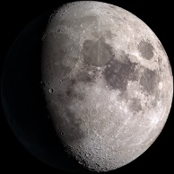
Waxing Gibbous, exact at 135 degrees
Inner Moon: transition between proliferation and ovulation
- Visually: 120-164 degrees
- Textbook: 135-179 degrees

The lover in ecstatic union with the beloved and the creator in sync with their audience. This phase relates to Beltane, spring equinox. Heightened senses, pleasure, amusement. In tantra yoga, this is the descending in-breath from soft palette to the throat, represents the first quarter of daylight and the element is water. In the hero’s journey, this is where we are facing fears, doubts, and uncertainties. We get an opportunity to show what we know through the trails and tests that are occurring now. In the menstrual cycle, waxing gibbous is a transition phase between the building up of the uterine nest and the high of ovulation. Use warm comfort foods and root vegetables.

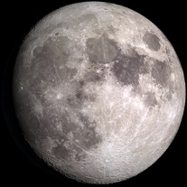
Full Moon, exact at 180 degrees
Inner Moon: days 15-21, ovulation
- Visually: 165- 209 degrees
- Textbook: 180-224 degrees

The healer, artist. Our humanity shines bright and the desire to connect with the resonate polarity is strong. Artistic and creative expressions are made manifest during full Moon phase. This is the polarity of our solar and lunar nature in orgasmic celebration and peak fertility during full Moon phase. In tantra yoga, this is the union of Moon and Sun, in and out-breath at the heart, breath pause kumbhaka. Relates with dawn and the element is earth. In the hero’s journey, this is the sacred Marriage of resonate polarities, between the archetypes of Sun/Moon. In the menstrual cycle, this phase is ovulation. The egg is released from ovary into fallopian tubes and the possibility of ferritization is greatest. Metaphysically, this is when we fertilize our creations with thought seeds and manifestation rituals have the greatest potential. The prime hormone for this phase is estrogen which stimulates luteinizing hormone which stimulates the release of the egg. This is also the peak of testosterone in the cycle so we see a lot of hormonal stimulation at full Moon phase. The full Moon phase is about 72 hours, which also coincides closely to the time from onset of ovulation where fertilization is possible. Orgasm, ovulation, the moment of truth, polarity connection, endorphin high. Use foods that are packed with flavor, colorful, juicy and nutrient dense.

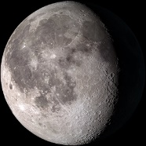
Disseminating, Waning Moon, exact at 210 degrees
Inner Moon: transition between ovulation and luteal phase
- Visually: 210-254
- Textbook: 225-269
The Shaman doing the deep inner work of acceptance and surrender. We sense into and through the chaos and crave liberation for self and others. We attune to the mysteries of life cycles, death and rebirth. We lose our sense of self-importance. This phase relates with Lammas. In tantra yoga, this starts surychara, ascending course of the Sun with the out-breath moving upward from heart to throat. Relates with first quarter of the day (morning) and the element is water. In the hero’s journey, this is the return journey. We are feeling gratitude for survival and ready to integrate the gifts from the journey. In the menstrual cycle, this is transition between the high of ovulation and the hormonal shifts of luteal phase.

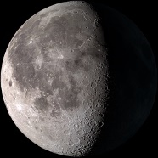
Last Quarter (3rd quarter) exact at 270 degrees
Inner Moon: days 22-28, Luteal
- Visually: 255-299
- Textbook: 270-314
The wise elder sensing the smell of ending and learning to gracefully let go and go home. Sense of longing. The bitter sweetness of knowing the necessity of ending and becoming acutely aware of death that permeates all of life. This phase relates with the autumnal equinox and Mabon. In tantra yoga, this is suryachara, ascending course of Sun with the out-breath moving upward from throat to soft palette. Relates with midday and the element is fire. In the hero’s journey, this is the phase is where we cross the return threshold. We feel freedom and courage to explore more of our humanity. In the menstrual cycle, this is luteal phase. Like the Luteal phase in inner Moon cycle, Balsamic Moon vibe is fierce, direct, got no time for BS. Get to the point. Be real. Show yourself. If pregnancy occurred, progesterone will remain high and increasing. If no pregnancy, it drops. We feel inflamed, irritated and things that need to change are made more than obvious and we have the energy to make necessary changes. Good time for moving or other big changes that require strength. If pregnancy occurred, progesterone will remain high and increasing. If no pregnancy, it drops. We feel inflamed, irritated and things that need to change are made more than obvious. Good time for moving or other big changes that require strength. Use foods that Use foods that are light, cooling, and inflammation reducing.

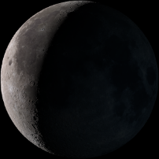
Balsamic Moon, exact 315 degrees
Inner Moon: transition between luteal and menstruation
- Visually: 300-360
- Textbook: 300-345
The mystic, deeply sensitive to psychic reality, energetic information, connection with disembodied energy like spirits. Ultra-creative, dream-like visionary with sharp mental acuity. Ethereal quality with little to no ego attachment. This phase relates with Samhain. In tantra yoga, this suryachara, ascending course of Sun, ascending out-breath moving upward from soft palette to third-eye. Relates with last quarter of day time and the element is air. In the hero’s journey, this is where we are sharing and offering the gifts and lessons learned. Preparation phase for the next call to adventure at new Moon.

