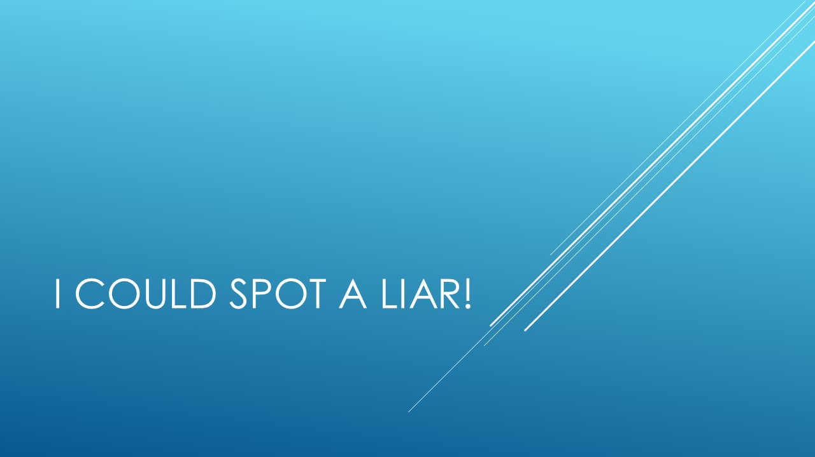

Use this workbook to take notes as the module moves along. There is a separate workbook for each module.

We are terrible at spotting lies. On average, we only get it right 50% of the time. We all have a tendency to believe some types of information or to judge certain types of people as liars.
Notes on accuracy of detecting deception.

Notes on how well law enforcement officials detect deception.

Additional reading: http://www.communicationcache.com/uploads/1/0/8/8/10887248/who_killed_my_relative-_police_officers_ability_to_detect_real-life_high-stake_lies.pdf

Additional notes.

Additional reading on confidence and ability to detect deception: http://www.ffri.hr/~ibrdar/komunikacija/seminari/DePaulo,%201997%20-%20Detection%20of%20deceiption%20.%20meta-analysis.pdf

Relevant books
The Truth about Trust. David DeSteno (2014)

Interesting websites:
https://www.apa.org/monitor/2016/03/deception

Sample essay questions:
Why are some groups of people better at spotting a liar than others?
Discuss the relationship between confidence and lying.

