Zoom Instructions – How to set up and use for the first time
Setting up Zoom is a simple process and you only need to do this once.
Please note: Depending on which browser you are using this process may look slightly different, but the steps will be the same.
- You will receive a link to a zoom meeting (which is a video chat). This might be for a study group, appointment or webinar.

E.G. https://zoom.us/j/206500673

- When you click on the link this screen will appear (if using Google Chrome). If you already have Zoom installed, you will be taken directly to the zoom meeting.
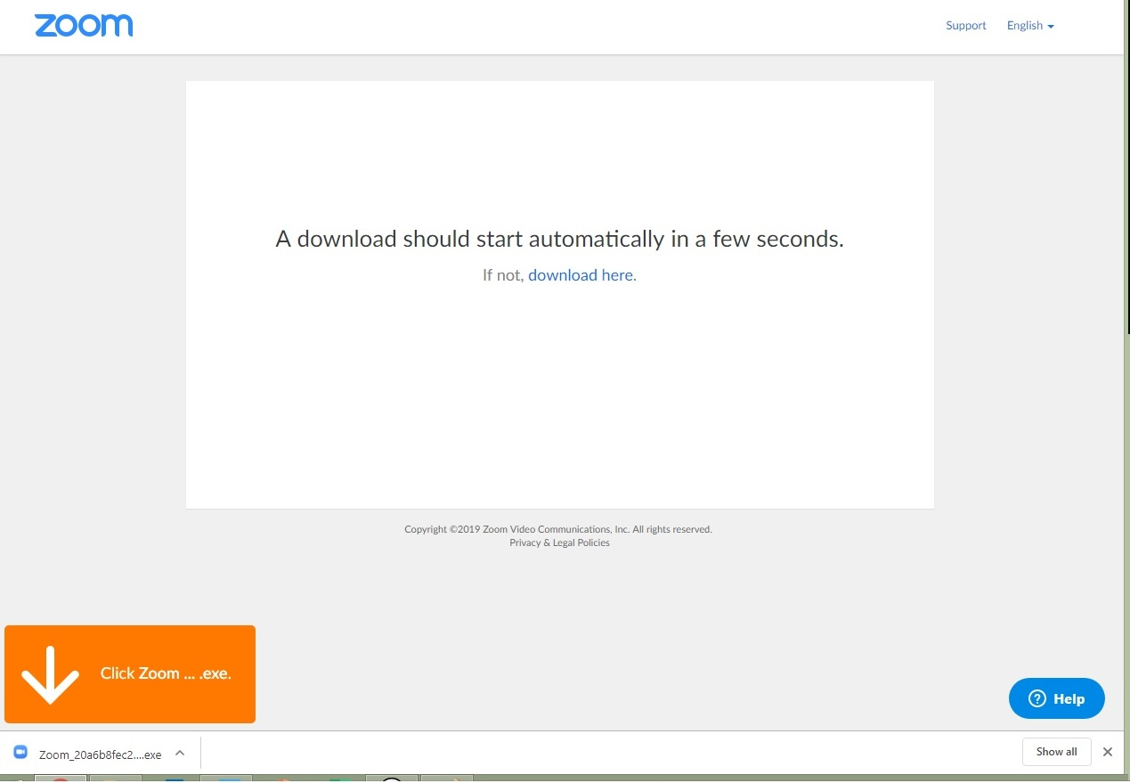
- As instructed click on the Zoom file, your computer may automatically download it (as in the above pic) or it may prompt you for permission first as per the message below.
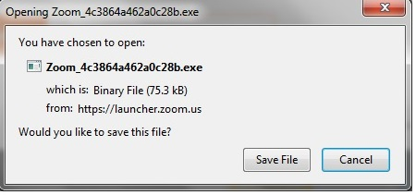
- Save the file (if prompted).
- And then select Run (if prompted).
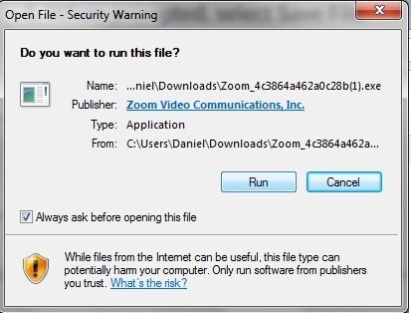
- You will see this message.
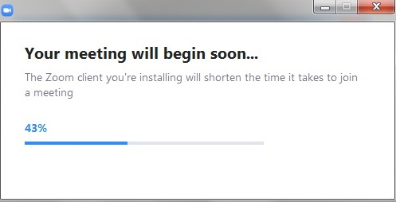
- When prompted enter the name you would like displayed in the meeting. And you have the option to switch off the video for the meeting.
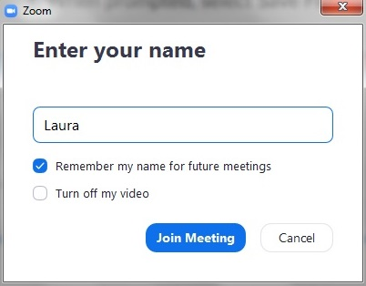
- You will be prompted to read and agree to Zoom’s terms and conditions.
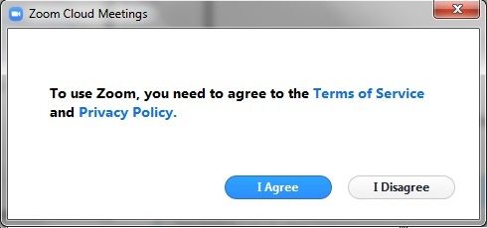
- When prompted click the green button – ‘Join with computer audio’. (You will have the option later to use the Mute facility so that no-one in the meeting can hear anything from your computer).
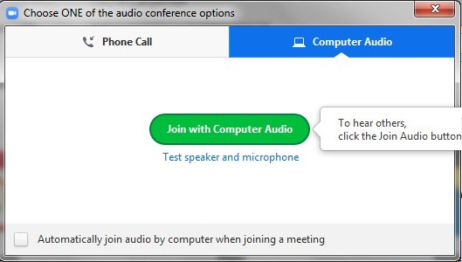
- If you are prompted to join a meeting select that option.
- Zoom will now open and you will see the following display.
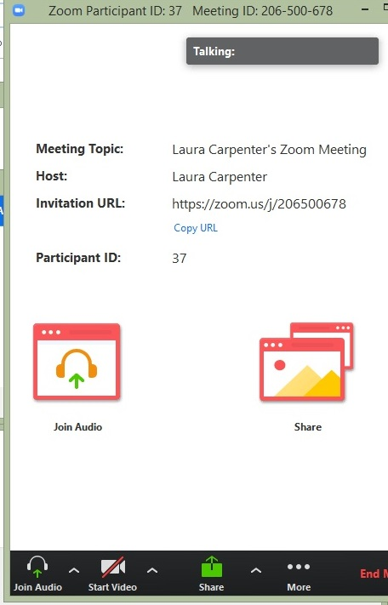
- You can maximise the screen using the icon in the top right corner of the screen. And if you appear on the screen and you want to turn your video off (for example if you are joining a webinar), simply select the stop video button.
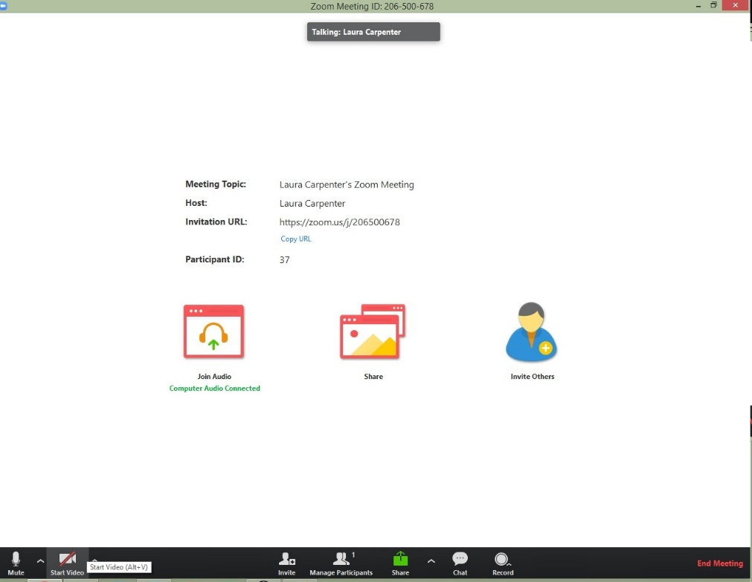
- If you are in a meeting, appointment or webinar you will either see me or a presentation front screen.
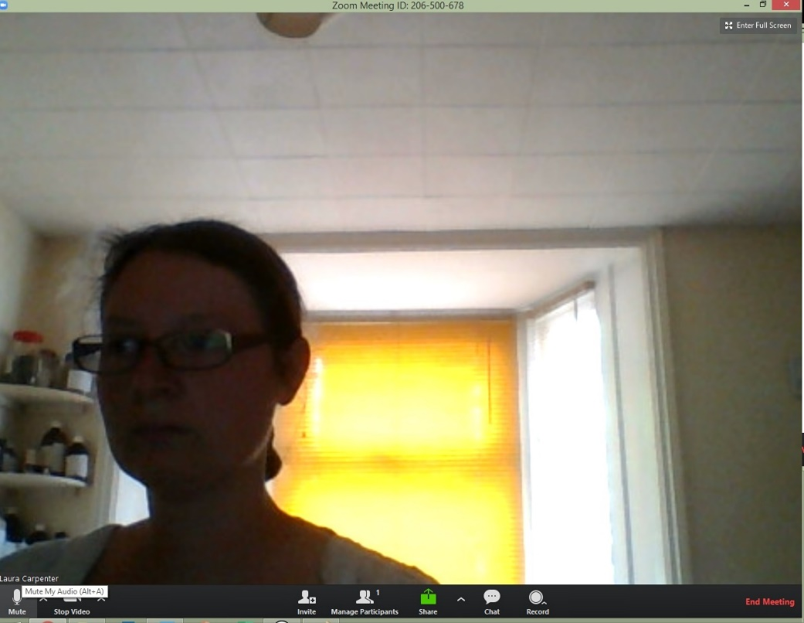
- If you are in a webinar everyone joining the meeting will automatically be put on to mute. This is because when 100 people all try to talk at once it causes an awful racket!
If you are joining for a meeting you may want to use the mute button while you wait for the other members of the study group to arrive.
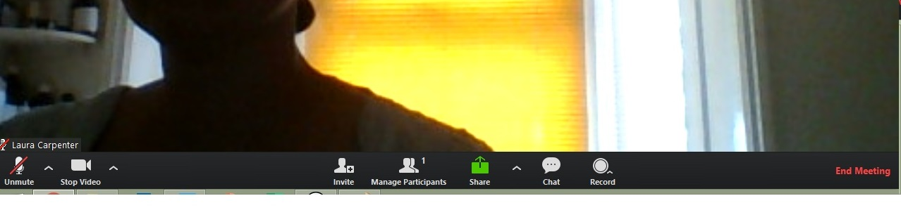

- If you are joining a study group or webinar you will need to use the chat facility to ask questions of the group as the sound will often be switched off. Select the chat button and then you can type to the whole group. If you want to ask a private question please use email.
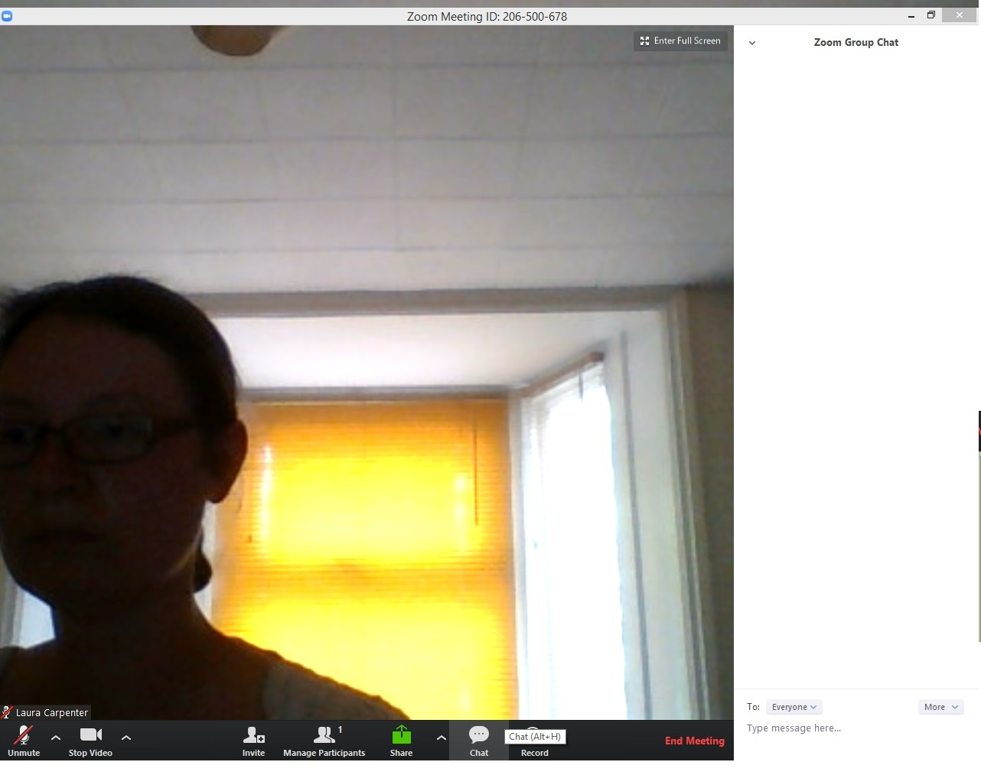

- When you want to leave the meeting, study group or webinar, simply scroll over the bottom section of the screen and the Zoom menu will appear. Select ‘End meeting’ or ‘Leave meeting’ in the bottom right corner.
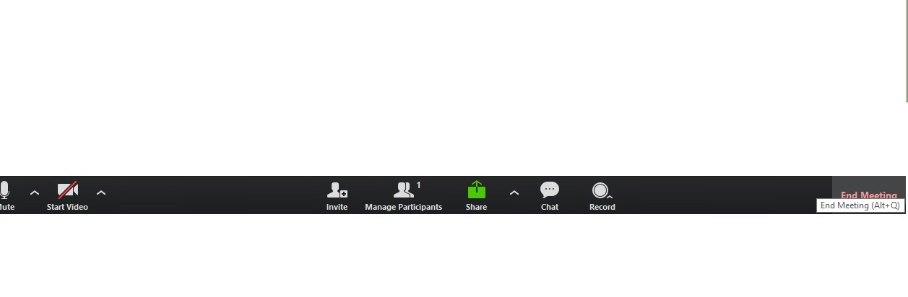
- You will be prompted to confirm that you want to leave the meeting. You can re-join with the link if something happens to your connection or you need to take a break during a webinar. (You won’t need to go through this whole process again – you will be taken straight into the meeting).
