The 4 Sacred Feminine Guides to Help You Through the Fires of Transformation: The Temple Body Warrior, The Divine Alchemist, The Creatrix, and the High Priestess.

“You are being asked to cross the threshold from the life you have been living into the aliveness of the fire that is flickering and glowing at your feet. Igniting you within, transforming you into a living sacred fire.”

Alanna Fairchild-
Rumi Oracle

Sacred Evolution Archetype for Transformation
The following is the archetype or the part of self within called The Creatrix or Divine Witch. She will be your guide for these 8 weeks and those that represent her for sacred transformation! The Creatrix works with the spirit body. Below is the list of the part within that will be your guide, what “body” it relates to, and the offerings they have to give through each transformation activation and attunement, and some questions for insight.

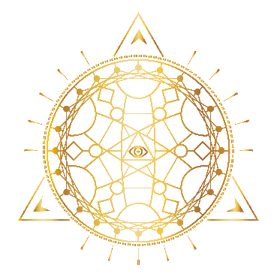

(SPIRIT Body)
The Creatrix/Witch (to create)

Purpose/Goals:
- Reconnect to the pelvic cauldron
- Reclaim your creativity
- Release Creative and Sexual Womb Blocks
- Access your passions
- Align with your sensuality
- Harness your unique gifts and talents
- Embody your Creative Expression
- Reawaken your Deepest Desires
- Align with your Highest Value and Wealth energy

The Creatrix embodies: magic, healer, creative expression, authentic expression, the shift in perception, energy, how we see ourselves, others, our wounds and stories, life force energy, chi, prana, in flow, body as a compass or resource, moon cycles, connected to all things, sacred, aware of choices, Intuitive, psychic, visionary, creative arts guide, sage, seer, spiritually aligned, womb, frequency, birthing a new reality, empowerment, connection to our higher consciousness, sacred gifts and talents, our own unique fingerprint.

When to call in the Creatrix: when feeling uncreative, dim, out of rhythm with self and others, unsure or the unknown, untrusting, fearful of future, out of touch with mother nature, sexually numb or cut off, low sex drive, over active sex drive, cut off from pleasure, scarcity, not enoughness, voiceless, fake, unauthentic, need to find authenticity, holding back.

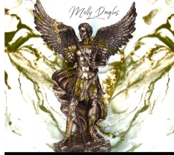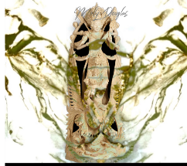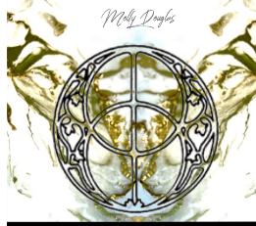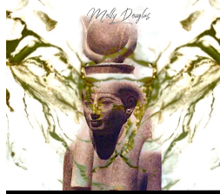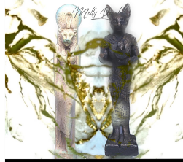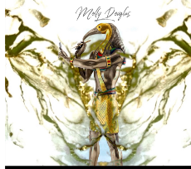
Your Spiritual Guides and Role Models

- Archangel Gabriel-, communicator- governs throat chakra expression
- Saraswati-Creative Universal FLOW, the sacred word, standing in your truth, gifts to share
- Mother Earth-creator, life giver, Midwife and Mary Magdalene- teacher, leader, Priestess of Isis

- Hathor-Cosmic Mother Creator and Egyptian Goddess of the Gateway Guide. Symbols: the bull, cow, or ox head-representing the yoni, woman, or womb.
- Bastet (moon) and Sekhmet (sun)-Governs Sacred Pleasure, Red and White Magic, womb power, Priestesses of the wild and sensual
- Thoth-Egyptian God of Wisdom, Expression and Magic- Manifesting.

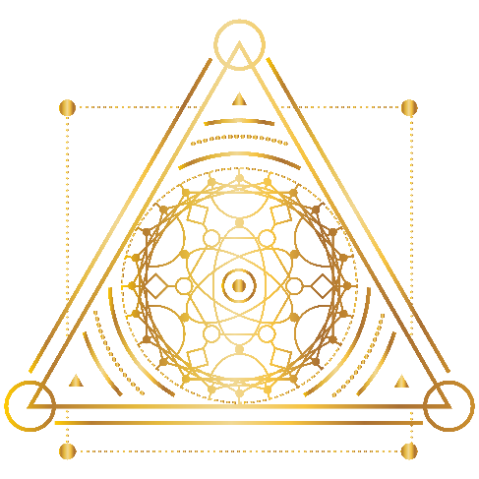

Rock Stars:
- Labradorite
- Moonstone
- Silver
- Carniolan
- Tiger’s Eye
- Turquoise
- Lapis Lazuli
- Aquamarine

Chakras:
- Sacral
- Throat
- Third eye

Feel free to answer in your journal. Let your intuition guide you. Save the first couple pages at the front of your journal for permissions and mantras.
Question for insight with your inner Creatrix:

How creative do you feel?
(List out any Creative Scars or times your creativity was shut down due to not feeling good enough- this can happen starting in childhood.)

What permissions do you need to let yourself explore and open up into your creative expression? (our permissions come from how we feel or what the head tells us we are not doing right... permission to have it not be perfect.)

Do you have trouble feeling seen and heard?

How do you allow yourself to play in life? (when there is no worry about outcome and you are in the present moment.)

How do you like to express yourself?

What parts of self do you feel cut off from or are most afraid to share with others?

How much time do you spend out in nature? What do you enjoy doing?

How free do you feel to express your wild sensual feminine spirit in connection with Mother Earth?

What ideas, creations, or parts of self are you ready to birth into the word?

Do you enjoy sensual touch, pleasure, and intimacy with others?
With yourself self?

Do you feel comfortable looking at and or touching your body?

What scars or wounds do you hold in your lower body from trauma, loss, or violation? (emotionally, physically, or sexually)

Where could you bring in more pleasure to your life?

How in touch do you feel with your moon cycle?

Do you hear and receive your body’s own intuitive messages?

What are your intuitive gifts that you are aware of?

What would you like to be able to do with your intuitive gifts?

What parts of your life could use some recharging, nourishment, lightness, or renewal?

Do you feel cherished, valued, and honored in your feminine nature?

How connected do you feel to your deep feminine power?

How much time and care do you take investing in you?

