The Low Back Series ~ A series for everyday or during periods of acute pain
Use a yoga mat against a wall for this series. There are three parts – repeat each exercise three times, alternating legs.

1. With your mat perpendicular to the wall, lie on your back with your left foot against the wall and your left knee slightly bent. Use both hands to pull your right knee into your chest. (Figure 1).

Inhale. As you exhale, push into the wall with your left foot and engage the left thigh, pushing yourself away from the wall. Keep the right knee tucked into the chest (Figure 2). Release the right leg and let gravity guide your right foot back to the floor. Scoot back to the wall and repeat on the other side.
Figure 2

Figure 1

2. Begin as you did in step one. Reach for the right foot (half Happy Baby Pose) and pull the thigh toward your chest. The sole of the foot is now parallel with the ceiling and the shin is perpendicular to the thigh. Use a strap if needed. Figure 3. Keep a hold of your left foot as you push into the wall with your left leg. Figure 4. Release and repeat on other side.
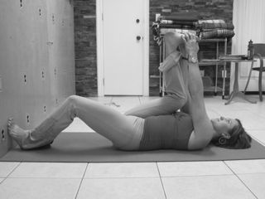

Figure 4

Figure 3

3. Begin as in exercise number two, but hold onto your foot with your right hand only (support the knee with your arm). Figure 5. Place your left hand on top of you left hip. Press away from the wall with your left foot as you exhale. Inhale, exhale and take your right foot out to the right. Figure 6. Inhale. Exhale, move your right foot back. Release and repeat on the other side. To stand up when you are finished, roll to your side in the fetal position and press yourself up to standing.

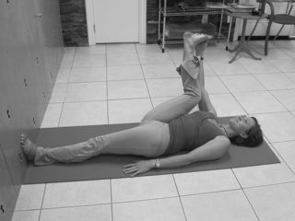

Figure 6

Figure 5

