Introduction

In Chapter 9 we discussed Rule #7 – Modern-Day Application. How do we apply an ancient message to a modern audience.

What is the Universal Message?

In an earlier chapter, we touched on the basic process for Bible Interpretation.

In Rule #9 – Modern-Day Application, we utilize the same chart to show how to apply any Bible passage to our current situation.

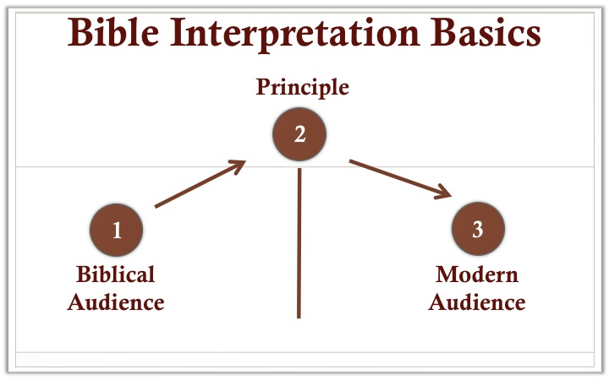

Step 1 – Try to identify the original message to the Bible’s original audience

In Leviticus 11, the prohibition against pork was likely related to the identity and holiness of God’s people.

Step 2 – Identify a principle within the original message
In Step 2, we take the original message of the Bible and try to translate that into a universal principle. We are looking for the essence of a particular event or narrative.
In our Leviticus 11 example, we might state the universal principle this way:
God wishes that his people retain their identity as Christians. In addition, he desires that they maintain a high moral standard regardless of the culture that surrounds them.

Step 3 – Application to a Modern Audience
The application process is quite simple once we have identified a principle. How would we maintain a Christian identity and high moral principles in our work? home life? church? society?
Each of these would have many different applications. At work we might agree not to cut corners or not to step on people to get ahead. At home, we would seek honesty and kindness in our relationships with our children or significant others.

Helpful Steps in Locating a Universal Principle

- God’s moral commands tend to be relevant in any era. No stealing, lying or cheating on your spouse are commands that help us build strong and lasting relationships.

- Make sure you understand the topic the passage is touching upon. “Thou shalt have no other gods before me” (Exo 20:3) is mostly about our relationship and fidelity to God.

- Ask yourself to whom is the passage directed? To families, children, parents? Individual or group? Rich or poor, male or female?

- Be careful with promises in the Bible.
- A promise to a New Testament believer is likely to be applicable to believers of our time
- A promise to an Old Testament believer may be applicable to believers of our time depending on context;
- A promise made to the nation of Israel cannot be spiritualized and applied to a modern nation.

- Do not confuse a principle with a promise. Many of the teachings in Proverbs are principles. They suggest likely outcomes from desired behavior, but it is not always the case.

- Does the text demand a change in thought, feeling or behavior?

- When dealing with Old Testament narratives or parables remember that these generally illustrate one central idea.

An example of Rule #7 – Modern-Day Application

Achan’s sin (Joshua 7) brought disastrous consequences upon himself, his family and his community. Using the various rules in this course and the guidelines in this final chapter we can derive the following applications from this narrative:

- It is never a good idea to do something which God has expressly forbidden.

- There is no such thing as a personal sin. Our sins have an impact on our families and / or community.

- Sooner or later, we will have to pay the consequences for our sins.

