Portrait Paper Doll

Essential Question How can we use proportion and details such as personal possessions, clothing, and facial expression to create a portrait of someone?

Grade 4th

Time 50 minutes

Art Concepts Portrait, proportion, figure, storytelling, texture, facial expression

Materials White paper, pencils, eraser, ruler, black marker or colored pencil, coloring materials (colored pencils, markers, crayons)

Artwork in Focus Recortando a Frida, 2005 by Jose Lozano

Talking about Art What is a portrait? Have you ever created a portrait before? If so, what details did you include to tell a story (storytelling) about the person in your portrait or express who they are?

A portrait is a picture of a person. It can be a picture of yourself (a self-portrait) or of someone else. Artists often include details in portraits such as a setting or background, objects, clothing, and accessories to give us clues about the identity of the person in their picture. Artists also show a person’s mood through their facial expression and pose. You can do this as well to tell us more about how your subject is feeling.

We are going to look at Recortando a Frida (2005), which is a portrait that local artist Jose Lozano made of a person who is an inspiration to him. Then we will create our own portraits.

For our portraits, we will use specific proportions. What does proportion mean? Proportion describes the relationship between the dimensions or size of different elements in an artwork. For example, when we think about the proportions of the human body, we know that our legs are roughly half of our entire height.

What do you notice about this artwork? Does the style of the portrait remind you of anything? Do you know who this person is? How do you know? What details has Lozano included that tell you who it is? This is a portrait of Frida Kahlo, a very well-known Mexican artist who famously had a monobrow, which the artist has included here.

Lozano is a first-generation Mexican artist who was born in California but also lived in Mexico when he was younger. Lozano makes artworks about Mexican and Mexican American culture that often depict the people around him. Kahlo is a Mexican artist who has had a huge influence on American art and on Lozano.

The title of this work is Recortando a Frida. Recortando means “cutting” in Spanish, and refers to Lozano’s decision to represent Kahlo as a paper-doll cutout. Lozano got the idea to incorporate paper dolls into his art while making some for his nieces. You can imagine cutting out the dress and placing it over the figure to change her clothes. Surrounding Kahlo are the objects that she had at different times during her life. Lozano said creating portraits in this way is “almost like writing a short story…. You can be in charge of placing or designing…people's lives.”

As I tell you a story about Kahlo I want you to search the image for details. Can you find the details that Lozano included about her life? She was a painter and she used certain tools to make her work, such as paintbrushes and a paint palette. She made many self-portraits that included lots of details and symbols to tell stories about her life, such as the self-portraits she painted of herself wearing traditional Mexican clothing. In 1937 she made a portrait called Me and My Doll in which she sits on her bed next to a small doll. Kahlo had a pet spider monkey called Fulang-Chang and several pet parrots, which she also included in her paintings.

When she was 18 years old, Kahlo was involved in a bus accident. When she was healing, she had a mirror fastened to her bed so that she could look at her reflection and create self-portraits while in a reclining position. The accident was an important event in her life that she often represented in her paintings, possibly in the symbol of a butterfly. Butterflies start their lives as caterpillars and go through a process of transformation.

Making Art Lozano represented a person who is significant to him, and for this lesson, you are going to draw a paper-doll/cut-out portrait of someone who is important to you.
- You might need to do some research on your chosen person before you start.
- Create your own cut-out portrait of that person by drawing them and then surrounding them with drawings of objects and accessories that tell us more about who they are.
- Start by using a ruler to draw an eight-inch-long vertical line on the paper where you would like your figure to stand. The top of the line will be the top of your figure’s head and the bottom will be where their feet are. Press lightly with your pencil because we will erase this line later.
- People come in all different heights and shapes, but there are some general measurements that can help us draw the human body in proportion. It is said that eight of your heads make up your whole body. Divide your eight-inch line into eight equal parts, marking a little dash at each of the inch marks.
- Lightly sketch an oval to represent the head in the topmost section of your line.
- Draw the neck, torso, and arms up to the wrists in the second, third, and fourth sections using overlapping circles and ovals.
- Draw the hands and legs in the bottom four sections of your drawing.
- Now that you have your figure in the correct proportions, you can go over your lines and add details such as clothing and hair to tell us who your person is. Erase any lines you don’t need.
- Next, surround the figure with objects and accessories that tell us more about them. If you have time, you can even draw them a change of clothes like Lozano did in his Kahlo portrait.
- Add texture and color to your drawing using coloring materials you have at home. For example, if the person in your picture has straight hair, add straight lines to your picture, and if they have curly or wavy hair, add swirly, curly, wavy lines to your picture.

Reflection Share your artwork with someone. Describe the person in your portrait and tell their story as they look at your drawing and look for the details.

Why did you choose to portray this person? What are some important qualities about them that inspired you to create the portrait?

What do you think about Lozano’s screenprint now that you have created something similar? How has your response to it changed?

Prompts for Research a significant person or historical figure prior to the
Supplemental Activities class.
Write a story about your portrait after class.

Curriculum Connections California Arts Standards for Public Schools—Visual Arts

4.VA:Re7.1: Compare responses to a work of art before and after working in similar media. 4.VA:Re7.2: Analyze components in visual imagery that convey messages. 4.VA:Re8: Interpret art by referring to contextual information and analyzing relevant subject matter, characteristics of form, and use of media.
History-Social Science Content Standards
To incorporate this standard, teachers can specify that students represent a historical figure from California.
4.4.3.4: Study the lives of women who helped build early California (e.g., Biddy Mason).
Images
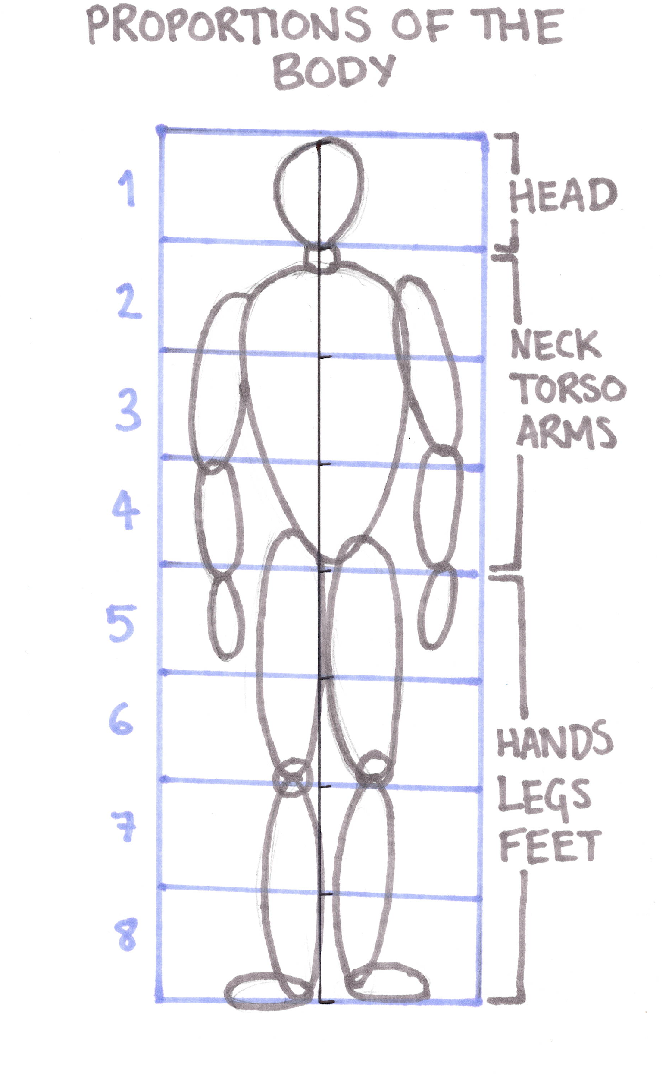

Prepared by Billie Rae Vinson with the Los Angeles County Museum of Art (LACMA) Education Department

