- Download IB’s Trader Workstation on your desktop/laptop.
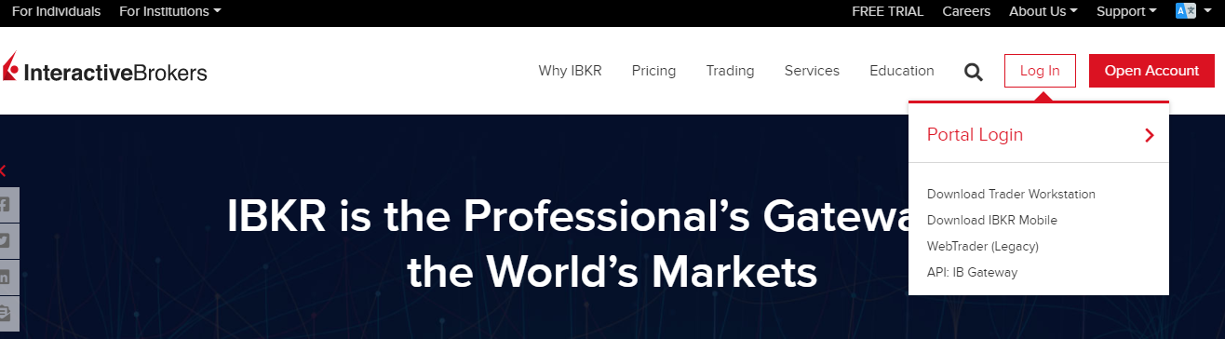

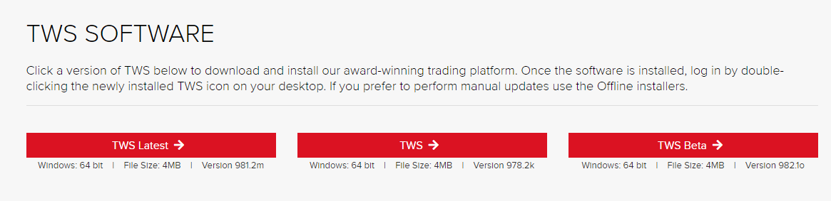
You can download “TWS latest” or “TWS”. Former is the most updated but might not be as stable as the latter. Do not download “Beta”.

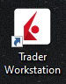 This should be the Icon you see on your desktop.

- Log in like you would normally on the IB website or your mobile app
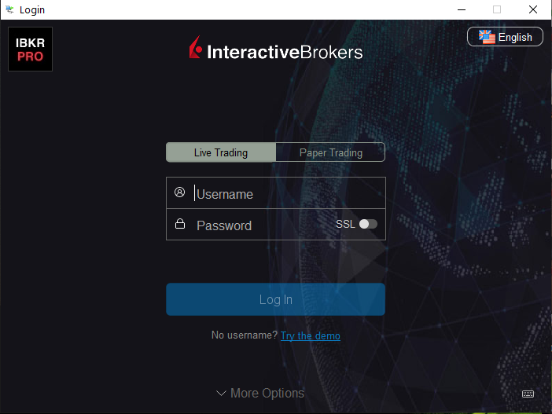
- Go to File ->Layout on the top left corner after you have logged in.
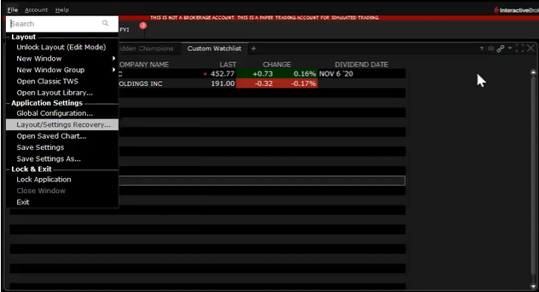

- A pop-up window will appear. Click “custom” and then “ok”.
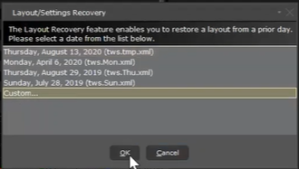

- Save the attached .xml on your desktop and select this layout file to open
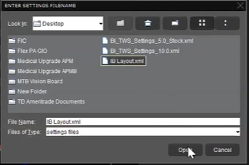
- Just let it load and do it’s thing.
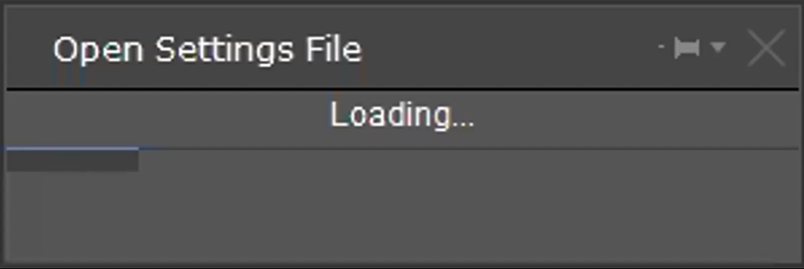

- End result should look like the below.
