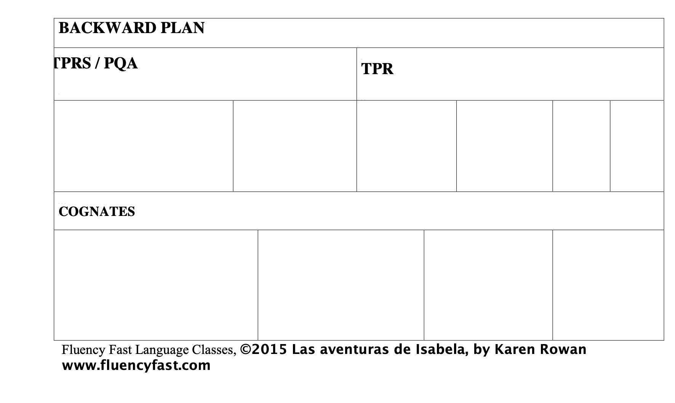

QUESTION WORDS |  | POSSIBLE SUB PLAN IDEAS:
PROPS |  | RESOURCES

BACKWARD PLAN TEMPLATE, by Karen Rowan www.FluencyFast.com
READER’S THEATER CHAPTERS |  |  | GOOGLE LINKS
 |  |  | WALKING TOUR |  | FORM | GUIDED TOUR
MOVIETALK
ESSENTIAL QUESTIONS |  |  | OTHER RESOURCES
REPRESENTATION |  | SOCIAL JUSTICE | CULTURALLY RESPONSIVE

Template
Character:
Conflict:
Resolution:

Story type:
- ____Overcoming the Monster
____Rags to Riches
____The Quest
____Voyage and Return
____Comedy
____Tragedy
____Rebirth

MAKE AN ENTRANCE:

GRAB ATTENTION

WAIT FOR ATTENTION

Trigger Dopamine:
____Build suspense
____Launch a cliff hanger
____Cycle of waiting and expecting
____Action

____Foreshadowing a secret
____Unexpected prop

____Novel stimuli

Trigger Oxytocin

____Mirroring Altruism and Heroism

____Emotion

____Empathy with characters who overcome struggle

____Conflict that cannot be resolved

____Be Specific, Add Details

Trigger Endorphins

____Physical action of laughing

____Happy Ending

