Redox
1. |  | Oxidation involves  A a decrease in oxidation number.  B an increase in oxidation number.  C a decrease in number of protons.  D an increase in number of protons.
2. |  | When zinc forms zinc oxide, zinc  A gains electrons and is oxidized.  B loses electrons and is oxidized.  C gains electrons and is reduced.  D loses electrons and is reduced.
3. |  | Which of the following elements in the third period of the periodic table is the strongest reducing agent?  A Aluminium  B Chlorine  C Magnesium  D Sodium
4. |  | The oxidation number of vanadium in VO₂⁺ is  A +3.  B +4.  C +5.  D +6.
5. |  | What is the oxidation number of chromium in the complex ion [Cr(H₂O)₄Br₂]⁺?  A –1  B +1  C +2  D +3
6. |  | In which compound does iodine have an oxidation state of +3?  A HIO₃  B NaI₃  C CrI₃  D NaIO₂
7. |  | Which of the following conversions involves the smallest change in oxidation number of the underlined element?  A Cl₂(g) à Cl–(aq)  B SO₂(g) à SO₄^{2–}(aq)  C VO₂⁺(aq) à V³⁺(aq)  D Cu₂S(s) à SO₂(g)
8. |  | In which of the following series does the oxidation number of chlorine increases from left to right?
  A | HClO₄ | HCl | Cl₂ | HOCl
  B | HClO₄ | HOCl | Cl₂ | HCl
  C | HCl | Cl₂ | HOCl | HClO₄
  D | Cl₂ | HOCl | HCl | HClO₄
9. |  | In which of the following compounds does sulphur exhibit the smallest oxidation number?  A Cu₂S  B (NH₄)₂SO₄  C Na₂S₂O₃  D H₂S₂O₇
10. |  | Which of the following conversions is an oxidation?  A S à ZnS  B S₂O₃^{2–} à S₄O₆^{2–}  C MnO₄– à MnO₂  D CH₃COOH à CH₃CH₂OH
11. |  | Which of the following is NOT a redox reaction?  A 2KClO₃(s) à 2KCl(s) + 3O₂(g)  B Mg(s) + CuSO₄(aq) à MgSO₄(aq) + Cu(s)  C Pb(s) + PbO₂(s) + 2H₂SO₄(aq) à 2PbSO₄(s) + 2H₂O(l)  D ZnO(s) + 2NaOH(aq) + H₂O(l) à Na₂[Zn(OH)₄](aq)
12. |  | In which of the following reactions is the underlined substance reduced?  A H₂S₂O₇(l) + H₂O(l) à 2H₂SO₄(l)  B 2Fe²⁺(aq) + Cl₂(aq) à 2Fe³⁺(aq) + 2Cl–(aq)  C Al(OH)₃(s) + OH–(aq) à Al(OH)₄–(aq)  D C(s) + O₂(g) à CO₂(g)
13. |  | In which of the following reactions does the oxidation number of an element decrease by 4 units or more?  (1) TiCl₄(g) + 2Mg(l) à Ti(s) + 2MgCl₂(l)  (2) MnO₄–(aq) + 4H⁺(aq) + 3Fe²⁺(aq) à MnO₂(s) + 3Fe³⁺(aq) + 2H₂O(l)  (3) 8HI(g) + H₂SO₄(l) à 4I₂(s) + H₂S(g) + 4H₂O(l)  A (1) and (2) only  B (1) and (3) only  C (2) and (3) only  D (1), (2) and (3)
14. |  | Which of the following combinations is correct?
   | Formula of ion | Name of ion
  A | ClO₄– | chlorate(V) ion
  B | CrO₄^{2–} | chromium(VI) ion
  C | NO₃– | nitrate(V) ion
  D | SO₃^{2–} | sulphite(IV) ion
15. |  | 2CrO₄^{2–}(aq) + 2H⁺(aq) à Cr₂O₇^{2–}(aq) + H₂O(l)  Which of the following statements concerning the above reaction is correct?  A It is a redox reaction.  B H⁺(aq) ions are oxidized.  C CrO₄^{2–}(aq) ions act as an oxidizing agent.  D The solution changes from yellow to orange.
16. |  | Using 1 mole of reactant, which of the following chemical changes involves the greatest number of moles of electrons?  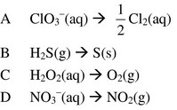
17. | Directions: Questions 17,18 refer to part of the electrochemical series shown below.  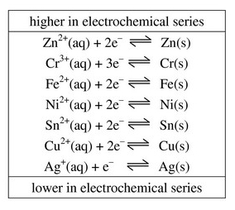
Metal X dissolves in HCl(aq) but does not react with water. It is a better reducing agent than Ni(s). It forms an oxide with the formula X₂O₃. What is X?
A Ag
B Cu
C Cr
D Zn
18. |  | Consider part of the electrochemical series shown below:  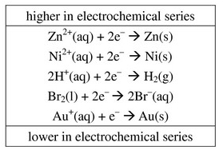  Which of the following species can reduce H⁺(aq) ions to H₂(g) in aqueous solution?  A Ni(s)  B Au(s)  C Br₂(l)  D Zn²⁺(aq)
19. |  | Consider the following equation for a redox reaction:  IO₃–(aq) + 5I–(aq) + 6H⁺(aq) à 3I₂(aq) + 3H₂O(l)  Which of the following statements are correct?  (1) The oxidation number of iodine in IO₃–(aq) is +5.  (2) One of ionic half-equations of this reaction is IO₃–(aq) + 6H⁺(aq) + 5e– à I₂(aq) + 3H₂O(l).  (3) I–(aq) ions are oxidized in the reaction.  A (1) and (2) only  B (1) and (3) only  C (2) and (3) only  D (1), (2) and (3)
20. |  | Iron(II) sulphate solution is mixed with aqueous chlorine. Excess aqueous ammonia is then added to the mixture. What would be the colour of the precipitate formed?  A Green  B Reddish brown  C Yellow  D White
21. |  | The table below shows the results of two tests on the solution of substance X.  X could be  A ammonium bromide.  B ammonium chloride.  C magnesium bromide.  D magnesium chloride.
  Test | Description | Observation
  I | Adding aqueous chlorine | A yellow-brown colour develops.
  II | Adding dilute sodium hydroxide solution and warm | A gas that turns moist red litmus paper blue is evolved.
22. |  | Which of the following statements concerning halogens is INCORRECT?  A Fluorine is a strong oxidizing agent.  B Aqueous chlorine is colourless.  C Bromine is a volatile liquid.  D Iodine vapour is purple in colour.
23. |  | In what order does the reducing power of the hydrogen halides increase?  A HCl < HBr < HI  B HCl < HI < HBr  C HBr < HI < HCl  D HI < HBr < HCl
24. |  | Astatine is a Group VII element below iodine in the periodic table. Which of the following statements concerning astatine are correct?  (1) It is a solid at room temperature and pressure.  (2) It is a stronger oxidizing agent than iodine.  (3) It reacts with potassium to form an ionic compound.  A (1) and (2) only  B (1) and (3) only  C (2) and (3) only  D (1), (2) and (3)
25. |  | In which of the following experiments would ammonium iodide solution react?  (1) Warming with sodium hydroxide solution  (2) Mixing with aqueous bromine  (3) Mixing with silver nitrate solution  A (1) and (2) only  B (1) and (3) only  C (2) and (3) only  D (1), (2) and (3)
26. |  | Which of the following processes would give an obvious colour change?  (1) Adding aqueous chlorine to potassium bromide solution  (2) Adding acidified potassium permanganate solution to potassium iodide solution  (3) Adding dilute sulphuric acid to sodium chromate solution  A (1) and (2) only  B (1) and (3) only  C (2) and (3) only  D (1), (2) and (3)
27. |  | An alloy contains 60% copper and 40% silver. When the alloy is heated with excess concentrated nitric acid, which of the following will be observed?  A Part of the alloy dissolves, leaving a reddish brown substance behind.  B Part of the alloy dissolves, leaving a silvery substance behind.  C The alloy dissolves completely to form a colourless solution.  D The alloy dissolves completely to form a blue solution.
28. |  | In acidic solution, rhenium (Re) and nitrate ion (NO₃–) react to give NO and ReO₄–. The chemical equation for the reaction is given below:  wRe(s) + xNO₃–(aq) + yH⁺(aq) à xNO(g) + wReO₄–(aq) + zH₂O(l)  What is the value of y?  A 2  B 3  C 4  D 5
29. |  | A mixture contains only copper and copper(II) hydroxide. Which of the following methods can be used to separate copper from the mixture?  (1) Add dilute sulphuric acid to the mixture and then filter.  (2) Add dilute nitric acid to the mixture and then filter.  (3) Add water to the mixture and then filter.  A (1) only  B (2) only  C (1) and (3) only  D (2) and (3) only
30. |  | Which of the following acids can be stored in a tank made of copper?  (1) Dilute hydrochloric acid  (2) Dilute nitric acid  (3) Dilute ethanoic acid  A (1) and (2) only  B (1) and (3) only  C (2) and (3) only  D (1), (2) and (3)
31. | Directions:  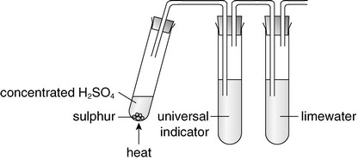
Which of the following combinations is correct?
 | Universal indicator | Limewater
A | Turns red | remains unchanged
B | Remains unchanged | becomes cloudy
C | Turns red | becomes cloudy
D | Turns yellow | remains unchanged

32. |  | Substance X gives identical product(s) when treated with dilute sulphuric acid or concentrated sulphuric acid. X might be  A carbon.  B sulphur.  C magnesium.  D zinc carbonate powder.
33. |  | Which of the following statements concerning the reaction of magnesium oxide and concentrated sulphuric acid is / are correct?  (1) Sulphuric acid acts as an acid.  (2) Sulphuric acid acts as an oxidizing agent.  (3) Sulphuric acid acts as a drying agent.  A (1) only  B (2) only  C (1) and (3) only  D (2) and (3) only
34. |  | Consider the conversions between three sulphur compounds shown in the flow diagram below.  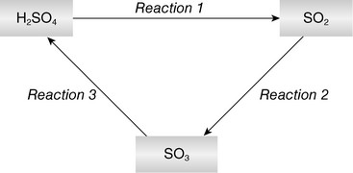  Which of the following statements are correct?  (1) Reaction 1 can be brought about by adding hot concentrated sulphuric acid to sulphur.  (2) Sulphur dioxide undergoes oxidation in Reaction 2.  (3) The oxidation number of sulphur increases in Reaction 3.  A (1) and (2) only  B (1) and (3) only  C (2) and (3) only  D (1), (2) and (3)
35. |  | Which of the following is / are suitable preparation method(s)?  (1) Preparing carbon dioxide from calcium carbonate and dilute sulphuric acid  (2) Preparing nitrogen dioxide from copper and concentrated nitric acid  (3) Preparing hydrogen iodide from sodium iodide and concentrated sulphuric acid  A (1) only  B (2) only  C (1) and (3) only  D (2) and (3) only
36. |  | Which of the following is NOT a property of sulphur dioxide?  A Its aqueous solution has a pH value smaller than 7.  B It dissolves in water to give an acidic solution.  C It turns moist blue litmus paper red.  D It can be reduced to sulphate ions.
37. |  | Which of the following statements concerning the reaction between sulphur dioxide and iron(III) sulphate solution is correct?  A Sulphur dioxide acts as a reducing agent.  B Iron(III) ions are oxidized.  C Sulphur dioxide is oxidized to sulphide ions.  D The colour of the iron(III) sulphate solution changes from pale green to yellow-brown.
38. |  | Which of the following pairs of solutions can be distinguished by treating with acidified potassium dichromate solution?  (1) Potassium carbonate solution and sodium carbonate solution  (2) Sodium sulphite solution and sodium sulphate solution  (3) Iron(II) sulphate solution and iron(II) nitrate solution  A (1) only  B (2) only  C (1) and (3) only  D (2) and (3) only
39. |  | Which of the following statements concerning a chemical cell is / are correct?  (1) Oxidation occurs at the anode.  (2) Reduction occurs at the negative electrode.  (3) Electrons flow through the electrolyte.  A (1) only  B (2) only  C (1) and (3) only  D (2) and (3) only
40. |  | Consider the following chemical cell. The zinc electrode gradually dissolves as a current flows through the external circuit of the cell.  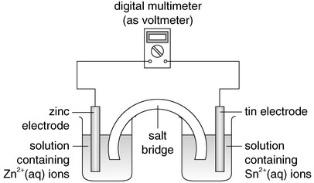  Which of the following statements concerning the chemical cell are correct?  (1) A current flows from the zinc electrode to the tin electrode in the external  circuit.  (2) The zinc electrode is the anode.  (3) Reduction occurs at the tin electrode.  A (1) and (2) only  B (1) and (3) only  C (2) and (3) only  D (1), (2) and (3)
41. |  | X and Z are metals. X reacts with Z(NO₃)₂ solution according to the following equation:  X(s) + Z²⁺(aq) à X²⁺(aq) + Z(s)  X and Z are used as the electrodes in a chemical cell with sodium chloride solution as the electrolyte. Which of the following statements concerning the chemical cell is correct?  (1) A current flows from Z to X in the external circuit.  (2) Oxidation occurs at the X.  (3) Both metal electrodes gradually dissolve.  A (1) and (2) only  B (1) and (3) only  C (2) and (3) only  D (1), (2) and (3)
42. | Directions:  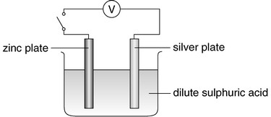
What will be observed at the metal electrodes when the circuit is opened?
(1) Gas bubbles are given off at the surface of the zinc plate immersed in the
acid.
(2) A metal deposits on the silver plate.
(3) The zinc plate gradually dissolves.
A (1) only
B (2) only
C (1) and (3) only
D (2) and (3) only
43. | Directions:
What will happen when the circuit is closed?
(1) Electrons flow from the zinc plate to the silver plate in the external circuit.
(2) Hydrogen ions are reduced.
(3) Both metal electrodes gradually dissolve.
A (1) and (2) only
B (1) and (3) only
C (2) and (3) only
D (1), (2) and (3)
44. |  | 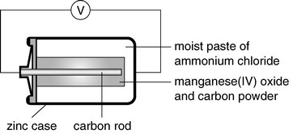  Which of the following statements concerning the above set-up is correct?  A Electrons flow from the zinc case to the carbon rod in the external circuit.  B Zinc acts as an oxidizing agent.  C Ammonium chloride acts as a reducing agent.  D Manganese(IV) oxide is oxidized.
45. |  | Which of the following reactions occurs at the cathode of a zinc-carbon cell?  A Zn²⁺(aq) + 2e– à Zn(s)  B 2NH₄⁺(aq) + 2e– à 2NH₃(aq) + H₂(g)  C Mn₂O₃(s) + H₂O(l) à 2MnO₂(s) + H₂(g)  D Zn(NH₃)₂Cl₂(s) à Zn²⁺(aq) + 2NH₃(aq) + 2Cl–(aq)
46. |  | Which of the following statements concerning the manganese(IV) oxide in zinc-carbon cells are correct?  (1) Manganese(IV) oxide acts as an oxidizing agent.  (2) The oxidation number of manganese in manganese(IV) oxide changes from +4 to +2 over discharge.  (3) Manganese(IV) oxide is used to remove the hydrogen produced in the cells.  A (1) and (2) only  B (1) and (3) only  C (2) and (3) only  D (1), (2) and (3)
47. |  | 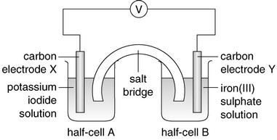  Which of the following statements concerning the above set-up is INCORRECT?  A Electrons flow from electrode Y to electrode X in the external circuit.  B The solution in half-cell A becomes brown in colour after some time.  C The colour of the solution in half-cell B changes from yellow-brown to green.  D Oxidation occurs in half-cell A.
48. |  | 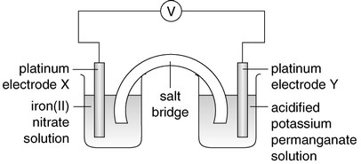  Which of the following statements concerning the set-up is correct?  A The salt bridge allows the passage of electrons between the two half-cells.  B A current flows from electrode X to electrode Y in the external circuit.  C Reduction occurs at electrode X.  D The purple colour of the acidified potassium permanganate solution becomes  less intense.
49. |  | 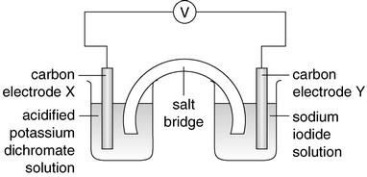  Which of the following statements concerning the set-up is correct?  A Electrons flow from electrode X to electrode Y in the external circuit.  B Oxidation occurs at electrode X.  C Electrode Y is the cathode.  D A brown colour develops around electrode Y after the cell has operated for some  time.
50. |  | 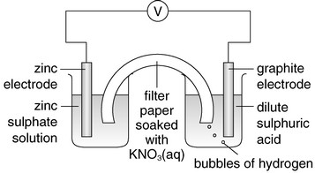  Gas bubbles of hydrogen are given off at the graphite electrode because  A the graphite electrode reacts with dilute sulphuric acid to form hydrogen gas.  B NO₃–(aq) ions supply electrons to hydrogen ions.  C hydrogen ions are reduced by sulphate ions.  D hydrogen ions accept electrons released from the zinc electrode.
51. | Directions:  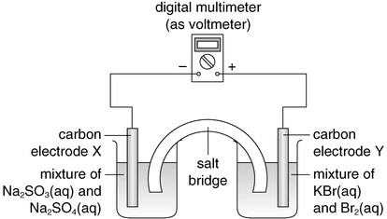
Which of the following combinations is correct?
 | Species being oxidized | Species being reduced
A | Br₂(aq) | SO₃^{2–}(aq)
B | Br–(aq) | SO₄^{2–}(aq)
C | SO₃^{2–}(aq) | Br₂(aq)
D | SO₄^{2–}(aq) | Br–(aq)

52. |  | The following diagram shows the set-up of a chemical cell.  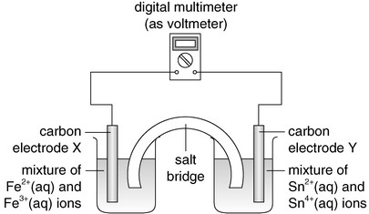  It is known that Fe³⁺(aq) ion is a stronger oxidizing agent than Sn⁴⁺(aq) ion.  Which of the following ionic half-equation represents the chemical change that occurs at the anode?  A Sn²⁺(aq) à Sn⁴⁺(aq) + 2e–  B Sn⁴⁺(aq) + 2e– à Sn²⁺(aq)  C Fe²⁺(aq) à Fe³⁺(aq) + e–  D Fe³⁺(aq) + e– à Fe²⁺(aq)
53. |  | The following diagram shows the set-up of a chemical cell.  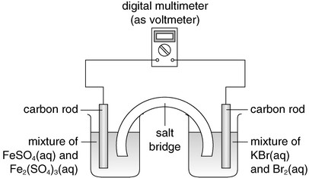  It is known that Br₂(aq) is a stronger oxidizing agent than Fe³⁺(aq) ion.  Which of the following combinations is correct?
   | Chemical change at the anode | Chemical change at the cathode
  A | Br₂(aq) à 2Br–(aq) | Fe²⁺(aq) à Fe³⁺(aq)
  B | 2Br–(aq) à Br₂(aq) | Fe³⁺(aq) à Fe²⁺(aq)
  C | Fe²⁺(aq) à Fe³⁺(aq) | Br₂(aq) à 2Br–(aq)
  D | Fe³⁺(aq) à Fe²⁺(aq) | 2Br–(aq) à Br₂(aq)
54. | Directions: Questions 39 and 40 refer to the chemical cell shown below.  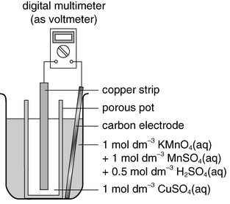
Which of the following ionic half-equation represents the chemical change that occurs at the anode?
A Cu²⁺(aq) + 2e– à Cu(s)
B Cu(s) à Cu²⁺(aq) + 2e–
C MnO₄–(aq) + 8H⁺(aq) + 5e–à Mn²⁺(aq) + 4H₂O(l)
D Mn²⁺(aq) + 4H₂O(l) à MnO₄–(aq) + 8H⁺(aq) + 5e–
55. |  | The following diagram shows a fuel cell. Hydrogen and oxygen are passed into the fuel cell.  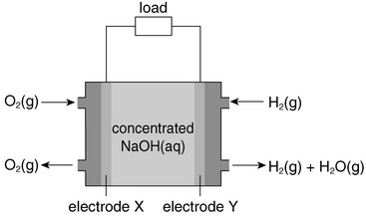  Which of the following combinations is correct?
   | Chemical change that occurs at electrode X | Hydroxide ions move towards
  A | O₂ + 2H₂O + 4e– à 4OH– | X
  B | 4OH– à O₂ + 2H₂O + 4e– | X
  C | 4OH– à O₂ + 2H₂O + 4e– | Y
  D | O₂ + 2H₂O + 4e–à 4OH– | Y
56. |  | The following diagram shows the basic structure of a direct methanol fuel cell.  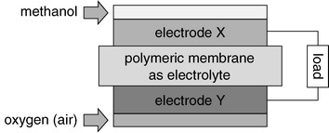  Which of the following combinations is correct?
   | Anode is | H⁺ ions move
  A | Electrode X | from X to Y
  B | Electrode Y | from X to Y
  C | Electrode X | from Y to X
  D | Electrode Y | from Y to X
57. | A rechargeable cell, contains a metal alloy (M) with hydrogen atoms adsorbed on its surface, and nickel in the form of NiO(OH)(s) and Ni(OH)₂(s).  The ionic half-equations for the chemical changes that occur at the electrodes of the cell are listed below:  Anode:  H (adsorbed on M) + OH–(aq) à H₂O(l) + e–  Cathode:  NiO(OH)(s) + H₂O(l) + e– à Ni(OH)₂(s) + OH–(aq)
Which of the following statements is correct when the cell is discharging?
A NiO(OH)(s) is reduced.
B The anode is the positive electrode of the cell.
C The concentration of OH–(aq) ions in the cell increases.
D Electrons flow from the cathode to the anode in the external circuit.
58. |  | Which of the following diagrams concerning the electrolysis of dilute sulphuric acid is correct?  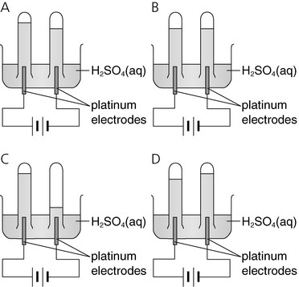
59. |  | 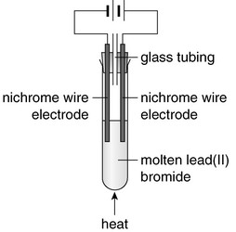  Which of the following statements concerning the above set-up are correct?  (1) Lead(II) ions are reduced.  (2) The experiment should be performed in a fume cupboard.  (3) A reddish brown gas is given off at the anode.  A (1) and (2) only  B (1) and (3) only  C (2) and (3) only  D (1), (2) and (3)
60. |  | In the electrolysis of a dilute copper(II) sulphate solution, carbon is used as the anode and copper as the cathode. Which of the following changes would occur?
   | At the anode | At the cathode
  A | Copper dissolves | copper deposits
  B | Copper dissolves | hydrogen given off
  C | Oxygen given off | copper deposits
  D | Oxygen given off | hydrogen given off
61. |  | Which of the following combinations concerning the electrolysis of a 2 mol dm^{–3} copper(II) chloride solution using carbon electrodes is correct?
   | Product at cathode | Product at anode | Blue colour of the electrolyte
  A | Copper | oxygen | remains unchanged
  B | Copper | chlorine | becomes less intense
  C | Hydrogen | chlorine | becomes less intense
  D | Hydrogen | oxygen | remains unchanged
62. |  | Consider the following set-up.  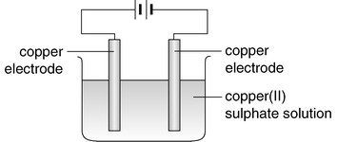  Which of the following combinations is correct?
   | Chemical change at the cathode | Chemical change at the anode | Change in the electrolyte
  A | Cu²⁺(aq) + 2e– à Cu(s) | 4OH–(aq) à 2H₂O(l) + O₂(g) + 4e– | becomes H₂SO₄(aq)
  B | 2H⁺(aq) + 2e– à H₂(g) | 4OH–(aq) à 2H₂O(l) + O₂(g) + 4e– | becomes more concentrated
  C | Cu(s) à Cu²⁺(aq) + 2e– | Cu²⁺(aq) + 2e– à Cu(s) | no change
  D | Cu²⁺(aq) + 2e– à Cu(s) | Cu(s) à Cu²⁺(aq) + 2e– | no change
63. |  | For the electrolysis of 2 mol dm^{–3} sodium bromide solution using carbon electrodes, which of the following statements is / are correct?  (1) A brown colour develops near the cathode.  (2) Oxidation occurs at the anode.  (3) The pH of the solution in the electrolytic cell decreases.  A (1) only  B (2) only  C (1) and (3) only  D (2) and (3) only
64. |  | In which of the following electrolytic processes will the solution in the electrolytic cell become alkaline?  (1) Electrolysis of dilute sodium iodide solution using carbon electrodes  (2) Electrolysis of dilute magnesium sulphate solution using platinum  electrodes  (3) Electrolysis of dilute copper(II) nitrate solution using copper electrodes  A (1) only  B (2) only  C (1) and (3) only  D (2) and (3) only
65. |  | In which of the following combinations will oxygen be the major product at the anode during electrolysis?  A (1) only  B (2) only  C (1) and (3) only  D (2) and (3) only
   | Electrolyte | Cathode | Anode
  (1) | 0.1 mol dm^{–3} CuCl₂(aq) | copper | carbon
  (2) | 2 mol dm^{–3} NaCl(aq) | platinum | platinum
  (3) | 0.1 mol dm^{–3} CuCl₂(aq) | copper | copper
66. |  | The diagram below shows a set-up with metal strips inserted in fresh potatoes.  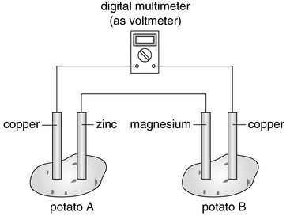  Which of the following statements concerning the set-up are correct?  (1) Electrons flow from the magnesium strip to the zinc strip across the conducting wire between the zinc strip and the magnesium strip.  (2) Oxidation occurs at the magnesium strip in potato B.  (3) The multimeter reading would increase if the zinc strip in potato A is replaced by another magnesium strip.  A (1) and (2) only  B (1) and (3) only  C (2) and (3) only  D (1), (2) and (3)
67. |  | Which of the following processes would give an obvious colour change?  (1) Electrolysis of concentrated sodium bromide solution using carbon  electrodes  (2) Adding potassium chloride solution to aqueous bromine  (3) Passing sulphur dioxide gas into acidified potassium dichromate solution  A (1) and (2) only  B (1) and (3) only  C (2) and (3) only  D (1), (2) and (3)
68. |  | Which of the following diagrams shows the correct set-up for coating the iron ring with zinc?  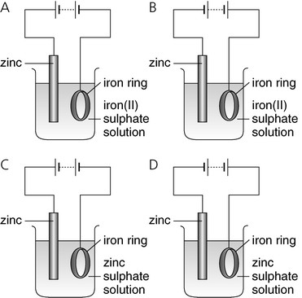
69. |  | Which of the following ionic half-equations represents the chemical change at the negative electrode when electroplating an iron object with nickel?  A Fe²⁺(aq) + 2e– à Fe(s)  B Fe(s) à Fe²⁺(aq) + 2e–  C Ni²⁺(aq) + 2e– à Ni(s)  D Ni(s) à Ni²⁺(aq) + 2e–
70. |  | Which of the following is NOT an application of electrolysis?  A Extraction of reactive metals from their ores  B Electroplating  C Removal of metal ions from sewage  D Anodization
71. |  | The wastewater generated from an electroplating factory contains dichromate ions. The wastewater is treated as shown in the flow diagram below.  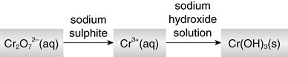  Which of the following combinations concerning the role of the reagents used is correct?
   | Sodium sulphite | Sodium hydroxide solution
  A | Oxidizing agent | precipitating agent
  B | Oxidizing agent | reducing agent
  C | Reducing agent | precipitating agent
  D | Reducing agent | reducing agent
72. | Directions:  The flow diagram below shows the stages involved in the extraction of zinc from zinc blende.  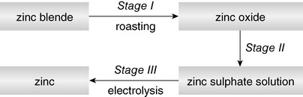
The reaction in Stage I gives a gaseous product. This gaseous product is
A oxygen.
B carbon dioxide.
C nitrogen dioxide.
D sulphur dioxide.
Assertion-reason questions
Directions: Select one option from A to D according to the following table:
A | Both statements are true and the 2nd statement is a correct explanation of the 1st statement.
B | Both statements are true but the 2nd statement is NOT a correct explanation of the 1st statement.
C | The 1st statement is false while the 2nd statement is true.
D | Both statements are false.

 | 1st statement | 2nd statement

1.
  Zinc-carbon cells are commonly used in hearing aids. | Zinc-carbon cells are rechargeable.
2.
  Lithium ion secondary cells show a good performance in high-drained devices. | Lithium ion secondary cells have a high energy density.
3.
  In a zinc-copper chemical cell, the zinc electrode acts as the anode. | Zinc releases electrons more readily than copper does.
4.
  When concentrated sulphuric acid is added to sodium bromide, bromine is formed. | Sulphuric acid is a strong acid.
5.
  Hydrogen iodide can be prepared by reacting sodium iodide with concentrated sulphuric acid. | Concentrated sulphuric acid is a strong oxidizing agent.
6.
  During the electrolysis of dilute magnesium sulphate with universal indicator using carbon electrodes, a blue colour appears around the anode after some time. | Sulphate ions are preferentially discharged at the anode, leaving excess hydroxide ions around the anode.
7.
  When a potassium hydroxide solution is electrolyzed using platinum electrodes, hydrogen gas is liberated at the anode. | Hydrogen ions accept electrons more readily than potassium ions.

Multiple choice questions
1 | B |  |  | 2 | B |  |  | 3 | D |  |  | 4 | C |  |  | 5 | D
6 | D |  |  | 7 | A |  |  | 8 | C |  |  | 9 | A |  |  | 10 | B
11 | D |  |  | 12 | B |  |  | 13 | B |  |  | 14 | C |  |  | 15 | D
16 | A |  |  | 17 | C |  |  | 18 | A |  |  | 19 | B |  |  | 20 | B
21 | A |  |  | 22 | B |  |  | 23 | A |  |  | 24 | B |  |  | 25 | D
26 | D |  |  | 27 | D |  |  | 28 | C |  |  | 29 | A |  |  | 30 | B
31 | C |  |  | 32 | D |  |  | 33 | A |  |  | 34 | A |  |  | 35 | B
36 | D |  |  | 37 | A |  |  | 38 | B |  |  | 39 | A |  |  | 40 | C
41 | A |  |  | 42 | C |  |  | 43 | A |  |  | 44 | A |  |  | 45 | B
46 | B |  |  | 47 | A |  |  | 48 | D |  |  | 49 | D |  |  | 50 | D
51 | C |  |  | 52 | A |  |  | 53 | C |  |  | 54 | B |  |  | 55 | D
56 | A |  |  | 57 | A |  |  | 58 | A |  |  | 59 | D |  |  | 60 | C
61 | B |  |  | 62 | D |  |  | 63 | B |  |  | 64 | A |  |  | 65 | A
66 | A |  |  | 67 | B |  |  | 68 | C |  |  | 69 | C |  |  | 70 | C
71 | C |  |  | 72 | D

Assertion-reason questions
1 | D |  |  | 2 | C |  |  | 3 | A |  |  | 4 | B |  |  | 5 | C
6 | D |  |  | 7 | C

