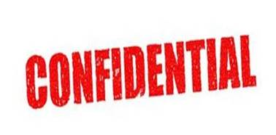
The employee must complete this form and give it to the Human Resources Department. The Sexual Harassment Complaint Form cannot be considered if not completed in full.

EMPLOYEE NAME: ______________________________________________________
EMPLOYEE NUMBER: ______________________________________________________
JOB TITLE: ______________________________________________________
DEPARTMENT: ______________________________________________________
IMMEDIATE MANAGER: ______________________________________________________

STEP ONE

Nature of sexual harassment allegation (use separate sheets if necessary):
______________________________________________________________________________
______________________________________________________________________________
______________________________________________________________________________
Desired Outcome:
______________________________________________________________________________
______________________________________________________________________________
______________________________________________________________________________

_______________________ ___________ ______________________________
Signed: Employee Date Employee’s name (write in full)

STEP TWO: DECISION TAKEN BY HR MANAGER
The HR Manager or duly authorized management must try and settle the matter informally unless the employee wants to go the formal route with the sexual harassment allegation. The Manager must complete which steps are to be followed in this matter – informal or formal?
______________________________________________________________________________
______________________________________________________________________________

_______________________ ___________ ______________________________
Signed: HR Manager Date Manager’s name (write in full)
(Or duly authorized Management)
STEP THREE: INFORMAL OR FORMAL STEPS OUTCOME
The HR Manager, or duly authorized management, must complete this section. If the matter is resolved informally, then both the HR Manager, or duly authorized management, and the employee lodging the sexual harassment complaint must sign below. If the formal route is taken, then the appropriate disciplinary documentation is to be used and attached hereto.
______________________________________________________________________________
______________________________________________________________________________

I, _________________________________________, the employee who raised the complaint of sexual harassment, do hereby state that the matter has been resolved to my satisfaction and I further state that I was not coerced in any way to make this declaration.
___________________________ ____________________________________
Signed: Employee Employee name (write in full)
Dated: ___________________________

___________________________ ____________________________________
Signed: HR Manager HR Manager’s name (write in full)
Dated: ___________________________

