A Creative Healing Journey during the month of May
Welcome to 'May We All Heal' (MWAH), a creative healing journey through the month of May, focusing on grieving and healing for grieving parents.
Healing, specifically healthy healing, has been my personal passion for as long as I can remember. As I write in my book:
Healthy healing doesn't mean re-writing (or forgetting) your past,
it means actively creating a new meaningful future - starting now.

This is what ‘May We All Heal’ can do for you:
- guide you through your dark nights when grief is raw and intense
- reignite your belief in your own resilience
- start – or continue - your journey towards healing
Come and join the ‘May We All Heal’ MWAH event here.

The History
In May 2015, a group of women from the Grieving Parents Support Network community created the ‘May We All Heal’ project, a creative healing journey for women and men. Since then, it has been running every year in May.
For the first project, we focused on creating a photographic journey following daily prompts, which were shared on Instagram and on Facebook using the hashtag #mayweallheal or #MWAH followed by the year. Participants especially benefited from the community that resulted from the event, both on Facebook as well on Instagram.
It allowed parents, mostly women but also men, to go deep into their journey of grieving and healing after the loss of their child.

May We All Heal - Playbook for Creative Healing After Loss
We now have a companion book for you, in the format of a beautiful, large format playbook. It will guide participating mothers and fathers to use creativity for healing. (It can even be used by anyone suffering loss, be that of a loved one, a relationship, a home or a pet).
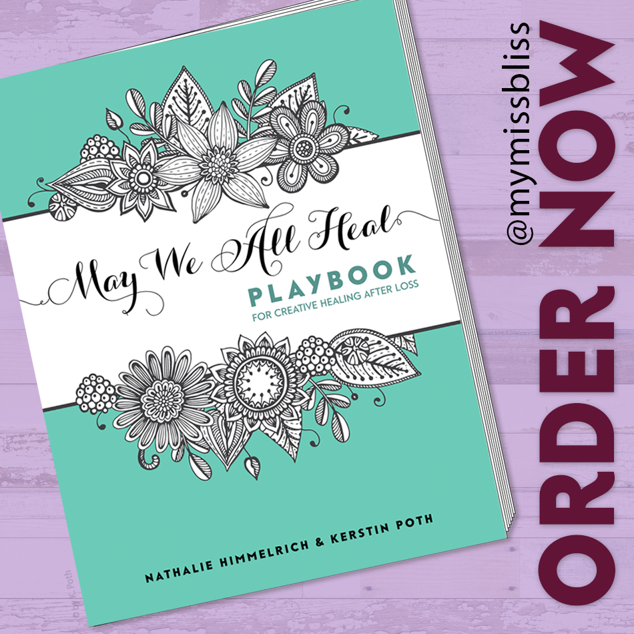
This can be through drawing, painting, doodling, coloring in, writing, and so on. Use this book for those artistic mediums that work well on paper, as the journal or diary to express your thoughts and feelings.
You can also expand your creativity outside the scope of the book, with pottery and clay work, body artwork, movement, expressive dance – your imagination is limitless!
Order it here.

"But I'm not creative!" you might say.
Don’t worry, everything that comes from you, whether in words and sounds, what you produce with your hands through drawing or scribbling, or expressed via movement, is a form of creative expression

It's not just for May.
We have since opened up the timeframe from one month to whatever timeframe and rhythm suits YOU. You have the option to follow the prompts suggested in the book (for one month) or use your own. Us the book in May or any other time frame you choose. Follow your intuition and dedicate time to your healing.
Share your pages on social media (IG or FB), if you like. You can also choose for them to remain private.
The book is available here and it's available as softcover and hardcover version.

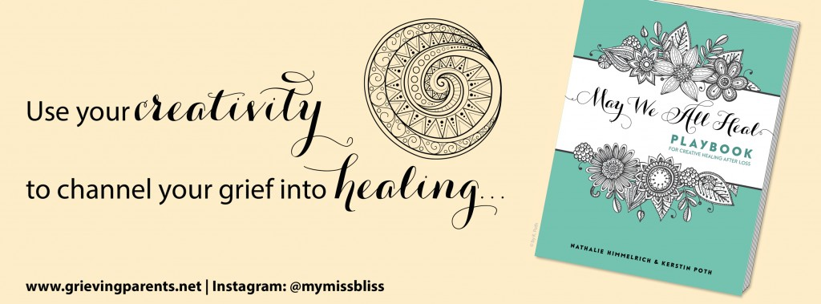

May We All Heal Event
'May We All Heal' is a FREE event which you can join in, with or without the companion book. Simply follow the prompts. They will be sent out via the newsletter (sign up here). Also make sure to follow Nathalie on IG @mymissbliss.
Sharing your healing journey on social media is optional but offers a beautiful support from the community, either on Instagram and on Facebook. You can find the Event details here.
Make sure to follow Nathalie on IG @mymissbliss to see more and stand a chance to win a book!
Having lost a love one to death, doesn’t mean we have to be lost to life.”
~ Nathalie Himmelrich
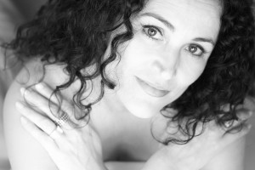
Finding ways for healthy grieving and healthy healing.
Your event host,
Nathalie Himmelrich

A big thank you to the whole community of #grievingparents as well as those inspiring women who helped co-created May We All Heal in 2015:
Lisa @strongwillsmama (formerly @lisajbabbitt)
Ginny @ginnylimer
Louise @louisebotterill
Megan @4ravens
Ashley @a_benner
Dee @the_jadedragonfly (formerly @dee_anaya)
(You can find them via their IG handle on Instagram)

Testimonials from other participants:
"I find the process surprisingly healing. I went into it with little to no expectations, but basically journaling my feelings via Instagram daily for 31 days and finding this community of support was so unexpected and needed."
"It was my first "thing", 7 months after Ben died, that pushed me out of deep deep grief and started me embracing grief and healing."
"I found 'May We All Heal' a wonderful resource in untangling the many layers of grief I have experienced since the loss of my precious babies. It allowed me to think about where I was at, and where I had come from in a fun and playful way without any pressure (I even skipped a couple of days as they didn't resonate with me)."
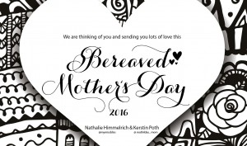
Dear Mother,
International Bereaved Mother's Day is on the first Sunday in May.
We are thinking of you and send you our love.
Please feel free to download our 2016 gift to you here, then print it and use allow yourself some time with your healing creativity.
Love
Nathalie

