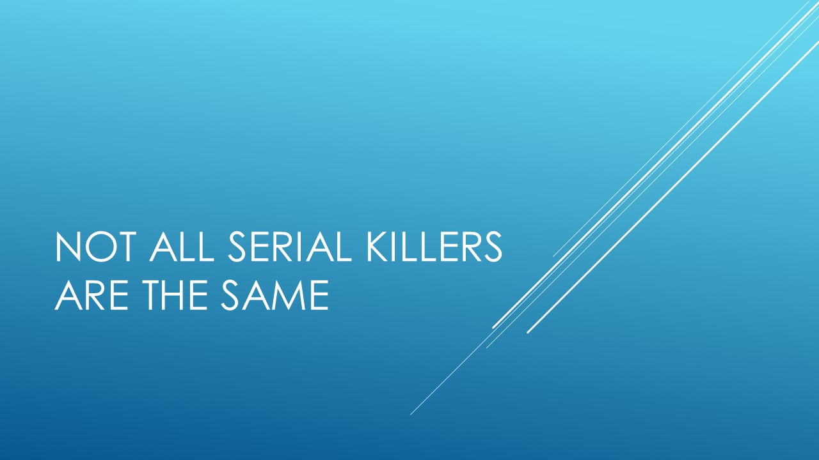

Use this workbook to take notes as the module moves along. There is a separate workbook for each module.

The psychology of serial killers can vary as much as that of any other criminal. There are no characteristic ways of behaving for serial killers. Their behaviours are dependent on their individual make up. The majority of single murders are committed by someone known to the victim. However, with serial killers it is more likely that the victim is unknown to them. However, the victims will still represent someone or something to the offender.
Notes on victim characteristics.

As there are very few British serial killers, detailed studies of their characteristics are based on American studies.
Notes on offender characteristics.

Additional reading: https://www.businessinsider.com/a-surprising-look-at-the-average-serial-killer-2015-5?r=US&IR=T

Sample essay questions:
Evaluate why characteristics of serial killers may have changed over time.
Compare and contrast two serial killers victim selection.

