MEDIUMSHIP APPRENTICE
PROGRAM WEEK 1
EMILY STROIA: INSTRUCTOR
COPYRIGHT 2016
COPYRIGHT © EMILY STROIA 2016, All rights reserved.

CLASS OUTLINE
In this series of videos you will learn:
- Why we practice Mediumship
- How to Discern Spirit from Ego
- Gifts of Mediumship
- Mechanics of Mediumship
- Exercises & Meditation
WHY WE PRACTICE MEDIUMSHIP:
- Personal reasons, i.e. connect with passed loved ones
- Feel a Personal Calling for It
- Know & Understand Life after Death
- Access divine wisdom & guidance
- Faith in a higher power
- Overcome fears & insecurities around gifts
- Help others with grief/loss

HOW TO DISCERN SPIRIT FROM EGO
Spirit manifests in different ways:
- Spontaneous or random at first
- A sense or “knowing” of someone else with you
- Signs/Symbols that catch your attention
- Information comes back to you until you deliver the message or write it down.
- Awareness shifts from the person’s energy to a presence near you
- Persistent
- May seem to not make sense or that you are making it up.

HOW SPIRIT MANIFESTS
Think about your first spirit phenomena experience. What happened? How was it?
- Dreams
- Seeing/feeling a presence in the home/bedside
- Feeling spirit after loss/grief
- Inspirational thought
- Synchronicities/Encounters
- Gifts/Apports, i.e. coins/feathers/gemstones/flowers
MEDIUMSHIP IS….
- Spirit = consciousness, divine intelligence
- Soul = divine imprint for each person, unique DNA designed to you
- Mediumship is a blending of two souls, telepathically communicating.
- Physical & Etheric merging to download/receive information
WHAT DEFINES SUCCESSFUL MEDIUMSHIP?
- Ability to connect with “Spirit” & accurately connect by delivering evidence & message to the recipient that resonates
- Evidential mediumship, shows life after death continues

MECHANICS OF MEDIUMSHIP
GIFTS OF MEDIUMSHIP INCLUDE:
- CLAIRVOYANCE - SEEING
- CLAIRGUSTANCE - TASTE
- CLAIRSCENT – SMELL
- CLAIRAUDIENCE – HEARING
- CLAIRSENTIENCE - FEELING
- CLAIRCOGNIZANCE – KNOWING
WHAT TYPE OF MEDIUM ARE YOU?
- Emotional; thoughts/feelings
- Visual; memories
- Factual; names/dates/numbers
- Inspirational;
- Audio
- Work with your natural-born gifts

OBSTACLES TO MEDIUMSHIP DEVELOPMENT
- FEAR
- Low Self-Esteem
- Lack of Confidence
- Religious beliefs, i.e. devil’s work
- Not trusting the information
- Comparison
- Impatience
- Perfection

HOW TO BUILD YOUR LINK TO SPIRIT
- Maintain mind/body/soul balance
- Let go of the idea of perfectionism
- Build a relationship with Spirit, i.e. Universe is a loving parent who would never harm you.
- Quickening of information you will receive
& decipher
- Understand the language & you are an instrument they are working with
- Practice!!!!

BASIC MEDIUMSHIP
TELL THE STORY STORY = LOVED ONE’S LIFE BASIC FACTS:
- SEX: MALE/FEMALE
- AGE: YOUNG/MIDDLE-AGED/ELDERLY
- HOW THEY PASSED: INJURY/ACCIDENT,
TRAGIC, I.E. SUICIDE/MURDER, ILLNESS
- MESSAGE
- MEDIUMSHIP IS THE MIRROR OF THE MIND

EXERCISE: TELL THE STORY OF YOUR LOVED ONE
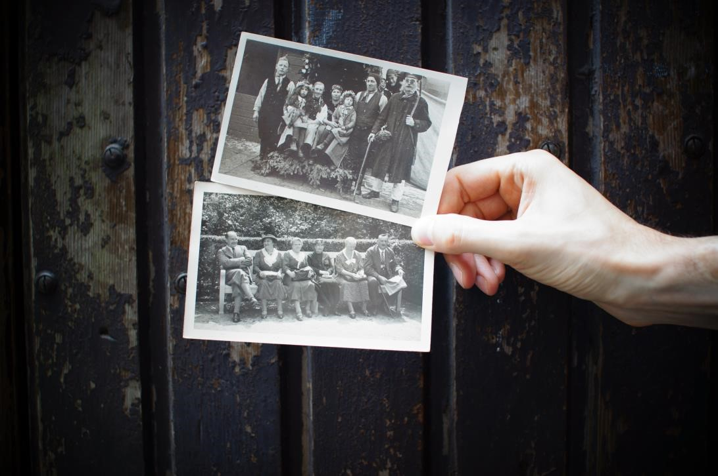
Imagine for a moment your Spirit Loved One in your mind.
Bring him/her to life.
Write down the basic facts:
Male/Female
Age
How they passed
What would they want to say to you? Message?

CONNECTING TO SPIRIT
- CLEAR YOURSELF ENERGETICALLY
- SET AN INTENTION & PRAYER
- FOR THE MOMENT RELEASE FEAR, ANXIETY & IMAGINE YOU ARE LIGHT
- VISUALIZE YOU & SPIRIT MEET IN A SACRED SPACE OF LIGHT.
- MEET IN THE MIDDLE.
- FEEL/SENSE/KNOW/ASK
- INFORMATION WILL BE RECEIVED.
- DO YOU FEAR THE WIND?

CONCLUSION & SPIRIT ASSIGNMENT
- BEGIN TO BUILD A RELATIONSHIP WITH SPIRIT • DAILY CHECK-INS: MORNING & EVENING RITUAL
- PRACTICE:
- SIT WITH SPIRIT MEDITATION
- PEER READINGS: BASIC MEDIUMSHIP READING CONNECTING WITH A LOVED ONE VIA A NAME
MEDITATION: ACCESSING SPIRIT

