TRAVIS
INTERNATIONAL
FILM
INSTITUTE

THE TRAVIS TECHNIQUE MASTER CLASS FOR ACTORS
(recorded in Auckland, New Zealand, August 2019)

Dear TIFI Student,

Welcome to the Travis Technique Master Class for Actors. During this two-part course (Part A: The Interrogation Process and Part B: The Power of Staging) you will be challenged to consider new ways of approaching your work as an actor, or a director.

During this master class we will be using scenes from two well known scripts: Ordinary People by Alvin Sargent and Manchester By The Sea by Kenneth Lonergan.

The more familiar you are with these scripts, scenes, and characters, the more you will benefit from this master class.

INSTRUCTIONS FOR PART A: THE INTERROGATION PROCESS FOR ACTORS

Reading Assignments: (all reading materials are supplied)

Read Manchester by the Sea by Kenneth Lonergan for Part A, The Interrogation Process
Read and study the selected scene between Lee, Randi and Rachel.

Below are the instructions given to the New Zealand actors who attended the master class so that they would be fully prepared.

Preparation for Participating Actors:

NOTE: During the Master Class six actors prepared to rehearse in two different scenes. They were given the following instructions:

Step One: Write a series of questions that you (the actor) would like to ask your character if and when you meet her/him. Do not answer these questions. Let these questions be as deep, probing and personal as you like.

Step Two: As the character (that you have been assigned) write a letter to each of the other two characters in your scene. In the letter tell them exactly and honestly what you think of them and what you want to say to them just prior to the scene beginning. Then tell them what you think of them and what you want to say to them right after the scene is over. Put the letters into envelopes addressed to each of the characters. Seal the envelopes. Bring them to the masterclass.

Step Three: Let your character find an object that brings comfort, security and confidence to your character. It needs to be something that your character can carry secretly and privately. Bring it to the master class.

Step Four: Select the wardrobe your character wants to wear the day of the scene. Please bring/wear this wardrobe to the master class.

Preparation for Observing Actors:

NOTE: A majority of the actors in attendance were observers, or auditors. They were given the following instructions:

Please do the following preparation as if you were going to play one of the characters in each scene.

- Write a list of questions that you, the actor, would like to ask the character you are about to play. Allow yourself to be as probing, outrageous and intimate as possible. There are no boundaries.
- Write (as your character) what you think of the other characters in the scene. Again, there are no boundaries; these are your (the character’s) personal and private thoughts.
- Write what you (your character) think the other characters think of you. There are no limits. It’s not a matter of being right about what they think, it’s a matter of being right about what you think, or fear, they think.
- Write what you would like to say, out loud, to the other characters in the scene. Be bold, be courageous, dare to be dangerous.

When you are in the master class you will understand why these questions, and your answers in writing, are so important.

All the best,
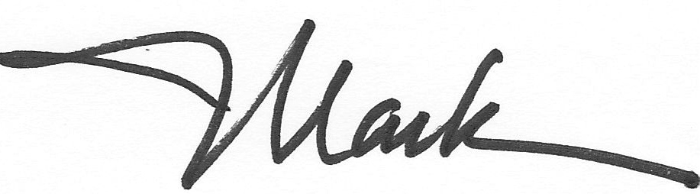
Mark W. Travis

Travis International Film Institute
www.thetravistechnique.com
markwtravis@gmail.com

