Incision Management Program Outline
Discussion of normal healing cascade
Primary vs secondary intention
Discussion of phases of healing
Surgical site infection identification
Review of NERD and STONES
Discussion of scars
Discussion of treatment techniques to minimize complications

Complete the narrated powerpoint instruction followed by a post-test and survey for CEU credit 1 contact hour provide by NYS approved provider Wound and Therapy Seminars LLC

Objectives
• Discuss Normal Healing
• Identify Signs of Infection
• Discuss Appropriate Treatments to Promote Incision Healing
• Recognize Appropriate Instances for Referral

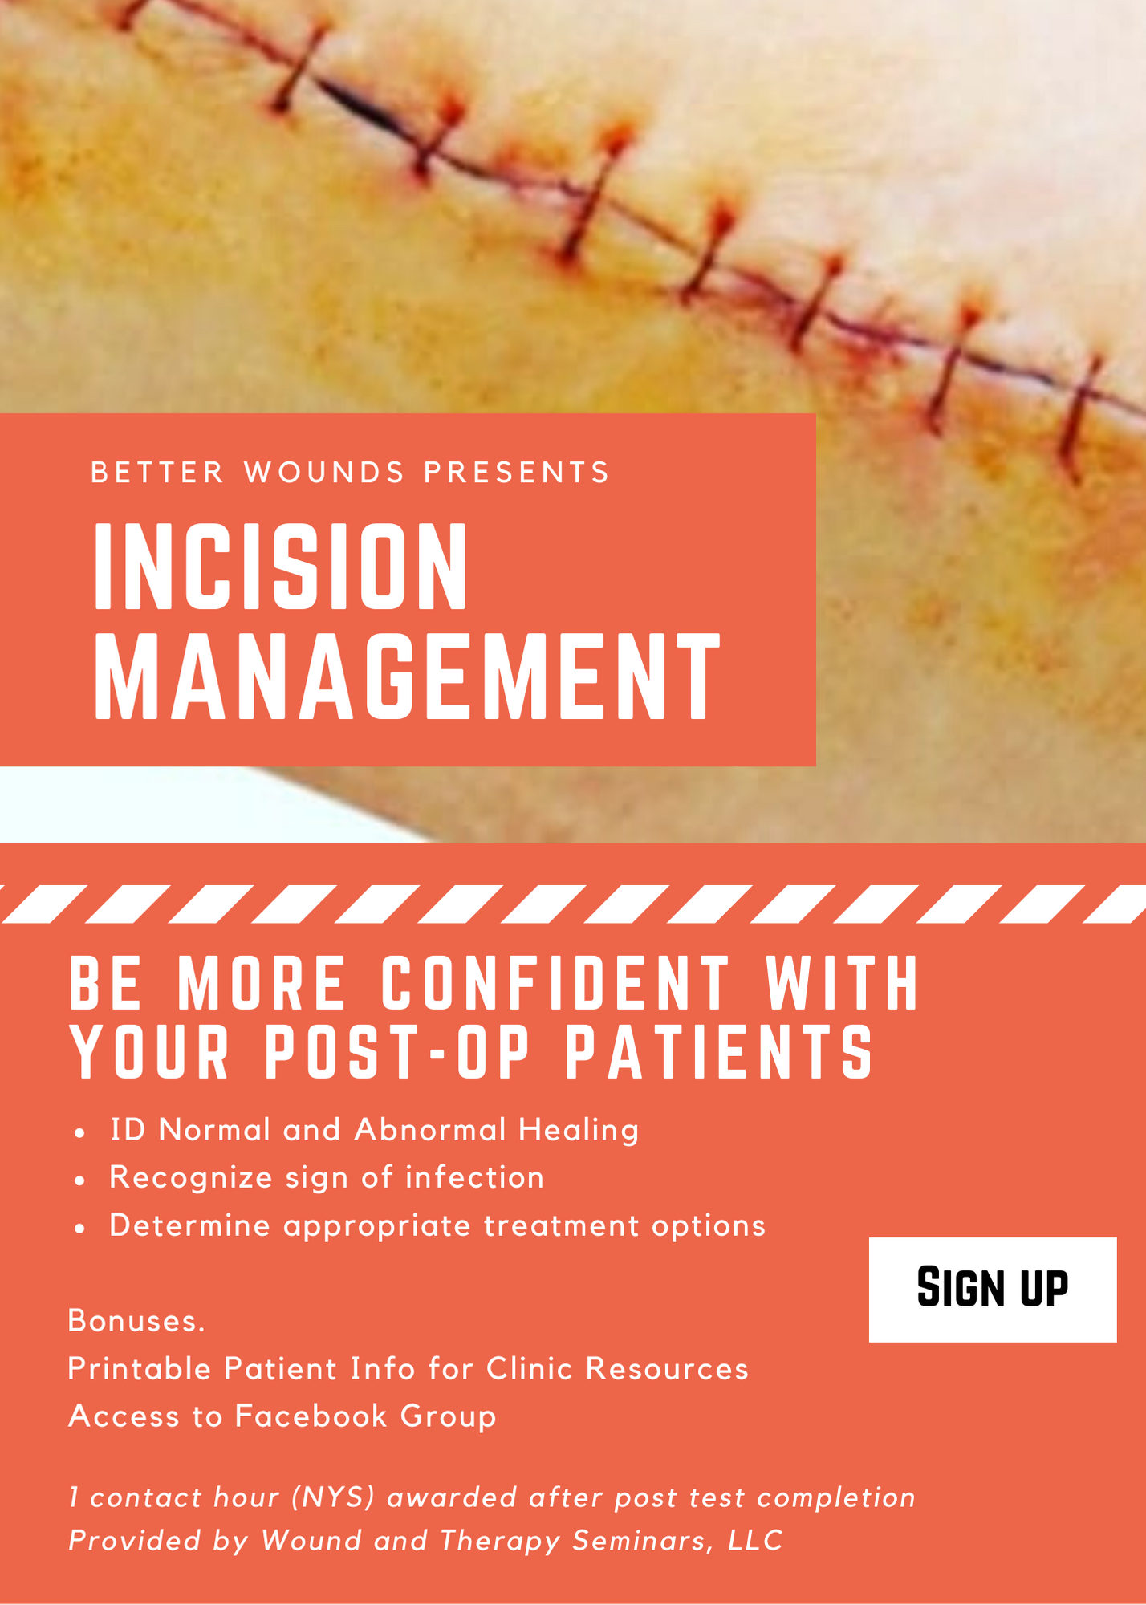

HEATHER CASCIO FLEXER, PT, DPT, CWS

betterwellnesspt@gmail.com
Linked In Profile
Better Wellness PT
Better Wounds

Education: Temple University Doctorate PT December 2013 License #021612-1
AAWM Certified Wound Care Specialist October 2005 ID #2289
MS/BS in Physical Therapy May 2000
The Sage Colleges, Troy, NY

Professional Experience
Better Wounds/Wound and Therapy Seminars LLC May 2018- Present
- Consulting Wound Specialist for Private PT offices
- Consulting directly to patients to determine plans of care for self-care
- CEU development
- Wound business development for private clients

Better Wellness PT, Troy, NY March 2014-present
- Owner and operator focused on private maintenance clients
- Rocktape and Selective Functional Movement AssessmentCertified, ANF Holistic Therapist
- Certified Wellness Coach

AMT, Northeast Regional Clinical Manager July 04-April 2017
- 1st NY Clinical Specialist participated in growing AMT from 1-145 current accounts in NYS
- Responsible for hiring, reviewing, action plans and termination employees for territory
- Developed, Organized and Presented Wound Education for various AMT/LTC/Hospice Events
- Developed and implemented Company Wellness Program 2014-present

The Sage Colleges, Troy,NY Aug ’12-present
- Co-Primary Principal Investigator for Research Titled “The Short Term Effect of Elastic Therapeutic Taping, using Rocktape, and an Exercise Program on Scapular Alignment in Individuals with Rounded Shoulder Posture: A Pilot Study” June 2016-ongoing.
- Adjunct Professor For Physical Therapy Department Integumentary Lecture and Lab

Senior Physical Therapist Albany Medical Center Aug ’01-present
Seton Home Care Agency, Staff PT April 2002-July 2004
Adjunct Faculty at Maria College, Albany, NY Spring Semester 2003
Northwoods at Hilltop , Staff PT Oct ’00-Aug’01

Continuing Education
Attend an annual wound conferences and PT based courses

More details and references upon request.

