Getting Into The Prayer Zone Course

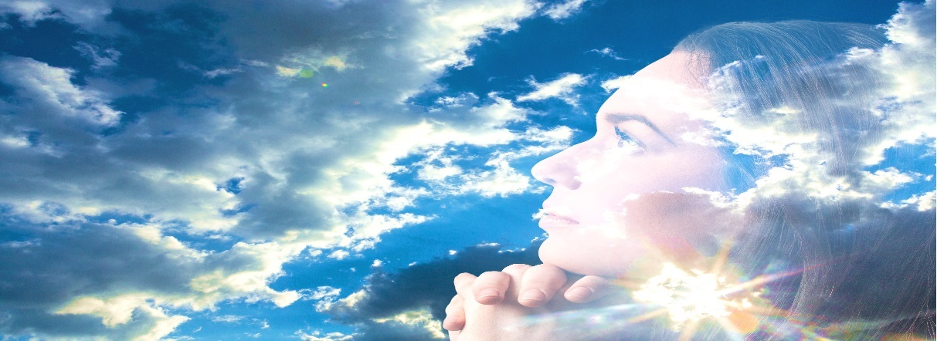

**The Awakening: The Stirring of the Spirit Man To Pray**

**Lesson 1**

1. Salvation awakens the inner man to the presence of God.
2. Once redeemed, man becomes a new creature and a new creation in Christ. (2 Corinthians 5:17)
3. Spirit Man becomes alive to God and becomes aware of God in their life. (Proverbs 20:27)
4. This begins the transformation of the vessel into the likeness of Christ.
5. The restoration process of the original divine image of man begins
6. Reconciliation and rededication back to God’s covenant with Man begins through redemption.
7. Through Jesus Christ, we have now access to God and His Presence through the practice of prayer. (Hebrews 4:16)

**Prayer Exercise 1: Are you saved? When did you get saved?**

_________________________________________________________________________________________________________________________________________________________________________________________________________________________________________________________________________________________________________________________________________________________________________________________________________________________________________________________________________________________________________________________________________________________________________________________________________________________________________________________________________________________________________________________________________________________________

**Exercise 2 What did you do differently when you got saved? Did you start to pray? How did your prayer life begin?**

___________________________________________________________________________________________________________________________________________________________________________________________________________________________________________________________________________________________________________________________________________________________________________________________________________________________________________________________________________________________________________________________________________________________________________________________________________________________

**Prayer Journal** : Write down what you pray about now and why. How would like your prayer life to improve and grow?

_________________________________________________________________________________________________________________________________________________________________________________________________________________________________________________________________________________________________________________________________________________________________________________________________________________________________________________________________________________________________________________________________________________________________________________________________________________________________________________________________________________________________________________________________________________________________________________________________________________________________________________________________________________________________________________________________________________________________________________________________________________________________________________________________________________________________________________________________________________________________________________________________________________________________________________________________________________________________________________________

_____________________________________________________________________________________________________________________________________________________________________________________________________________________________________________________________________________________________________________________________________________________________________________________________________________________________________________________________________________________________________________________________________________________________________________________________________________________________________________________________________________________________________________________________________________________________________________________________________________________________________________________________________________________________________________________________________________________________________________________________________________________________________________________________________________________________________________________________________________________________________________________________________________________________________________________________________________________________________________________________________________________________________________________________________________________________________________________________________________________________________________________________________________________________________________________________________