USE THIS COPY FOR YOUR FACEBOOK EVENT PAGE OR FOR AN EMAIL TO SEND TO YOUR FRIENDS…
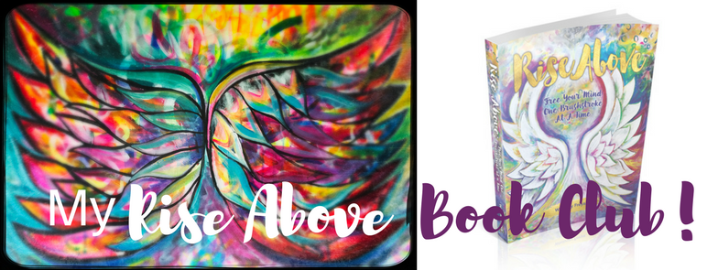

Hi! I want to invite you to join my NEW Rise Above Book Club! It’s time to get your WINGS!!!

I am hosting a free + casual gathering to introduce you to Whitney Freya’s new book Rise Above and to the upcoming experience that will be MY OWN Rise Above Book Club!

Join me on <<DATE>> at <<TIME>> to learn more.
We will be gathering at <<LOCATION—VIRTUAL or PHYSICAL LOCATION>> for a fun evening of creative possibility.

<<ADD A BIT OF YOUR PERSONAL TESTIMONY>> I purchased Whitney’s book Rise Above, Free Your Mind One Brush Stroke at a Time recently and I LOVE it! In the book she teaches PRACTICAL steps we can each take to RISE ABOVE and make our day-to-day life more enjoyable and more in FLOW.

She also provides really interesting insight into working with symbols and animal totems—I can’t wait for us to explore this together. AND there are painting exercises, step-by-step instruction and her own personal stories that are really interesting.

I am part of a group that she has asked to start a Rise Above Book Club because life can get pretty scary these days and there is a lot that can bring us DOWN. Personally, I am choosing to RISE ABOVE and I know it will be so much more fun to do this together!

I hope you will join me for this introductory event.

I will be kicking off the book club <<DATE>> to meet <<WEEKLY? MONTHLY?>> for <<6, 8, 12 WEEKS or MONTHS?>>. So if you can’t make it to this introductory gathering, just message me or email me to let me know you are interested so I can save you a spot!

You can learn more about Whitney at WhitneyFreya.com and her book is available on amazon.com, amazon.ca or (INTERNATIONAL ORDERS) at RiseAbovetheBook.com.

Thank you for sharing this email / event with anyone you think would be interested and for being open to what is possible! Hope to see you on <<DATE>>.

<<YOUR SIGATURE>>

