The Face Reading Intermediate Courses English Version No.1

Welcome everyone to my Face Reading (Physiognomy) Intermediate Course (FRIC). In this FRIC course, I will tell everyone the secrets and essence of how to change your personality and fate. Please take a look at the first 9 videos first, and then continue all my courses. Thank you for your support and encouragement throughout the year, so that I am confident to continue to pass on my life selflessly and thoroughly to everyone.

Why study Face Reading (Physiognomy)? What is the usage of Face Reading?

Physiognomy can be used in our life, personal relationships, work, business, industry and commercial, signing contracts, meetings, and any negotiation, comparison of war generals, military, and various issues, etc.

Let's look at two real examples first. Only then can we understand the importance of face reading.

Why did the marriage of the most beautiful Cinderella in the world marrying Prince Charming turned out to be a marriage of hatred between life and death?

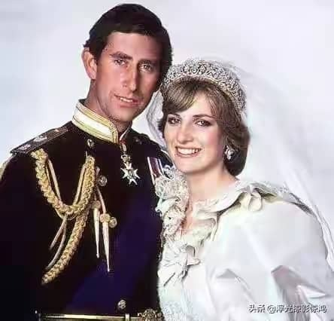

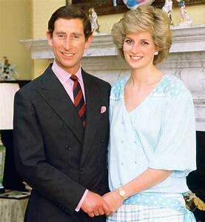
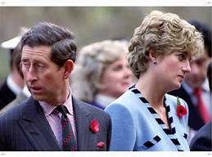

- The Metal (Golden) cum Fire-shaped (50% fire) Prince Charles, and the Metal (Golden) cum Fire-shaped (fire 20%) Princess Diana. Both of them have the same higher and protruding cheek-bones. These means that when they expressing love, passion is like fire. However, when they were separated, they were ruthless.
- Prince Charles is a grudge or hatred husband? And Diana is a measure of forgiveness lady?
- Both individuals have explicit and bone protruding nose bridges and narrow husband and wife’s portion, which is located between the end of their eye and their hairs, and it is also name conjugal palaces.

From their faces, it can be known that they are resentment and have no good relationship between husband and wife while their old ages.

Why are a pair of good partners and good assistants, but they will become enemies in the end?

- The faces of the above two persons are Metal (Golden) faces. Metal and metal sure will crush each other’s.
- Mr. Yoon Seok-Youl’s (尹锡悦) left and right eyebrows are downs and ups, he also got the thin lips. This means that he is very stubborn, cold, ruthless and dual personality people. Mr. Moon Jae-in's (文在寅) sword eyebrows are sharp. and his upper lip is protruding. This means that his character is very stubborn too. If there is hatred, he will revenge. When he feel unhappy, he will show on his face or speaking out.
- The distance between their eyebrows are narrow, their chins are square shape, and their antihelix of their ears are protruding out. This means that they will have personality disagreement is inevitable.

No matter how good friends, partners, comrades in arms, they will become enemies in the end while working together!

The usages of Face Reading (Physiognomy):

- How to choose good friends, couples, husband or wife that suit yourself by face reading?
- How to use the skill of face reading to choose a job, career, and entrepreneurship that suits you?
- How to use the skill of face reading to choose suitable work partners, company shareholders, and business team?
- How to use the skill of face reading to instantly understand the interview officer's personality, temper, and like or dislike hobby? Use them to make your interview successful?
- How to use the skill of face reading to fight for your own victory in business bidding, competition, and contract challenges meetings? Defeat rival companies?
- How to make use of the skill of face reading to predict the character, temper, and expertise of the employees, during the interview, and to arrange the correct job and position of the new employee in order to help the company make money?
- How to use the skill of face reading to prevent, or wrongly employed a villains, who might make the company loss business, or loss money or even bankrupt in future?

How to accurately judge the position of the age on the face?
  - Men are 1 to 7 years old in the left ear and 8 to 14 years old in the right ear.
  - The forehead is 15 to 30 years old.
  - Men’s eyebrows are 31 to 34 years old starting from the left eyebrow.
  - The front corner of the man’s left eye has risen from 35 to 40 years old.
  - The nose is 41 to 50 years old.
  - The majority of people are between 51 and 60 years old.
  - The middle of the lips is 61 to 70 years old.
  - The lower part of the lip is 71 to 80 years old.
  - From the edge of the chin, the man turns to the left, aged 81 to 100.
- For detailed location, please refer to the face map below

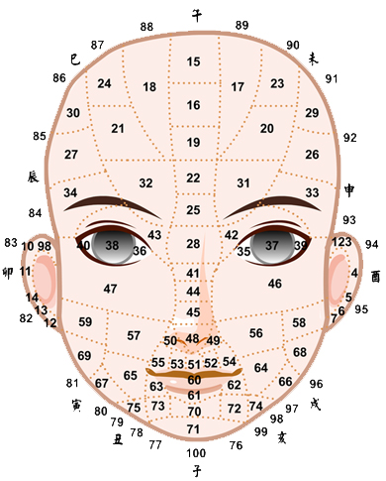

Why do charity? How powerful is charity can change the person’s destiny?

Practical example:
My father and mother were married in Dapu, Guangzhou, China in 1938. According to ancient Chinese marriage regulations, both parties must match their life chart by using the birthday and birth time’s eight characters. At that time, the fortune teller said that my father's life span was only 47 years old.
Later in 1980, I learned the fate analysis, zewei dou number, horoscope, numerology and face reading for more than 20 years. My three famous teachers were in China, Taiwan and Malaysia. I asked my teachers about my father’s fate. After reading my father's horoscope, they also said that at the age of 47, my father would die.

But my father lived to be 93 years old. Why?

Let’s start with my grandfather. My grandfather has two wives. My father was born by a step-wife. My grandfather was a famous businessman in the ending years of the Qing Dynasty and the early years of the Republic of China. He owned 5 rice shops and grocery stores. During his old ages, because of the famine, he took the rice to cook as porridge from all the rice shops to rescue the victims in the village! Finally those shops were closed down, he was bankrupted.

This is why my father left his hometown to go to South East Asia (At that period Chinese called it as “Nanyang”). He arrived Singapore, Malaysia, and practice as a Chinese Medicine Doctor to save the sick people around this part of the world. When he was young, he was famous for heal the royal family member of Johor Sultan Palace.

I grew up and I only knew that our family’s life was difficult. Breakfast consisted of a pot of porridge and three eggs for the whole family of 8 people. I thought my father has failed very much at being a Chinese Medicine Doctor. On the market, others Chinese Medicine Doctors succeeded in making money. Why my father is not succession doing this?

My father saved countless people in his life. The poor people didn't charge for the rash and even cooked the medicine, put it in a glass bottle, and give to them to take it away. Sometimes he gave them the carriage fee to go home, or asked us to send the cocked medicine to them by bike without correcting money.

When I grew up, in 1999, I went back to China to visit my father’s hometown paid homage to my grandparents and ancestors. Only then, I knew that the Shude Primary School in the countryside, roads and bridges were built with donations from overseas Chinese group sponsored by my father. No one in our family knew this charity that my father did in his life. It turned out that all the money he earned in his life was doing charity silently.

No one of our brothers and sisters wants to learn Chinese medicine, because, seeing my father fail in his career, we all thought that Chinese Medicine Doctor can't make money?

During my father 47-year-old, his business failed, his investment in a tin mine went bankrupt, and he was admitted to hospital with a serious illness. He thought it was just like his fate analysis and numerology indicated that he would die in the young ages. As a result, He recover from the serious sick and his life span is extended almost nearly 100%.

This is a true example of changing one's fate or destiny by doing a lot of charity and merits.

Therefore, I have always taught everyone that we must be doing a lot of charities then our home will receive a lot of celebrations and good virtues! I hope everyone can join me to do charity and good deeds together.

20% of any income from the Face Reading Intermediate Courses will be donated to charity bodies and the receipt will be under your own name. I will send it to everyone, who participating my courses.

I sincerely invite everyone to support my Face Reading Intermediate Course. We can be a happiest to do good charity and merit together!

