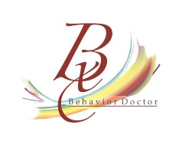
www.teacheropedia.com
Teacheropedia is a subsidiary of Behavior Doctor Seminars
12311 west 129th terrace
Overland Park, Kansas 66213
913-593-0981

Quote for Online Professional Development

Ten Rules that Govern Behavior $45.00

This seminar is asynchronous modules for classroom teachers with pre and post-tests, handbooks, and videos. It also includes one free virtual meeting with Dr. Laura A. Riffel to ask questions from staff members. The administrator will receive a coupon link for each staff member to sign on and take the course. They will receive a certificate of completion and documentation of what they covered during the training. The platform ensures everyone completes at least 90% of the materials.
To read more about this training: https://teacheropedia.teachable.com/p/ten-rules-that-govern-behavior

Check payable to:
Behavior Doctor Seminars
12311 west 129th terrace
Overland Park, Kansas 66213

