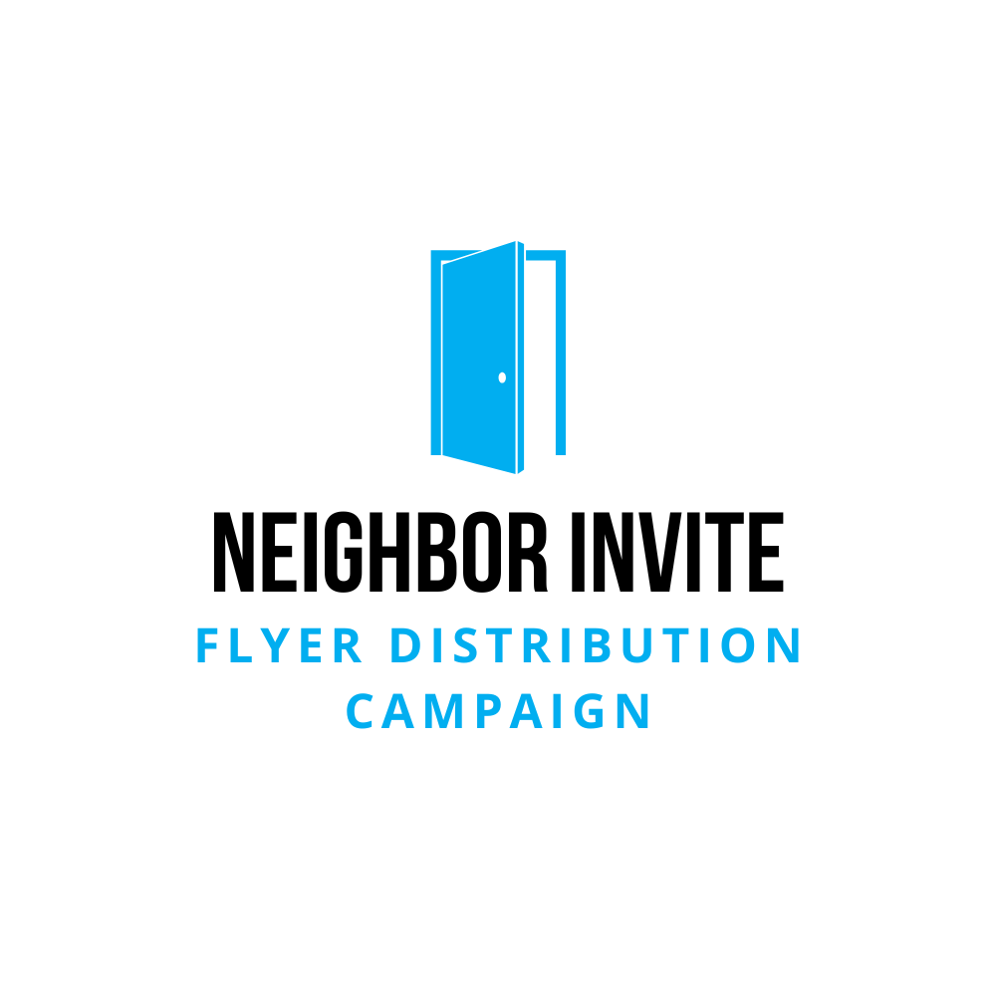 | Ask Video Bullet Points

Bullet Points
Greeting & Purpose:
- Thank viewers for their time.
- Invite them to be part of a special outreach project.
The Ask:
- Request about an hour each month to deliver 70–150 flyers.
- Emphasize that it’s simple and straightforward.
Why It Matters:
- God is already at work—people just need an invite.
- Most attend because a friend invited them—this effort reaches those without that connection.
- This small step could lead to big change in someone’s life.
What’s Provided:
- Flyers, route details, training, and a supportive team leader.
- Everything is set up to make participating easy and impactful.
Closing & Call to Action:
- Encourage them to consider helping.
- Remind them it’s about caring for the community and making a difference.
- Ask them to reply or let you know if they’re interested.
Final Vision:
- This simple act of delivering flyers can open the door to hope, community, and transformation.
- “Will you join us?”

