Section 1: Change How You Think
Are you aware of any ways that you think that cause problems in your life-If so, what are they?

After watching the video on Black and White Thinking, can you identify situations where you get stuck thinking in absolutes? Give a couple examples:

How does that thinking affect you?

Write a few examples of “Gray” thinking that you could replace those thoughts with:

If you’d like more exercises on this topic-check out this preview from my upcoming course “30 Days to Emotion Processing”
Day 15: Cognitive Distortions
“When you change the way you look at things, the things you look at change” - Max Planck
“It is in the Darkness of their own Eyes that men get lost”- Black Elk

We’ve been focusing lately on soothing the deeper, less conscious parts of the brain, today we’re going to talk about the thinking part of our brains and how to utilize our thinking to better process emotions.

It seems like our default setting is to believe that our circumstances are the cause of our emotions. For example ‘I’m sad because I didn’t get the job”.

However, it is very common that our emotions are rooted in our thinking patterns, rather than what happens to us. I might be feeling sad because I’m thinking “I’m such a failure” or “This career will never work out” or ‘Nothing good ever happens to me”. When we allow our thinking to be mindless, then we run the risk of getting stuck in thought patterns that are distorted, untrue, or unhelpful.

When we start to notice our thinking, we can also gain power over it. We begin to realize that our feelings are not facts and neither are our thoughts. This allows us to make space for multiple ways of thinking about a situation. When we do that we can choose which of the thoughts to believe in and act upon.

The “Benefits” of Negative thinking:
Everyone says ‘Be positive” but almost everyone spends some time thinking negatively-why is that?
Negative thinking is comfortable. Often it is an attempt at self-protection, for example have you ever heard someone say “I’d rather expect to fail, and be pleasantly surprised, than to expect to succeed and be disappointed”. Negative thinking is just another subtle way to attempt to avoid pain, we seek to protect ourselves from disappointment by expecting the worst.

When this type of thinking is habitual it changes from a defense mechanism to a paradigm. The whole way we see the world becomes distorted, leading to depression, anxiety, anger, loneliness, and unachieved dreams. Again, short-term avoidance leads to long term suffering.

The side-benefits we get from negative thinking make it hard to let go of. It’s often not helpful to say “Just be positive” because people just don’t believe, or want to risk believing the positive thoughts. If we want to overcome distorted or negative thinking we have to recognize it and replace it with more truthful or helpful thinking.

Basically it comes down to this: “Don’t believe everything you think”. Challenge your thoughts, look for exceptions or evidence to the contrary. This is going to require you to open yourself up to a little vulnerability, but it will also open you up to Joy.

Perspective Exercise: ask a close friend or family member( or therapist or coach) to tell you which of these cognitive distortions you commonly use. See attached chart (and video examples if that’s your thing):
Matt and Anna: https://www.youtube.com/watch?v=65jiOtaFWJI
Automatic Thoughts: https://www.youtube.com/watch?v=m2zRA5zCA6M

Write about how thinking that way serves to protect you or is avoidant.

If you were to be more truthful, hopeful or vulnerable what would you think, say, or do differently?

Cognitive Distortions | Truthful Antidotes
All-or nothing thinking: you’re either perfect or you’re a failure. Especially with performance. You think in extremes, everything is black or white You may say “I’m failing math” When you’re getting a C. | Try to see both sides of an issue, allow yourself to try without having to be perfect. “Making an effort moves me towards my goal” look for exceptions.
Overgeneralizing-take one bad instance and assume that everything will be awful after that. “I’m never going to get a good job” “People will always take advantage of you” “I’m going to mess up every relationship I’m ever in” “Nothing good ever happens to me”  If this happened once, then it will probably always happen again | instead of using words like always or never, talk/think about one problem at a time. Look for exceptions and small changes that you can make.
Filtering: (aka Horriblizing)We only see the negative in a situation or in ourselves. “I’m a complete failure” “My parents are such idiots” ‘You never listen to me” “I’m the only one around here who gets things done” | Ask “What else is there?” Is there more information that’ I’m ignoring? Can I see both the good and bad at the same time? Look for small examples of the opposite view. Find ways to understand the other and have compassion or empathy.
Mind Reading: assuming that people don’t like us or assuming that we know how they are feeling about us. “Nobody likes me” “Everyone is judging me” “My boss must think I’m incompetent” | Ask clarifying questions, even sensitive ones. Get more information. Fact check. Remind yourself that you may not be making accurate guesses about other people's perceptions.
Catastrophizing “What if” always worrying about disaster striking. Seeing the other person as a villain-as 100% evil/ bad. “This is never going to work” “Today is a terrible, horrible, no-good, very bad day. I think I’ll move to Australia” | Look for examples of how things have worked out in the past. Ask “Am I safe now?” Focus on the present and on the work you need to do. Try to open yourself to the possibilities that things could be good. Find something to be grateful for.
Emotional Reasoning: we believe that what we feel must be true automatically. Ie “If I’m feeling stressed about school, the teacher must be giving us too much homework” “I feel hurt, so the other person must be a Jerk!” | “Just because I feel____ doesn’t mean ____” separate feelings and thoughts. It's essential to recognize that emotions, just like our thoughts, aren't always based on the facts, they can be influenced by hormones, sleep, hunger, and lot of other things.
Labeling: Putting a name to something. Instead of thinking, "He made a mistake," you might label your neighbor as "an idiot." | Think/speak in terms of actions, and behaviors. He was unkind” or “I made a mistake” Instead of “He is a jerk” and “I am a failure”
Fortune-telling: a person may anticipate that things will turn out badly, and will feel convinced that their prediction is already an established fact “This is never going to work” | Look for other potential outcomes. Decide where to place your hope. Choose to open yourself up to positive possibilities and prepare for negative ones. Take action in line with your values
Personalization: everything others do is some kind of direct reaction to me. They think if anything bad ever happens it is their fault. “If my son misbehaves, it must be because I’m a bad mother” “If my boss yells at me, it must be because I’m messing up?” | What might be going on for the other person? Is this about them or me? “Maybe they are just having a bad day…” or maybe there’s something I need to change, but look out for always thinking just one way or the other.
Unreal-Ideal- comparisons to others will always let us down. “Susan seems to handle this job just fine, how come I’m struggling?” “Bob seems to have it all together, perfect job, perfect wife- I’m such a loser” | Values- ask yourself, what kind of character do I want to develop. Build your self-worth on your integrity, not on trying to be better than others. Rather than measuring your life against someone else's, commit to focusing on your own path to success.
The idea of Cognitive distortions was developed by Psychiatrist Aaron Beck and his student David Burns. For more information on this check out Burns’ book “The Feeling Good Handbook”.

And just for fun a short clip from “Dan in Real Life”-do you see any distortions going on? https://www.youtube.com/watch?v=N1Ah2yqKISk

Extra Exercise:
Cognitive Restructuring Activity: This is a good example of what a cognitive therapist would walk you through to help you overcome distorted thinking: http://recoveryisbeautiful.tumblr.com/post/40734794410/redefiningbodyimage-this-looks-like-a-really

Section 2: Nutrition

How is your nutrition overall? Do you think that you eat a healthy variety of foods?

Do you drink Caffeine daily? Have you noticed any side affects or do you struggle with Anxiety or sleep difficulties?

After viewing the video associated with this section can you see a few small changes you can make that may improve your health? Write down at least one goal (ie eat more vegetables, speak with my doctor, etc).

Section 3: Light Therapy
Do you get exposure to natural daylight throughout the day? When, how much?

Do you notice your mood changing with the seasons (ie low energy or depression in the winter, or agitation/insomnia in the spring)?

Do you use screens in bed or in the last hour before bedtime? How do you think that is impacting you-sleep or otherwise?

What steps, if any, do you think you can take to improve your exposure to Light to help your brain regulate it’s energy levels?
Here’s a link to two of my blog posts that may be helpful:
This one is about Seasonal Affective Disorder in general: http://argemma.wixsite.com/therapyinanutshell/single-post/2016/12/01/SAD-and-Light-Therapy
This one has specific strategies for combatting Seasonal Affective Disorder
http://argemma.wixsite.com/therapyinanutshell/single-post/2016/12/22/SAD-Part-Two

Section 4: Exercise
How much exercise do you get per week?

How does your body ask for exercise (ie-it feels stiff, sluggish, fat)? How do you feel after you exercise?

When is the best time for you to exercise, when are you most motivated and available?

What are your favorite ways to get movement in? What do you enjoy doing with your body?

Who could be your social support-either exercising with you or keeping you accountable?

Have you ever tried Mindful Exercising? If you’d like to-here are a couple tips: https://chopra.com/articles/6-tips-for-a-mindful-exercise-routine

Section 5: Gratitude

Write down 20 things you are grateful for:

List a few people you are grateful for, find a way to express that appreciation today (Write a note, call them and thank them, etc).

Read the Story from “The Hiding Place”. How could gratitude be helpful for you even in difficult circumstances? http://www.bcsaschools.org/fine_arts/Thankfulness%20-%20Ten%20Boom.pdf

How are you going to make Gratitude a daily practice (ie. Gratitude Journal, an App, prayer, etc)?

Section 6: Self-Regulation
What are some situations where you feel anxious or tense?

What do you notice in your body when you feel anxious or stressed?

How do you feel when you take slow deep breaths?

Try one session of progressive muscle relaxation- how do you feel during the activity? How do you feel afterwards?

Section 7: Mindfulness
Are you judgmental with your emotions? Which ones do you label as good and which ones are “bad”?

While doing one mindful breathing activity, try to suspend judgment, and instead just notice what those thoughts/emotions/sensations feel like. What does it feel like to just notice things that are uncomfortable instead of trying to make them go away?

Now that you’ve tried mindfulness, set a goal to do it once per day for one week. At the end of the week write down-what was your experience like? How did mindful practice impact your day?

Section 8: Sleep
How is your sleep right now? Do you feel rested?

How many hours do you get on an average night?

Do You have a consistent sleep schedule (normal bedtime and wake time)?

Do you have a good bedtime routine? What is it? What could be improved?

Do you struggle with insomnia (Falling asleep or staying asleep)? If so, set some goals to improve your routine, environment, sleep hygiene or caffeine intake: What will you change?

Section 9: Journaling
Let’s journal about journaling!
Do you already keep a journal? Is it working for you?

Are there any situations/emotions/memories that feel overwhelming, confusing or difficult for you that you haven’t written about? Write a list:

Do you have an active strategy to notice the positive things and your growth in your life? If so-what is it? If not- how could you use journaling to improve your happiness through keeping track of your steps forward?

Section 10: Connection
Fill out the Support Network Web,
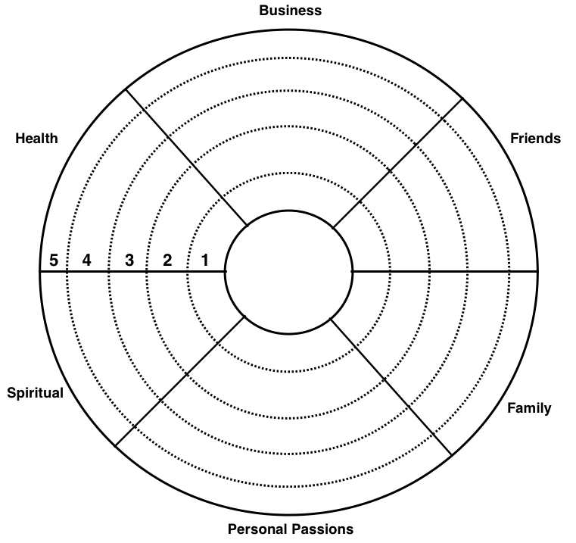

what areas do you have lots of support?

What areas could you improve your support/connections?

Do your closest friends know how much they matter to you? Take a minute right now to make sure to show them you appreciate them:

Write down a few ideas and goals for how you’d like to improve your social connections (ie call up a family member, join a club, invite a friend over to hang out, etc)

