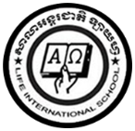**LIFE INTERNATIONAL SCHOOL**

KHMER SUBJECT FOR KSL

TEACHER : **CHEN SOTHARY**

**Name : …………………………………………………….**

1. **Learning the Khmer vowels from ៅ to ះ**

**ៅ ុ ំ ា ះ**

**…………….. ……………. …………….. …………….. ……………..**

**…………….. ……………. …………….. …………….. ……………..**

**…………….. ……………. …………….. …………….. ……………..**