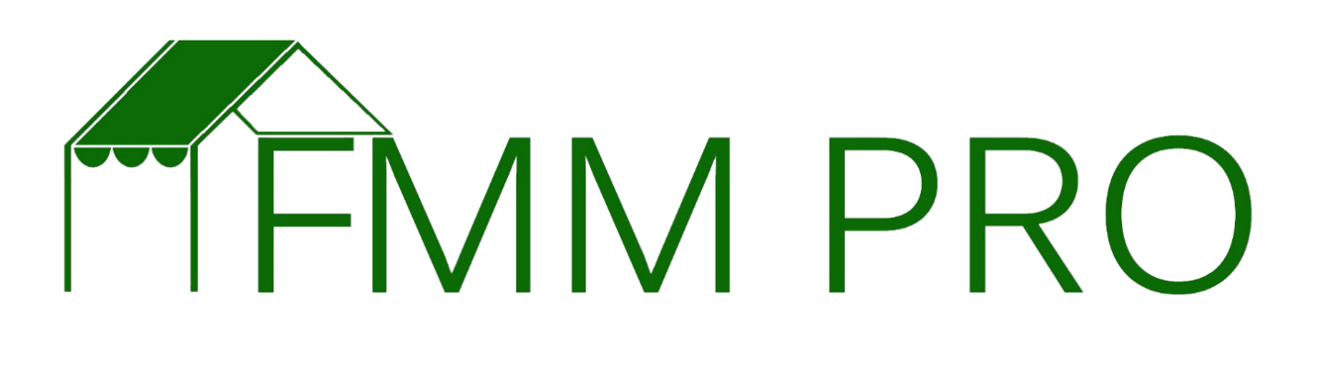

As a farmers market manager food safety should be a top priority. Understanding the risks, conducting a food safety risk assessment during a market day, as well as putting in practice policy and procedures to mitigate risks will go a long way towards protecting your customers and farmers as well as protecting the market should a food borne illness be traced back to the market. The purpose of this assignment is to help you think through the risks and create policies to protect your market and your customers.

1. Identify each of the risks associated with the following categories:
2. Temperature
3. Hygiene
4. Water
5. Animals
6. Cross-contamination
   1. Displays
   2. Travel
   3. Consumer
7. Sampling
8. Labeling
9. Traceability
10. Other:
11. Once you have identifies each potential risk, it is time to create a means for review and assessment of those risks. Create a food safety checklist that identifies the risk, how it will be assessed and how often it will be assessed. This checklist will ensure that each assessment is thorough.
12. You last step is to create a policy regarding each risk and how the market and vendors will uphold a marketplace that is as safe as possible for your vendors and customers. This policy should be included in your market rules and shared with the market staff and all vendors.

