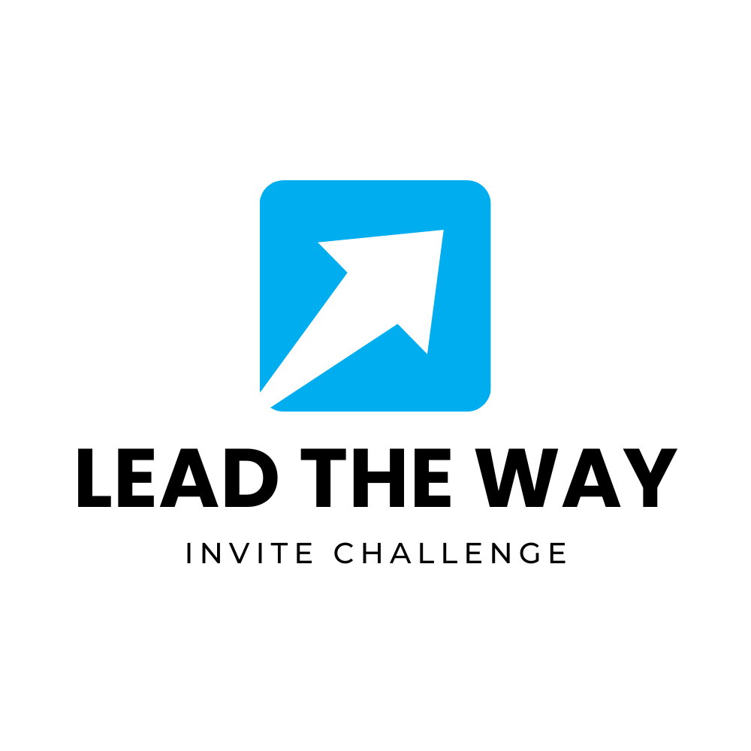

**During Challenge Follow Ups**

**BIG IDEA:** This document contains “copy & paste” emails that you can use to remind your team throughout the lead up to the Big Day!

### **Email 1: Early Reminder**

**Subject:** The Lead the Way Invite Challenge is ON – How’s Your Team Doing?

Hey Team,

We’re off and running with the **Lead the Way Invite Challenge**! How are you doing with your invites?

Check in with your **Team Invite Coordinator** regularly—they’re tracking how many invites we’re making and updating the wall calendar. Remember that we’re aiming for the highest invites per capita, so every personal invite counts!

This week, let’s focus on finding moments to invite people in your circles. Whether it’s handing out an invite card, sending a text, or extending a direct ask—every invite matters!

Let’s keep going strong. We’ve got this!

### **Email 2: Reminder + Leaderboard Update**

**Subject:** Check Out Who’s Leading in the Lead the Way Invite Challenge!

Hey Team,

Quick update on the **Lead the Way Invite Challenge**:

Currently, the team with the highest invites per capita is **[Team Name]**! 🎉

If your team hasn’t started tracking yet, there’s still time. Be sure to check in with your Team Invite Coordinator so we can keep the calendar updated and keep the momentum going.

Remember: this is all about inviting people to experience the hope and joy of Christmas. Let’s keep extending those invitations and pray for open hearts.

Let’s go!

### **Email 3: Mid-Challenge Motivation**

**Subject:** Halfway Through the Invite Challenge – Let’s Keep Going!

Hey Team,

We’re halfway through the **Lead the Way Invite Challenge**, and the invites are coming in strong!

As a reminder, our **Team Invite Coordinators** are here to track how many invites we’ve made so far. Don’t forget to update them so we can keep the wall calendar updated on our progress.

This week, let’s challenge ourselves to reach out to people we haven’t yet invited—friends, family, coworkers. Every invite counts, and it could be the start of something unique for them.

You’re making a real difference. Let’s keep going strong together!

### **Email 4: Final Push Before the Holidays**

**Subject:** One Week Left in the Invite Challenge – Let’s Finish Strong!

Hey Team,

We’re in the final stretch of the **Lead the Way Invite Challenge**—only one week left!

I’ve been hearing incredible stories of personal invites being made. Let’s give it one final push before we wrap up the challenge. Reach out to those you’ve been thinking about but haven’t invited yet. This is the moment!

Remember, your **Team Invite Coordinator** is tracking invites, so keep those updates coming as we make our final count for the wall calendar.

Let’s go all out and finish strong. Every invite could be a turning point for someone’s Christmas!