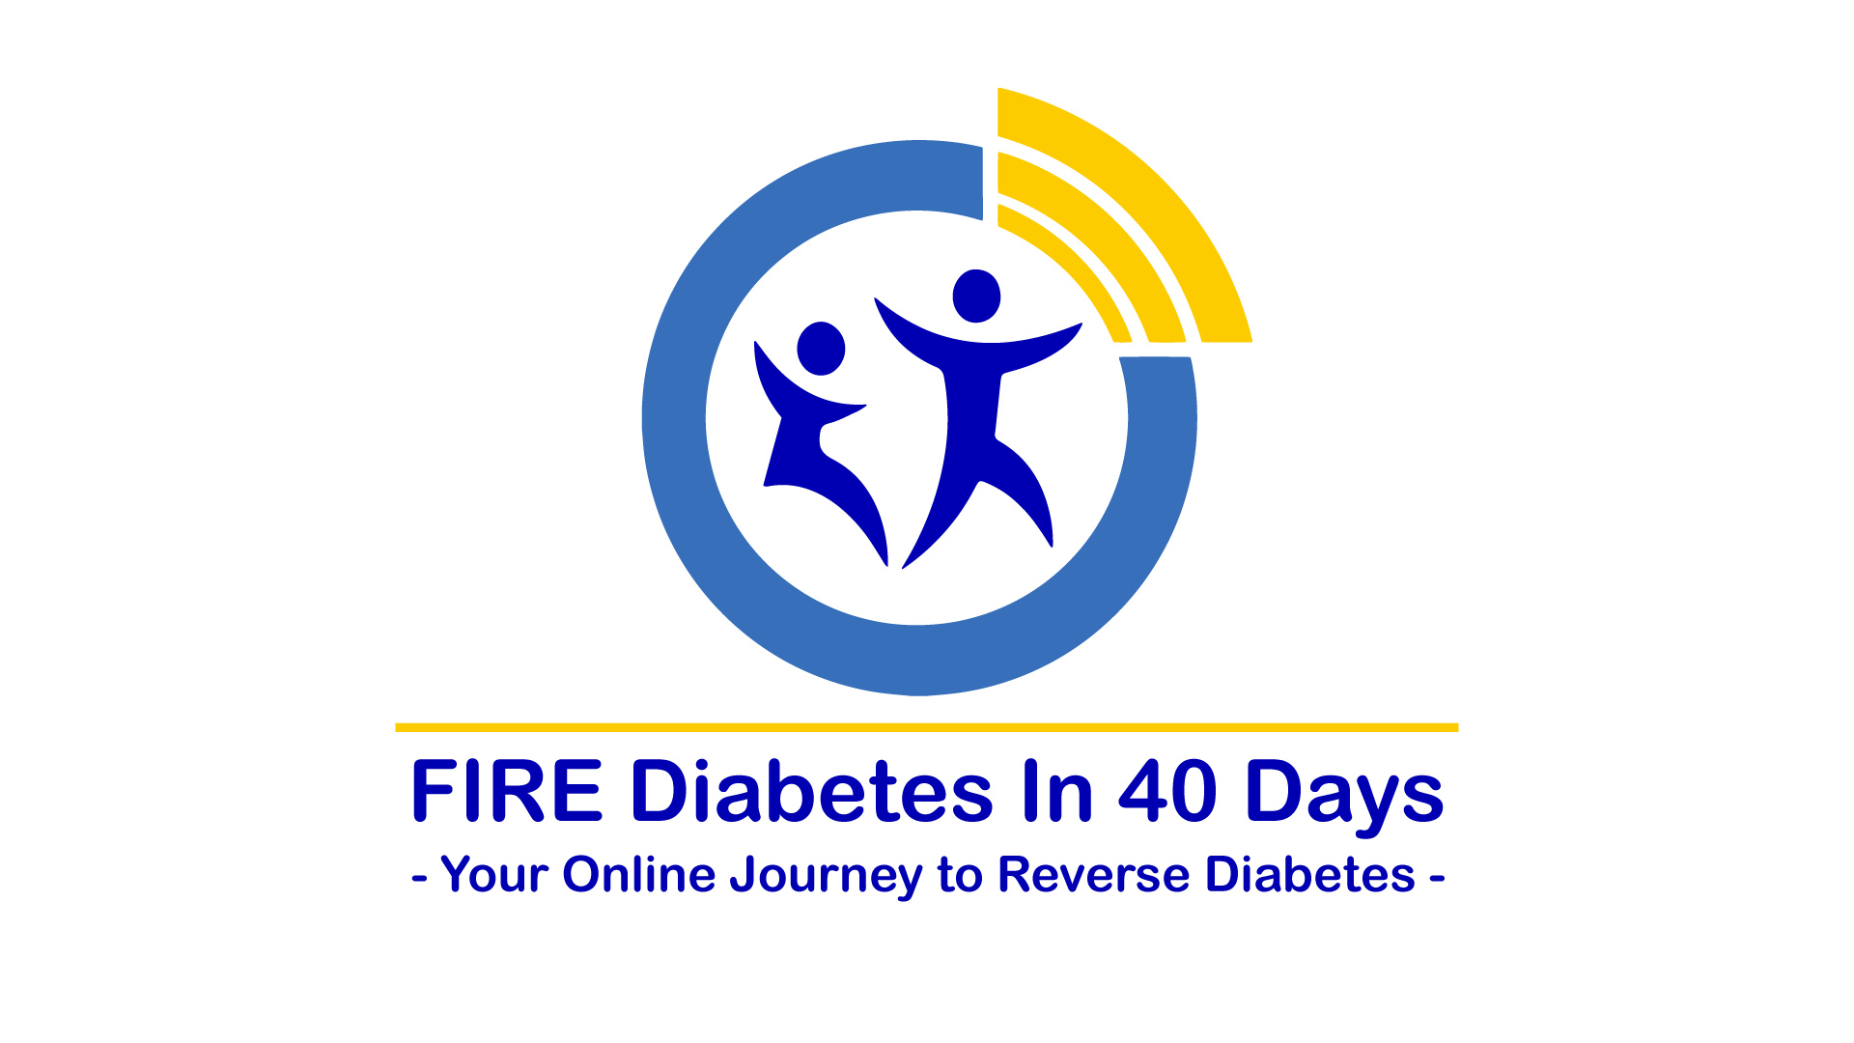

PRE-TRAINING #2  
*FIRE Away* Worksheet

Falsehoods

- 6 Myths That Hold You Back -

# Mission #2: Truth Can Change Your Life, If Only You Will Believe It

Welcome to Day 2 of the Pre-training!

Yesterday, we focused on the "Fall of The Big Domino", namely that fixing insulin-resistance is SIMPLE.

Today, we look at six major myths and false beliefs that have held you back from reversing your diabetes. This is likely the "meatiest" of all our videos in this course. It is intense! You may need to watch it more than once over the next two weeks, to get your head around the stuff being said. It represents a total mind-shift - at times, you may feel you are drinking from a fire hydrant!

But once you grasp what we're saying, things will get easier and easier as we go along.

**HERE IS YOUR *FIRE AWAY* TO-DO LIST FOR TODAY:**

* If you haven’t done it yet, Under the “Welcome section” on Teachable, **introduce yourself** by leaving a comment. We’d love to get to know you better.
* Watch today’s **video.**
* Download the **handout**, “Falsehoods: 6 Myths That Hold You Back” and read it.
* Fill out the worksheet below
* Share what you’ve learnt by leaving a comment on Teachable
* Join our private and exclusive **FIRE Diabetes Club** Facebook Group (<http://tiny.cc/fd40-club>). **Share there what you’ve learnt** today and yesterday.
* **Add the FIRE Diabetes mobile number** (for messaging only; no phone calls) to your phone's **address book**: +27 66 236 4044, as well as our email address: info@firediabetes.com.
* If you haven’t done so yet, **download the App.**

# Reflect on the following questions after you’ve read the handout and watched the video

1. List the truths that set you free (“demythify”) you today.

|  |
| --- |
|  |

1. Are there some of these myths that are still difficult to “unbelieve”? Why? What are you going to do about it?

|  |
| --- |
|  |

1. What are you going to do to ensure that these myths don’t crawl back into your mind and derail your progress on this journey to FIRE Diabetes In 40 Days?

|  |
| --- |
|  |

1. What is the one thing you heard today that really stuck with you?

|  |
| --- |
|  |

1. Pick a way to tangibly capture this lesson so you don’t forget it.

* I will share it on Teachable as a comment
* I will journal it
* I will write it on my whiteboard or wall
* I will place a post-it note on my mirror
* I will post it on social media and tag it with #FIREdiabetes