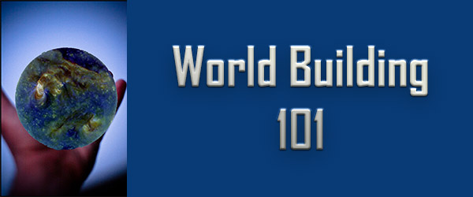

Introduction to Worldbuilding

Every novel creates a unique world in which the reader lives while reading the book. While some authors may feel the idea of worldbuilding only applies to speculative fiction. The fact is that every author, even those writing contemporary fiction set in "real" locations, picks and chooses what to show and what to leave out creating a specific experience of that place which is qualitatively different from what a reader would experience if s/he were there in person.
So, we are all Worldbuilders, and in this class, we are going to dig into many of the nuances of worldbuilding which can make your world more believable and one to which the reader wants to return.

The Importance of Setting

You can think of fiction as being the narrative of someone, doing something to solve some problem, somewhere. The "someone" we call Character. The "something" being done is Plot. The "somewhere" is setting. Sadly, Character and Plot often are at the forefront of a writer's thoughts and setting is an afterthought if it gets any thought at all.
However, the setting is the invisible character in each story. Could Huckleberry Finn take place anywhere else but on a raft floating up the Mississippi River in the Antebellum South? Would Oliver Twist work, if Oliver were raised in a suburban foster home instead of a Victorian orphanage/workhouse? Those settings shape the stories as much as the characters and the actions they take which create the plot.

Overview of Setting

This will be an in-depth course. Each of the following may have more than one lesson. Some may have several.

Physical Setting

This is what most people think about when they consider setting, and I'll be looking at many different aspects of physical setting including geography, topography, climate, architecture, and the sensual side (sight, smell, touch, sound, taste).

Temporal Setting

This includes historical period, time of year, and time of day. We will spend some time on how to research historical periods to be sure your setting is realistic

Cultural Setting

Culture is the shared beliefs, traditions, activities, objects, and expectations of a group of people. Most of us are members of multiple cultures. Ethnicity, membership in a certain club or organization, religion, even activities like playing video games or riding motorcycles give us membership in different cultures. We will look in depth at what culture is, how it can be defined, and look at some distinctions between different classifications of cultures such as high-context and low-context, other-oriented and individual-oriented. If you are going to create a culture, you need some understanding of how cultures differ.

Institutional Setting

I spent thirty-five years of my life in academia. Before that, I was in broadcasting. I have worked in churches and large corporations. Each of these has certain unique characteristics. If, like me, you write mysteries, a murder investigation on a military base is going to proceed differently from one at a college which will be different than one in a prison.

Social Setting

Having dinner with friends to celebrate your birthday is not the same as having dinner with the same people at the same restaurant to discuss a business deal. The social contexts of human interaction provide a different type of setting. Each social setting has its own metarules, expectations, behaviors, rituals, and language.

Magical Setting

This is specific to those writing fantasy. Some beginning writers treat magic as a form of omnipotence and the deus ex machina to get the writer out of trouble when s/he paints the protagonist into a literary corner. The best fantasy novels, though, set a limit on the use of magic. Iron might prevent a magic spell from penetrating a room, magic rebounds when used to kill or injure, magic can only work with certain hand gestures, spells, or songs. These are common ways to limit magic. The magical landscape must have limits and consistency. If a spell cannot work in a lead-lined room in chapter five, it can't do so in chapter thirty-seven unless something changes.

Science and technology setting

For science fiction stories, this is a significant part of the story. I write stories about a colony on the moon. Periodically, some plot point will turn on the moon having only 1/6 the gravity of earth. This produces many elements of the story. Lunar natives, for instance, can't go back to earth because their bones would be too brittle. People glide on the lunar surface. A popular sport is crater skimming. Someone is crater skimming and cuts a hole in their moon suit becoming seriously injured. Is it a manufacturing flaw, the skimmer's misstep, or sabotage.
For believable science fiction, you also can't use science like magic. Even stories set in the distant future need to abide by some of the basic rules of nature, and future technology has some basis in modern scientific theory. We will discuss the science to fiction journey.
Well, that's enough to get you started. I'm sorry for the lateness of this. Your exercise will be to watch a favorite film or TV show with the sound off and try to get a sense of the world in which that show takes place from the visual cues only. Write up a short description. I'll be setting up a Facebook Group over the weekend where you can post the results if you want.

