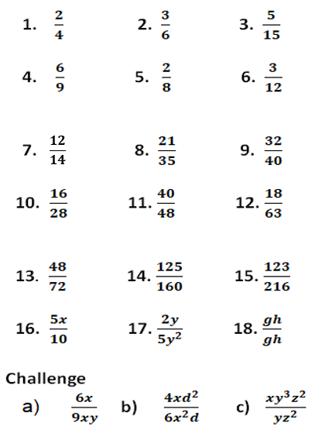

**Simplifying Fractions**