The Next 150 Hours:
Getting Underway with
Story-Building
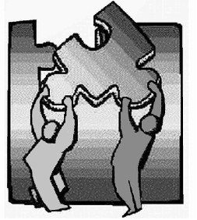
Phase 2 of a Six-Phase Programme
following the
Growing Participator Approach

Including At-A-Glance Session Plans
by Greg Thomson, Contributing Editor Rebecca Huston

Don't learn the language!
Rather, discover a new world,
as it is known and shared by the people
among whom you are living.
The Next 150 Hours:
Getting Underway with Story-Building (Phase 2)
Including At-A-Glance Session Plans

Copyright 2008, all rights reserved.
Informal copying and distribution freely allowed.
Please obtain permission for formal publication.

The Primary Growth Activity in Phase 2: Building Stories Using Wordless Books 4
Why Story-Building with Picture Stories? 6
Phase 2A - Getting Your Tongue Loose, You Take the Lead 7
Phase 2A, Session 1 7
Resources Needed 7
A. Preparation 7
B. The Session at a Glance 8
C. Detailed Instructions 8
D. After the Session 12
Additional help: “I can't think of very much to say.” 12
Additional help: A more Realistic Example of What You Might Actually Sound Like 19
Phase 2A, Session 2 22
A. Before Your Session 22
B. The Session at a Glance 22
C. Detailed Instructions 22
D. After the Session 23
Phase 2A, Session 3 24
A. Before Your Session 24
B. The Session at a Glance 24
C. Detailed Instructions 24
D. After the Session 25
Phase 2A: Subsequent Sessions 26
Details 26
Phase 2B - Shift Perspective, the Nurturer Takes the Lead 27
Phase 2B, Session 1 27
A. Before Your Session 27
B. The Session at a Glance 28
C. Detailed Instructions 28
D. After the Session 30
Phase 2B, Session 2, 3, etc. 31
Alert! Don't Forget Step 7 when You Reach the End of the Picture Book. 31
Phase 2B, Perhaps Session 5 (or 10 or 15...) 31
A. Before Your Session 31
B. The Session at a Glance 31
C. Detailed Instructions 32
D. After the Session 32
Phase 2C - Telling Stories from Life with Simple Pictures 32
Option One: Draw As You Go 33
Option Two: Prepare in Advance 35
Stories from the Nurturer’s Life, Also 35
Option Three: All-in-One Picture 35
Phase 2C: Improving your Ability to Converse 36
About Grammar Learning in the Midst of Story-Building 36
Looking Ahead to Phase 3 37
Additional Supercharged Participation Activities for Phase 2 37
Story-building forever! 39
Conclusion 40
Appendices 40
Appendix 1: Is this the right Phase for me? 40
Prerequisites For Starting Phase 2 40
Where You're Headed Over the Early Months of Growing Participation 41
How Far Might You Grow During Phase 2 Specifically? 43
How Much Guidance Do You Need? 44
Appendix 2: Story Building Without Wordless Books 44
Using Cuisenaire Rods to Tell a Story 44
Adapting This Technique for Phase 2 Story-Building 47
Appendix 3: Some Challenges of Story-Building Activities 48
Challenges 48
In Summary 50
Appendix 4: Some Background Concepts 50
The CUTE Principles 50
New Concepts and Terms 51
Appendix 5: Evaluating Your Sessions with Your Nurturer 54
Appendix 6: Annotated Bibliography of Children’s Literature for Growing Participators 55
Wordless Books 55
Other Useful Children’s Literature (nearly Wordless) 59

The Next 150 Hours:
Getting Underway with Story-Building (Phase 2)

This guide is first and foremost for language learners who want to carry on directly from The First Hundred Hours (by Greg and Angela Thomson), either individually or in small groups. We recommend 150 hours of story-building activities as described in this guide. The figure 150 is arbitrary, but we believe that anyone will benefit from that many hours of story-building, and that this will prepare them well for going on to Phase 3, the Shared Story Phase.
Some users of my earlier paper, “The Story-Building Phase”, found it difficult to move suddenly from the detailed, hour-by-hour guidance of The First 100 hours, to total self-reliance in structuring their activities in Phase 2, and so they encouraged me to write a guide to Phase 2 similar to The First 100 Hours. Unfortunately, it is not really in the nature of the Phase 2 activities to be described by detailed hour-by-hour instructions. However, we certainly can provide a more graceful transition from the structure provided for Phase 1 to the activities of Phase 2. This present guide to Phase 2, then, is a more detailed syllabus for continuing on from Phase 1 into Phase 2.
Some people who have not followed The First Hundred Hours (Phase 1) programme but have developed some communication ability in another language may find that the activities of Phase 2 can accelerate their ongoing growth. This guide is written for them as well.

The Primary Growth Activity in Phase 2: Building Stories Using Wordless Books
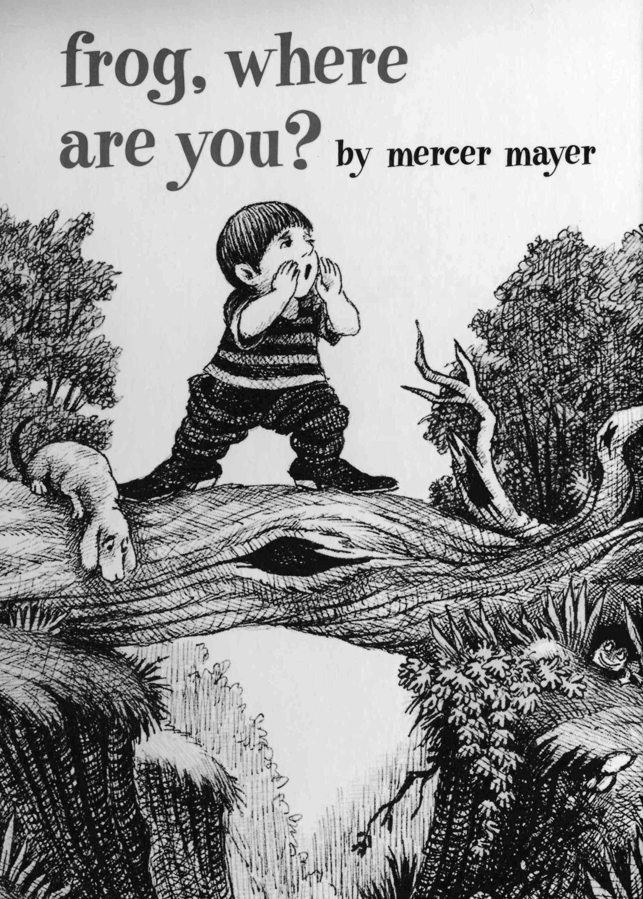
The primary growth activity during Phase 2 is Story Building, relying on wordless picture story books. Phase 2 can be broken down into 2A, 2B, and 2C.
During Phase 2A, using wordless picture storybooks, you will discuss all of the depicted situations and events on their pages with a host friend, who will help you to say what you are trying to say and more. In the process the two of you will build up the components for a story. It will be your original creation. Then your host friend will narrate the whole story, with all the details you both have agreed upon, while a sound recording is made of this narrative, to be added to your Listening Library for future listening pleasure (and for further strengthening your listening ability).
During Phase 2B, the process will shift to the host friend using new wordless picture storybooks to tell you a story. You will then clarify whatever you are unable to understand in her story.
During Phase 2C you will draw stick-figure stories depicting stories from your own life and the life of your host friend.
During Phase 2A the growing participator will take responsibility for the shape of the sessions. Thus the host friend will not have to do any preparation for the growing participation sessions. During Phase 2B the host friend may want to do a limited amount of preparation for the sessions, mainly by becoming thoroughly familiar with the picture story books that are being used. During Phase 2C the stories will be created on the spot, though some people may wish to prepare the necessary drawings in advance.

Phase 2 at a Glance | Suggested Goal
2A: Getting Your Tongue Loose - You Take the Lead | 50 hours
2B: Shift Perspective - the nurturer Takes the Lead | 75 hours
2C: Telling Life Stories with Simple Pictures | 25 hours

The instructions given here are addressed to language learners and are based on the Six Phase Programme, following the Growing Participator Approach, which views languages as the primary way humans participate in community together, the way they share life experiences with one another. Therefore, rather than language learners, I prefer to use the term “growing participators”. When the term “language learners” is used, it is possible to view the gaining of language as separate from this dynamic of sharing life experiences in relationships. Language is commonly viewed as a “thing” with many “parts” that we can “get” (“acquire”), part by part, until we “have” the whole language (or however much of it we desire). The term “growing participator” is an attempt to avoid this fallacy, to keep the focus on the living dynamic of language in community. Language is a kind of social activity: people who are less capable in the activity can engage in it with people who are highly skilled in it, until they themselves are skilled in it. So let’s not say then that this guide is addressed to language learners. Let’s say rather that it is addressed to growing participators.
This guide is also intended to be help those host friends who help the growing participators grow, often referred to as “language helpers”, “language teachers”, or “language tutors”. We will refer to them as “nurturers”. This is because their role is to nurture the newcomers in such a way that those newcomers will participate more and more deeply in the host community. We could also call them “mentors” as they function as highly skilled participators who let newcomers participate with them, so that the newcomers can learn to participate themselves.
The concept of a nurturer belongs to the overall approach to language and culture learning that we call the Growing Participator Approach. Many concepts belonging to this approach are explained in The First 100 Hours. If you are puzzled by any other terms that we are using, you may find that they are explained in Appendix 4 (New Concepts and Terms).
In Phase 2, as in Phase 1, it is usually best if the activities are carried out by two to four growing participators working together with a single nurturer, though the activities also work well with a single growing participator interacting with a single nurturer. When the activities are done in a group, care needs to be taken to insure that all participants have ample opportunity to contribute.
The picture book itself gives you an abundance of ideas for meanings to attempt to express. But at the same time, you will gain confidence through (and even enjoy!) the process of struggling to express your ideas. This struggle is something you’ll be doing for a long time if you are serious about progressing deeper into the life of the host community. With the help of the pictures, your nurturer will often guess the point of what you are trying to say, and help you to formulate it well. That is how you will grow.
The emphasis will be on communicating only in the host language, as much as is possible, during your sessions. If your nurturer shares some other language with you already (most often, this would be English) there is opportunity to take advantage of this for short, scheduled periods of “debriefing”, and then return to mainly communicating in the host language. If the nurturer and you have no language in common except for the host language, that can work well too. The debriefing times are not essential.
Depending on your exact style of talking about wordless picture storybooks, you may need as few as five or six such books to fill up a hundred and fifty hours of growing participation activities, or you may want to get your hands on every wordless picture storybook you can find. We’re going to give you explicit instructions to keep you going for the first few hours. After that you will be able to carry on, using the description of the early sessions as a guide to later ones as well.
For your first story-building experience, we will base the directions on the book Frog, Where are You? by Mercer Meyer. It has a simple story line (and is unlikely to go out of print, as it is widely used in cross-cultural child-language research). In case you do not have it, I have included copies of the first five pages so that you can see what I am referring to.
Many other children’s picture books can be just as useful for these sessions, as long as they contain only a few words, with the complete story line depicted in the pictures. Cover up the words so that they do not distract from your own original story that you are creating.

Why Story-Building with Picture Stories?
Although it isn’t possible to have all of our normal communication well planned and mastered in advance, neither is it necessary to go straight from the security of the Phase 1 activities to totally unstructured, “anything goes” communication activities. Wordless picture books provide a gentle path in the direction of decreasing structure for your communication activities, and increasing spontaneity.
Wordless picture storybooks are an extremely useful resource. They work well in many regions of the world. The only places they have not worked so well in are “traditional”, pre-literate people groups. In those places it is important to develop locally adapted picture stories. The story building activities with local content could then function both as growth activities for you, the newcomer, and as pre-literacy activities for host people serving as nurturers.
Here are some other reasons this type of activity is excellent for this phase in your language and culture learning:
- Using visual support makes it possible to interact more and more deeply. This type of storytelling provides a pleasant and interesting basis for interaction. People naturally enjoy stories—they spice up our life! (In fact, some would say that our life is a story.) This, in turn, helps with motivation.
- Using a picture story allows continuity in our communication activities from one day to the next. The activities have built-in repetition, which allow us “go from the known to unknown.” We start by using language we are able to use, and our host-language friend helps us to improve and expand that language.
- Using story-building techniques allows us to learn new vocabulary and grammar in a meaningful, memorable and personal context.
- Review becomes as simple as re-listening occasionally to the stories that were built earlier.
- Continued story building provides a powerful transition from being able to understand and produce “here-and-now” speech, to being able to understand and produce “story speech.” “Here-and-now” speech is speech that is directly related to what the speakers and listeners are seeing and doing: describing ongoing, visible activities, objects, and situations, or giving instructions for actions to be carried out immediately.
- In addition, during story-building activities, we will continue to increase in our ability to interact socially. This is a major step in our growth in language ability.

Phase 2A - Getting Your Tongue Loose, You Take the Lead

(Recommended Goal: 50 Hours in Sessions with Nurturer)

Phase 2A, Session 1

Resources Needed
1. A timer with bell (or just a wrist-watch or clock)
2. Something to write on
3. The book, Frog, Where are You?
4. A sound-recording device
5. You
6. The nurturer
7. If possible, one or two fellow growing participators (the activity can be more fun and natural in a small group than in a pair)
8. Paper for making a drawing of something you are trying to explain
9. A notebook or loose-leaf paper for your word log

A. Preparation
Before your session with the nurturer, examine the wordless picture storybook Frog, Where are You? in order to become aware of the main events that are going to take place as you work your way through the story.

B. The Session at a Glance
Timing | Activity | Resources Needed
5 to 10 min | Small talk. Explain the procedure to your nurturer. | picture story
55 min cycle | Centred around “the monolingual half hour” with a picture story: Steps 1 through 5 | picture story, word log, recording device
Repeat the 55 minute cycle as time allows

C. Detailed Instructions
5 to 10 min | Small talk, and explain the procedure to your nurturer.
At the beginning of Phase 2, your ability to carry on small talk is still extremely limited. Avoid the temptation to converse extensively with your nurturer in English (or any other language besides the host language).
A good practice is to learn at least one new fact about your nurturer each day, using only the host language. That will help to keep your growing participation personal. You can also share something parallel about yourself. If there are two or more growing participators going through Phase 2 together, they will also be learning about each other at this time, growing slowly together into a new little host-world community, under the mentoring of the nurturer.
Show the nurturer the picture story you're about to use. Allow her to flip through the entire picture story. Otherwise she might want to race ahead and see what happens next. Explain what you want to do during the session today.

Times | Steps | Resources
30 min | Step 1, The monolingual half hour with a picture story. | picture story, word log, pencil and paper, a watch, or better yet, a kitchen timer
5 min | Step 2, Debriefing | picture story, any jottings made during Step 1.
10 min | Step 3, Page-by-page recording | picture story, recording device, word log
10 min | Step 4, Listen and point (and act out) and Step 5, Record a brief sample of this | picture story, word log
30 min | Step 1 again. The monolingual half hour (as time goes on, this step can be lengthened more and more—it may eventually be a monolingual hour)
 | Etc. (Continue cycling through the five steps as time allows.)
O.K. Time for Step 1. Set the timer. For thirty minutes you must function entirely in your new language until the bell rings. This is going to be a struggle. That is how you will grow.

Step 1. Describe What You See.
Open to the first page of the book (in our examples here, Frog, Where are You?). Begin trying to describe the first picture. Describe everything you can, and find out how to say things that you don’t know how to say. You will speak in broken language. Your nurturer will be helping you to smooth it out as you go.
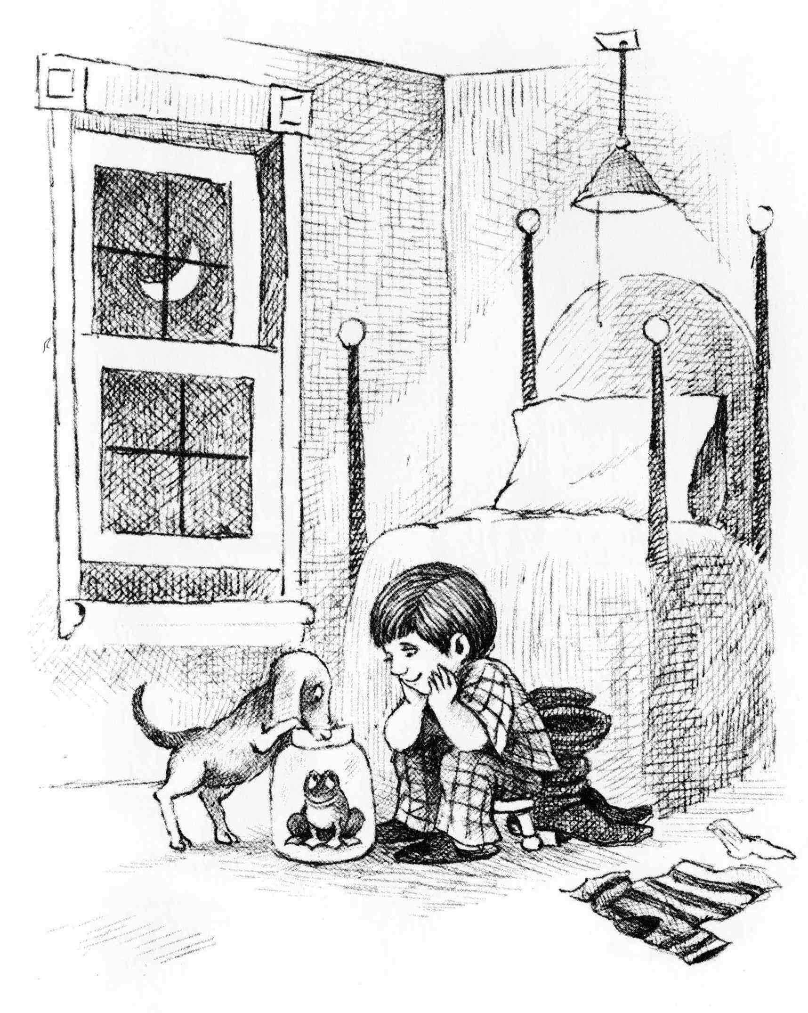

Example:
Here is an example of how the activity might begin if the growing participator were learning English:
Growing Participator: This is boy.
Nurturer: That is a boy.
GP: A boy. This is a frod.
N: Yes, but not frod. Frog.
GP: Frog is in… what is this?
N: The frog is in a big jar. It’s a jar, a big jar.
GP: jah?
N: Yes, jar. jar-r-r. [emphasising the r sound]
GP: jar-r [emphasising the r sound]; a big jar-r.
N: Yes. The frog is in a big jar.
GP: The frog is in a big jar. And dog looking at frog.
N: Yes, the dog is looking at the frog.
GP: And the boy is looking at the frog.
In the section below, “Additional help: ‘I can't think of very much to say,’ you’ll find many more examples of things you might say, or things you might ask the nurturer how to say, when discussing the first few pages of Frog, Where Are You?

Negotiate, Negotiate, Negotiate.
The point is to get your tongue loosened up—to get you communicating spontaneously—a lot—not just memorising and reciting, but rather expressing yourself in your own words as best you can, with the nurturer often stepping in and helping you out. You are to negotiate meanings and use power tools that you learned in Phase 1. Negotiating meanings means that you say what you can, and get help from your nurturer as often as you need it in order to say things you are not sure how to say, or even things that you have no idea how to say. Your nurturer is there to help you. In attempting to learn new things you will be heavily negotiating meanings. There is a clear example of negotiating meanings in the section below, “Additional help: A more Realistic Example of What You Might Actually Sound Like.”
Power tools are expressions in the host language that you can use to learn more of the host language. Examples are, What is this? What is this called? What is he doing? What kind of X is this? A number of such power tools are learned in The First 100 Hours programme.
When you try to get an idea across to your nurturer and fail, do not revert to talking in English (or any other shared language besides the host language). Leave it for the time being, making a written note to yourself about the difficulty. This can be used in the debriefing step later in this session.
If your nurturer fails to get a point across to you, the same applies. She is to make a note to herself, and not break into English (or whatever other language you already both know well). Her notes to herself can be used in debriefing.

Keep up the word log.
Always have your nurturer write down any new words that you encounter along the way. This is a continuation of your word log from Phase 1. Don’t forget your hourly goal of becoming acquainted with an average of seven or eight new vocabulary items.

Two or more growing participators growing together
If there are two or more growing participators doing the activity together, they might want to take equal turns saying things about the picture, especially if one is quiet and the other more outgoing.

Going on until the monolingual 30 minutes is up
Don’t be quick to move on to page 2. If you can’t think of much to say about page 1, look at the section below, “Additional help: ‘I can't think of very much to say.’ At this stage, you should attempt to spend at least fifteen minutes on a page. You may spend your whole monolingual thirty minutes on page 1. If not, continue Step 1 with page 2, 3, etc. You probably won’t get beyond page three in half an hour, if you are seriously trying to say a lot about every page.

Step 2: Optional Debriefing after 30 monolingual minutes (5 minutes)
You may do this step after the monolingual half hour is up. (If you set a timer, the bell will ring.). You can only do this step if you and your nurturer share some common language (such as English) that you both already know reasonably well. In this step, you revert to that language for the debriefing. You may have made notes when you attempted to say things and failed, and your nurturer may have done the same. You are now free to ask about those things in another language: “Here I was trying to say that the boy is dreaming about his frog. How would I have said that?” New words that are introduced in this debriefing time are also added to the word log.
A caution with debriefing: Debriefing should be a few minutes to deal with any areas you “couldn’t get across.” It is absolutely NOT supposed to be used to get English translations of all the new words and phrases encountered, nor to hear lengthy lectures in English about the host language grammar, or nor to hear lengthy efforts to “explain the culture” in English (or any other language besides the host language).

Step 3: Page-by-Page Recording (10 minutes)
Go over page 1 with the nurturer, reminding her of all you discussed together, and all the new words that were entered in the word log.
Make a voice recording of the nurturer describing the page in detail, but talking only about things you talked about together during Steps 1 and 2, and using all of the new words and expressions that arose in Step 1.
Repeat this sequence with page 2, and any additional pages you talked about.

Step 4: Listen and Point (and Act Out) (5 to 10 minutes)
The nurturer next uses the word log to remind herself of the new words you encountered during that session. She uses these new words to describe parts of the pictures to you. As she says a word from the log (or a phrase or sentence containing that word), you respond by pointing at what she is describing. Example: Suppose one of the new words was window frame. The nurturer will ask you, “Where is the window frame?” and you will respond by pointing to the window frame. Or suppose the word “moon” is old, and “bright” is new. She might say, “The moon is bright.” Assuming you understand the whole statement “The moon is bright”, you need only point at the bright moon.
If a new word is a verb, you can act it out rather than pointing. Suppose, for example, that “dog” and “fly” are old words, but “catch” is a new word. Then she might say, “The dog catches a fly.” How might you respond nonverbally? Well, you could point at the dog, and then play charades: your finger is a fly, and your other hand is the dog’s mouth. You say “arf arf” as your one hand catches the finger of your other hand, representing the dog catching the fly.
In this manner, the nurturer will repeat new words many times, and you will be able to mentally process them. Such extra encounters with these new words will strengthen them in your mental lexicon (which is developing in your brain). Many of the words will re-occur as you go forward through this and other picture books. Because of this, eventually you will be able to recall them when you want to say them, but don’t focus a lot of energy on memorising them to a level where you can recall them at this point. Rather, just become very familiar with them so that you recognise them and understand them when you hear them. Memorisation is time-consuming, and for many people, inefficient.

Step 5: Record it (brief)
Make a brief, summary sound recording of this activity to listen to in the evening. By listening to it again you will strengthen your experience with all of the new words.

ALERT, ALERT, ALERT! There will be a Step 6! (But not yet)
Step 6 will come only when you have finished discussing the entire picture story book. In that step, the nurturer will tell the entire story, in normal story form (“in the past tense”). The instructions for that step are given below under “Session 3,” although in reality it may take you more than three sessions to get through an entire picture story book.

RETURN TO STEP 1, AND CONTINUE WITH ADDITIONAL MONOLINGUAL HALF HOURS, DEBRIEFINGS, ETC. AS TIME PERMITS.
55 min cycle | Centred around “the monolingual half hour” with a picture story: Steps 1 through 5 as before | picture story, word log, recording device

We recommend 20-25 hours per week of this activity at the beginning of phase 2.
When you reach the end of a wordless picture storybook, please see Session 3 instructions for The End of the Book Activity (Step 6).

D. After the Session
Your homework is to listen several times to the sound recordings of the descriptions of the pages you talked about today. Also listen to the recording summarising the “listen and point” activity, once again pointing appropriately as you listen. In this way, you will further strengthen the words in your mental lexicon before the next session.

Additional help: “I can't think of very much to say.”
(You can skip this section if you don't need additional help.)
Many people complain that they cannot think of many things to say about a page in a wordless picture storybook. The sample lists here, based on the first five pages of Frog, Where are You? are meant to stimulate your thinking. Soon you’ll be making your own lists.

Take Time, Be Creative
The examples below are provided to spur you on to be creative. Add more possibilities of your own. You will not say all the things we have listed, but it is good if you spend not less than ten minutes on a page. If you would spend the whole half hour on page 1, that would be wonderful (assuming you talk a lot and learn something)!
A few people react negatively to the idea of “making things up on the fly” rather than memorising in advance. However, making things up on the fly is what language is all about. Ideas you come up with on your own will often be more fun than ideas that I came up with for you in the examples. Eventually you may move more quickly from page to page, especially in Phase 2b when the nurturer is the primary one making up the stories.

Don't Translate, Memorise or Over-Plan!
This list contains things that you should have some idea how to say based on your Phase 1 growing participation. The point is not to translate this list into your host language in advance of the session and memorise the sentences to use in the session!! Neither should you try to plan in advance the exact words and sentences that you are going to say in the session, but rather just get a general idea of the kinds of ideas you might try to express.
If you were in fact to have the items in this list translated into the host language, and were then to memorise them in preparation for a growing participation session, it would mean that you had profoundly missed the point of growing participation!!

Possible Ideas for Page 1 (Based on Abilities at the End of Phase 1—The First 100 Hours)
This is a boy. | He is in his bedroom. | These are his boots.
He is not wearing his boots. | The boots are behind him. | They are between the boy and the bed.
He is wearing slippers. | He is wearing pyjamas. | His shirt is on the floor.
His socks are on the floor. | He is sitting on a small stool. | The stool has three legs.
He is sitting in front of his bed. | It is a very high bed. | The bed is against the wall.
The bed is near the corner. | It is night time. | This is the moon.
The window is open. | There is no curtain on the window. | There is a pillow on the bed.
There is a light over the bead. | There is a string on the light. | It is warm outside.
There is a blanket on the bed. | The dog’s tail is curved. | The boy has a dog.
The boy has a frog | The frog is in a big jar. | Where is the lid?
There is no lid. | The dog is standing with his front paws on the edge of the jar. | The dog’s nose is in the jar.
The dog is looking into the jar. | The dog is looking at the frog. | The dog is happy.
He is smiling. Everyone is smiling. | The boy is looking at the frog and he is happy. | The frog is looking at the boy and he is happy.
They are all very happy. | The boy is sleepy. | The dog is saying, “I like you, frog”. “You are a good frog.”
The boy is saying “Sleep in the jar frog”. “Good Night” “I’m going to bed.” “I’ll see you in the morning.” | The boy is saying to the dog, “We like this frog. He is our friend.” | The frog is saying, “I am happy. I like this jar. I like this room. I like you, boy. I like you, dog. You are my friends. Thank you for the fly”.

New Things You Might Try to Learn to Say for Page 1 (Things you may not have learned in Phase 1, but can learn now)
The dog’s tail is wagging. | Pull the string and turn out the light. | They should close the window.
There is a shadow under the dog. | The boy is resting his face in his hands and resting his elbows on his knees. | The glass is clear. (The window is clear.)
The boy is saying, “Don’t bark at the frog.” “He will be frightened.” | The wind comes through the window. | The boy is saying, “Dog, catch a fly. Give it to the Frog. Frog, eat the fly.”
The dog’s ears are hanging down. | The dog is saying, “I will guard the frog.” | The jar has a big opening.
The frog might go out. | The boots are wrinkled (the bed is wrinkled). | The moon is bright. Outside it is not very dark.
The boots have high heels. They have high tops and pointed toes. | Inside the light is on. It is very bright. | There is a pillowcase on the pillow.
The boy’s shirt is spread out on the floor. In is not bunched up. | It is striped | The pyjamas are plaid ones.
There are four posts at the corners of the bed. | The boy’s hair is very thick. | The window slides up and down.
His hair is parted here. | This is the windowsill. | Where is the other sock?
This is the window frame. | One sock is missing. | There are eight panes.
How old is the boy? | When the boy goes to sleep, the frog may go out through the window. | The boots are longer than his feet.
The frog says, “I am in jail. I will go out.” | The frog might go out. | The frog can hop. He can hop high.
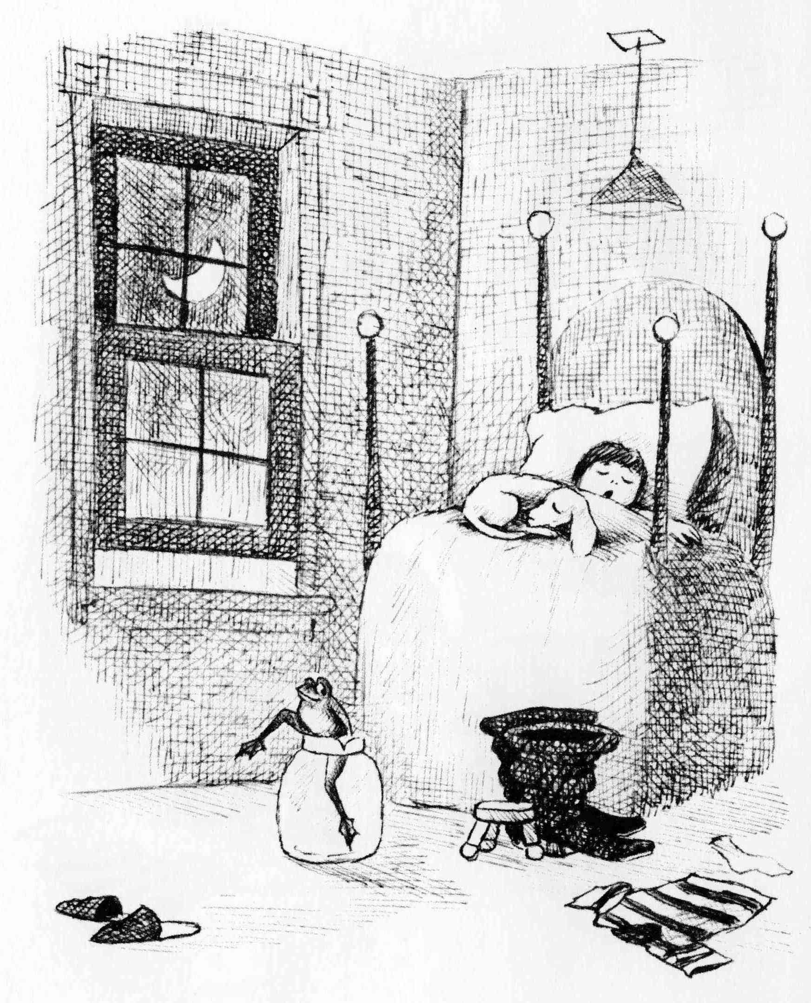

Possible Ideas for Page 2
Possible things you could already say, based on Phase 1, and also based on things you said in connection with page 1: (including many things that were said in connection with page 1, such as “The frog is happy”, etc., etc., etc., etc.)
There is no lid | It is dark in the room. | The dog is asleep.
The frog is not asleep. | His eyes are closed. | The frog is climbing out of the jar.
The boy is yawning. | He is not hopping. | His eyes are closed.
One leg is out of the jar. | The dog is lying/sleeping by his feet. | The frog’s hand is on the rim of the jar.
The boy is under the blanket. | The frog has a wide mouth. | His head is on the pillow.
He is happy. He has a wide smile. | Now he is not wearing his slippers. | What time is it?
His slippers are on the floor. | Where is the frog going? | The light is out
What does he want to do?

New Things You Might Try to Learn to Say for Page 2
The dog is curled up on the bed. | It is still dark outside. The moon is still bright. It is not very dark. | The window is still open. It is still night. The shirt is still on the floor. The sock is still on the floor. The other sock is still missing.
The moon is shining through the window. | The boy and the dog are dreaming. | The frog has webbed feet.
They are dreaming about their frog. | He has strong legs. | They are snoring.
He is green. | The frog is thinking, “The boy and the frog are asleep. They are not watching me.” | His leg is bent.
One leg is still in the jar. | His legs are long. | The frog’s chest is sticking out.
His legs are strong. | He is thinking, “The window is open. I will go out.”
(Some of these meanings, like the idea of “still”, may be very challenging to negotiate, and after attempting to do so, you will give up, make a note, and later ask about how to express the idea during the debriefing time.)
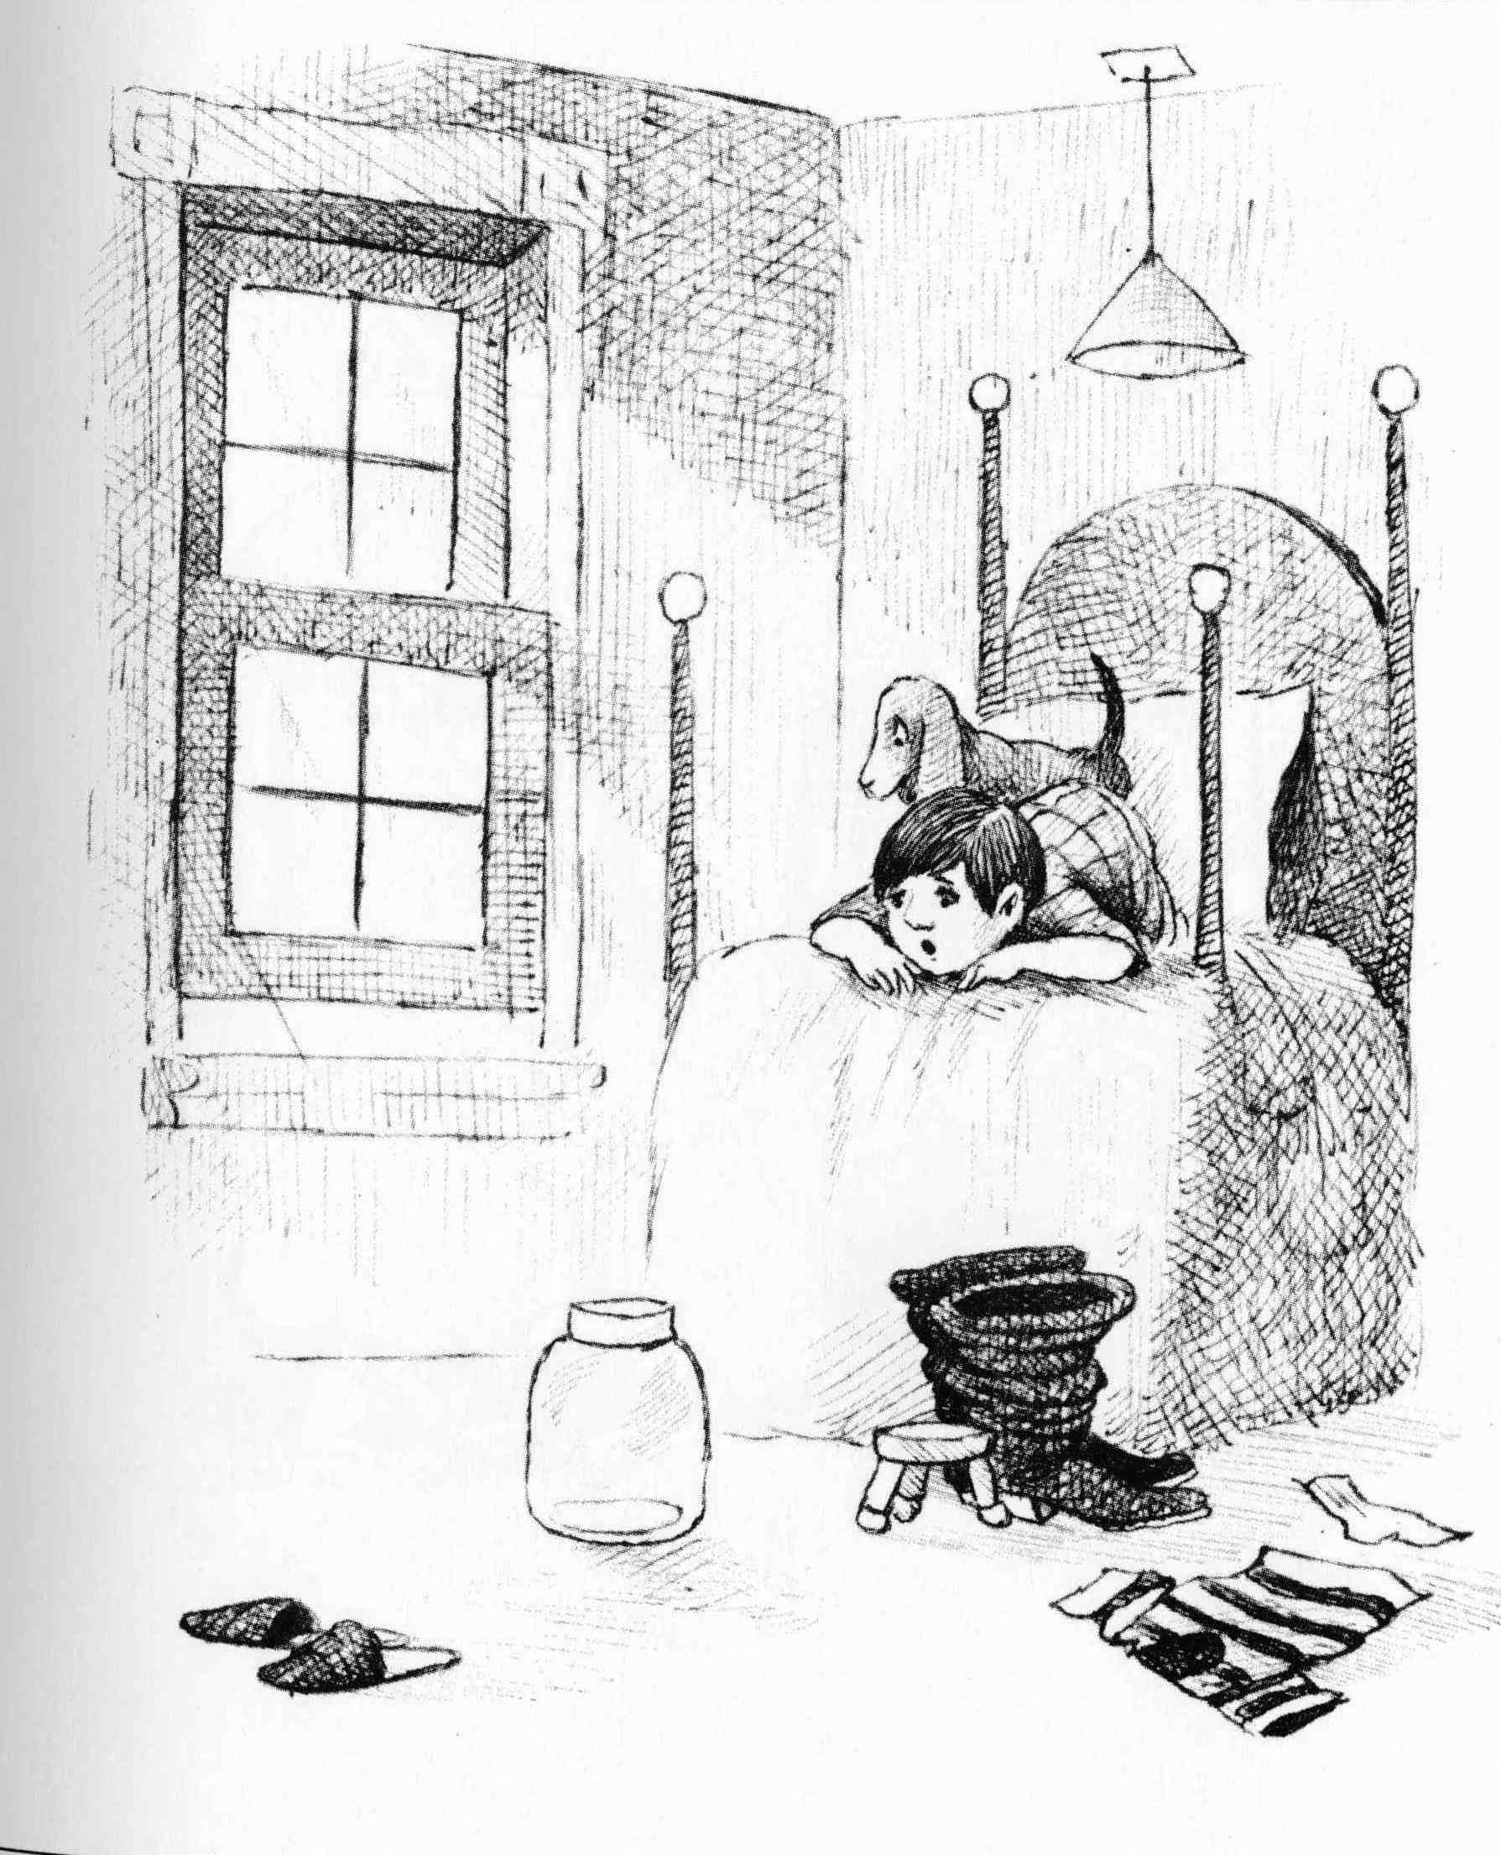

Possible Ideas For Page 3
Things you might already be able to say: (including various things from the previous two pages.)
It is day. | His mouth is wide open. | The boy is awake.
His eyes are wide open. | The dog is also surprised, etc. | The boy can see the jar.
The dog is awake. | The dog is looking out the window. | There is no frog.
It is morning. | The boy is laying on his belly. | It is bright outside.
The dog is standing on the bed. | The sun is shining through the window. | His arms are bent.
The light is not on. | He is looking down from the bed. | It is light in the room.
He is looking at the jar. | The boy is saying, “Where is the frog”. “The frog is gone.” | The jar is empty.
He is not under the blanket. | His head is at the foot of the bed and his feet are at the head of the bed. | He is upset.
The boy is surprised. | The slippers are still there, the boots are still there, the stool is still there, the shirt is still there, the sock is still there, the jar is still there, but the frog is not there. The boy sees everything, but he does not see the frog. | He is frightened.
The frog is not in the jar. | There is a shadow behind the pillow.

New Things You Might Try to Learn to Say for Page 3
It is not night any more. | The boy is saying, “Maybe someone stole the frog”. “Maybe a kidnapper took him.” “Maybe an enemy took him.” “Maybe a robber took him.” “Maybe an animal took him.” | These are the sun’s rays.
The boy’s bum is sticking up. | The boy is saying, “Maybe he is just hiding.” “Maybe he is playing.” “Maybe he is in danger.” “Maybe he will die.” | His face is resting on the backs of his hands.
The boy says, “We must find the frog”. | The slippers are facing away from the bed. The boots are pointing away from the chair. | The blankets are pushed back.
His elbows are pointing toward the posts on the corner of the bed.
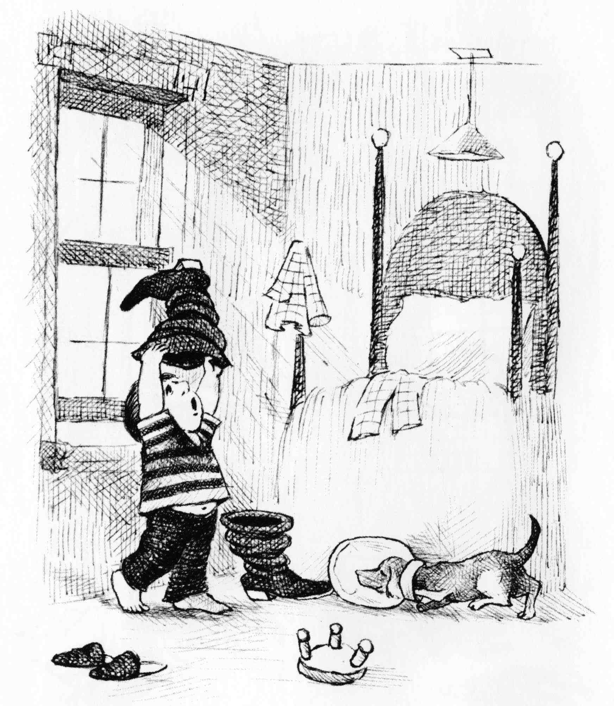

Possible Ideas for Page 4
Do some brainstorming. What details can you describe or learn to describe. Try mainly to stay in the present tense. Not, “The boy took off his pyjamas”, but “The boy is not wearing his pyjamas.” We’ll let you try out your own creativity on page 4, because there are lots of details, and lots of things going on, and other details of the scene that you could mention. (Just think of all the places in the room that the frog is not!)

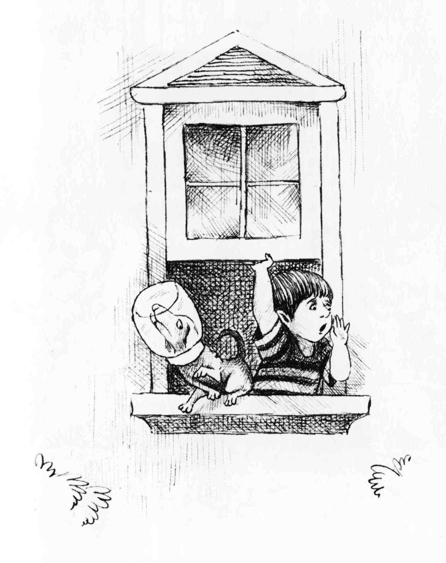

Possible Ideas for Page 5
List your own ideas before looking at mine:
Here the picture may seem sparse. How creative can you be? How many ideas did you come up with? Well, just for fun, I came up with the following. That picture wasn’t so sparse after all!

The boy is looking out the window. | The frog is outside. | He is saying, Frog, Where are You?
He is holding the window. | The window is wide open. | The dog’s head is still stuck in the jar.
All of his feet are outside the window. | His rear end is on the windowsill. | He is losing his balance.
He is about to fall. | There are bushes on each side of the window. | There are leaves on the bushes.
The top of the window is shaped like a roof. | The boy is holding his hand beside his mouth. | He is shouting very loudly.
The dog cannot hear him well. | The boy does not see (notice) the dog. | The boy is thinking about the frog.
The dog is not thinking about the frog. | The dog is pointing his nose upward. | The dog is pawing at the air.
The boy is facing to the right and the dog is facing to the left. | The dog is looking out of the corner of his eye. | Maybe he is looking at the boy.
What will happen next? | The boy keeps yelling and yelling, “Frog, where are you? Come home frog? Are you O.K.? Can you hear me?” | The dog can’t breath. He is suffocating.
The dog’s hind leg is touching the boy’s side. | The boy is leaning against the windowsill. | Who will help the dog?

Possible Ideas for Page 6
You’re on your own, and I’m done showing off. If you still find it hard to be creative, don’t worry about it. You may just need to use more picture stories than someone who is more creative. Instead of spending 150 hours in five picture stories, you may use thirty picture stories.
In fact, some people might argue that there are advantages in using a larger number of stories. Each story brings a new theme, topic, problem, moral, etc.
If you are doing this alone with your nurturer, it won’t be as easy to keep talking on and on about each individual page as it is when two or three growing participators are doing it together, since all of the demand for creativity falls on one person. In that case, you might expect to use a greater number of picture stories than you would if you were in a group of growing participators together with a nurturer.

Additional help: A more Realistic Example of What You Might Actually Sound Like
You might get the wrong impression from the examples in previous section. Those are examples of sentences you might be able to say (or to learn to say) at the beginning of Phase 2 based on the vocabulary and other abilities you developed in Phase 1. However, your speaking must be spontaneous. You can’t plan all that you are going to say and memorise it in advance. As you keep noticing things you might try to say, you must struggle to come up with the necessary words and phrases on the spot. Thus, rather than producing smooth, natural speech such as you see in the in the previous section, you’ll be speaking your host language in a more “broken” version. In this present section we base our examples on a different picture story (based on the book The Big Fat Worm, by Nancy Van Laan. Illus. Marisabina Russo. Alfred Knopf, 1995).
The story begins when the bird meets a worm and they have a conversation. The growing participator knows the original story, but the nurturer does not. Since the growing participator is in the lead, following the basic plot of the original story, he wants the dialogue to be one in which the bird summons the worm, wanting to eat it, but the worm doesn’t trust the bird’s intentions. We’ll use “broken English” in our examples. As I say, depending on what host language you are learning, you’re likely to find that you are often resorting to broken language, whether “broken Arabic”, “broken Kazakh” or “broken [substitute the name for your host language]”.

Saying what you can:
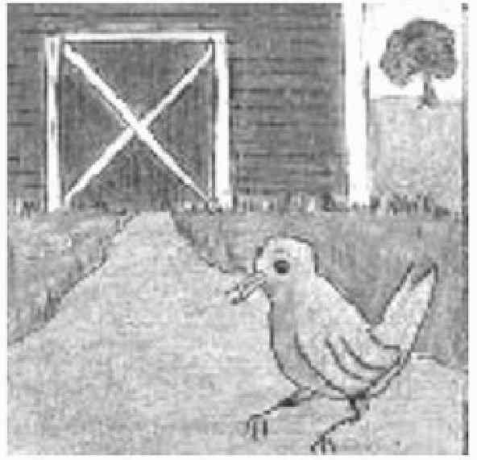 | Growing Participator: Grass. Much grass. Green.  Nurturer: Yes. There is a lot of green grass. There is green grass everywhere.  GP: Green grass everywhere.  N: Yes. There is green grass everywhere.
You may learn new vocabulary by pointing at things in the pictures, and using power tools: 'What is this? What is he doing? What is he thinking?' Other times, it will be necessary for you to “negotiate meanings” with the nurturer. In the following example the growing participator begins by using the power tool, What is this?, while pointing to the barn that is behind the bird. Only a bit of the barn is visible. Thus the nurturer cannot tell that it is a barn and answers, “I don’t know.” What ensues after that is some negotiation of meaning.

Learning new things (assume that all of this is in the host language, not English)
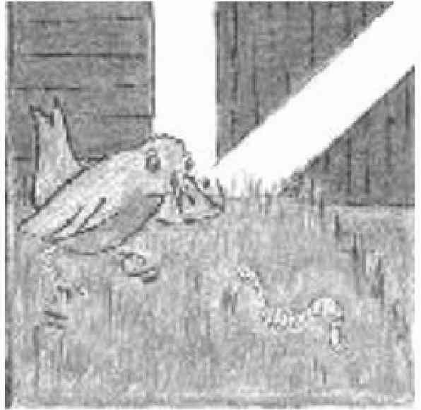 | GP: What is this?  N: I don’t know. What is it?  GP: It is a building.  N: Yes, it is a building.  GP: What kind of building?  N: I don’t know.  GP: Cows in the building. Horses in the building. Sheeps in the building.  N: Oh! It is a barn.  GP: This is a barn.  N: Yes barn. Farmers keep animals in a barn.  GP: Cows live in a barn.  N: Yes. Cows, horses, are kept in a barn.  GP: Barn. Please write it.  N: (Writes the word barn in the word log.)

Debriefing in English (after thirty minutes with no English):
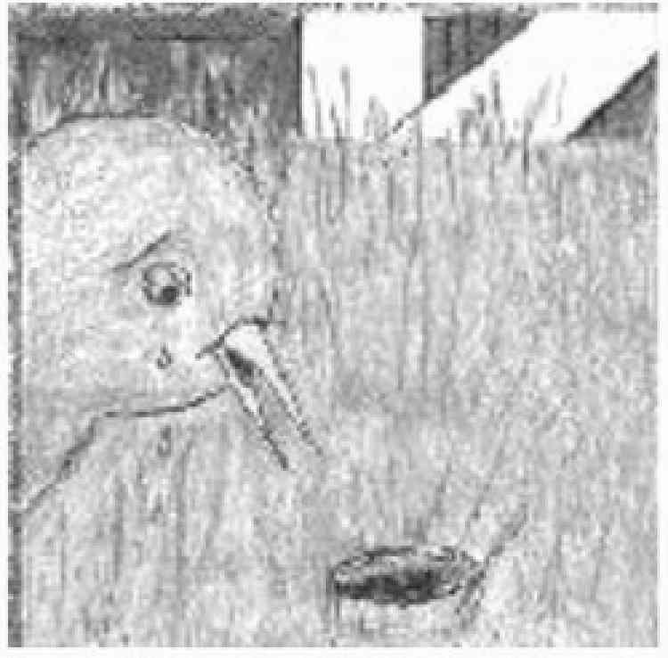 | GP: (in English): I was trying to say that the bird is still hungry. Still.  N: Oh. We would say alsdkfj lkasjdfl pqoieru.  GP: alsdkfj lkasjdfl pqoieru  N: Yes, alsdkfj lkasjdfl pqoieru.  GP: (Talking in the host language now, rather than English): Here the bird hungry. The bird want eat worm. Here worm is going in a hole. The worm is in his hole. The bird is still hungry.  N: Yes. The bird didn’t catch the worm. He will look for another worm.  GP: Right. The bird is still hungry. [Alsdkfj lkasjdfl pqoieru.]  N: Yes. Still hungry [Alsdkfj lkasjdfl].
Such debriefing times might last five minutes.

What sort of details might you come up with?
How much detail should go into the stories that are created? Many picture stories can take many hours to work through in the way just described, spread over several days. How long each will take depends in part on your creativity! Less creative growing participators can compensate simply by use a greater number of picture stories than the more creative ones will have time for.
The following is an example of a somewhat creative interchange:
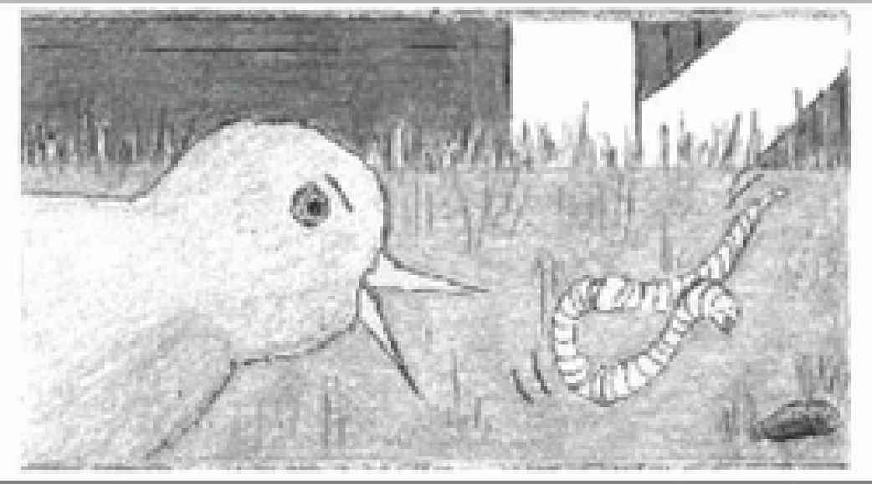 | GP: The bird says to the worm, “Come to me. I am your friend.” The worm says, “You are not my friend. You are my…” (GP looks at N in a way that indicates a need for help from N)  N: Enemy
GP: Enemy. The worm says, “You are not my friend. You are my ene…”
N: Enemy. He is saying, “You are not my friend, you are my enemy”.
GP: You are my enemy.
N: Yes. Enemy.
GP: (gesturing toward N) You are not my enemy. You are my friend.
N and GP: [laughter]
GP: Please write it.
N: [writes enemy in the word log]

There was nothing in the picture that required the GP to say anything about the bird and the worm being friends or enemies, or anything else beyond the most basic details such as 'The bird sees the worm. The worm is going into the ground.' The GP was being creative in coming up with this little dialogue. Such attempts at creativity will make the Story-Building activity more fun and more interactive and hence better for relationship-building between you and your nurturer. They will also result in more interesting stories.

Phase 2A, Session 2
Resources needed - Same as in Session 1.

A. Before Your Session
Listen again to your recordings from the previous session. Look over the next few pages that are coming up in Frog, Where are You? Try to think of many things you might say about each page, but don’t spend time planning specifically how you might say them. You will again be communicating spontaneously, negotiating meanings and using power tools, expressing yourself in your own words.

B. The Session at a Glance
Timing | Activity | Resources Needed
5 to 10 min | Small talk
55 min cycle | Centred around “the monolingual half hour” with a picture story: Steps 1 through 5 | picture story, word log, recording device
Repeat the 55 minute cycle as time allows

C. Detailed Instructions
5 to 10 min | Small talk.
Take time to value your nurturer and build your relationship. Remember that you are limited in what you can communicate at this point, but you can each day learn some new fact about your nurturer and your fellow growing participators, and share a fact about yourself.

Times | Steps | Resources
30 min | Steps 0 and 1, The monolingual half hour with a picture story. | picture story, word log, pencil and paper, a watch, or better yet, a kitchen timer
5 min | Step 2, Debriefing | picture story, any jottings made during Step 1.
10 min | Step 3, Page-by-page recording | picture story, recording device
10 min | Step 4, Listen and point (and act out) and Step 5, Record a brief sample of this | picture story, word log
30 min | Step 1, The monolingual half hour (as time goes on, this step can be lengthened more and more)
 | Etc. (Continue cycling through the five steps.)
Set the timer. For thirty minutes function entirely in your new language.
New Step [Let’s call it Step 0]: Go over the pages of the book that you covered during Session 1, trying to quickly refresh all the things you talked about.
New pages: Open to the first page of the book that you have not yet talked about. Describe everything you can, and find out how to say things that you don’t know how to say. If you did not finish page 4 on Session 1, you can still find ideas above (if you need help) of things to talk about. From page 6 onward, you need to come up with your own ideas.
When you try to get an idea across to your nurturer and fail, do not revert to talking in English or another shared language. Make a note to yourself about the difficulty. This will be used in debriefing. If your nurturer fails to get a point across to you, the same applies. She is to make a note to herself. This will be used in debriefing. Always have your nurturer enter into the word log any new words that you (begin to) learn. This is a continuation of your word log from Phase 1.
Each time you finish a page, if you have not used up your thirty minutes, repeat the above procedure on the next page. Continue to do additional pages until the thirty minutes are over. Use steps 1 to 5 as in Session 1: 1) monolingual 30 minutes; 2) debriefing, 3) recording page by page, 4) listen and point or act out, 5) record again. Until all of your time is up, continue with the monolingual half hours (take a tea break, and give your nurturer a break, when you grow weary!).

ALERT, ALERT, ALERT! There will be a Step 6! (but probably not yet)
Although it is unlikely, you might reach the end of a picture story book during Session 2. In that unlikely event, please see Session 3 instructions for The End of the Book Activity (Step 6).

D. After the Session
As before, your homework is to listen several times to the sound recordings of the descriptions of the pages you talked about today. Also listen to the summary recording of the “listen and point” activity, once again pointing appropriately as you listen. In this way, you will further strengthen the new words before the next session. Listening to former sessions’ recordings again will refresh and strengthen those words as well.

Phase 2A, Session 3
Resources needed - Same as in Session 1.

A. Before Your Session
Listen again to your recordings from the previous session or sessionss. Look over the next few pages that are coming up in your wordless picture story book. Try to think of everything you might say about each page, but don’t spend time planning how you might say it. You will again be communicating spontaneously, negotiating meanings and using power tools.

B. The Session at a Glance
Timing | Activity | Resources Needed
5 to 10 min | Small talk..
55 min cycle | Centred around “the monolingual half hour” with a picture story: Steps 1 through 5 | picture story, word log, recording device
Repeat the 55 minute cycle as time allows

C. Detailed Instructions
5 to 10 min | Small talk.
Find out a new fact about the others; share one about yourself. Other small talk as you are able to conduct it in the host language.
Times | Steps | Resources
30 min | Steps 0 & 1, The monolingual half hour with a picture story. | picture story, word log, pencil and paper, a watch, or better yet, a kitchen timer
5 min | Step 2, Debriefing | picture story, any jottings made during Step 1.
10 min | Step 3, Page-by-page recording | picture story, recording device
10 min | Step 4, Listen and point (and act out) and Step 5, Record a brief sample of this | picture story, word log
30 min | Step 1, The monolingual half hour (as time goes on, this step can be lengthened more and more)
 | Etc. (Continue cycling through the five steps.)
Step 0: Again, go over the pages of your picture story that you did on the previous sessions, trying to quickly refresh all the things you talked about. Then go on to new pages until the thirty minutes is over.
Use Steps 1 to 5 as in Session 1: 1) monolingual half hour, 2) debriefing, 3) recording page by page, 4) listen and point or act out, 5) record again. Until your entire time is up, continue with the monolingual half hours followed by the other steps (take a tea break, and give your nurturer a break, when you grow weary!).

ALERT, ALERT, ALERT! Step 6: End of Book Activity (if you have finished discussing all of the pages in the book)
This final activity related to your picture book will probably not even happen during session 3. Perhaps session 7. Or 10. We include the instructions here in case you finish going through your wordless picture book during Session 3. Save these instructions for whenever you reach the end of the book.

The Point of this Step 6: Hearing the “Story Form”
So far you have been describing the pages of your wordless picture book mainly in the “here-and-now” form (which in English would be present tenses, with lots of progressive forms and use of the verb to be, as in He is smiling; he is sitting on the stool, he is looking at the frog). Now you want to hear the story you have been building in the normal story form (which in English would now include a lot of simple past tense verbs as in He sat down on the stool and smiled. He looked at the frog.).

The Procedure: Step 6A, Careful, highly detailed version of the story (page by page)
1. Explain to your nurturer that you now want to record the whole story in the form of a story.
2. Go over the first page with her, reminding her of all you talked about. Ask her to include as many of those details in the story as possible. For example:
Once upon a time there was a boy and a dog. One evening the moon was shining bright, and so it wasn’t very dark outside. In the boy’s bedroom the boy was sitting on a three-legged stool. His shirt was spread smoothly on the floor… (In normal story-telling, a storyteller would probably not give this much background for each scene, but this is not a normal story!)
3. Now have your nurturer tell the story up to the end of the first page. Record her as she does this.
4. Turn to the second page. Again review all of the detail that was discussed.
5. Record the next portion of the story to the end of the second page.
6. Go to the third page, and continue the above pattern.
Continue page by page, until you have recorded the whole story, in a story form, a page at a time. You now have a continuous recording of the whole story, but it was recorded one page at a time.

Step 6B: Less detailed, more natural, flowing versions of the story (whole book at one go)
1. Let your nurturer listen to the recording of the complete story created in Part A, to refresh her memory.
2. Now ask her to tell the whole story without pausing. She should still watch the pages of the picture story as she tells the story. Tell her not to worry about every detail, but to still include as much as possible. Record this version of the story as well.
3. Now ask her to tell the whole story from memory, not looking at the pictures at all. She will naturally include less of the background details. Record this third version as she tells it.

D. After the Session
You now have much to listen to in the evening. This will be your first heavy exposure to “the past tense”, though you have had a lot of experience with the same verbs in the “here-and-now” forms. Thus the verbs are familiar, but hearing them over and over in “the past tense” is a new experience, which should make a strong impression on you.

Add both Versions of the Full Story to Your Listening Library
You will find profit in listening to them occasionally over the next few years. Label them well. Listen to each one a few times in the days following the session in which it was recorded, and occasionally after that. Your listening library will be useful during long flights (better than airline movies), cross-country motor-trips, holidays at the lake, while relaxing in the bathtub, walking to work, etc. You really can’t listen too much.

Phase 2A: Subsequent Sessions
Timing | Activity | Resources Needed
5 to 10 min | Small talk. | picture story
55 min cycle | Centred around “the monolingual half hour” with a picture story: Steps 1 through 5 | picture story, word log, recording device
Repeat the 55 minute cycle as time allows

Details
Times | Steps | Resources
30 to 90 min | Step 1, The monolingual portion may grow in duration. You may start finding that a half hour goes quickly, and prefer to continue talking freely about successive pages in the picture story book for longer periods than thirty minutes.. | picture story, word log, pencil and paper, a watch, or better yet, a kitchen timer
5 min | Step 2, Debriefing | picture story, any jottings made during Step 1.
10 min or more | Step 3, Page-by-page recording | picture story, recording device
10 min or more | Step 4, Listen and point (and act out) and Step 5, Record a brief sample of this | picture story, word log
30 to 90 min | Step 1, The monolingual half hour (as time goes on, this step can be lengthened more and more)
 | Etc. (Continue cycling through the five steps.)

The general pattern, then, in Phase 2A is as follows:
- Begin each session with 5 to 10 minutes of small talk that you can manage in the host language.
- Next comes Step 0: Using only the host language, go over the pages of the picture story you have worked on during the previous session (or even two previous sessions).
- Go on to new pages, cycling through Steps 1 through 5 (and possibly 6)
  - Spend thirty minutes or more talking about the pictures in the picture story book monolingually, that is, using only the host language (Step 1)
  - Optionally, debrief in English or another language that you and the nurturer already both know well, after each monolingual 30 minutes. (Step 2)
  - Record what you talked about, page-by-page. (Step 3)
  - Listen and point (and act out). (Step 4)
  - Make a brief recording to capture the content of the listen-and-point activity. (Step 5)
  - When you complete a wordless picture story book, record the whole story “in the past tense”. (Step 6).
- During each session of Phase 2A do as many monolingual half hours as you have time for, following the pattern outlined in previous sessions.
- Remember your after-session activities of re-listening to your recordings.

Phase 2B - Shift Perspective, the Nurturer Takes the Lead

(Recommended Goal: 75 Hours in Sessions with Nurturer)
During Phase 2B you will continue with activities centred on wordless picture storybooks. Up to this point, the growing participator has been taking the lead in talking about the pictures. This is to get your tongue loose.
Now that you are talking a lot more freely, it is good to change your approach. You need to be hearing a lot more of what your nurturer would say, because you want to eventually sound like her and other host people. You want to hear and understand the stories more and more from her perspective.
In Phase 2A, you controlled the perspective, which limited the variety of new vocabulary that was used. You weren’t yet ready to follow the stories that the nurturer might tell. However, now you have listened many times to the stories in your listening library, and are gaining greater ability to follow a simple story that has pictures to go along with it. Thus, it is now realistic to let the nurturer take the lead in story building.

Phase 2B, Session 1
Resources needed - as before.

A. Before Your Session
You no longer need to look ahead in the wordless picture story book and think of all the ideas that you may wish to try to get across to the nurturer. In fact, you no longer need to do any preparation before the session, other than to listen well to recordings of recent sessions.
I find that nurturers appreciate the opportunity to look over the picture story in advance. When you are going to start a new picture story in Phase 2B, the nurturer may want to take it home with her the night before, in order to have a chance to look it over. However, she needs to know that it is not her job to plan exactly what she is going to say. She should just figure out what is happening on each page, and come prepared to talk extemporaneously about it.

B. The Session at a Glance
Timing | Activity | Resources Needed
10 min | Small talk
55 min (or more) Cycle | Centred around picture story activity | Wordless picture story, word log, recording device

C. Detailed Instructions
5 to 10 min | Small talk.
If you went directly from the Phase 1 (First 100 Hours) programme into this Phase 2 programme, talking was a much bigger struggle fifty hours ago than now (referring to fifty hours of supercharged participation sessions, not just fifty hours of life in general). It is becoming more realistic to make a bit of small talk about what is going on in life outside of the sessions. Let this component evolve naturally.

Timing | Activity | Resources Needed
10 minutes | Step 1: Nurturer talks freely, describing successive pages in a wordless picture story (one you have not previsously used). | Wordless picture story book, recording device
30 to 80 minutes | Step 2: Monolingually massage the recording (explained below) | Wordless picture story, recording device, word log, pencil and paper (to make any notes for debriefing
5 to 10 minutes | Step 3: Optionally debrief in English (or other shared language)
15 minutes | Step 4: Sound recording for new vocabulary | Word log, wordless picture story, recording device
5 to 10 minutes | Steps 5, 6: Listen and point (or act out) and record a sample of this activity
Repeat cycle as time allows

By Phase 2B, you may feel little need ever to resort to English (or other shared language) during supercharged participation activities. In fact, during this period, you may transition into using only your host language with your nurturer at all times. To the extent that you still feel a lot of need to use English (or other shared language), you need to continue setting the timer for a monolingual half hour or more, and then allowing brief times for debriefing.

Step 1: Nurturer talks about the wordless picture story book.
The nurturer describes the situations and activities that are depicted on the first one or more pages of a new wordless picture storybook. She should point at the parts of the picture that she is describing as she speaks. A recording is made of this. This is similar to what you did in Phase 1A, except that the nurturer is now doing most of the talking, describing what is depicted in each picture fully and naturally. Rather than constantly interrupting and asking for clarification, the growing participators can simply listen to the description. Since they are recording it, they will have the opportunity to discuss it in Step 2.
What if the nurturer makes a mistake in how she understands a picture? Well, first of all, we need to be careful what we consider a mistake. She will describe the picture from the point of view of her experience. It will be her story that you will be trying to understand, not the story that you would have come up with looking at the same pictures. In fact, although you and she are looking at the same physical pictures, you do not see the same story in them. A Kazakh nurturer was talking about a picture in which a police officer was sitting outside a jail reading a book. To me, the police officer was looking at a children’s book. To my Kazakh nurturer, the police officer was reading a law code book. This reflected the social situation in Kazakhstan at a time when there was a huge amount of new legislation, and the police and other officials were spending much time trying to keep up with it. Hopefully, you will often find that you are surprised by what your nurturer sees in the pictures, because you are not just learning her language—you are discovering the world that host people experience, and the ways they talk about about their shared world.
There will be other instances, however, when the nurturer misinterprets a picture so seriously that it will make it difficult to go on in the story. The same man referred to a mouse as a dog. Since this is an interactive activity, the growing participator was able to step in and say, “It isn’t a dog, it’s a mouse.” Occasionally this results in momentary disagreement and discussion, which is good. Keep the interaction as real and lively as possible.

Step 2: Massage the recording
Listen to the sound recording together with the nurturer. Indicate to her when you do not understand something she said. Negotiate the meanings of new words and expressions without reverting to English (or other shared language). Add new words to your word log. This is the process we call massaging the recording. It is a basic technique that will play a major role in the remaining phases of the Six Phase Programme. (For those translating this guide into other languages, you will not usually be able to use a word meaning “massage”. This is a metaphor which works in English, but does not carry over into other languages.)
You will find that massaging the nurturer’s descriptions of the pictures will lead to lots of conversational interaction between you and the nurturer (and other growing participators if a group of you are doing this together). Suppose the nurturer is trying to explain to you a word that means, “in vain”. She might try to define it using words you already know, or give examples of things that someone might do in vain: You swept your floor, and then a bunch of people came in and scattered trash and left. You swept in vain. You told a friend, “Cheer up,” but he remained sad. You spoke to him in vain. Once you think you understand the word, you may want to make up further examples to be certain you do understand it. You can see how reverting to English, and simply translating the word as “in vain” would short-circuit this process. You want to interact a lot, not simply hear quick translations of parts you don’t understand.

Step 3: Debrief (optional).
If you failed to negotiate some meanings of new words and expressions monolingually, then again as in Phase 2A, after each monolingual period (whether thirty minutes or sixty minutes, or whatever time period you will have decided on), you can use English (or any other shared language) for a few minutes to clarify these things. As we noted, the need for this debriefing should altogether vanish by the end of Phase 2, since you are developing the ability to negotiate any meaning in the host language. It may be well on its way to vanishing by Phase 2B. You can try some “monolingual days” in which the entire session is carried on without any use of English (or another shared language besides the language you are learning). If they go smoothly, try a “monolingual week”. Soon you may find that you work as well with a nurturer who knows no English as with one who knows English.

Step 4: Sound Recording of New Vocabulary
The page-by-page recording that was Step 3 in Phase 2A is not necessary in Phase 2B, since it was already done in Step 1 of Phase 2B! However, you can still make a special vocabulary recording which simply highlights the new words.
It is good to have the basic word spoken, followed by a sentence containing it, followed by the basic word again. This will allow for refreshing and strengthening a large number of vocabulary items in a short time, simply by listening attentively to these recordings.
Suppose the new word is the verb churn. The nurturer would record a sentence such as the following, with the word churn preceding and trailing:
“Churn. The woman is churning the butter. Churn.”
If it were the noun churn, she might record a sentence such as the following, with the word “churn” preceding and trailing.
“Churn. The woman is using a churn to make butter. Churn.”
Note how the context provided by the sentence contains a strong reminder of the meaning of the word churn, so that if you didn’t remember the meaning of churn at first, you would remember it as soon as you hear the sentence. By way of contrast, the following example would not provide a helpful context for remembering the meaning of churn:
“Churn. I don’t have a churn. Churn.”
That is because the sentence in no way helps you to remember what a churn is. If you make such vocabulary recordings, help your nurturer to understand how to create context sentences that clarify the meaning of each new word.

Steps 5 and 6: Listen and Point (and Act Out), Then Record
It is also still advisable to use special activities to strengthen new words that you have encountered, such as the listen-and-point activity described under Phase 2A.

Alert, alert, alert! There will be a Step 7
Once the nurturer has described all of the pages, she will tell the whole story, “in the past tense.” It may take two or three sessions or more to reach that point

D. After the Session
Listen well to the recordings.

Phase 2B, Session 2, 3, etc.
You can begin by going over what you talked about in the previous session, attempting to tell the nurturer as much of it as you can, and getting her to help you recall things as needed (which will be a lot). Then go on with the story from where you left off, following the Phase 2B, Session 1 outline.
You can enrich your growing participation sessions at this stage with other activities, such as those described below in the section “Additional Supercharged Participation Activities for Phase 2”. Also, your ability to make small talk should keep inching forward. This is important to your deepening relationship with your nurture (and with other host people).

Alert! Don't Forget Step 7 when You Reach the End of the Picture Book.
Each time you reach the end of a story, have the nurturer tell the whole story from beginning to end. She can do this creating the same three versions of the story as described under Phase 2A.

Phase 2B, Perhaps Session 5 (or 10 or 15...)
Jumping ahead a bit, the time may soon come when the page-by-page descriptions of the situations and activities are getting highly redundant. That is, most of what the nurturer would describe is similar to what has already been described in earlier picture story books: “These are trees. There is a bird in this tree.” Etc., etc. What will be wholly new will be the plot of the story that is depicted. At this point you can move to the following format for language sessions:

A. Before Your Session
As you may have been doing already, let the nurturer take the picture book home each day to reflect on it before the next day’s sessions. Emphasise to her that she is not to plan in detail what she will be saying—it is to be spontaneous, natural interaction. However, she can make sure she understands all of the pictures.

B. The Session at a Glance
Timing | Activity | Resources Needed
5 to 10 min | Small talk.
50 to 110 minute cycle | Picture story activity, cycling through the steps. | picture story, recording device, word log

C. Detailed Instructions
Timing | Activity | Resources Needed
10 min or more | Step 1: The nurturer tells the story “in the past tense” as you follow the pictures. You record this as she talks. | picture story, recording device
30 to 70 min | Step 2: Massage the story that she told. | recording; picture story; word log
15 minutes | Step 3: Make a vocabulary recording | word log, recording device
10 minutes | Step 4 and 5: Listen and point (and act out), then record a sample of this | picture story, word log, recording device
Repeat cycle as time allows

1. Small talk
Bit by bit, your ability to interact and strengthen this relationship is increasing.

2. Monolingual Half Hour (or more)- Start with the Whole Story
The nurturer now begins by telling you the whole story. In Phase 2A, this was the “End of the Book Activity”, Step 6A. At the beginning of Phase 2B, it was Step 7, and still the “End of the Book Activity”. Now it becomes Step 1. The nurturer will at once simply tell the story, picture by picture, without pausing. You will record this.

3. Monolingual Half Hour , Continued- Massage the Story
Then you massage the recorded story in the usual way: Listen to the recording together with the nurturer. Point out to her anything she said that that you cannot understand. Negotiate the meanings of unknown words and expressions—don’t revert to English (or any other shared language besides the host language that you are learning). Add all new words to your word log.

4. Vocabulary recording
Then you can make a special vocabulary recording as earlier, and strengthen new vocabulary with the listen and point activity, or simply by discussing each new word again.

D. After the Session
As before.

Phase 2C - Telling Stories from Life with Simple Pictures

(Recommended Goal: 25 Hours in Sessions with Nurturer)
Now you will develop your communication skills and deepen your relationship with your nurturer, as you make your own picture story, using stick figures (or triangle people as described in The First 100 Hours). You can tell the basic outline of your own life story from birth to the present time, or your nurturer can tell hers. You can also tell the story of some portion of your life, or events in your life that are especially entertaining, or that are especially important for understanding the person you are today. As you and your nurturer come to know more about each other’s lives, it will take your relationships to new depths.
NOTE: If you attempt this activity and find it too difficult to carry out at this time, it would be better to postpone it until later, perhaps during Phase 3. In that case, simply continue with Phase 2B activities for another twenty-five hours.
Timing | Activity | Resources Needed
5 to 10 min | Small talk.
55 to 110 min cycle | Centred around “the monolingual half hour” with a picture story: Steps 1 through 5 | picture story, word log, recording device
Repeat the 55 minute cycle as time allows

Timing | Activity | Resources Needed
30 to 70 min or more | Step 1: The growing participator tells a story from his or her life, drawing key characters as they are introduced, and other pictures to symbolise key components of the story. Since this is tied to pictures, much of it may be “in the present tense”. | Pencil and paper
10 min | Step 2: Once the entire story has been told, the nurturer relies on the drawings to retell the story naturally “in the past tense” and you record this. | Drawing, Recording device
15 minutes | Step 3: Make a vocabulary recording. | word log, recording device
10 minutes | Step 4 and 5: Listen and point (and act out), then record a sample of this. | word log, recording device
Repeat cycle as time allows

Option One: Draw As You Go
You can draw the pictures as you talk, or you can prepare them in advance. The following picture is one I drew as I interacted with my nurturer, building the story of how my parents became acquainted. Although the pictures will not be self-explanatory for you, they contained adequate information to enable my nurturer to remember many details of the story, and tell a very good version of it afterward.
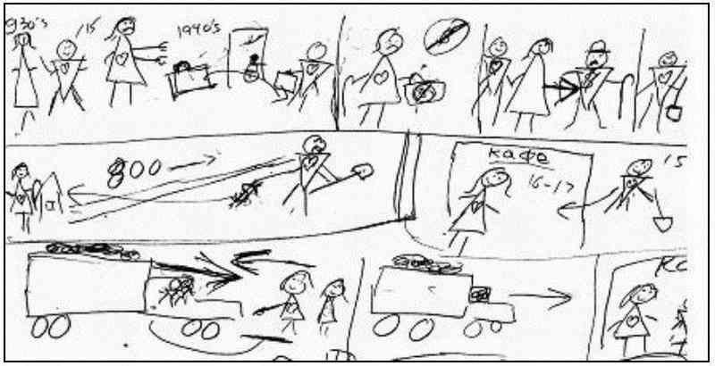

The story begins in the 1930s when my grandmother put my grandfather’s suitcase on the front porch and locked the door, indicating that he no longer lived there. When my father was about fifteen, my grandmother was very poor, but her daughter married a rich man, who gave my father a job in Nevada. Thus, he was working about 800 kilometres from home, sending money home to his mother. My mother at the time was sixteen or seventeen and working in a café. And on it goes…
Step 1
You can imagine how I drew bits of the picture as I added bits of the story:
Growing Participator:
This is my father. He had several brothers and sisters. This is his older sister. He was a child in the 1930s. Life was very difficult. This is his mother. My grandfather was unkind. He drank a lot. One day, in the 1940s, my grandfather came home. His suitcase was outside the door of his house. The door was locked. My grandma would not let him in. He took his suitcase and left. He didn’t live with my grandmother after that. Then my grandmother had no money. My father’s older sister married a rich man. My father went to work for him. Etc., etc.
(This example is a bit misleading. There was lots of struggling, negotiation of meaning and vocabulary learning.)
Note that only key details are depicted in the pictures. These were enough to enable the nurturer to recall and tell the entire story.
Step 2
After the growing participator has struggled to convey the entire story to the nurturer, with lots of help from the nurturer, the nurturer tells the whole story freely from start to finish, pointing to relevant parts of the drawing as she speaks. This is recorded. It can even be captured on video.
After the session
The nurturer’s clear, natural retelling of your stories will be a great addition to your listening library. Listen to them a few times in the days following the session in which they are recorded and occasionally thereafter.

Option Two: Prepare in Advance
Angela Thomson preferred to prepare the following picture story in advance of the session, depicting how her parents met. This had the advantage that her discussion of the story was not interrupted by having to draw as she talked. (Note the use of triangle people.)
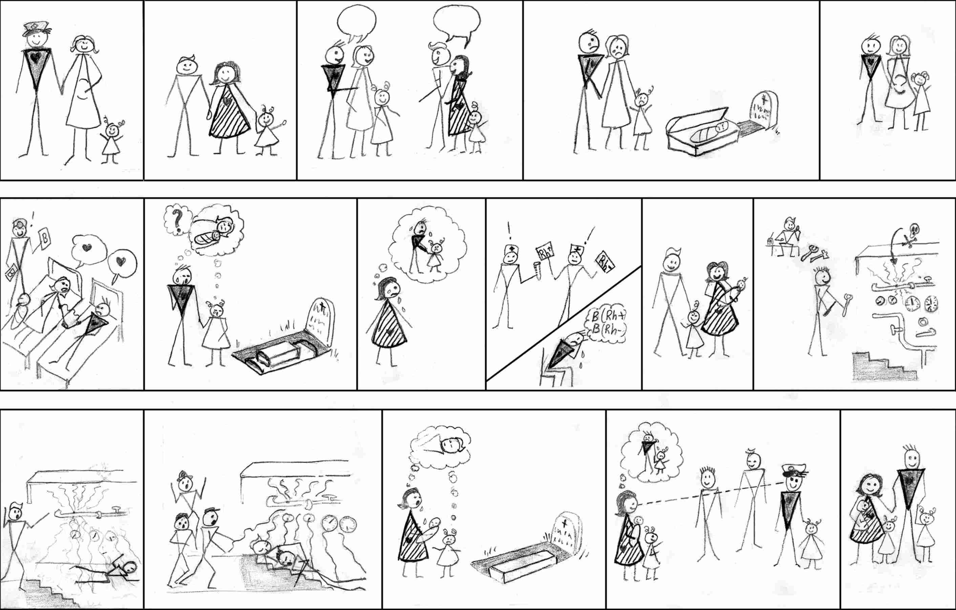

Stories from the Nurturer’s Life, Also
After the nurturer has seen you draw pictures depicting parts of your own life, she can attempt to share her own life in the same way. The drawings can be done interactively, with you helping the nurturer with her drawings. The very activity of drawing helps to slow down the story, letting it grow bit by bit, and keeping it understandable to you. Obviously, this activity helps to further strengthen your relationship with your nurturer, as she shares her own life with you.

Option Three: All-in-One Picture
A nurturer made the following drawing. It shows the layout of his childhood home and the surrounding grounds. He used it extensively then in subsequently telling of events that occurred in that setting.
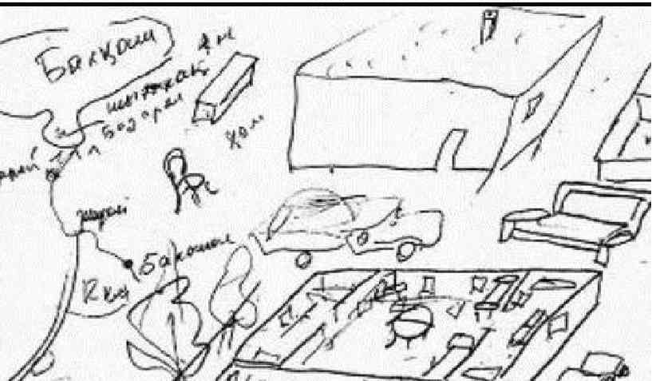

Phase 2C: Improving your Ability to Converse
Your basic communication ability will have grown considerably since the beginning of Phase 2 (particularly if you went directly from the First 100 Hours programme into Phase 2). It is time to think about more than getting your point expressed. You can be thinking about interacting more and more naturally in conversation with your nurturer.
- Have your nurturer and another host person interact over a wordless picture story, so you see a 'native' model of how to interact.
- You and your nurturer can agree to build some stories together using wordless picture story books, each contributing to the story in a balanced, natural conversational manner.
When you are observing two host people interact, pay attention to how the listener reacts to the speaker: How much eye contact is there? What does the listener say while the speaker is talking? What nonverbal reactions to you see (such as nodding heads or facial expressions)? Does the listener ever start talking at length without waiting for the speaker to finish their sentence? Or are there long silences before a listener and speaker trades roles (the listener becoming the speaker, and the speaker becoming the listener)?
You don’t want to make great generalisations based on observing a single pair of host people interacting, but this experience can help you to start paying more attention to how host people converse.

About Grammar Learning in the Midst of Story-Building
Not all growing participators love to talk about grammar. Many, in fact, find this difficult and discouraging. In The First 100 Hours programme, someone who enjoys grammar can design the special grammar activities used there, and others can have fun learning grammar without even knowing it. The present section is really included for those who like to talk about grammar. Much of the grammatical learning that I am talking about will probably happen whether you understand this discussion easily or not, and so don’t let it discourage you if the discussion seems complicated.
After Phase 1, moving to each new phase or sub-phase can suddenly make you become aware of new grammatical forms. For example, in Phase 2A, Step 6, when you hear the stories in their entirety while readily following their meaning, there will be a clear step forward in your experience of the host language. By the time the story is told in Step 6, almost all of the vocabulary in the story will be quite familiar from the previous discussions of the individual pages and other activities. In fact, most of the vocabulary will be extremely familiar by that point, from having been repeated a few times in different contexts and strengthened when you listened to in the vocabulary recordings. During the earlier steps of Phase 2A, you built up a little story world, based on what is depicted on each page of the picture book, and the meanings you negotiated. Then in Step 6, this little story world is recast into a complete, connected story “in the past tense”. At that point you may find that many new grammatical features belonging to stories will stand out in stark relief from the already familiar vocabulary and phraseology that you experienced in your here-and-now discussions of each individual picture. Your brain is not having to juggle the myriad details of the words and expressions, and can therefore tune in to these different aspects of the language.
In one case, some growing participators had talked many times (in Russian) with the nurturer about a little bear coming up to a tree and coming up to a flower. Every time the verb was podkhodit, ‘(he) is coming up to’. The prefix pod- carries the idea of “up to”, and the stem is khodi- “go/come”. When the story was finally told in narrative form, suddenly there was a verb podoshol, ‘(he) came to’. The verb (ignoring the prefix) suddenly changed from khodit to shol. You can imagine how this new verb form, “the story event form” of the verb meaning “go”, hit the learners like a flying brick! Where did that come from?! Someone learning English this way would have a similar reaction when creating a story. The previously familiar 'is going… is going… is going” (in the “here-and-now” form) suddenly becomes 'went' (in the story event form). Where did that come from?!
This new verb form especially stood out because it was surrounded by the familiar elements of the story. This illustrates a natural progression from familiarity with the verb forms needed to describe what is going on in each picture (“here-and-now forms,” such as is going, is kicking) to the forms of the same verbs to relate the events in a story (the “story event forms,” such as went, kicked). The “story event forms” of verbs will start to pile up quickly in your experience, always (or at least, usually) related to already well-known “here-and-now” forms of the same verbs.
This in turn illustrates a principle that moving from one phase or sub-phase to the next by using appropriate learning activities can make certain grammar forms suddenly much more salient. This is an advantage of the phased approach to supercharged participation activities. The progression of phases is not arbitrary, but principled!

Looking Ahead to Phase 3
- Getting out and about: In Phase 3, you will be listening to descriptions of common everyday activities that you have frequently experienced. Therefore, the more you are out and about, experiencing everyday activities in Phase 2, the more ready you will be for that activity of Phase 3 (Scripts of Life).

- Becoming familiar with some well-known host stories (through translations): Late in Phase 3, you may listen to stories that are well known in the host world, and that you have first become familiar with by listening to them many times in English, or another language that you know. Thus when you listen to them in the host language in late Phase 3, the overall plot and many details will already be familiar to you, making them “shared stories”. In preparation for this, during Phase 2 you may wish to be recording such stories in English (or some other language that you already know reasonably well), and listening to them occasionally, so that by the time you are in late Phase 3, they will be highly familiar to you.

Additional Supercharged Participation Activities for Phase 2
For an occasional change of pace, to increase variety and enrich communication, here are some other activities you can intersperse in your story building activities.

Lexicarry
Try to tell your nurturer what is happening in each story strip of Lexicarry. (Lexicarry: Pictures for Learning Languages, 2nd edition, by Patrick R. Moran. Battleboro, Vermont: Pro Lingua Associates, 1990) This is really just story building using Lexicarry. During Phase 1 you learned to understand expressions that might be used in the situations depicted in Lexicarry. The activity suggested here gives you a chance to move more of those expressions and vocabulary from the level of comprehension-only to using them in your own speech, and hearing them embedded in little stories that you can understand.

Picture Strips and Acting Out Activities
Try using simple wordless cartoon strips such as those in Action English Pictures (by Noriko Takahasi and Maxine Frauman-Prickel. Englewood Cliffs, NJ: Prentice Hall, 1985.) You also could act out activities and have your nurturer talk about what you are doing. These would depict common everyday activities, such as the steps in brushing your teeth. In Phase 3, there will be an activity (mentioned above in the section “Getting Ready for Phase 3”) called “Scripts of Life” in which the nurturer might spend ten minutes explaining in minute detail how to brush your teeth. In Phase two, a picture strip depicting the steps in the process of brushing your teeth would involve much less detail—perhaps totalling less than a minute of recorded talking.

Role-Plays
Continue doing occasional role-plays of real life communication situations as in Phase 1. You can role-play any activity in which you participate in everyday life in your host community: Shopping, using a taxi, paying your phone bill, etc.

Grammar and Phonetic Awareness
Repeat many of the grammar awareness activities from Phase 1, and the phonetic discrimination activities for sound distinctions that you still have difficulty hearing.

Busy Pictures
Describe busy pictures to add exposure to more vocabulary, if you are not adding enough words to your iceberg in your sessions. Busy pictures are pictures in which a large number of people or animals are involved in a large number of actions or situations. Busy books are collections of busy pictures. An example is The Big Book of Things to Spot (1001 Things to Spot), by Ruth Brocklehurst, Gillian Dogerty, Anna Milbourne, and Teri Gower. Tulsa, Okla.: Educational Development Corporation, 2003.

A Word Log Idea
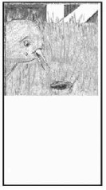 | A great way to do your word logs for Phase 2 is to “key” your stories to your word log. Make photocopies of a wordless book page with the picture on half the page and the rest of the page blank. Your nurturer can write new words encountered on that page of the story in the blank space under the photocopied picture.
Some growing participators have scanned or photocopied their favourite wordless books so they can produce word logs which include four pictures per page surrounded by blank space. Note this example from a wordless book reproduced with wide white spaces for new words to be noted down next to their related pages. |  | 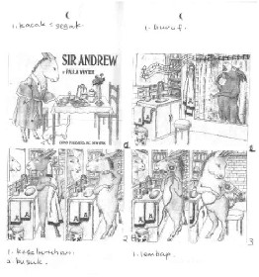

Story-building forever!
As we progress in language ability, if there are ever times when we feel the need to force ourselves to talk a lot more, and to talk in ways that go beyond the kinds of things we always talk about with acquaintances, story-building activities can be a good tool to help us to stretch ourselves into new areas of conversation.
Even after we are in Phase 3, 4, 5 or 6, there may be times that we wish to return to story building activities. They are profitable in different ways as our ability increases, but always profitable.
The Phase 2A activities are also always useful for orienting a new nurturer to her role in supporting growing participators as they struggle to communicate. Phase 2B activities can be used to orient a nurturer to the process of massaging recordings.
From time to time, you can reuse picture stories that you used months earlier, functioning at a new level of ability, and growing further still in the process.

Conclusion
I trust that the detailed, step-by-step approach to story-building that we have provided above will enable more people to profit from story-building activities. For Phase 1 (in The First 100 Hours programme) we provided about ninety pages of detailed instructions for a variety of growing participation activities to occupy you for one hundred hours. Now, for an additional one hundred fifty hours, we give you about thirty pages. This decrease in the guidance we provide reflects your growing capabilities, as well as the changing nature of the activities. You exercise a more and more control over your own growth activities as you become more and more flexible.
You aren’t yet to the point of sitting around with lots of people having lots of conversations on lots of topics, but it won’t be long until you reach that stage. It will come sometime during Phase 3, the next 250 hours.

Appendices

Appendix 1: Is this the right Phase for me?

Prerequisites For Starting Phase 2
Normally you will enter Phase 2 having completed Phase 1, the First 100 hours of the Six Phase Programme. Having done that, you would have finished gaining the abilities listed below.
- Very minimal ability to negotiate meanings. To negotiate meaning means to get your point across to your nurturer, with lots of effort, and with co-operation, help and patience from her. It also means understanding the point the nurturer is trying to get across, if she puts special effort into making her meaning clear to you.
- Familiarity with between 500 and 1,000 vocabulary items
- Familiarity with language needed to talk about the “here-and-now.” This includes familiarity with language such as:
  - “I, we, you, s/he, they etc.” as subject, object, possessor, etc.
  - names for basic objects, actions and properties, animals, and humans
  - properties of these: size, shape, emotions, etc.
  - spatial-locational descriptions (in the box, under the table, etc.)
  - terms for human relationships (such as kinship terms) and perhaps some roles (such as shopkeeper)
- Some familiarity with simple sentence forms that enable you to
  - make statements
  - ask questions
  - describe situations that are in view
  - give instructions
- Ability to use “power tools” (language that helps you learn more language), such as:
  - “Please repeat.”
  - “Please speak more slowly.”
  - “Please speak more clearly.”
  - “What is this called?”
  - “What am I doing?” (asked while acting out an action)
  - “What is he doing?”
  - “What kind of X is this?”

Where You're Headed Over the Early Months of Growing Participation
One crucial assumption underlying the Growing Participator Approach is that growth in your ability to communicate, and growth in the depth of your relationships should be viewed as two aspects of the same growth process.

The broad progression of growth in relationships:
From a shallow relationship with your nurturer
…to a deeper relationship with her and shallow relationships with a few other people
…to deep relationships with a number of people and shallow relationships with many people.

The broad progression of growth in communication ability:
From here-and-now language
…to simple story language
…to complex story language, explanatory language and more.

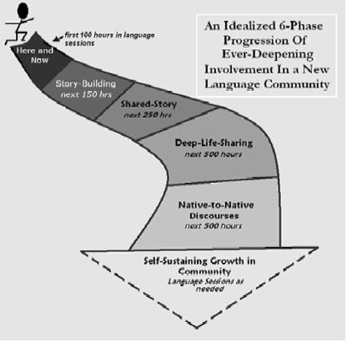

The progression of communication ability and relationships in more detail:
Starting from the very beginning of your entry into the new culture, while you have as yet no ability to participate in the life of the host speech community, your ability to communicate and participate can develop in a rational sequence such as the following:
You can grow…
…from the ability to understand speech about the “here and now” (when you can see or participate in what your nurturer is talking about) (Phase 1)
→ to the ability to talk a lot about the here and now (Phase 1 and especially Phase 2)
→ to the ability to understand simple connected stories that you have built together with your nurturer, and begin getting to know the basic outline of her life story and share your own (Phase 2)
→ to the ability to produce simple stories and carry on simple conversations on a narrow range of topics and possibly start a few shallow relationships in addition to your relationship with your nurturer (Phase 2 and especially Phase 3)
→ to the ability to understand simple verbal explanations of unknown words and ideas, and to develop rich relationships with a number of host people and start going deep in your relationship with your nurturer (Phase 3)
→ to the ability to understand complex stories (etc.) with familiar plots (Phase 3)
→ and to carry on simple conversations on a wide range of topics and provide simple verbal explanations (Phase 3 and especially Phase 4)
→ to the ability to understand deep, complex explanations of the culture, going very deep in several relationships and readily forming new relationships (Phase 4)
→ to the ability to tell detailed stories, and provide verbal explanations of moderately abstract ideas, and to form new relationships quite readily (Phase 4)
→ to the ability to understand almost everything a host person might normally say to another host person, to tell rich, textured stories, and begin to be accepted as a legitimate participant in host social groups (Phases 5 and 6)

How Far Might You Grow During Phase 2 Specifically?
Phase 2 will involve you in the first few levels of the above sequence. By the end of Phase 2 you should have changed in ways such as the following:

Relationally…
You will have greatly increased your ability to “negotiate meanings” (explained above), but will not yet have reached the point of having conversations on many topics. Thus, you will have significantly increased the extent that you can talk and interact freely, while still being limited in the range of topics you can enter into conversations about.
This means that your relationships cannot generally go deep yet, but you may be able to put increasing effort into establishing relationships and seeing how far you can take them. You are not yet under pressure to do this, however. That comes in Phase 3.
You may reach the point where you find it profitable to live with a host family, if you can find a family who will be specially committed to “negotiating meanings” with you (as defined above).
Your relationship with your main nurturer (language helper) will have deepened considerably because you will have learned much about one another’s lives. (This refers to your relationship with her in her world, not in yours. That is, it is not a goal to grow close together through extensive socializing in your mother tongue or a trade language.)

Mental language processes…
You will have greatly increased in your ability to talk about the “here and now”, about things that you see going on before your eyes, including things going on in pictures.
You will have become familiar with over a thousand additional vocabulary items. (Aim to become acquainted with seven or eight new words per hour of session, on average.)
You will be using increasingly complex sentences in your own everyday speech.
You will be starting to understand long, connected stories that you have built up with your nurturer.
You will be starting to understand explanations that your nurturer provides, if she keeps it simple, and you can negotiate the meanings.
When you hear natives talking to one another without regard to your need to understand, you will still understand relatively little.

Language learning abilities…
You will be much less dependent on guidance from others in your language learning activities than you were in Phase 1.

How Much Guidance Do You Need?
If you have completed Phase 1, the First 100 Hours (also referred to as “The Here-and-Now Phase”) you may have appreciated the fact that you were given detailed instructions for designing supercharged participation sessions. In this phase you will need to become comfortable with less specific plans, gaining confidence in your interactions with people.
Clearly, this is a challenge for some growing participators. They wish to be certain about how to say whatever they are going to say before they say it. They want to be able to learn specifically everything they will ever need to say! “At least” they want to have total understanding of “the grammar” so that they can be confident that they are never making any mistakes. Well, communication just doesn’t work the way they wish it would. Real communication is full of uncertainties, risks and mistakes.

Appendix 2: Story Building Without Wordless Books
Sarah Janek provided us with the following suggestions for using Cuisenaire rods. We feel this technique is also well suited to the Story-Building Phase. What she describes is a lesson in English as a Second Language, with a native English user as teacher. We’ll consider how to adapt this for our purposes. (Elaine Thiessen demonstrated a similar activity using small objects or small toys.)

Using Cuisenaire Rods to Tell a Story
by Sarah Janek

Introduction to cuisenaire rods
These are small blocks of wood (or plastic) of varying lengths & each length has a different colour. Originally invented by Georges Cuisenaire, who was a Belgian primary school teacher, for the teaching of mathematics in 1952. (they can easily be made in many places)
theme: Telling about your childhood home (adaptable to any story)
Level: upper intermediate (adaptable to all levels)
time: 60-75 minutes
lesson objective: listening and speaking skills. Learning how to tell stories about your past.
introduction:
5 -10min Tell your students the story of your childhood home, building with the blocks a representation of each part as you describe. (Go slow and be sure to do lots of vocab concept checking)

When I was a child…we had a one-story house. We had a garage connected to our house. Inside the garage, my dad had a red truck and my mom had a gray car. We didn’t live in a city, town, or village. We lived in the country 10 miles outside the nearest village. There was a long, winding road to our house from the main road. About 200 meters from our house was my grandmother’s house. She lived by herself (alone) in a two-story house. In between our house there was a wire-fenced pen where bulls stayed. To visit my grandmother, I had to crawl through the wire fence and sneak past the bulls. They were dangerous, but they never chased me. We had a chicken house and inside were 50 chickens. It was my job to take care of the chickens. We raised chickens for the meat not for the eggs. The most common type of chicken for meat is called a Broiler. They grow to 3 kilo’s in six weeks and then stop growing. Our birds were very lazy and liked to sleep, but we wanted them to eat so that they would gain the most weight. It was my job to scare them from sleeping and keep them interested in eating their feed. Behind our house there were woods. Usually at sunset we would see the deer come from the woods up to our yard. They liked to sleep in the grass near our house. We used to feed the deer corn. Sometimes my brother would shoot a deer with his gun and we would eat the meat.

Inside our yard, there was a tall tree with a rope tied to the top branch. My dad had climbed up to the top of the tree and tied a rope for us so that we could swing from it. Next to the tree was a tall building that we liked to call our fort because we used it to hide and play in. We would climb a ladder to the roof of the fort and jump off of the roof with the rope. We always leaned out from the roof carefully and swung in between the tree and the building so that we wouldn’t hit anything when we swung back and forth on the rope. One time while guests were visiting, they asked us, “Who taught you to swing from the roof like that?” Then my Dad walked up and said, “I did, would you like to try?” We swung from the roof of the fort many times and never broke any bones.

activity: test listening and highlight grammar/vocab (Controlled Practice)
5-10 min call on students to retell the story by pointing to each block and asking them to tell you what it is. (this is helpful to mention this step before telling the story. nonetheless, motivation to listen well is incredibly high, and even the weakest students feel comfortable retelling)
- write on the board the new vocabulary words you introduced and concept checked and the grammatical form you want them to practice in the next steps.
- story uses past tense, comparative and superlative forms, adjectives, negatives
- would/used to + infinitive is the primary focus for grammar
ask students to tell me what I used to do (write this form on the board)
activity: culture comparison!!! (Freer Practice)
10-20 min Discuss in groups of three what differences you see in my childhood home and yours. report to the group three cultural differences you notice and culture questions you want to ask. (possible points to make: grandmother living alone, distance between houses, outside a village, type of fence, no neighbors)
- practice of question forms
- write on board language items they bring up
activity: Tell your story (Freer Practice)
10-20 min in groups of three take turns telling the story of your childhood home using the rods to explain as you tell. Then have one member of the group explain what the rods represent as the teacher goes around to listen to their explainations. Rotate until each student has told their story, and explained classmate’s story to the teacher.
homework:
10 min - (In the next lesson you will want to review your story again, this time asking them to draw a picture of what they see as you tell the story again with the blocks. Have students compare pictures to check/review indiv. comprehension. After they turn in their “picture quizzes” then hand out an accurate picture describing the scene from your story – doesn’t have to be good.)
- Ask them to write a story using this form for the next class.
- Give them a written form of your story, and ask them to circle the verb form you are practicing (used to/would).
- for the next lesson, take the words you heard them using in their own stories and prepare corrections and other vocab to build on what you heard them use.
- next lesson, turn in written form of second story, pair students and have them tell their story to each other. then the whole class listens as each pair explains the other’s story to the class.
notes:
I was completely surprised at the level of excitement over this exercise. I was pleased at how much speaking was going on all at one time. They were content telling each other about it as I went around to listen to each group. Any story can be told with these blocks and solicited back from the students to teach vocabulary in story context. But that’s just the beginning…storytelling is only one of many uses of the rods I was taught in my four week training course.

Adapting This Technique for Phase 2 Story-Building
Let’s use the example of the familiar children’s story about the Little Red Hen (familiar to many Anglophone children). We might begin by talking in the here-and-now mode with some small objects, designating one small object to be a chicken, one to be a cat, one a goose and one a rat. One by one, we pick up each object and identify which character we are using it for:
This is a little red hen.
This is a cat.
This is a goose.
This is a rat.
This is some wheat.
The little red hen is walking.
She sees the wheat. [You may need to negotiate meaning with the nurturer to come up with the word for wheat. The same applies to “plant” in the following sentence.]
“Who will help me plant the wheat?” [Hold the object that represents the hen, while saying this. Then successively hold the cat, the goose and the rat as you say the following.]
“Not I,” said the cat.
“Not I,” said the goose.
“Not I,” said the rat.
“Then I will plant the wheat myself,” said the little read hen.
The hen planted the wheat [Act this out].
In this way, the parts of a story are put together. The first time, there might be a lot of struggling and negotiating meaning and form. The story can be repeated more smoothly with the same nurturer, or with additional host people. Finally, the host person tells the entire story in a normal story form.
Such an activity might work in a host group where books in general are unfamiliar, or where available wordless story books are too far removed from everyday experience to be useful. Instead of Cuisenaire rods, natural objects—sticks, stones, leaves, seeds, pieces of fruit, etc. might by used. Instead of the Little Red Hen, stories can be build that make sense within the local setting. A rock might be used for a sheep, a fat stick for a canoe, and so on.

Appendix 3: Some Challenges of Story-Building Activities
This section is especially addressed to language learning advisors attempting to help nurturers use the ideas in this article. I acknowledge the significant contribution of Madeline Ehrman's research in her book, Understanding Second Language Learning Difficulties (Ehrman, 1996).
Besides language learning advisors, struggling nurturers may themselves appreciate these thoughts, which may give them insight into some of their frustrations.
In this section, I will return to some traditional terminology such as “learner,” “teacher” and “language learning” because I am addressing the needs of some “language teachers” who, for one reason or another, are not “nurturers.”

Challenges
Availability of Resources and Viability of Picture Stories: One simple problem is that wordless picture books aren’t readily available in most parts of the world, and it may take time to collect several of them. Also, the available picture stories tend to involve Northern World situations. For other parts of the world it may be necessary to create picture stories more appropriate to the regions. In the section above on adaptive the Cuisenaire rod technique we talked of story building activities that use small objects rather than pictures to build stories. These might be useful in people groups where reading and writing are not practiced. However, we should also consider introducing picture stories (especially new ones that we create especially for that group) as a valuable means of raising awareness about books and literacy. Picture stories can then help growing participators grow even as they create literacy awareness among the host people.
The Nature of Communicative Activities: Other problems will come from the nature of communicative language learning activities. Communicative activities are ones that require genuine communication. Fortunately for many nurturers, and learners, communicative techniques are fun and rewarding (most of the time!). But for some, they provoke strongly uncomfortable reactions. It is important to address some concerns which may be encountered in any phase, and which relate to communicative language learning activities in general. Because Phase 1 provided much more constrained (and thus, predictable, and 'safe') conditions for speaking, sometimes these concerns become more pronounced when the learner enters Phase 2.
Frustrations in Making New Relationships: Some problems I discuss here may not simply be problems with communicative techniques. They may rather signal more basic problems linked with the need to become involved in relationships in a new language. In some cases, it may help learners to postpone communication for awhile in order to gain more confidence. This can’t be postponed forever, though! Perhaps it is better to take the plunge, but debrief often with a language learning advisor, so that frustrations don’t become overwhelming.
Introverts: Turning to more personal issues, highly introverted learners may prefer to view language as primarily something cognitive, rather than as participation in life with people. It is crucial to encourage such people to recognize the problems that their personality may raise for them as language learners! They may need extra courage and encouragement. They may find hope in realizing that even developing a small number of secure and comfortable relationships can lead to healthy growth.
Extraverts: A warning is in place for extraverts as well—their drive to have relationships may lead them to find host friends who know another language that they already know, such as English, rather than building relationships in the host language.
Visual Learners: Some people consider themselves extreme “visual learners.” They may say that they “need to see everything in writing in order to learn anything,” or “I can’t remember anything unless I write it down.” These people may have trouble accepting the focus in these supercharged participation activities of listening and interaction. They may have trouble even accepting the goal of 'growing participation.' Additional activities in this phase that may encourage them (allow them to also use their preferences) would include: adding on (not substituting) having host people write down the stories they have built and recorded, and then during review time, read those stories as an additional kind of input and reinforcement. However, they shouldn’t lull themselves into thinking that they can develop adequate listening comprehension ability by reading.
Concrete Learners: Some people might thrive on the concreteness of the pictures during this phase. However, they may want shape their learning goals by what they feel is immediately “useful” to them. For example, they want to learn things that they will need to say often in various contexts. In many cases, when it is explained, concrete learners can recognize the value of more broad-based learning.
Need for Structure: Other learners may feel a strong need for a clear advance-plan of the specific details of what they are going to learn, word-by-word, structure-by-structure. The idea of letting the learning arise out of unplanned, free interaction during Story-Building activities may frustrate them greatly. The idea of communicating in a sink-or-swim spirit (with a caring nurturer making sure that they swim!), struggling to make sentences up “on the fly” and “by the seat of the pants” may cause a lot of anxiety to such learners. Sooner or later, though—hopefully sooner—they will need to start getting more courage to make things up “on the fly”. It is easier to do that in a supercharged participation session then many other host social situations, and picture stories provide a lot to talk about without having to wrack one’s brain about what to mention next.
Loss of Previous Identity: Growing participation involves the loss of one’s previous roles and identities. You must invest patience and effort as you slowly develop new roles and identities in the new language community. This affects most people very deeply. For some, the idea of talking about children’s picture stories might be the last straw! They want to talk about adult themes that reinforce their adult identities. If such people can learn to appreciate the fact that growing into adulthood may work better than trying to start out full-grown, they may be able to deal with this issue.
Tolerance for Ambiguity: One aspect of Phase 2 may be pleasing to some learners who experienced frustration in Phase 1. In Phase 1, there was an emphasis on not getting hung up on all the details of the speech that one was hearing in the supercharged participation activities. This may have been frustrating for nurturers with a “low tolerance for ambiguity”, because they feel that any details they do not understand are a major problem.
In Phase 2, there is much more opportunity to talk about the details in the host language. Still, there are many details of a language that will be too complex to fully understand, and it may still be necessary for puzzled language learners to tell themselves, “I’m just not getting it right now—let’s leave it and come back to it in a few months!”

In Summary
Fortunately, many language learners can readily adapt to Story-Building activities and grow significantly and steadily by making them a major part of their supercharged participation sessions for a hundred and fifty hours. Other language learners may discover very different techniques that have similar effects. The important qualities each activity should have:
- provide massive “comprehensible input”
- provide extensive opportunities to interact richly on a wide range of topics
- foster steady growth in relationships with the nurturers and (other host people)
- help the growing participator become a redemptive presence in the lives of host people
If so, then may those techniques be widely promoted and applied!

Appendix 4: Some Background Concepts

The CUTE Principles
These are the four principles under-girding the Six Phase Program.

Communing
Growing participation (language learning) refers to the learner developing in the context of relationships with people of the new speech community. This is the purpose for which language exists!
Language exists because people want to interact with one another about what they are experiencing. More specifically, as you learn the host language, you will be growing in relationships that are firmly and deeply embedded in their culture and world. Your highest concern should be to give yourself to them, not to pull them into greater involvement in your former culture and world.

Understanding
The foundational language skill, the one that develops first and upon which all the other abilities are based, is the ability to understand speech. The learner will be able to grow in relationships first and foremost by becoming someone who understands, someone to whom members of the host speech community can talk. This requires a wide-ranging approach to the language since nurturers need to be prepared for whatever people may want to talk about in the course of normal conversations. This will require extensive vocabulary, extensive knowledge of the local world with its beliefs, values and assumptions, and a complex, high-speed “understanding machine” which can take the sounds of speech from the air and, through many steps, convert them into an understanding of the speaker’s ideas.

Talking
The ability to put your thoughts into your own words will emerge out of your ability to understand what others say. You want to become someone who is easy to listen to. That doesn’t call for perfection, but as a minimum it means you will have interacted with people, and learned enough through those interactions, that you can do it smoothly.
If you focus on talking before you have built up a solid foundation of understanding, you may end up having chosen too narrow an approach. Those who focus in on learning only things that they feel they are soon going to want to say (or that they are frequently going to want to say) often end up not able to understand most of what is going on around them.
Understanding the “grammar” can help many language learners to improve their speaking. However, this cannot substitute for strong familiarity with how people talk, and extensive experience talking oneself. Putting one’s own thoughts into words for hundreds or thousands of hours will develop a complex, high-speed “talking machine” in the language learner’s head, which rapidly and automatically converts his thoughts into those movements of the mouth and vocal cords that produce speech. Talking also especially brings into focus issues related to speaking in a manner that sounds polite and socially appropriate. One’s own “thoughts” are just one part of what is communicated.

Evolving
The nature of your supercharged participation activities will change steadily over time, reflecting the changes in your ability to understand and talk (which reflect your ability to participate in host relationships). The nature of your life and relationships in general will also continue to change.
You’ll find that growth into new phases happens gradually, not by leaps and bounds. Neither should you be settling down permanently in any one phase.
You will start out with very limited communication ability, and grow to higher levels. The path to ‘speaking well’ runs through the large country of ‘speaking atrociously.’ There is no other path! Some people have great difficulty accepting this.
To apply principle E, you need to ask yourself, “What kinds of real live interaction (putting my own thoughts into my own words, on the spot) are possible for me now, which will allow me to grow further?,” rather than “What kind of interaction would I prefer to engage in right now, that allows me, among other things, to interact as though I could already speak with the same skill as an adult of the host community?” The path to ‘the adult topics I want to talk about’ runs through a large country of ‘engaging in simpler communication.’

New Concepts and Terms

Redefinitions
In this paper, I suggest newer terms for what we call “language learning”, “language learner”, “language helper”, etc. The more familiar terms are understood in a wide variety of ways, many of which are very different from what I have in mind as I explain this phase and foundational principles of language learning. Take a moment to consider these clarifications:

Traditional concept | New concept | Explanation
Knowing and or using a language | Participation in a speech community | A language or dialect sets a group of people apart from another group, and unites those within the group to one another.  Participation within the community takes place as one member of the community shares life experience with others of the community. All participants in the interaction are changed as they share the experience. Such participation is normally face-to-face. More impersonal participation takes place through reading, T.V., etc.  Our goal in learning the language is to become a welcome participant in the community – understanding the world from their perspective, and being changed as well as becoming a change agent in the midst of these interactions.  No one person participates directly with the whole speech community at any one time, but rather with small parts of it. Language sessions as well as times interacting with other subsets of the host community provide us with opportunities to become more welcome and active participants.  When one or more language learners meets with a language helper or teacher, they can use the time, by means of purposeful activities, to actually participate in the host community. Such sessions would then provide an efficient means for the learners to develop the necessary skills to allow them to “participate” with more subsets of the host community. Unfortunately traditional language sessions often end up involving discussions and “practice” of language in a more abstract sense – hence the need for this term.
Language learning | Growing participation or growth as participators | Some would-be language learners are not steadily becoming more able and willing to be involved in the lives of members of their new speech community – hence the need for this more accurate term to describe the process of language learning.
Language learner | Growing participator (GP) | Since participation in a speech community is the essence of learning, knowing, and using a language, the learner will become increasingly able and active in his community.  Some will find that their language learning does not involve them in growing relationships with members of the speech community – hence the need for this term.
Language helper, tutor, teacher, language resource person (LRP) | Nurturer (N) | As they interact with the learner in the host language during language sessions or a language class, this person (or persons) becomes the first member of the speech community with whom the GP participates. The nurturer caringly meets the growing participators in their “growth zone” (see the next list of terms) and interacts with them there. In this way the nurturer supports the Participators in their efforts to interact, thus allowing them to become more able Participators.  Some language helpers do not function in this way – hence the need for this term.
Language session, language class | Supercharged participation sessions (SPS) | Participation in a speech community is the essence of learning, knowing, and using a language. However, for many weeks and months, the learner’s normal every-day life interactions in that community may provide relatively limited opportunities for them to participate and grow. This will depend on their level of language ability and the nature of the host-society situations in which they live.  Supercharged participation sessions are specially designed interaction times, during which learners can plan to maximize their meaningful participation and growth. This first small community in which they are participating will consist of one or more GPs and a nurturer. Within that community, constant high-powered (supercharged) participation is possible, allowing much more rapid growth than can happen in the larger community.  Some language classes and sessions do not foster this type of interaction – hence the need for this term.
Language learning activities, and language learning techniques | Supercharged participation activities (SPA) | This is what the GP’s do during the SPS’s.  Some learning activities and techniques do not treat the language session as a time for participation in community. The term SPS reminds us of what should be the primary function of language sessions: participation in a relationship with a host person (the nurturer) in a way that allows for rapid growth into community interaction.
Target language | Host language | The language of the nurturer and her speech community. This change in term puts the focus on becoming a part of a new community, rather than a task that the learner is trying to accomplish.
Comprehensible corpus | Listening library | During the course of the various phases of supercharged participation sessions, the nurturers will be compiling a set of sound recordings that they can later listen to with pleasure, in order to further strengthen their listening ability. These recordings can include picture descriptions, stories, interviews with host people, and recordings of TV and radio broadcasts, which have been “massaged” (see the next list of terms). Recordings will be added to the listening library as they are created during sessions, leading to hours of recordings, which the nurturer will be able to largely understand.  This change in term makes it more understandable to those who aren’t trying to become professional linguists.

Other Important Concepts in this guide
Communities of practice | These are subsets of the host language community, networks of relationships the learner has with native speakers, which deepen and develop over time.
Growth zone | This refers to the current ability the nurturer has in the new language, which may only be evident as they interact with a sympathetic native speaker.
Here-and-now language | This refers to language directly related to what the speakers and listeners are seeing and doing at the moment. It might be describing ongoing, visible activities, objects, and situations, or giving instructions for actions to be carried out immediately. In many languages, when people talk about pictures, they discuss them using “here-and-now”, as though it is presently happening. “Here-and-now” communication is easier for nurturers to grasp than “displaced communication,” such as stories about events that happened at another time or place, or discussions of abstract ideas.  Language learning activities during Phase 1 will mainly involve “here-and-now” speech.  Phase 2 activities begin with the “here-and-now”, as a stepping-stone to a wider range of tenses and situations. Phase 3 activities involve displaced or abstract communication. Phase 2 is thus a bridge, building on here-and-now interaction ability, in order to develop displaced communication ability.
Negotiate meaning | The interactive work that takes place between speakers when some misunderstanding occurs. This is something all people actually do as they interact with each other. We are more aware of this work when we are trying to communicate in a new language or with a non-native speaker. Through the interchange, during which meanings are clarified, learning occurs.
Power tools | These are expressions that the learner can use to gain more language from host people. For example, phrases you would use to ask host people about how to express yourself in the host language: “What is this called? Who is that? What am I doing? Please say that more slowly!”
Word log | This is a running list of all the new words and phrases that arise during Supercharged Participation Sessions. Often you will have made a sound recording of the story or discussion during which a group of these words occurred – this should be indicated in the log. This log will be useful to refer to when later listening to the recording. This is a vital list which serves various useful purposes.
Word log recording | This is a specially made recording, summarizing new words or phrases that have arisen, in the same order that it is entered into the word log. A good pattern is for each vocabulary item to be recorded in a basic form, followed by a sentence which has it in the context in which it was learned (such as, a story where it was first encountered), followed by a repetition of the basic form of the word.  For example, after discussing childhood activities which included the idea of a slope down which a bicycle was ridden, the recording might run as follows: “slope—You rode your bicycle down a slope—slope.” In the recording, there should be a sentence such as that for each new word.  An alternative is to make a vocabulary recording in which the nurturer and GP are simply discussing each word found in new additions to the log, clarifying what each word means through their discussion. We consider making a vocabulary recording to be optional, but highly useful.

Appendix 5: Evaluating Your Sessions with Your Nurturer

Helpful Questions
Here are some helpful evaluative questions for the learner to consider:
1. In line with Principle C of the CUTE principles, does this activity allow for lots of pleasant and interesting interaction between my nurturer and me (the growing participator)? Did my nurturer work hard to help me to understand her, and to help me express myself?
2. In line with Principle U, does this activity allow me to hear “massive” amounts of speech that I understand? Was I exposed to new vocabulary that I came to understand (at least eight words per hour)? Did I encounter many other words that I still know only weakly? Was the level of language a bit of a challenge to listen to, but still manageable?
3. In line with Principle T, does this activity provide me with adequate opportunities to talk? Did I use some vocabulary in speaking that I have previously only understood? Was the level at which I attempted to talk a challenge for me, but manageable with my nurturer’s help?
4. In line with Principle E, were the activities well adapted to my current ability level? How long has it been since I’ve added major new activities?

Appendix 6: Annotated Bibliography of Children’s Literature for Growing Participators
Compiled by Rebecca Huston
I have compiled below a list of some of the best wordless and nearly wordless children's books I've found in the West. A good starting point on the Internet for finding these books is http://www.amazon.com. Alternatively do an internet search using the terms “wordless books, bibliography.” At your library, use the search terms “books without words.”
Many other children’s books, available in many countries, are usable as wordless picture stories. Usually if the illustration fills all the pages with just a line or two of text on each page or two, then a complete story will be depicted in the illustrations. (If necessary you can cover the words with paper while you are using it.) By contrast, if the book has alternating pages of text and pictures, with a full page of text opposite each full page picture, then the pictures by themselves will not convey a complete story line.
In the list below, OOP stands for 'Out of print' as of the time this article was revised. Many books are reprinted, so check on this.
For better prices—averaging about 33% off—on new books, try these websites: http://www.bookcloseouts.com; http://www.strictlybargainbooks.com; www.icobooks.com. For used or out of print books, search (from least to most expensive): http://www.half.com; http://www.ebay.com; http://www.amazon.com. Also to find the best prices, try book price search engine www.addall.com

Wordless Books

Alexander, Martha. Bobo’s Dream. New York: Dial Press, 1970. OOP
Since this stars a dog, this may be strange in some cultures. A cute story line in which a little dachshund dreams of being a hero to his little boy. Two stars.
Anno, Mitsumasa. Anno’s Journey.
Besides a variety of scenes and activities in the country and in towns, scenes from Western fairy tales and literature are hidden here and there. Anno’s U.S.A., Anno’s Britain (OOP) and Anno’s Italy (OOP) are similar, but Anno’s Journey may be the best in general. Another one is Anno’s Flea Market (OOP) It should be usable in just about any part of the world. Five stars. (* These books may actually be more appropriate to Phase 3 as there is so much to talk about.)
Anno, Mitsumasa. All in a Day. Paperstar, 1986.
The events of January one, at three-hourly intervals, in eight countries around the world, in each case, the artwork done by an artist from that country. Lots to talk about, but not much of a story line. Has text. Two stars.
Anno, Mitsumasa. Anno’s Counting Book.
This is the most intelligent counting book I’ve seen. It involves the development of a community (with the number of houses, trees, etc. growing). Lots to talk about. Four stars. Anno’s Counting House is similar but not as good.
Aruego, Jose. Look What I Can Do. New York: Scribner, 1971.
This is “nearly wordless”. Two water buffalo have a competition showing off. Very nice if you want a book without western material culture.
Baker, Jeannie. Window. New York: Greenwillow Books, 1991.
Each picture is a view from a window which transforms over time as the area progresses from a rural area to urban to run-down urban and back. Four stars.
Bank, Molly. The Grey Lady and the Strawberry Snatcher.
Fantastical story about a person who tries to steal strawberries from an old, grey lady.
Blake, Quentin. Clown. New York: Holt.
A clown doll is thrown in the trash, comes alive, and has various adventures. Lots of pictures, but may be hard to interpret. Three stars.
Briggs, Raymond. The Snowman. OOP
The story of a boy and his snowman who comes alive for one night. This book will be mainly usable in northern countries. Urban home setting. Pictures are not crisply clear, but there are lots of them. Two stars. You need to make sure you get the “out of print” version, which is wordless, rather than the re-printed simplified reader.
Brinton, Turkle. Deep in the Forest. Dutton Children’s Books, 1987.Hoban, Tana.
We recommend doing regular Goldilocks first. This is a reverse story where a little bear turns up at a people house. Simple story. Could be used relatively early. Probably usable in most locations. Two stars.
Brouillard, Anne. Three Cats. Charlottesville, VA: Thomasson-Grant, 1992. (Originally published in Belgium by Editions Dessain entitled Trois Chats).
Dreamy abstract art. Three cats bite off more than they can chew jumping in the water going after three fish.
Brouillard, Anne. Three Topsy-Turvy Tales. Charlottesville, VA: Thomasson-Grant, 1992. (Originally published in Belgium by Editions Dessain entitled Petites Histoires).
Hard to figure out but can be as simple as Phase One or as complicated as Phase Three.
dePaola, Tomie. Pancakes for Breakfast. New York: Harcourt, Brace & Company, 1978.
Assumes a lot of knowledge about making pancakes, butter, maple syrup, etc. Can generate a rich story with emotions and values. Four stars.
dePaola, Tomie. The Hunter and the Animals. Holiday House, 1981.
A man steps out to hunt but cannot find the various animals until he awakes from a nap to be their friend. Hungarian art. Might be a bit hard to interpret in other parts of the world. Three stars.
Day, Alexandra. Good Dog, Carl. New York: Simon & Schuster, 1986.
Perhaps the best of the Carl books for language learning. American (or European) home. Not too complex. Can be used relatively early. Three stars. Other Carl books include Carl’s Birthday, Follow Carl, Carl’s Masquerade, Carl’s Afternoon in the Park and Carl’s Christmas. Usability in other cultures may vary, but most should be usable if one doesn’t worry about the implicit meanings, and sticks to the actions.
Drescher, Henrik. The Yellow Umbrella. New York: Bradbury Press, 1987.
Visitors at a zoo drop a yellow umbrella in the pen of a couple monkeys. The monkeys use the umbrella to fly home going through several adventures on the way. Cute plot with universal understandability. Three stars.
Dupasquier, Philippe. I Can’t Sleep. New York: Orchard Books, 1990.
A beautiful book that happens in a sleepless household at night. First father can’t sleep, then his daughter, then each member of the family appears, culminating in a gathering around the kitchen table. Four stars.
Giannini, Enzo. Goldilocks and the Three Bears. Boston: Houghton Mifflin, 1991.
A wordless version of Goldilocks.
Goodall, John S. Creepy Castle. Simon & Schuster, 1998. OOP
A pair of mice in medieval dress investigate a scary castle. Cute and adventurous. Three stars.
Goodall, John S. Naughty Nancy. Simon & Schuster, 1975. OOP
A mouse flower girl gets into all kinds of trouble at a wedding party. Two stars.
Goodall, John S. The Surprise Picnic. Simon & Schuster, 1997. OOP
A Victorian cat family sets out on a picnic and has more of an adventure than they planned on. Three stars.
Hartelius, Margaret A. The Chicken’s Child. New York: Scholastic Book Services, 1975. OOP
A hen sits on an egg, but what hatches is a bit of a surprise. This is a wordless book cross between The Ugly Duckling and a childhood favorite called Pretzel. Four stars.
Henrietta. (No family name given). A Mouse in the House. London: Stoddart, 1991.
A different variety of picture story. Consists of photographs of clusters of objects in various parts of a house, with mouse tracks going around, under, over. etc. Good for using dirctional/locational expressions (over and over). Four stars. (for the purpose suggested). See also Country Mouse in a City House. Caution: There is another book entitled Mouse in the House but with a different author.
Hoban, Tana. Is it Red? Is it Yellow? Is it Blue? New York: Scholastic, 1978. Colors.
This is listed as an example of Hoban’s books. If you want some basics to do things like numbers, colors, opposites, etc. in Stage 1, her books are all interesting photographic “essays.” They may also give you ideas for doing your own photographic essays.
Hughes, Shirley. Up and Up. New York: Trumpet Club, 1979. Reprinted in UK. OOP in U.S.
A girl gets taken for a ride by a balloon. Three stars.
Hutchins, Pat. Changes, Changes.
A wooden man and a wooden woman manipulate wood blocks to react to crises in their little toy block world. Very fun. Lots of room for creative language. Three stars.
Jenkins, Steve. Looking Down. Sandpiper Houghton Mifflin, 1995.
Starting from an asteroid, each view gets closer to the earth, ending with a large view of a ladybird in the grass. Not much of a story line, but lots to talk about. Two stars.
Krahn, Fernando. The Secret in the Dungeon. New York: Clarion Books, 1983. OOP
A little girl’s visit to a castle is a little more startling than she expected.
A number of other wordless books by Krahn which are worth a look include: April Fools, Amanda and the Mysterious Carpet, The Creepy Thing, Robot-Bot-Bot, The Self-Made Snowman, The Mystery of the Giant Footprints, Here Comes Alex Pumpernickel, and Sleep Tight Alex Pumpernickel. Three stars on all but all are out of print. OOP
Ladwig, Tim. Psalm Twenty-Three. Eerdmans, 1993.
Depicts the day of African American children in an urban setting. Not a great story line, but a new setting.
Mayer, Mercer. A Boy, A Dog, and a Frog. New York: Dial Press, 1967.
A good starting point for the Mercer Mayer frog stories. Lots of basic actions. Some emotions. Good plot. Usable in most place. Four stars.
Mayer, Mercer. A Boy, a Dog, a Frog and a Friend. Puffin Pied Piper, 1971.
A snapping turtle spoils a peaceful fishing outing, and ends up a guest at its own funeral. Great plot. Probably usable in most locations. Five stars.
Mayer, Mercer. One Frog too Many. Puffin Pied Piper, 1975.
Excellent story. Includes themes of jealousy, alienation, reconciliation, other emotions. With a little explanation, probably usable in most places. Five stars.
Mayer, Mercer. Ah Choo. Puffin Pied Piper, 1976. OOP
Themes of allergies, arrest, trial, imprisonment. Good story line. Probably usable in most places. Four stars.
Mayer, Mercer. Frog Goes to Dinner. Puffin Pied Piper, 1977.
Set in an elegant restaurant. Setting may be unfamiliar in some places, but lots of action. Four stars.
Mayer, Mercer. Frog on His Own. Puffin Pied Piper, 1973.
Fun storyline. You will laugh together. Lots of variety, though. Three stars.
Mayer, Mercer. The Great Cat Chase: A Wordless Book. 1974.
This original edition was a wordless book. Then they ruined it. They reissued it (Rainbow, 1994) with words. So buy it and cover up the words again.
Mayer, Mercer. Oops. New York: Dial Books, 1977. OOP
Mayer, Mercer. Hiccup. Puffin Pied Piper, 1976. OOP
A weird story about trying to cure hiccups. Western cultural values. A fun story, though. Could generate interesting conversation. Three stars.
McCully, Emily Arnold. First Snow. Harper Collins, 1985.
A mouse family heads out in their truck with sleds and skates to enjoy the first snow of the winter. Cute and a lot of winter activity to discuss, but may only be relevant to people in countries with snow.
Meyer, Renate. Hide-and-Seek. New York: Bradbury, 1969. OOP
Illustrates a game of hide and seek.
Ormerod, Jan. Moonlight. New York: Lothrop Lee & Shepherd (or Puffin?), 1982.
A little girl goes through her evening routine including supper, bath time, dressing for bed, sleep, drink of water, nightmare . . Four stars.
Ormerod, Jan. Sunshine. Puffin, 1981.
A little girl wakes up and then proceeds to wake up Mum and Dad—morning routine. Four stars. Try other Jan Ormerod books which are “nearly wordless” including “Sleeping”, “Reading,” “Making Friends”, “Bend and Stretch”, “This Little Nose.”
Popov, Nikolai. Why?
A rat wants to sit on the rock where a frog is sitting. A fight ensues. Allies join. Technology increases. Until the frog and rat are in tatters alone again. Shows the senselessness and futility of war. Story line issimple. Three stars.
Robinson, Colin. Sunrise. New York: Bedrick/Blackie, 1992. OOP
A peaceful village wakes up. Four stars.
Schories, Pat. Mouse Around. Canada: Harper Collins, 1991.
Setting is a Western city, so may be some cultural unknowns in some other places. An excellent “travel narrative”. The events from page to page are fairly simple. Could be used at an early stage, and at higher stages as well. Four stars.
Spier, Peter. Noah’s Ark. New York: Dell Yearling.
A wordless Noah’s Ark answering the question, “What did Noah do on the ark all that time?” A good step toward familiar stories level. Three stars.
Spier, Peter. Peter Spier’s Rain. OOP
Children playing in the rain.
Wezel, Peter. The Good Bird. New York: Harper & Row, 1969. OOP
(originally published in Switzerland under title Der Gute Vogel Nepomuk.
Wiesner, David. Free Fall. New York: Lothrop, Lee and Shepherd, 1988.
A boy falls asleep and dreams through the adventures in the book he was reading – castles, kings, queens, monsters, journeys, fish and swans. A bit weird, but lots to talk about. Two stars.
Wiesner, David. Tuesday. New York: Clarion, 1991.
In the middle of the night, lily pads become like magic carpets as hundreds of frogs fly through town, causing various problems. Weird idea, but lots to talk about. Three stars.
Winter, Paula. The Bear and the Fly. Crown Publishers, 1987. OOP
A Northern World cultural setting, a rich story about a bear family. A peaceful supper is interrupted by a fly. Efforts to kill the fly end up with everybody lying unconscious, the house in shambles and the fly happily exiting. We like to use it fairly early for everyday experiential language.
Winter, Paula. Sir Andrew. OOP
A gentleman donkey gets dressed for the day and sets out on a stroll.
Young, Ed. Up a Tree. Harper & Row, 1983. OOP
A cat gets stuck up a tree, refuses rescue from the villagers, and misses dinner. Not too exciting a plot but deserves mention because all the “characters” are from Asia (in turbans, headcoverings). The illustrator is originally from China.

Other Useful Children’s Literature (nearly Wordless)

Carle, E. The Very Hungry Caterpillar. New York: Scholastic.
Great for learning food, fruit, numbers, the days of the week and the life cycle of the caterpillar. You can easily cover up the text with about 25 small post-it notes. Four stars.
Day, Alexandra. Boswell Wide Awake. New York: Farrar Straus Giroux, 1999.
Words can be ignored. A wakeful boy (bear) wanders around the house checking on things. Three stars.
Eagle, Kin. It’s Raining. It’s Pouring. Illus. Rob Gilbert. Watertown, MA: Charlesbridge Publishing, 1994. www.charlesbridge.com
This has some text but is useful for reinforcing weather language. Provides lots to talk about.
Frazee, Marla. Hush, Little Baby. Orlando: Harcourt, 1999.
This may be a little culturally bound to a traditional western folk setting. A family tries to get a baby to stop crying in some unusual ways. The text is short.
Geeson, Andrew. A Windy Day. Bath, England: Bright Sparks Book, 2000.
This has some text which can easily be covered up.
Gray, Nigel and Philippe Dupasquier. A Country Far Away. New York: Orchard Books, 1988. OOP
A lovely multicultural book which compares life in Africa with life in England via pictures. Short brief text. This is a very rich book with a rich range of situations in two very different worlds, allowing also for comparison with a third setting. Five stars.
Hutchins, Pat. Rosie’s Walk. (Also try her other book The Wind Blew.)
Nearly wordless text of a chicken’s adventurous walk.
Langoulant, Allan. Everybody’s Different. Milwaukee: Gareth Stevens Children’s Books, 1990.
Compares and contrasts people, clothes, transportation, clothing, ways of talking, sounds, games, etc. Some of the statistics are now dated. Three stars.
O’Connor, Jane. The Teeny Tiny Woman. Illus. R.W. Alley. New York: Random House, 1986.
This has some text which can easily be covered up.
Van Laan, Nancy. The Big Fat Worm. Illus. Marisabina Russo. Alfred Knopf, 1995. OOP
An excellent choice for the very first picture story for Phase 2. It is possible to create a fun and interesting story around these pictures by enriching the dialogues. Lots to talk about for early learners. The text can easily be covered up with post-its. Five stars (if early learners are in mind).
Watanabe, Shigeo. Hello! How are you? Illus. Yusuo Ohtomo. London: Bodley Head, 1980. OOP
A little bear goes around greeting people. The text is short and can easily be covered up. If a language has a variety of greetings based on familiarity of the individuals and relative social status, this book can bring some of that out. A great book for sometime near the beginning. Five stars.

