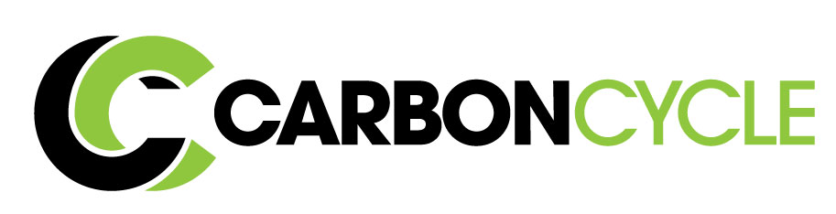
The Team:

Omar Galal- Founder and Design Engineer
Serial Entrepreneur for the past 12 years. Responsible for operations, construction, and product R&D.

David Seidel- Technology Expert
Over 35 years of experience in environmental engineering and perfecting of technology. Dave will design and provide guidance to equipment and future product development.

Alex Giannikoulis- Sales and Finance Specialist
With having a successful seven figure exit, Alex will build a market strategy and build the sales team to take the multitude of created products to market.

Enginuity, LLC- On-site Engineering and Mfg. Company
Enginuity is a 12 year old product development and manufacturing company with a diverse metal and plastic fabrication facility with a core team of technicians, machinist, welders, and production personnel. Responsible for 50 product designs currently on the market. They will design and build future facilities.
Disrupting the Idea of “Waste”.
Overview:
CarbonCycle converts unwanted waste into value-added products with our proprietary technology. We are able to create a multitude of usable carbon and oil-based products from plastic, tires, paper, and other materials.

The Problem:
America generates more than 500 billion pounds of municipal waste a year. This garbage is either sent to a landfill, burned, dumped, or collected by our waterways and oceans. Not only is this an obvious environmental problem, but is also a financial and ethical one for many industries. The waste is made from valuable natural resources that are currently being thrown away and underutilized. This comes at a cost to the consumers, companies, our Earth, and our children’s future.

The Solution:
CarbonCycle’s solution is to modernize the age-old technology of pyrolysis. By using this ability to take waste and then heat it in a batch manner, with the absence of oxygen, we can separate the materials into their most basic elemental components. Plastic is essentially made from oil whereas wood and paper products are mostly comprised of carbon. The by-products of oil and carbon have a multitude of applications from bio-diesel to air and water filters.

Our unique business model reverses the concept of paying for the materials and COGs and creates a revenue from it instead. We do this by offering an environmental and financially responsible option for unwanted material disposal at a discount cost to our customers. We accept the “waste” and in return converting it to high demand, revenue generating commodities, and value-added products. Unlike current disposal means, our technology and processes use little to no additional energy and produces little to no harmful pollutants.
Current Status:

- Raised $250,000.00 to start project
- Pilot plant built and in operation
- Secured first $400k feedstock contract
- Received 8 letters of intent for future business
- Received $3,000,000.00 investment commitment

Market Opportunity:
America spends a minimum of 13.5 Billion dollars on waste disposal at landfills and this number is only expected to grow. There has also been an increased awareness and desire for many companies to purchase carbon credits or move to a zero-waste policy. CarbonCycle gives companies discounted alternative options and the ability to recycle their waste at a lower expense.
Future:

1st Round: Scaling current test facility to be able to convert 3 tons per an hour of feedstock which will produce 3 million gallons of crude yearly and 6000 tons of carbon products.

2nd Round: Build a full scale pyrolysis facility with quality control testing laboratory. This facility will be built in a preselected location based on disposal costs and feedstock availability. An estimated $800,000 in yearly profit will be generated by this facility at half capacity.

The crude oil market is an astonishing $1.7 trillion dollar market with a large demand for a carbon neutral, sustainable, and domestic sourcing.
The diverse carbon market (over $15 billion) includes charcoal, activated carbon, biochar, and many other industrial uses. CarbonCycle’s ability to create custom products with diverse feedstock material allows for a high margin competitive advantage.

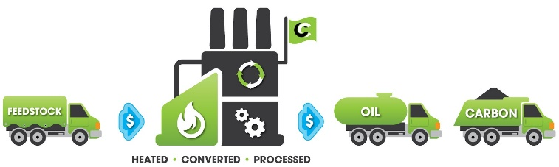
CarbonCycle has already established our $250K testing facility and contracted for $400k of feedstock disposal fees for the 2018 year. This “dirty” plastic will be used in our testing facility that will convert it into over 2 million gallons of crude oil with an estimated revenue of $750K.
Contact: OGalal@ThinkEnginuity.com
Mobile: 480.235.6124

