Luke Staengl

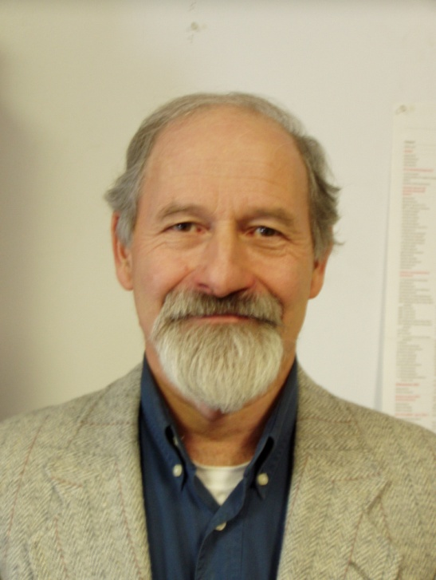
Luke is a visionary pioneer in many fields of human endeavor – from learning to understand the human psyche, sociology, as well as practical solutions to some of the worlds pressing problems of resource conservation, environmental preservation, and the development of thrivant renewable energy systems for communities.

Luke founded an Intentional Community in the Blue Ridge Mountains (Anahata Bio-Community) and a revolutionary education center (Anahata Education Center) which focus on personal growth, interpersonal relationship, new ways of accessing and processing our unconscious contents, and understanding human behavior and motivation. Another aspect of these centers is the study and application of renewable energy, symbiotic systems and permaculture, as well as other evolutionary modalities and technologies.

Because of his interest in a different approach to education he co-founded Blue Mountain School in the early 80s, and is a strong supporter, both with his time and his money. He serves on the Blue Mountain School Board of Trustees.

From 1979 – 1990 Luke was also the leader in several renewable energy projects which produced ethanol, methane, feed and fertilizer, as well as a variety of high value polymers, from agricultural and industrial wastes. To this end he co-founded the Bio-based Materials Center at Virginia Polytechnic Institute which focused on producing these high value substances from biomass.

In 1991, Luke founded Pragmatic Environmental Solutions Company [PESCO]. As president of PESCO he has led it from modest beginnings to a company with international recognition. PESCO systems are recycling everything from acetone to xylene and motor oil, in locations ranging from Australia to Virginia.

In 2007, Luke and two Partners formed another company – PESCO BEAM Environmental Solutions Pvt. Ltd. in Chennai, India, combining PESCO’s knowhow with its long term fabrication and engineering partners, Beam Engineering, Pvt. Ltd. PESCO-BEAM continues to develop state of the art environmental and recycling equipment and systems for deployment all over the world.

Luke also served as Board Member and Vice President of Sustain Floyd Organization (SFO – www.sustainfloyd.org) which focuses on creating a sustainable resilient Floyd economy, through the development of local industries which will provide markets for local crops, and creating value added industries for local raw materials, resources and talent.

Luke has given lectures and talks on a variety of subjects, often focusing on what we can do to implement sustainable practices and technologies, symbiotic systems and other related topics.

