Section 2 – Lesson Two

Fingerpicking over Two Chords

Last Assignment
So how did playing your first pattern go? Did you experiment a bit and try some new permutations? If you did, was that fun? Here’s a question - when you started playing with other variations, did you keep using the designated right hand fingers per string? If so, awesome.

Sometimes we may notice as beginners that you start off playing each string with the right fingers but then if we relax our concentration, we find that one finger may take over. So for example, maybe the index finger tries to play all the strings!

This might be the easiest way to play something today but the problem is that if we want to play something complex or start to speed up, it’s going to be impossible. So it’s important that during the first week, we pay particular attention to using the Big Rule of which finger play which strings. Even at a really slow speed (like super slow!) if you are using the correct right hand fingers and thumb to hit the appropriate string, then I am happy.

If it was a bit difficult to keep the right finger hitting each string, go back and play exercise 1 again. That will iron that out for you, guaranteed! Play exercise 1 for a while and then go back to exercise 2 and see that the right fingers are being used!

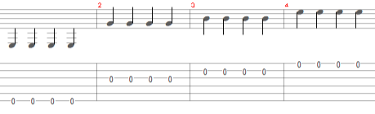

Using a Metronome
The next thing we will do to help us practice is use a metronome. A metronome is just a tool that plays a solid beat, and our goal is to play along with one. I suggest that you buy one. This Snark metronome is nice and does the job but any metronome will do. If you don’t have one, it’s ok as you can play along with me when I’m using the metronome and that will be enough for now. But I’d recommend buying one anyway - it will be huge for your progress.

I use a Snark Metronome because it costs around $20 and has different volumes which is great if you want to be able to practice sometimes a bit more loud and sometimes more softly if there are other people you don’t want to disturb. There’s also free online metronomes that you can use. They will work fine today if you don’t have a physical metronome, but it means you need to turn it on and off at your computer or laptop and I prefer to be able to press a physical button.

Here is a link to a good free online metronome - https://www.metronomeonline.com/legacy

Playing Exercise 2 with a Metronome
Let’s start at 40 b.p.m.
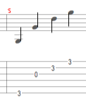

So try it yourself, play one note for each hit on the metronome. I’ll let it play for a little while so that you can try that. So how did that feel? If it was too hard you can slow the metronome down even more. Or if it was too easy then you can speed it up! But for now, you just want to use the right fingers of the right hand and make a good connection. Speed will come in time, believe me!

Please don’t skip this exercise. Playing something very slowly in time to a metronome and then upping the speed to a higher tempo and then to a higher tempo again is a really fundamental part of being able to play accurately in time. At the very least, play along at 60 bpm. It should sound pretty nice and we’re using the right fingers of the right hand and it’s a great start to building our fingerpicking technique, which will get pretty complex - but it all starts here.

Another Pattern
So now we are going to play a very similar pattern. Except now we’re playing the C chord with our left hand. The one thing to note here is that the thumb hits a bass note on the fifth string.

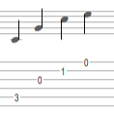
Start slowly and make sure the right fingers are hitting the right strings.

Assignment 2
Your exercise is to play the G pattern above followed by the C pattern, If you know the chords well already, then your job is to think about the fingers of the right hand - are they sticking to the right strings? Is the thumb hitting the 6th string for the G bass note and the 5th string for the C bass note?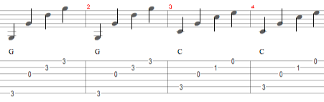

If you are completely new to guitar, then don’t worry about this being difficult. It’s great practice and I’m going to give you a great tip for how to change chords quickly in the next section. But don’t go there yet! Spend 10-15 minutes trying to change chords and using the right fingers of the picking hand (left hand).

If you have done your 15 minutes homework and you want to mess around, try new things, experiment and see what sounds musical, feel free!

