Connecting PUTTY to HDP Sandbox

Launch PUTTY
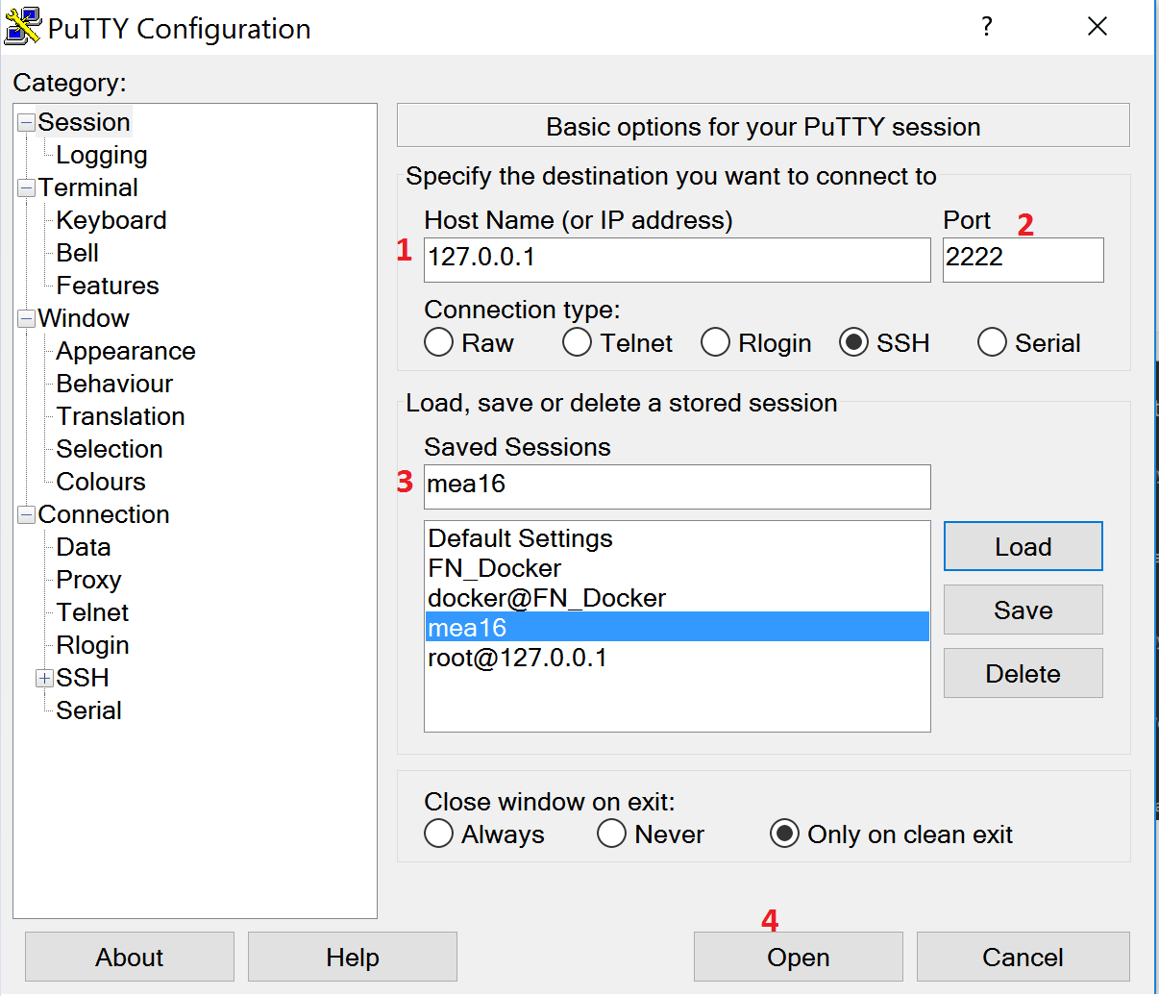

Enter User Name and Password
UserName: root
Password: password (you would be required to change this after first login)
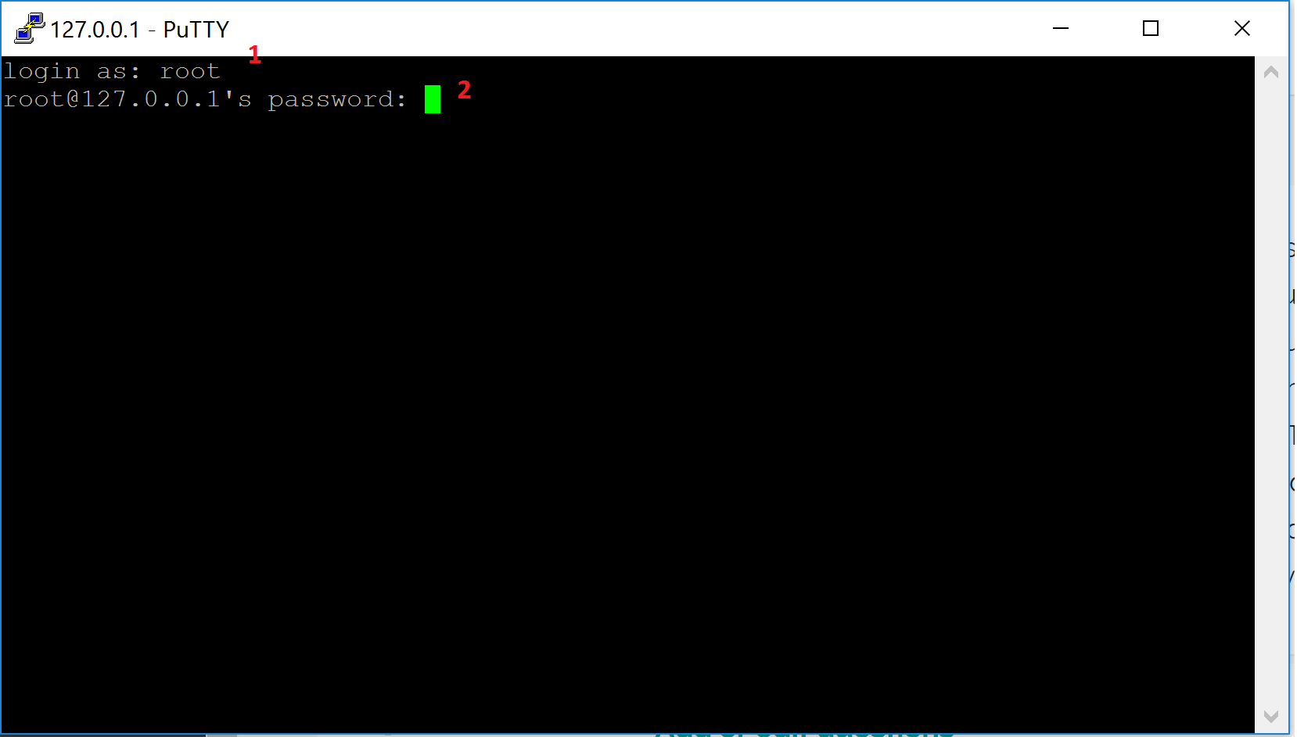

Successful login looks like this.
