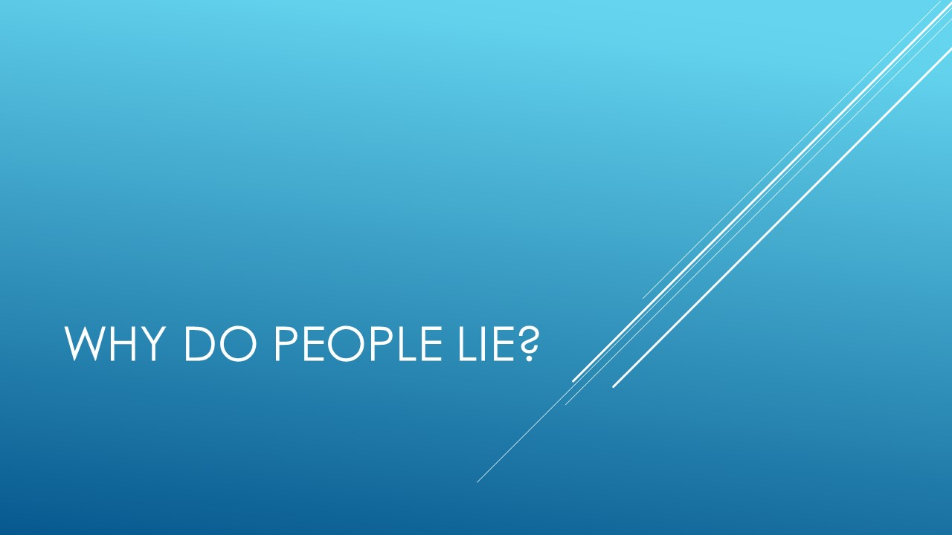

Use this workbook to take notes as the module moves along. There is a separate workbook for each module.

How many times on average are we lied to during the day?

We lie and are lied to in all contexts. We lie to our children, our partners, our co-workers, our bosses, some people lie to the police and courts. Lying is ingrained in our culture and lifestyle. But it’s not all bad, some lies are just little white lies which we tell to protect ourselves or other people.

Notes on ways babies and plants lie.

Additional reading: http://www.abc.net.au/science/articles/2003/07/31/2857387.htm

Notes on contexts we lie in.

Motivations for lying.
It has been suggested that there are 9 main motivations for lying which can be classed into two main categories. These can be offensive or defensive motives. Offensive
Notes on Offensive motives.

Notes on Defensive motives.

Additional reading: https://www.paulekman.com/blog/why-people-lie/
Additional information.

Relevant books
The Post-Truth Era: Dishonesty and Deception in Contemporary Life (2004) Ralph Keyes

Interesting websites:
https://www.nationalgeographic.com/magazine/2017/06/lying-hoax-false-fibs-science/

Sample essay questions:
Outline the various ways in which lying helps society.
Describe the 9 main motivations for lying.

