90-Day Business Startup Board
DigiArtCandy.com
Facebook.com/digiartcandy
We’ll demonstrate this in the course!

You can create your own 90-day business launch board using some of the examples here. Your board may look something like the image below (not a complete snapshot). Column/section headings and tasks within your columns may vary, but you get the idea. You can copy and paste right into Asana. It’s a great way to start your business plan. Already in business? This gives you ideas!

CAN BE A LIST, TOO: Don’t forget that you have the option to create this as either a board or a list. If you decide to copy/paste as a list, be sure to add a colon after each section header so Asana will automatically know it’s just that (saves you a lot of time).

NOTE: In this course, Michele will show you how to add your own sub-divider images just as she did in the snapshot below.

She created these brand-colored ribbon graphics in… PowerPoint! You can easily create your own, too!

Michele Grant teaches entrepreneurs how to create their own video/static ads and graphics using PowerPoint. Visit DigiArtCandy.com to sign up for upcoming courses and workshops.

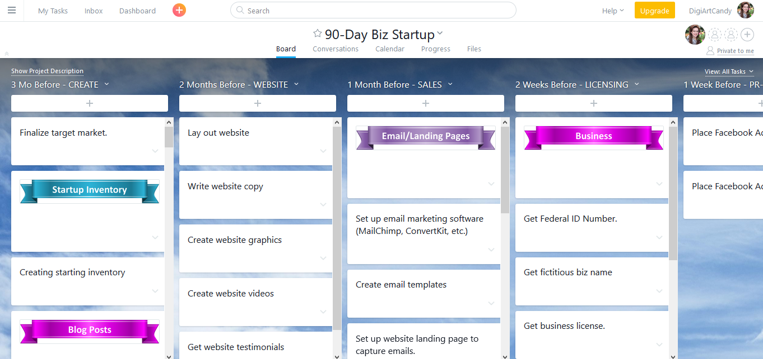

Copy and paste some or part of the list below into Asana:

3 Months Before - CREATE
Finalize target market.

STARTUP INVENTORY
Creating starting inventory

BLOG POSTS
Create 5 weekly blog posts with graphics & downloadables.
Determine key words for all blog posts
Create 30 days of FB posts
Create Facebook posts announcing launch/freebies.
Create YouTube posts announcing launch/freebies.

FACEBOOK AD 1
Create FB Launch #1 Ad: FB film/PPT video ad.
Create FB Launch #1 Ad: FB graphic
Create FB Launch #1 Ad: Freebie downloadable.
Create FB Launch #1 Ad: FB Ad copy.
Create FB Launch #1 Ad: Landing page in MailChimp.
Create FB Launch #1 Ad: Landing page graphics.
Create FB Launch #1 Ad: Landing page video(s).
Create FB Launch #1 Ad: Landing page copy
Create FB Launch #1 Ad: Blog video(s)
Create FB Launch #1 Ad: Blog post copy
Create FB Launch #1 Ad: Blog graphic(s)
Create FB Launch #1 Ad: Blog post downloadable(s)

FACEBOOK AD 2
Create FB Launch #2 Ad: FB film/PPT video ad.
Create FB Launch #2 Ad: FB graphic
Create FB Launch #2 Ad: Freebie downloadable.
Create FB Launch #2 Ad: FB Ad copy.
Create FB Launch #2 Ad: Landing page in MailChimp.
Create FB Launch #2 Ad: Landing page graphics.
Create FB Launch #2 Ad: Landing page video(s).
Create FB Launch #2 Ad: Landing page copy
Create FB Launch #2 Ad: Blog video(s)
Create FB Launch #2 Ad: Blog post copy
Create FB Launch #2 Ad: Blog graphic(s)
Create FB Launch #2 Ad: Blog post downloadable(s)

Set up Dropbox (or Google Drive, OneDrive, Hightail, etc.)

2 Months Before - WEBSITE
Lay out website
Write website copy
Create website graphics
Create website videos
Get website testimonials

1 Month Before - SALES
EMAIL | LANDING PAGES
Set up email marketing software (MailChimp, ConvertKit, etc.)
Create email templates
Set up website landing page to capture emails.

YOUTUBE
Set up YouTube Channel
Create YouTube header
Create YouTube About copy
Create YouTube starting 3 videos & copy

2 Weeks Before - LICENSING
BUSINESS
Get Federal ID Number.
Get fictitious biz name
Get business license.
Get business bank account (as soon as have license).
Change personal PayPal to business account (as soon as have license).

1 Week Before - PRE-LAUNCH
Place Facebook Ad #1
Place Facebook Ad #2

Day Before - RECHECK
Test everything.
Test website.

LAUNCH DAY
Post Facebook launch posts.
Post YouTube launch posts.
Send out launch press releases.

Week After Launch - SELL
Set up webinar campaign
Set up Facebook ad campaigns
Comment and advise in online forums

