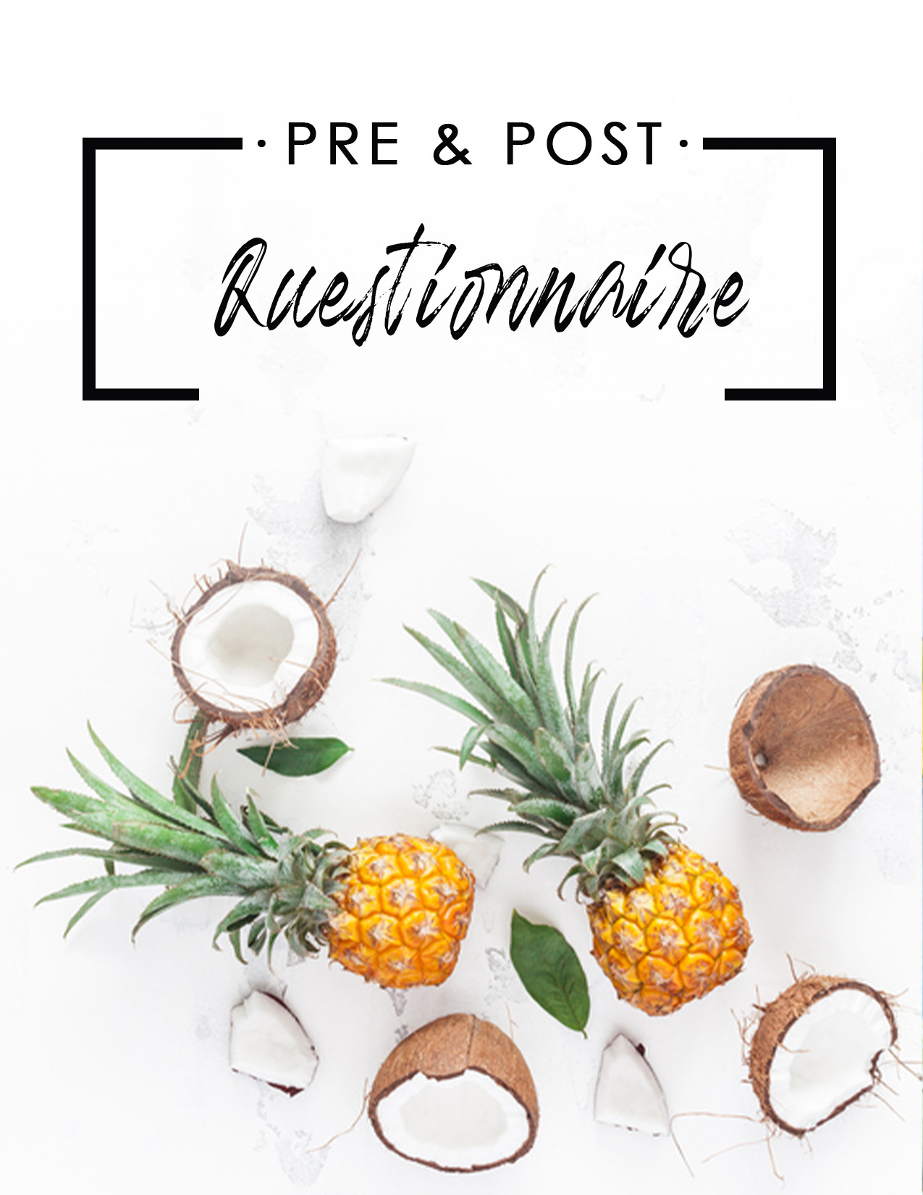
PRE-DETOX QUESTIONNAIRE

NAME _____________________________________________ DATE___________

TELL ME A LITTLE ABOUT YOURSELF!

- How are your energy levels? Are they consistent during the day or do you notice a lot of variations?

- Do you get sugar cravings?

- What is the quality of your sleep – do you wake often during the night or sleep like a baby?

- Are you productive during your day?

- Do you experience brain fog?

- Do you have hormonal imbalances – (applies to both men and women)?

- Do you feel hungry often?

- Do you eat breakfast?

- Do you experience gas and/or bloating?

- Do you have skin problems?

- Do you exercise?

- Do you have a tough time losing weight?

- Do you have joint pain?

- Do you get headaches?

- Do you have food intolerances or environmental sensitivities?

- Is there anything else you want to share with me today?

What are your health goals – what do you want to achieve by the end of this program?

1.

2.

3.

LET’S TALK MORE ABOUT YOUR BODY AND YOUR LIFE.
- How many times per day do you have a healthy bowel movement?

- Do you sweat easily when you work out?

- How much water do you drink?

- How much protein do you consume per day?

- Do you have a difficult time digesting fiber?

- Do you take any supplements?

- Do you take a probiotic?

- How would you rate the stress level in your life?

- How much coffee do you drink?

- Do you consume alcohol or smoke and if so, what and how much?

- Do you eat processed foods?

- Do you eat wheat or dairy, and if so, how much?

- Do you use all-natural cosmetic products, including makeup and lotions?

POST DETOX QUESTIONNAIRE

NAME ________________________________________ DATE __________________

- What have you learned about your food habits during the program?

- What has changed in your life? How are you feeling now?

- Have you realized certain foods were not right for your body?

If yes, what foods? Please list them below.

- What have you learned about the importance of the daily detox?

What 3 tools will you carry with you post detox?

- What are your health goals for the future?

Let’s get clear today and write them down.

- Mastering your fuel:

List the foods that give you a ton of energy.

List the foods that deplete your energy.

Congratulations! You have just unlocked your own personal Healthy Blueprint!

If you feel you need more support after this program, it would be an honor to continue to work with you.

Contact me today!

[Insert contact info]

