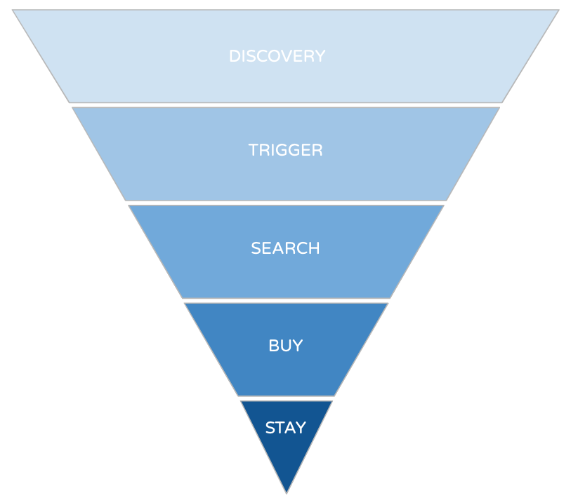

**Customer Conversion Funnel - Worksheet**

|  |  |
| --- | --- |
| **Audience Avatar** |  |

|  |
| --- |
| **Discovery Phase: What thoughts, opinions, feelings does your customer think in relation to your type of product / service (indirect)?** |
|  |
| **Trigger Phase: What action, or realisation would trigger your customer to begin researching your product / service (indirect)?** |
|  |
| **Search Phase: What search phrases & methods might a customer use to find your product/service (not your brand)?** |
|  |
| **Buy Phase: What objections or questions do your customers have that might be preventing them from buying?** |
|  |
| **Stay Phase: How can you encourage your customers to remain a loyal consumer / brand advocate? What would drive this for them?** |
|  |