**Work Interest**

Take the assessment [here](https://www.mynextmove.org/explore/ip) by completing rating the question (strongly dislike, dislike, unsure, like, strongly like). There are 60 questions and the assessment takes about 15 minutes to complete.

Below is a screenshot of what the assessment will look like.

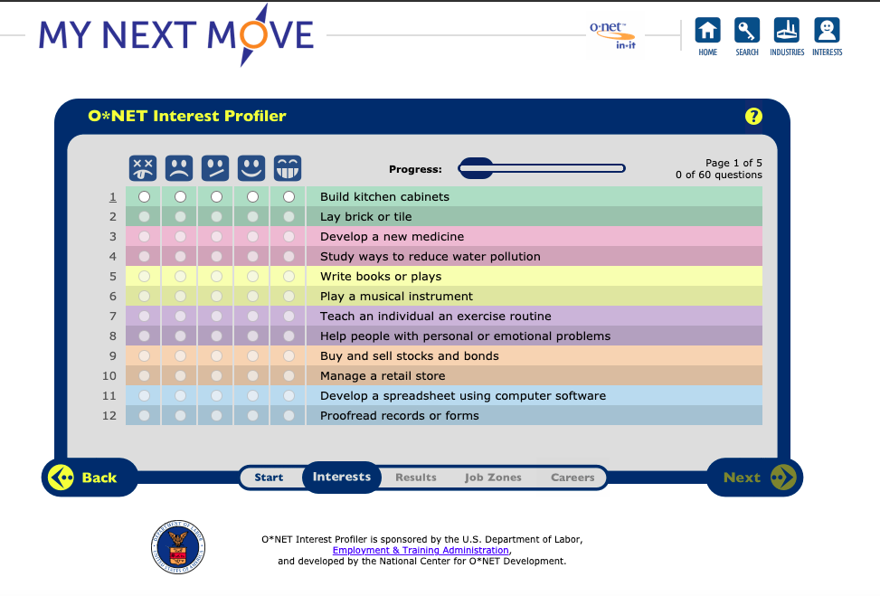

**Record the results from your assessment below**

* Realistic =
* Investigative =
* Artistic =
* Social =
* Enterprising =
* Conventional =

Below is an example of how the results will populate

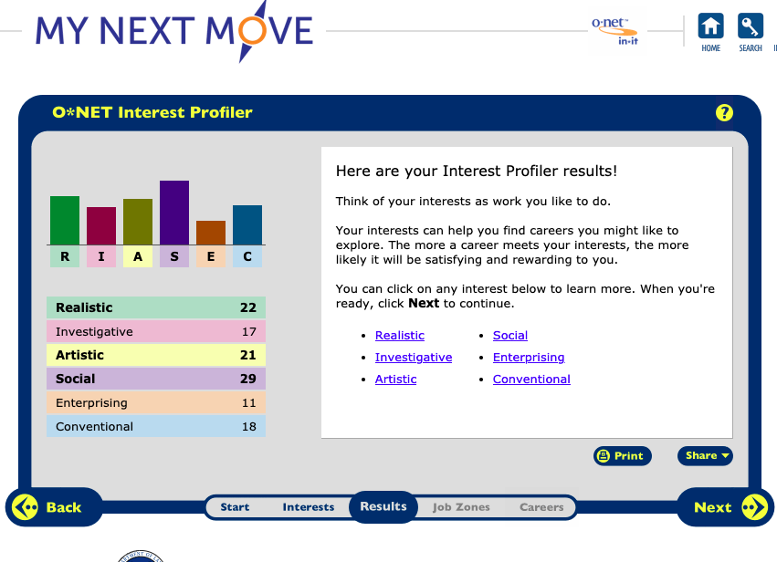

You can see careers that match your results based on the level of preparation (education & training)

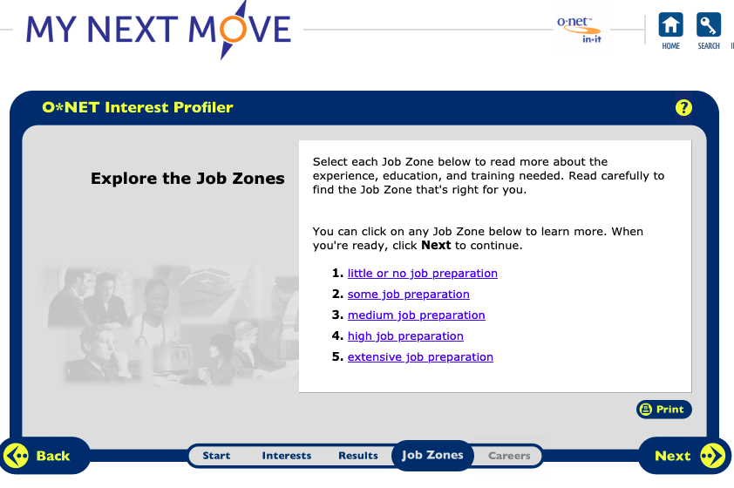

Below is an example of careers based on the assessment results and level of preparation

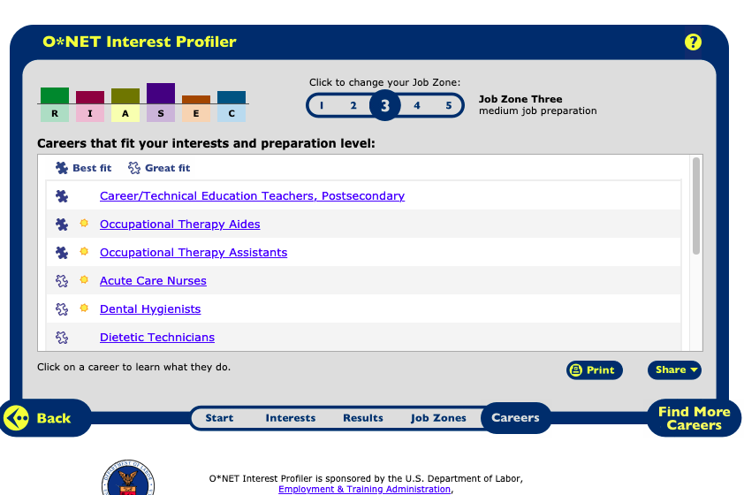

1. What were your thoughts about your results?
2. Do you think they should be different in any way? Explain how?
3. What careers seem interesting to? If so, please list them.
4. Are there any careers that you would want to learn more about? If so, please list them.
5. What would be a good “next step” for you after taking this assessment?