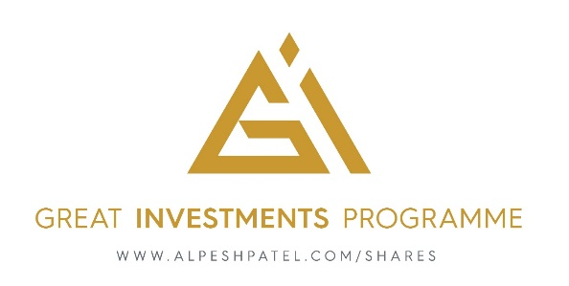

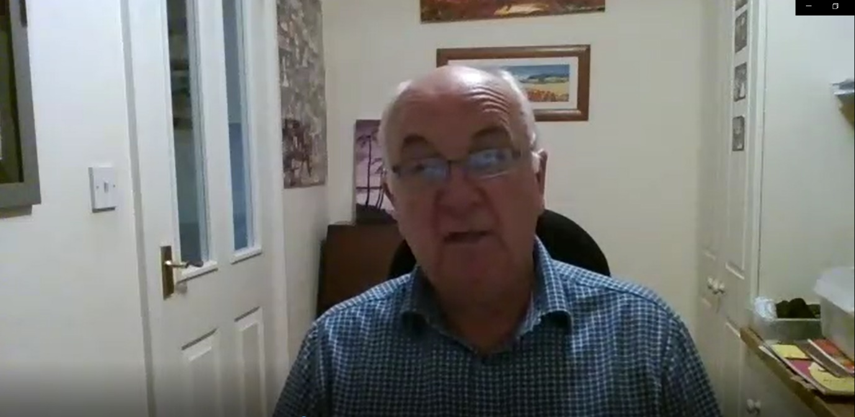

**Background**

video

Mike had owned his own business since 1986 and had most of his retirement funds tied up in an ISA and a self-administered pension fund. Mike is relatively experienced as managing his wealth, investing since the privatizations in the 1980’s and had an IFA for many years who was nice enough but never challenged him. Mike discovered the Great Investments Programme through a video he was sent, & liked the way Alpesh presented the information & outlook, being straightforward & easy to follow.

It was a convenient time for Mike to seek someone to teach him investing so he could manage his own money and decided to try the Great Investments Programme.

**Journey**

Mike became cautious of his investments due to political changes. The investments started to do well but Mike decided that he would invest the money that became available himself, with the learnings from Alpesh’s course. As a relatively experienced investor, Mike did not need to watch all the learning materials but could progress at his own pace.

When Mike started listening to Alpesh’s guidance and following the advice, his investments started returning very well. Mike enjoyed the 1-2-1s with Alpesh because he challenged Mike’s traditional thinking about what is possible or probable regarding the best stocks to buy, and principles to manage through the proprietary Great Investments Programme software.

Although naturally optimistic as a person, Mike was historically pessimistic with his investments. The Great Investments Programme helped Mike to see clearly what stocks to invest in and how this can be achieved to make returns safely, and it’s proved a great success.

**Outcome**

Mike started investing 6 weeks ago and has made £34k on the original amount invested, which he is very happy with. ‘It’s going to be a nice gift for the kids and sure, a happy retirement. My most important realization is not just to look at the home market. My biggest success can be attributed to just one thing – listening to Alpesh!’

**Great Investments Program:** Alpesh Patel is an award-winning hedge fund manager who developed the profitable Pips Predator Indicator, an exclusive trade signals software. The Great Investments Program is a trading mentoring/apprenticeship program that lets students learn at their own pace through a carefully developed, proprietary library of educational materials so they can secure their financial future.