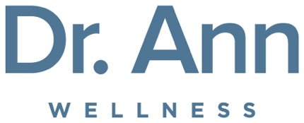

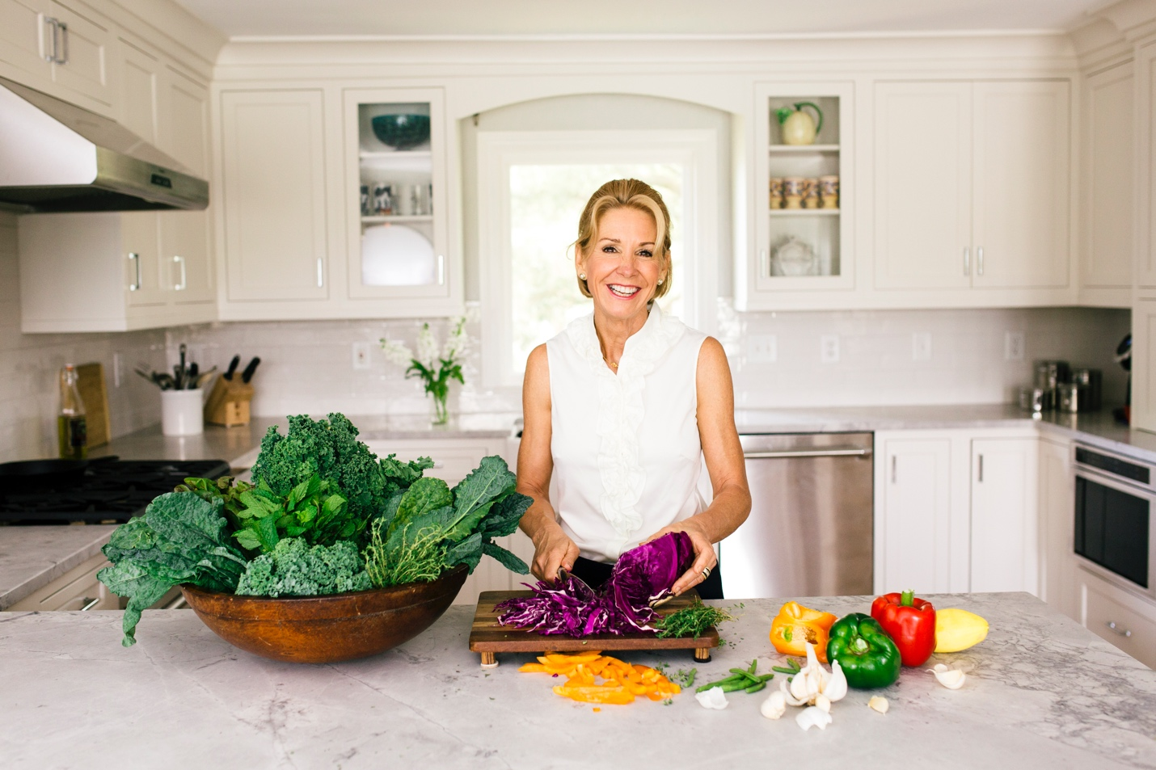

Snapshot:

- Best-selling author
- Life-changing keynote speaker
- Physician, Med School Valedictorian
- Founder and CEO of Just Wellness, LLC
- Featured expert in national media – The Dr. Oz Show, Oprah and Friends Radio, Time, WebMD, Prevention, US News and World Report, among others
- Wife and mother of four

Biography:
As a physician, best-selling author, and motivational speaker, Dr. Ann Kulze, is on a personal crusade to share the joys of healthy living with as many people as possible. She is a renowned authority in the areas of nutrition, healthy lifestyles, and disease prevention. As a gifted teacher with exhilarating energy and passion, Dr. Ann transforms all the “new science” of healthy living into programs that are simple, easy, and fun!
With her unique background and formal training in both nutrition and medicine, along with her extensive “hands on” experience as a wife, mother of four, and trusted family physician, Dr. Ann has distinguished herself as a one-of-a-kind “real world” nutrition and wellness expert. Growing up in a family with a rich heritage in science and medicine, Dr. Ann developed an interest in wellness and specifically nutrition at an early age. Following her passion, she attended Clemson University and graduated with honors with a degree in Food Science and Human Nutrition. She received her medical degree from the Medical University of South Carolina, where she received numerous academic awards and graduated as the Valedictorian of her class. Following her professional training, she worked as a family physician for 14 years and ultimately retired from her clinical practice in 2002 to devote her professional life solely to wellness promotion.
Dr. Ann is the founder and CEO of Just Wellness LLC, a wellness education firm committed to providing high quality, user-friendly educational resources. She is a highly sought motivational speaker and has delivered over 300 inspirational speeches, including many keynotes. Dr. Ann has also authored six books on health and wellness, including the award-winning, best-selling Eat Right for Life® series (WELCOA). Hundreds of North American businesses and organizations, including some of the country’s leading medical centers, have used her books to guide their employees and members to better health.
Dr. Ann has been featured in many national media outlets including the Dr. Oz show, Oprah and Friends Radio, Time Magazine, NPR, WebMD, CNN Radio, Prevention, and Redbook, among many others. She was the national spokesperson for Ruby Tuesday’s SMART EATING initiative and is a regular guest on the Midwest’s WBCL’s mid-morning program.
When she is not writing, researching, or motivating others through her public or corporate speaking engagements, Dr. Ann lives her wellness message, enjoying swimming, running, kayaking, cooking, and spending time with her wonderful family.
Dr. Ann lives with her husband and four children in her native Charleston, SC. She currently serves on the Medical Advisory Boards of the Wellness Council of America (WELCOA) and the Prevent Cancer Foundation, the Board of Directors for the Lowcountry Open Land Trust, and the City of Charleston Wellness Advisory Council. She is a recipient of the Prevent Cancer Foundation’s Champion Seal and an Aspen Institute Liberty Fellow.

