Module 1 Part 2
Virtual TT

worksheet

Review
Course criteria and papers.
How many observations are there?
What is key to doing the observations?
Sections of the Louise Hay paper are?
Meaning of the word ‘yoga’
What does the meaning of ‘yoga’ have to do with NOT using the word ‘you’ when instructing?
What queries or questions do you have? | Post on the Private Facebook Group a little introduction of yourself!
Anything that isn’t clear? | I’m asking questions, questions is a teaching tip explain why it is a teaching tip!

Bones, Joints & Muscles
Write the primary functions of bones
How does yoga help our bones?
What is WIIFM?
Where is cartilage located in the body?
What is cartilage’s function?
Joints have a fluid to facilitate smooth movement what is this fluid called?
What is the main function of the hip socket? The shoulder socket?

In between the vertebrae are little, things that look like little jelly donuts what are they called? When we are consistently misaligned over time what can happen to them?
Ligaments attach bone to bone are they more or less elastic than tendons?
Tendons attach muscle to?
Ray Long Volume 2 page 18
Gogli Tendon Organ
Muscle spindle, reflex arc is it a muscle??

If a student has pain near a joint what MUST you instruct them to do????
WHY??

What is the relationship between Stretching and endorphins?
See Page 11 Volume 2

Antagonistic vs. Synergistic muscles how do they work together
in the legs in uttanasana,
in the arms in warrior 2,
in the upper body in cobra?

IDA, Pingala & other fun stuff
Open up the document on the facebook page with the handwritten diagrams, | You can also print it up and look at it at the same time as the video.
What is the main nadi that goes up and down the center of the body? Hint: Wendy calls it the I95
What are the names of the 2 winding nadis that intertwine up and down the chakras?
Ida, Pingala, Purusha, Prakriti are ways to explain what?

Purusha and Prakriti have 3 children, the gunas what concept do they represent?

We are all born with a dense curled up energy at the base of our spines, often depicted as?
Explain what Kundalini Rising has to do with the order of our yoga class | Ida, Pingala, Purusha, Prakriti are ways to explain what?

sun salutations
Write Instructions next to each image, if there are no Sanskrit names please include those! Remember rule of 3… | Question: what does the teaching tip Yogi See Yogi Do have to do with teaching?
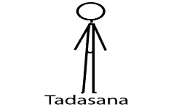
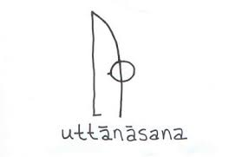
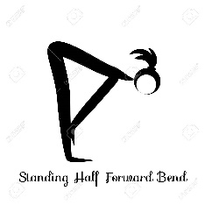
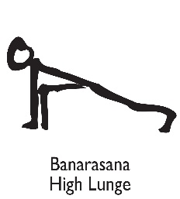 | Which leg goes back first in round 1? 2?
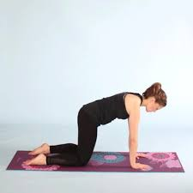 | This is called a transition pose to make the sun salutations more accessible. 3-3-3- is not needed here
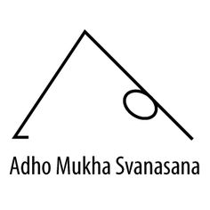
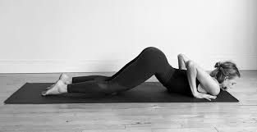
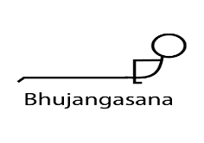
 | Which leg steps forward in round 1? 2?
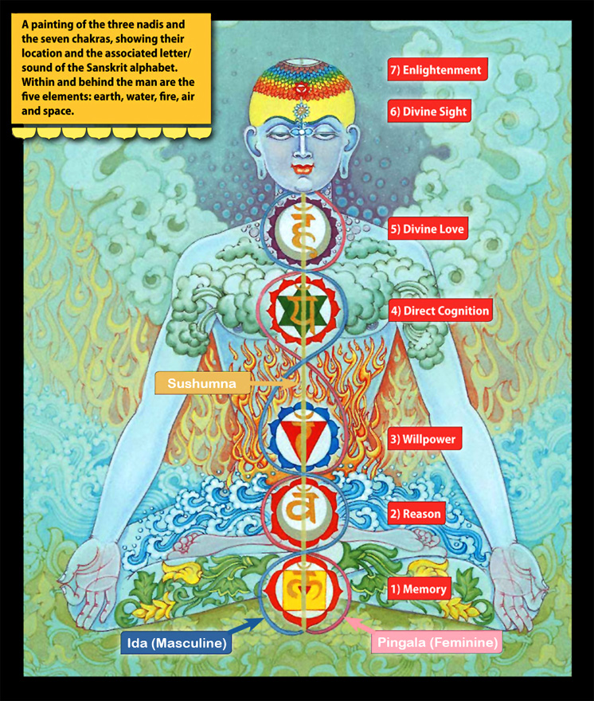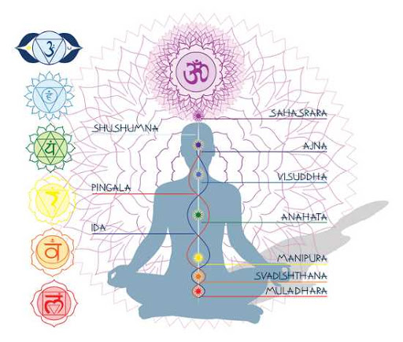
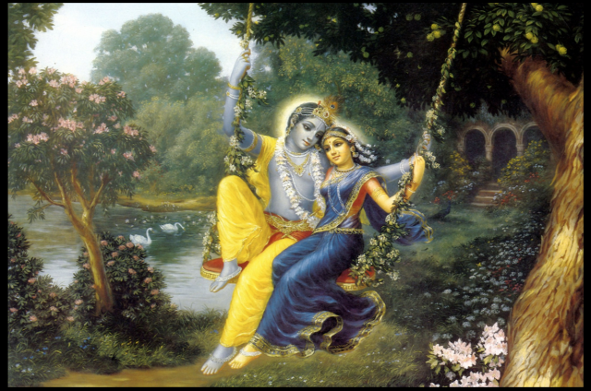
Purusha and Prakriti
