Training Thresholds

Jane is 20 years old and she is taking part in a 12 minute continuous training session.

She is wearing a heart rate monitor to record her heartrate during the session.

Plot the resting heart rate at 0mins, and continue to plot recorded scores across the graph, every 2 minutes – including the recovery rate.

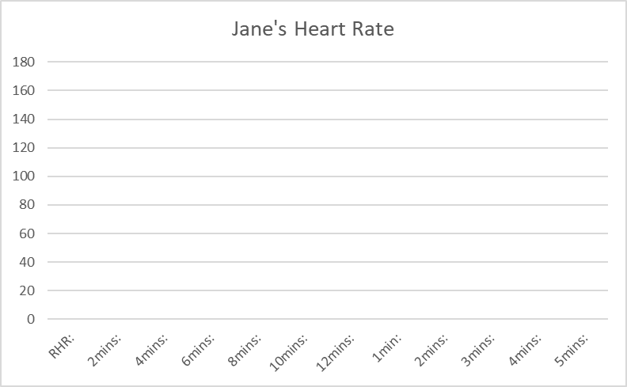

**Jane**

Before exercise

Resting HR: 62

During exercise

2mins: 104

4mins: 150

6mins: 159

8mins: 168

10mins: 171

12mins: 176

After exercise (recovery rate)

1min: 131

2mins: 101

3mins: 77

4mins: 66

5mins: 64



1) What would Jane’s heart rate be if she worked her to her maximum?

2) Calculate her aerobic training zone?

3) Calculate her anaerobic training zone?

4) Draw a line on the graph for her anaerobic training zone and a line on the graph for her aerobic training zone in a different colour

Training Thresholds

Pamela is 14 years old and she is taking part in a 12 minute continuous training session.

She is wearing a heart rate monitor to record her heartrate during the session.

Plot the resting heart rate at 0mins, and continue to plot recorded scores across the graph, every 2 minutes – including the recovery rate.

Pamela

Before exercise

Resting HR: 58

During exercise

2mins: 76

4mins: 85

6mins: 93

8mins: 104

10mins: 111

12mins: 123

After exercise (recovery rate)

1min: 92

2mins: 86

3mins: 75

4mins: 62

5mins: 62

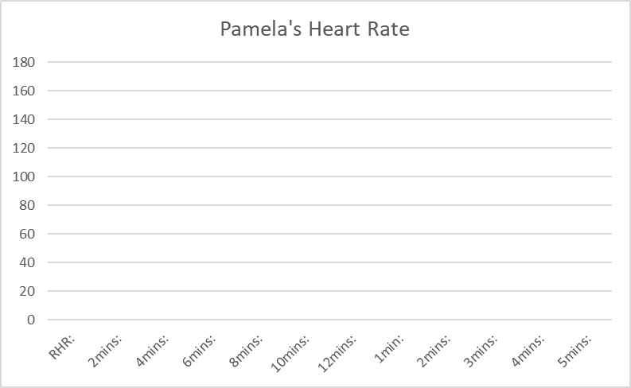

1) What would Pamela’s heart rate be if she worked her to her maximum?

2) Calculate her aerobic training zone?

3) Calculate her anaerobic training zone?

4) Draw a line on the graph for her anaerobic training zone and a line on the graph for her aerobic training zone in a different colour

Training Thresholds

John is 30 years old and he is taking part in a 12 minute fartlek training session.

He is wearing a heart rate monitor to record his heartrate during the session.

Plot the resting heart rate at 0mins, and continue to plot recorded scores across the graph, every 2 minutes – including the recovery rate.

1) What would John’s heart rate be if she worked her to her maximum?

2) Calculate his aerobic training zone?

3) Calculate his anaerobic training zone?

4) Draw a line on the graph for her anaerobic training zone and a line on the graph for her aerobic training zone in a different colour

John

Before exercise

Resting HR: 69

During exercise

2mins: 120

4mins: 132

6mins: 112

8mins: 158

10mins: 142

12mins: 171

After exercise (recovery rate)

1min: 131

2mins: 108

3mins: 79

4mins: 71

5mins: 70