The SPARK Method Case Study

Course Title | Flawless Project Management with the SPARK Method
Course Learning Goals | - Know where to start with Project Management, communicate and cooperate effectively.  - Know how to lead a team.
Case Study Check List Area | - “A” - Action – Act, Listen, Improve

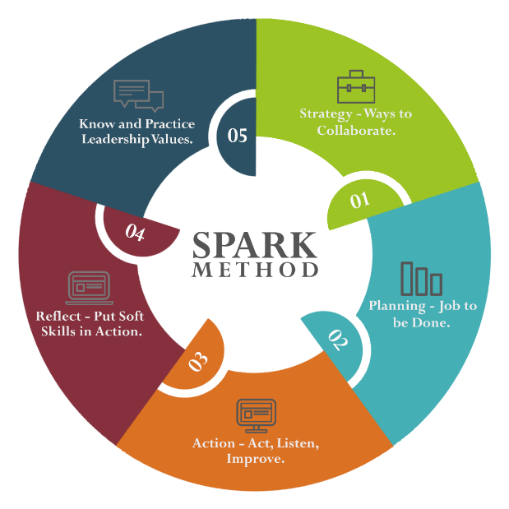
Case Study Section Title | Task Description | Training Lesson Completed | Case Study Task Completed | Tested on a Real Project | Feedback  Gathered | Wrote Comment How It Worked
“A” –  ACTION  Act, Listen, Improve | - Collect Feedback on your communication strategy.
 | - Feedback on Stakeholder map creation process and precision.
 | - Feedback on meetings organization and agendas.
 | - Feedback on e-mails quality and precision.
 | - Feedback on quality of audio conferences.
 | - Feedback on quality of meeting with usage of screen sharing.
 | - Feedback on quality of meetings with usage of video conferences.
 | - Feedback on quality and usage of chat conversations.
 | - Collect Feedback on quality of following planning activities you’ve performed:
 | - Work Breakdown Structure creation process.
 | - Schedule creation process.
 | - Cost Estimates.
 | - Change Management.
 | - Risk Analyzes.
 | - Issue Management.
 | - Lessons Learned.
 | - Choose your favorite way to get feedback.
 | - Anonymous via web tooling.
 | - 1-on-1 direct feedback.
 | - Direct feedback via e-mail or another written medium.
 | - Implement changes based on received feedback.
 | - Understand impact of feedback and how others see you if you consider their realistic and value-added suggestions.
 | - Reflect on received feedback.
 | - Compare knowledge of your performance before and after all feedback is received.

