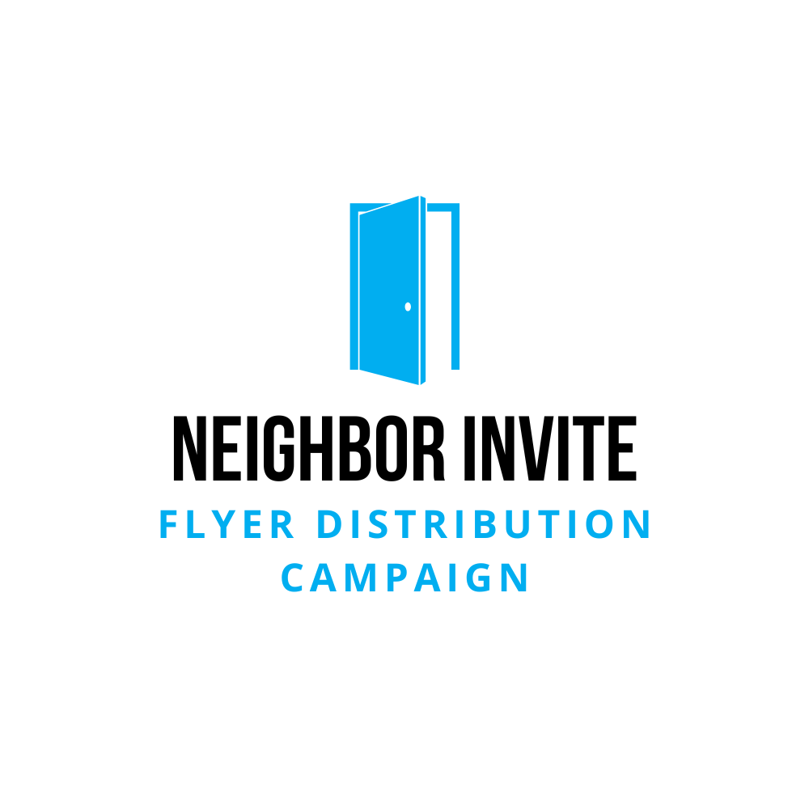 | Frequently Asked Questions (FAQ)
Thank you for volunteering for the Neighbor Invite Campaign! You’re playing a crucial role in connecting people to community, kindness, and purpose. This FAQ is designed to answer common questions, provide guidance, and make your experience smooth and enjoyable.
📝 General Questions
Q: What is the purpose of this campaign?
A: We’re inviting our neighbors to experience the life-changing community at our church. This isn’t just about flyers—it’s about creating opportunities for people to find hope, connection, and belonging.
Q: How long will it take to complete my route?
A: Most routes take about 60 minutes to complete, depending on the size of the neighborhood and your walking pace.
Q: Can I bring my family or friends to help?
A: Absolutely! Walking with friends or family makes the experience more enjoyable. Kids are welcome and often love participating (just ensure adult supervision for safety).
Q: Can I do multiple routes?
A: Yes! If you have extra time and energy, we’d love your help with additional routes. Just let your team leader know or sign up for more after completing your first.
Q: What if I can’t complete my assigned route?
A: No worries—life happens! Please let us know as soon as possible so we can arrange for someone else to complete it.
🚶 Logistics & Safety
Q: Where do I pick up my flyers?
A: Flyers are available at weekend services or during office hours. Check your email for pickup details.
Q: Where should I place the flyers?
A: Place flyers in mailboxes or designated mail slots. Do not place them on cars, doorknobs, or in areas where signage prohibits it.
Q: What should I do if I encounter a "No Solicitation" sign?
A: Respect the sign and skip those homes. Our goal is to invite, not to intrude.
Q: Should I talk to people if they’re outside or come to the door?
A: Yes—if you feel comfortable! A simple, friendly explanation works: "Hi! I’m helping invite our community to our church. We’d love to see you have you join us!” Keep it brief and warm.
Q: Is it safe to walk alone?
A: We recommend going in pairs or groups for safety and encouragement. If you must go alone, let someone know your route and estimated return time.
Q: What if I encounter an aggressive person or uncomfortable situation?
A: Stay calm, politely disengage, and move on. Your safety is the priority. Report any incidents to your team leader.
Q: What should I wear and bring?
A: Wear comfortable shoes and weather-appropriate clothing. Bring water, sunscreen, and a fully charged phone. Avoid headphones to stay aware of your surroundings.
Q: Can I deliver flyers in the rain or bad weather?
A: Safety first! If weather conditions are poor, wait until it’s safe to complete your route.
📨 Flyer Distribution Details
Q: What if I run out of flyers before finishing my route?
A: Contact your team leader or the church office. We’ll provide additional flyers promptly.
Q: My route seems longer than expected—what should I do?
A: Let us know via the Route Completion Form so we can adjust route sizes for future distributions.
Q: Are there areas I should avoid?
A: Yes, please avoid gated communities without prior permission, private roads, and buildings marked with “No Trespassing” or similar signs.
Q: Can I deliver flyers to apartment complexes?
A: Yes, but only if mailboxes are accessible. Do not enter secure buildings without permission.
Q: Can I add a personal note or invitation to the flyer?
A: We appreciate your enthusiasm, but please use only the provided flyers to maintain consistent messaging.
🗣️ Engagement & Conversations
Q: What if someone wants to talk or asks for more information?
A: Be friendly and listen. If they have questions you can’t answer, offer to connect them with someone from the church and pass along their information (with their permission).
Q: What if someone is upset about receiving a flyer?
A: Apologize politely and move on. Our goal is kindness and respect.
Q: Can I pray for people if they ask?
A: Yes! If you’re comfortable, praying with someone is a great way to serve. If not, assure them you’ll pass along their request to the church.
📝 Feedback & Follow-Up
Q: What should I do after completing my route?
A: Fill out the Route Completion Form to confirm you’re finished and share any stories or feedback. Your input helps us improve and celebrate successes.
Q: Why is the Route Completion Form important?
A: It helps us track completed routes, adjust for future distributions, and gather encouraging stories that motivate others.
Q: I had an amazing experience—should I share it?
A: Absolutely! Your stories inspire others and show the campaign’s impact. Use the feedback form or reach out to your team leader.
Q: I noticed several houses marked "vacant" or "for sale." Should I still leave flyers?
A: If mail delivery appears active, go ahead. If the mailbox is blocked or obviously unused, skip it.
Q: Can I post about my route on social media?
A: Yes! Sharing your experience can encourage others to get involved. Just be respectful of people’s privacy (no photos of homes or addresses).
📞 Need Help or Have Questions?
If you need assistance or have questions, contact us:
📧 Email: [Insert Contact Email]
📞 Phone: [Insert Contact Number]
Thank you for being part of something that truly matters. Your efforts are opening doors—literally and figuratively—for people to find hope and community!

