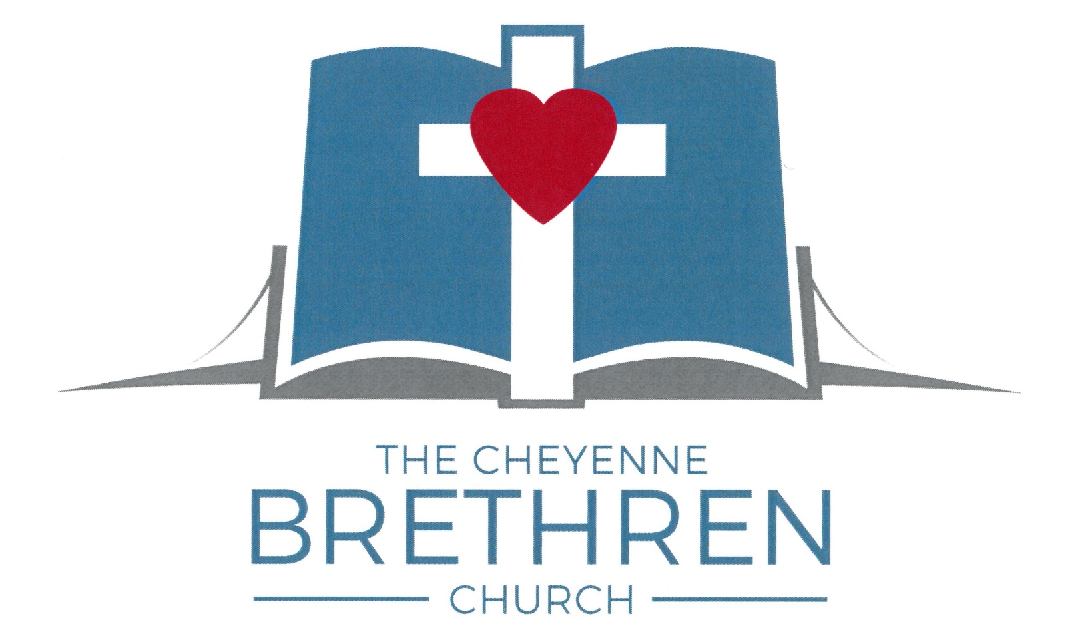

Ministry and Policy Manual
2022 Revision

Table of Contents
Ministry Descriptions of the Cheyenne Brethren Church 5
M1. Church Member 5
A. Qualifications 5
B. Responsibilities 5
C. Accountability 5
M2. Deacon / Deacon Council Chairperson 6
A. Qualifications 6
B. Responsibilities 6
C. Accountability 7
M3. Lead Pastor 8
A. Qualifications 8
B. Responsibilities 8
C. Accountability 9
M4. Assistant Pastor 10
A. Qualifications 10
B. Responsibilities 10
C. Accountability 10
M5. Moderator / Vice - Moderator 12
A. Qualifications 12
B. Responsibilities 12
C. Accountability 12
M6. Ministry Council At-Large Member 13
A. Qualifications 13
B. Responsibilities 13
C. Accountability 13
M7. Recording Secretary / Assistant 14
A. Qualifications 14
B. Responsibilities 14
C. Accountability 14
M8. Treasurer / Assistant 15
A. Qualifications 15
B. Responsibilities 15
C. Accountability 15
M9. Financial Secretary / Assistant 16
A. Qualifications 16
B. Responsibilities 16
C. Accountability 16
M10. Support Ministries Coordinator 17
A. Qualifications 17
B. Responsibilities 17
C. Accountability 17
M11. Adult Ministries Coordinator 18
A. Qualifications 18
B. Responsibilities 18
C. Accountability 18
M12. Child & Student Ministries Coordinator 19
A. Qualifications 19
B. Responsibilities 19
C. Accountability 19
M13. Pastoral Care Committee Member / Chairperson 20
A. Qualifications 20
B. Responsibilities 20
C. Accountability 21
M14. Committee Member / Coordinator 22
A. Qualifications 22
B. Responsibilities 22
C. Accountability 22
M15. Nursery Worker / Nursery Team Leader 23
A. Qualifications 23
B. Responsibilities 23
C. Accountability 23
M16. Usher-Greeter / Usher-Greeter Coordinator 25
A. Qualifications 25
B. Responsibilities 25
C. Accountability 25
M17. Children's Church Leader / Coordinator 26
A. Qualifications 26
B. Responsibilities 26
C. Accountability 27
M18. Brethren Kids in Christ (BKIC) Leader / Coordinator 28
A. Qualifications 28
B. Responsibilities 28
C. Accountability 29
M19. Worship Team Member / Director 30
A. Qualifications 30
B. Responsibilities 30
C. Accountability 31
M20. Small Group Leader / Team Leader (08/20) 32
A. Qualifications 32
B. Responsibilities 32
C. Accountability 33
M21. Drama Team Member / Director 34
A. Qualifications 34
B. Responsibilities 34
C. Accountability 34
M22. Brethren Youth in Christ (BYIC) Leader / Coordinator 36
A. Qualifications 36
B. Responsibilities 36
C. Accountability 37
M23. Adult Activities & Services Member / Coordinator 38
A. Qualifications 38
B. Responsibilities 38
C. Accountability 38
M24. Property Maintenance Team Member / Coordinator 40
A. Qualifications 40
B. Responsibilities 40
C. Accountability 40
M25. Fleet Maintenance Member / Coordinator 42
A. Qualifications 42
B. Responsibilities 42
C. Accountability 42
M26. Work Activities Member / Coordinator 43
A. Qualifications 43
B. Responsibilities 43
C. Accountability 43
M27. Audio-Video (AV) Team Member / Coordinator 44
A. Qualifications 44
B. Responsibilities 44
C. Accountability 45
M28. Rental Property Manager 46
A. Qualifications 46
B. Responsibilities 46
C. Accountability 46
Operating Policies of the Cheyenne Brethren Church 48
P02-1: Building and Sign Usage 48
P02-2: Wedding or Funeral Honoraria and Usage Fees (2008 revision) 49
P02-3: Marriage and Pre-Marital Counseling (2016 Revision) 50
P02-4: Janitorial Cleaning Timeline 53
P02-5: Registered or Convicted Sex Offenders on Campus 54
PO2-6 Annual Role Revision Guidelines (revised 2022) 55
P05-1: Church Master Calendar (Revised 07-01-12) 56
P05-2: Child Care at Congregational Meetings 60
P05-3: Ministry Meeting Policy (08-01-11) 61
P05-4: Church Event Weather or Emergency Closing Policy (11-2014) 62
P08-1: Usage of Donations (7-1-2012) 63
P12-1: Private Vehicles Used for Transportation of Minors 64
P12-2: Housing of Minors and Leaders/Chaperones on Church Sponsored Activities 65

Ministry Descriptions of the Cheyenne Brethren Church

M1. Church Member

A. Qualifications
1) Made a public profession of faith of Jesus Christ as their personal Savior and Lord.
2) Been baptized by believer's baptism.
3) Completed a series of studies established by the Pastor to familiarize the member with the history, beliefs, and practices of the Brethren Church.
4) Present to the Pastor an ability to share their faith and/or testimony with others.
5) Communicate a willingness to donate minimum of three (3) hours a month to ministry activity within the church.

B. Responsibilities
1) To support and encourage the fulfillment of the purpose of the Cheyenne Brethren Church.
2) To support the Articles of Incorporation and By-Laws of the Cheyenne Brethren Church.
3) To endeavor to be Biblical in the practice of stewardship in all areas of life, including tithing to the church (Malachi 3:6-12).
4) To encourage the fellowship and growth of the body of Christ through regular attendance of worship services. A minimum of twelve (12) Sunday services (morning or evening) is recommended (Hebrews 10:19-25).
5) To commit to personal spiritual growth and relational accountability through participation in a Teach, Love and Care (T.L.C.) group if physically able. (Acts 2:42ff)
6) To use their Spiritual Gifts, Habits, Abilities, Personality, and Experience (S.H.A.P.E) in some area of ministry in the church and in the community.
7) To actively share their faith within their community

C. Accountability
1) A Church member is accountable to the Congregation and its selected representatives, namely the Pastor(s) and the Deacon Council (Matt.18:15-17).

M2. Deacon / Deacon Council Chairperson

A. Qualifications
1) Member in Good Standing of the Cheyenne Brethren Church.
2) Meets the qualities of a Deacon as set forth by the Congregation. These qualities are based upon the following scriptures: I Timothy 3:8-13, Titus 1:5-9, Acts 6:1-7
a. Worthy of Respect.
b. Sincere and Honest
c. Not in bondage or addiction to any habit or substance that is harmful to their bodies or damaging to their Christian testimony.
d. Honest and fair in all business practices.
e. Spiritually mature and active in the church's life.
f. Willing to learn and accept the counsel of others.
g. Willing to serve a probationary period.
h. Family has a good testimony in the church and community.
i. Manages home and personal finances well.
j. May be single or married, male or female
3) Ordained as a Deacon by a recognized Brethren Church.
4) Duly called to fill the office as set forth by The Revised By - Laws of the Cheyenne Brethren Church, and the Manual of Procedure of the Brethren Church.
5) Able to commit 2-4 hours a month to fulfill the responsibilities. Chairperson must commit to 3-6 hours a month

B. Responsibilities
1) To abide by the qualifications of a Deacon.
2) To assist the Pastor(s) in the temporal and spiritual affairs of the church.
3) To assist the Pastor(s) in the visitation of the sick and needy, and in the regular visitation of the membership.
4) To assist the Pastor(s) in the practice of the ordinances of the church, which are baptism, communion, and the anointing of the sick., and in exercising church discipline.
5) To supervise the selection of deacons and assist in the call of pastoral staff.
6) To serve as role models for the Congregation through the regular attendance of church services and Bible studies.
7) Deacons not chosen to serve on the Deacon Council are to assist in Ordinances, Visitation, and Church Discipline, but are not required to attend Deacon Council meetings.
8) Any other task in deacon service assigned by the Pastor(s), Ministry Council, or the Congregation.

In addition, the Deacon Council Chair will …
1) Prepare agendas, call regular and special meetings, and prepare reports for regular Ministry Council and Congregational meetings, excluding matters of church discipline and reconciliation other than member status, which shall be reported to the Ministry Council at least annually.
2) Review the Ministry Description with team members and all relevant policies at least annually

C. Accountability
1) The Deacon is directly accountable to the Elder(s).
2) The Deacon is ultimately accountable to the Congregation, and while holding office will abide by its decisions in all matters.

M3. Lead Pastor

A. Qualifications
1) Member in good standing of a recognized Brethren Church.
2) Licensed or Ordained by the Brethren Church.
3) Duly called to fill the office as set forth in The Revised By - Laws of the Cheyenne Brethren Church and A Manual of Pastoral and Congregational Procedures of the Brethren Church.
4) Able to commit the time necessary to fulfill the responsibilities of the office

B. Responsibilities
1) To support the fulfillment of the Vision and Mission of the Cheyenne Brethren Church, and the By-Laws of the Cheyenne Brethren Church
2) To support the By - Laws of the Cheyenne Brethren Church.
3) To read and expound the Word of God at times and places established by the congregation and in other situations as the Spirit leads.
4) To oversee all work of the Congregation, including, but not limited to, Child and Student Ministries, Support Ministries, Adult Ministries, Missions, and Auxiliary Organizations.
5) To administer the Ordinances of the Church namely, Trine Baptism, Brethren Communion, The Laying on of Hands, The Anointing of the Sick, the Burial of the Dead, the Reception of members, and the Dedication of Infants.
6) To visit the members and friends of the church and to make regular contacts within the community, with a minimum of contacting each member family twice each calendar year.
7) To pray for and with the members and friends of the church individually and collectively.
8) To be devoted to the care of the poor, the sick, and the dying.
9) To administer government and discipline under the direction of the Congregation.
10) To educate the Congregation concerning the history and practice of the Brethren Church, and to encourage the loyal support of the national organizations and ministries of the Brethren Church.
11) To attend all Congregational and Ministry Council meetings, and other meetings as may be required to administer adequate supervision.
12) Serves as ex-officio voting member of all Ministries.
13) To keep accurate records of his/her pastoral ministry and activities, to be reported to the Congregation on a regular basis.
14) To abide by the contract then in force with the Congregation.
15) To abide by the conditions found in A Manual of Pastoral and Congregational Procedure of the Brethren Church.
16) To supervise the maintenance of complete and accurate records of the ministry and statistics of the Congregation.
17) To serve as the President, Chief Executive Officer, and Statutory Agent of the Cheyenne Brethren Church.

C. Accountability
1) The Pastor is directly accountable to the Ministry Council.
2) The Pastor is ultimately accountable to the Congregation, and while holding office will abide by its decisions in all matters
3) As an Elder, the Pastor is also accountable to the District and National Association of Brethren Church Elders. Regional Leadership Team and the National Board of Oversight

M4. Assistant Pastor

A. Qualifications
1) Member in good standing of a recognized Brethren Church.
2) Commissioned, Licensed or Ordained by the Brethren Church.
3) Duly called to fill the office as set forth in The Revised By - Laws of the Cheyenne Brethren Church and A Manual of Pastoral and Congregational Procedures of the Brethren Church.
4) Able to commit the time necessary to fulfill the assigned responsibilities.

B. Responsibilities
1) To support the fulfillment of the Vision and Mission of the Cheyenne Brethren Church, and the By-Laws of the Cheyenne Brethren Church
2) To read and expound the Word of God at times and places established by the Congregation and in other situations as the Spirit leads.
3) To oversee the organization of assigned subordinate work of the Congregation in their area of expertise and training, under the supervision of the Lead Pastor and the Ministry Council.
4) To assist the Lead Pastor in the administration of the Ordinances of the Church namely, Trine Baptism, Brethren Communion, The Laying on of Hands, The Anointing of the Sick, the Burial of the Dead, the Reception of members, and the Dedication of Infants.
5) To assist the Lead Pastor in visiting the members and friends of the church and to make regular contacts within the community.
6) To pray for and with the members and friends of the church individually and collectively.
7) To care of the poor, the sick, and the dying.
8) To administer government and discipline under the direction of the Lead Pastor and the Congregation.
9) To attend all Congregational and Ministry Council meetings, and other meetings as may be required to administer adequate supervision.
10) Serves as ex-officio voting member of the Ministries over which the Associate Pastor has been given supervisory authority by the Lead Pastor or the Ministry Council.
11) To keep accurate records of his/her pastoral ministry and activities, to be reported to the Congregation on a regular basis.
12) To abide by the contract then in force with the Congregation.
13) To abide by the conditions found in A Manual of Pastoral and Congregational Procedure of the Brethren Church.
14) To supervise the maintenance of complete and accurate records of any assigned ministry and statistics of the Congregation.

C. Accountability
1) The Associate Pastor is directly accountable to the Lead Pastor and through the Lead Pastor to the Ministry Council.
2) The Associate Pastor is ultimately accountable to the Congregation, and while holding office will abide by its decisions in all matters
3) As an Elder, the Pastor is also accountable to Regional Leadership Team and the National Board of Oversight

M5. Moderator / Vice - Moderator

A. Qualifications
1) Voting member in good standing of the Cheyenne Brethren Church.
2) Duly called to fill the office as set forth in The Revised By - Laws of the Cheyenne Brethren Church.
3) Demonstrated giftedness in the areas of leadership and administration.
4) Able to commit 12 hours a month to fulfill the responsibilities of the office

B. Responsibilities
1) Serves as chairperson of the Ministry Council.
2) Supervises with the Lead Pastor all other subordinate organizations of the church, assuring that all officers and committees are fulfilling their responsibilities.
3) Presides as Chairperson at Ministry Council and Congregational Meetings.
4) Ex - Officio voting member of all Ministries, and Committees.
5) Convenes all Special Meetings of the Ministry Council and Congregation.
6) Assures that accurate records are kept of the ministry and statistics of the church.
7) Meet regularly with the Pastoral staff to coordinate agenda items for the Ministry Council meetings, church planning and visioning.
8) The Vice-Moderator will fulfill the responsibilities of the Moderator in their absence.
9) The Vice - Moderator will also perform other responsibilities as assigned by the Moderator.
10) Review the Ministry Description with team members and all relevant policies at least annually

C. Accountability
1) The Moderator and Vice - Moderator are directly accountable to the Ministry Council.
2) The Moderator and Vice - Moderator are ultimately accountable to the Congregation, and while holding office will abide by its decisions in all matters.

M6. Ministry Council At-Large Member

A. Qualifications
1) Member in Good Standing of the Cheyenne Brethren Church.
2) Feels called of God and gifted in the areas of leadership and administration.
3) Able to commit 3-5 hours a month to fulfill the responsibilities of the office
3) Duly elected to fill the office by the congregation.

B. Responsibilities
1) To provide input, support and representation for the congregation in the Ministry Council.
2) To attend all Ministry Council and Congregational meetings.
3) To assist in the administration of the responsibilities of the Ministry Council.
4) To Serve as Recording Secretary or Assistant Recording Secretary if selected by the Ministry Council
4) To give thirty (30) days’ notice when resigning. (to permit the timely locating of a replacement).

C. Accountability
1) The At-Large member is directly accountable to the Moderator.
2) The Committee member is ultimately responsible to the Ministry Council, and through them to the Congregation.

M7. Recording Secretary / Assistant

A. Qualifications
1) Voting member in good standing of the Cheyenne Brethren Church.
2) Duly called to fill the office as set forth in The Revised By - Laws of the Cheyenne Brethren Church.
3) Demonstrated giftedness in administration and able to keep accurate and legible minutes of business proceedings.
4) Able to commit 1-2 hours a month to fulfill the responsibilities

B. Responsibilities
1) Attend all Congregational and Ministry Council meetings and record the proceedings of said meetings.
2) Make available to the Congregation legible minutes of said meetings.
3) Keep and maintain the records of the corporation.
4) Assist the Lead Pastor in maintaining the statistics of the Congregation.
5) Sign all credentials of the church, including, but not limited to membership, transfer, and delegate.
6) Shall sign all official correspondence.
7) The Assistant Recording Secretary will fulfill the responsibilities of the Recording Secretary in his/her absence.
8) The Assistant Recording Secretary will also perform other responsibilities as assigned by the Recording Secretary.

C. Accountability
1) The Recording Secretary is directly accountable to the Moderator and the Ministry Council.
2) The Recording Secretary is ultimately accountable to the Congregation, and while holding office will abide by its decisions in all matters.

M8. Treasurer / Assistant

A. Qualifications
1) Voting member in good standing of the Cheyenne Brethren Church, or a friend willing to abide by the requirements of a member.
2) Duly called to fill the office as set forth in The Revised By - Laws of the Cheyenne Brethren Church.
3) Demonstrated giftedness in accounting and math and able to keep accurate records of church financial records.
4) Able to commit 1-2 hours a week to fulfill the responsibilities

B. Responsibilities
1) Pay all obligations ordered paid by the Moderator, Ministry Council, or the Congregation.
2) Keep full and accurate records of all expenses of the corporation.
3) Make deposits in the name of the corporation.
4) Attend all Congregation meetings
5) Report at all Congregation meetings, Ministry Council meetings, and at other meetings as needed the financial condition of the corporation.
6) Make available to any member at any reasonable time and hour a current report of the financial condition of the corporation upon request.
7) The Assistant Treasurer will fulfill the responsibilities of the Treasurer in his/her absence.
8) The Assistant Treasurer will also perform other responsibilities as assigned by the Treasurer.

C. Accountability
1) The Treasurer is directly accountable to the Moderator and the Ministry Council.
2) The Treasurer is ultimately accountable to the Congregation, and while holding office will abide by its decisions in all matters.

M9. Financial Secretary / Assistant

A. Qualifications
1) Voting member in good standing of the Cheyenne Brethren Church, or a friend willing to abide by the requirements of a member.
2) Duly called to fill the office as set forth in The Revised By - Laws of the Cheyenne Brethren Church.
3) Demonstrated giftedness in accounting or math and able to keep accurate records of church financial records.
4) Demonstrated ability to maintain the confidentiality of giving records.
4) Able to commit 1-2 hours a week to fulfill the responsibilities

B. Responsibilities
1) Receive all moneys coming to the corporation.
2) Keep full and accurate records of all donations to the corporation.
3) Make deposits in the name of the corporation.
4) Attend all Congregation meetings
5) Provide regular reports of donations to donors at least annually, and at other times as required by the Ministry Council or requested by a specific donor.
6) Report to the Lead Pastor significant changes in the giving pattern of donors, without revealing the nature or amount of the donations.
6) The Assistant Financial Secretary will fulfill the responsibilities of the Financial Secretary in his/her absence.
7) The Assistant Financial Secretary will also perform other responsibilities as assigned by the Financial Secretary.

C. Accountability
1) The Financial Secretary is directly accountable to the Moderator and the Ministry Council.
2) The Financial Secretary is ultimately accountable to the Congregation, and while holding office will abide by its decisions in all matters.

M10. Support Ministries Coordinator

A. Qualifications
1) Voting member in good standing of the Cheyenne Brethren Church, or a friend of the church willing to abide by the guidelines of a member.
2) Duly called to fill the office as set forth in The Revised By - Laws of the Cheyenne Brethren Church.
3) Demonstrated giftedness in administration and knowledgeable concerning the maintenance needs of the church properties.
4) Able to commit 4-5 hours a month to fulfill responsibilities

B. Responsibilities
1) Supervise the maintenance of all church assets and properties., including the setting of vision and goals for ministries under their supervision, in cooperation with those ministries
2) To attend all Congregational, Ministry Council and Ministry meetings.
3) Maintain current maintenance schedules for the proper repair or replacement of equipment and facilities.
4) Develop an annual budget for the church in the ministries under their supervision, using input from the other ministries.
5) Authorize expenses under their authority
6) Assure that an agenda of each meeting is published two weeks prior to said meeting when possible, and assure that minutes of meetings are kept and that a summary of said minutes are published in a timely fashion.
7) To prepare reports of their activity for all regular Congregational and Ministry Council Meetings
8) Select ministries to be represented on the Ministry Team with the affirmation of the Ministry Council.
9) Any other responsibility assigned by the Ministry Council or the Congregation.
10) Review the Ministry Description with team members and all relevant policies at least annually

C. Accountability
1) The Support Ministries Coordinator is directly accountable to the Moderator and the Ministry Council.
2) The Support Ministries Coordinator is ultimately accountable to the Congregation, and while holding office will abide by its decisions in all matters.

M11. Adult Ministries Coordinator

A. Qualifications
1) Voting member in good standing of the Cheyenne Brethren Church, or a friend of the church willing to fulfill the guidelines of a member.
2) Duly called to fill the office as set forth in The Revised By - Laws of the Cheyenne Brethren Church.
3) Demonstrated giftedness in areas of leadership, administration, and/or helps.
4) Able to commit 4-5 hours a month to fulfill the responsibilities

B. Responsibilities
1) Supervise all ministries of the church for individuals over the age of 18, including the setting of vision and goals for ministries under their supervision, in cooperation with those ministries
2) To attend all Congregational, Ministry Council and Ministry meetings.
3) Approves all Adult curriculums in cooperation with the Deacons.
4) Develop an annual budget for the church in the ministries under their supervision, using input from the other ministries.
5) Authorize expenses under their authority
6) Attend all regular Congregational and Ministry Council Meetings, and to prepare reports for said meetings.
7) Assure that an agenda of each meeting is published two weeks prior to said meeting when possible, and assure that minutes of meetings are kept and that a summary of said minutes are published in a timely fashion.
8) Select ministries to be represented on the Ministry Team with the affirmation of the Ministry Council.
9) Any other responsibility assigned by the Ministry Council or the congregation.
10) Review the Ministry Description with team members and all relevant policies at least annually

C. Accountability
1) The Adult Ministries Coordinator is directly accountable to the Moderator and the Ministry Council.
2) Adult Ministries are ultimately accountable to the Congregation, and while holding office will abide by its decisions in all matters.

M12. Child & Student Ministries Coordinator

A. Qualifications
1) Voting member in Good Standing of the Cheyenne Brethren Church, or a friend of the church willing to fulfill the guidelines of a member.
2) Duly called to fill the office as set forth in The Revised By - Laws of the Cheyenne Brethren Church.
3) Demonstrated giftedness in the areas of administration, Leadership, Helps, and/or education.
4) Able to commit 5-7 hours a month to fulfill responsibilities

B. Responsibilities
1) Supervises all ministries of the church for individuals under the age of 25, including the setting of vision and goals for ministries under their supervision, in cooperation with those ministries
2) To attend all Congregational, Ministry Council, and Ministry meetings.
3) Approves all Child and Student curriculums in cooperation with the Deacons.
4) Assists in the development of the church budget in the ministries under their supervision, using input from the other ministries.
5) Authorizes expenditures under its authority.
6) Attend all regular Ministry Council and Congregational Meetings, and to prepare reports for said meetings.
7) Assure that an agenda of each meeting is published two weeks prior to said meeting when possible, and assure that minutes of meetings are kept and that a summary of said minutes are published in a timely fashion.
8) Select ministries to be represented on the Ministry Team with the affirmation of the Ministry Council.
9) Any other responsibility assigned by the Ministry Council or the Congregation.
10) Review the Ministry Description with team members and all relevant policies at least annually

C. Accountability
1) The Child & Student Ministries Coordinator is directly accountable to the Moderator and the Ministry Council.
2) The Child & Student Ministries Coordinator is ultimately accountable to the congregation and will support their decisions in all matters.

M13. Pastoral Care Committee Member / Chairperson

A. Qualifications
1) Member in good standing of the Cheyenne Brethren Church, OR friend of the church willing to abide by the ministry description of a member
2) Duly elected/selected to serve by the Congregation and the Pastor(s).
3) Able to commit 1-2 hours a month to fulfill responsibilities of office. The Chairperson must be able to commit 2-4 hours a month.

B. Responsibilities
1) To keep all conversations within the Committee completely confidential.
2) To promote open, honest communication between the Committee members and the Pastor.
3) To meet with the Pastor and the Pastoral Family at least quarterly.
4) To meet with other Pastoral Staff Pastoral Care Committees at least twice a year to coordinate church wide events for the pastoral staff, such as Pastor’s Appreciation
5) To encourage the Pastor through regular events, such as annual Pastoral Appreciation Day. Materials are available from Focus on the Family (800-232-6459).
6) To represent the Pastor’s interests in church matters.
7) To openly discuss problems presented by either the Pastor or the Pastoral Family.
8) To promote harmony in the church by discovering and supervising mutually acceptable solutions to problems as they are presented, including the invitation of a transition team to assist the church in the event of conflict, retirement, death, or other forms of departure of a pastor from the church. This process is to be conducted with the involvement and cooperation of appropriate district and national personnel.
9) To communicate with appropriate regional personnel, such as the regional leadership team and the regional resource coordinator, to report activities and to use them as a resource person.
10) To study written materials designed to assist the committee to understand the unique needs of the pastoral family.
In Addition, the Chairperson will
1) Set agendas and call all meetings
2) Assure records are kept of all meetings, and that reports of non-confidential activities are given to the Ministry Council.
3) Attend all Congregational Meetings
4) Attend Ministry Council Meetings when requested by the Moderator, or necessary to communicate committee concerns.
5) Review the Ministry Description with team members and all relevant policies at least annually

C. Accountability
1) The Committee members are directly accountable to the Chairperson.
2) The Chairperson is accountable to the Moderator and the Pastor they support.
2) The Committee members are ultimately responsible to the Congregation, and shall abide by their decision in all matters.

M14. Committee Member / Coordinator

A. Qualifications
1) Member in Good Standing of the Cheyenne Brethren Church, OR regular attendee willing to abide by the responsibilities of a member, with permission of the founding Ministry.
2) Feels called of God and gifted in the committee's area of ministry.
3) Called to fill the office by the founding Ministry.
4) Able to commit 1-2 hours a month to fulfill responsibilities. The Coordinator must be able to commit 2-4 hours a month.

B. Responsibilities
1) To perform the tasks assigned by the founding Ministry.
2) To attend all committee meetings.
3) To authorize expenditures under their authority as assigned by the founding Ministry.
4) To give thirty (30) days’ notice when resigning. (to permit the timely locating of a replacement).

In addition, the Coordinator will
1) Attend all Committee and founding Ministry meetings and to prepare reports for said meetings.
2) Responsible to assure that an agenda of each meeting is published two weeks prior to said meeting when possible, and assure that minutes of meetings are kept and that a summary of said minutes are published in a timely fashion.
3) Review the Ministry Description with team members and all relevant policies at least annually

C. Accountability
1) The Committee member is directly accountable to the founding Ministry.
2) The Committee member is ultimately responsible to the Ministry Council, and through them to the Congregation.

M15. Nursery Worker / Nursery Team Leader

A. Qualifications
1) Member in Good Standing of the Cheyenne Brethren Church, OR regular attendee willing to abide by the responsibilities of a member, with permission of Child & Student Ministries.
2) Feels called of God and gifted in the area of children's ministry.
3) Called to fill the office by the Child & Student Ministries.
4) Willingness to serve in the office for a period of not less than one (1) year.
5) Successfully passes a criminal background check
6) Able to commit 3-5 hours a month to fulfill responsibilities. Team Leader must be able to commit 5-7 hours a month.

B. Responsibilities
1) To prepare the room for the children prior to their arrival.
2) To be in the room ready to serve 15 minutes prior to the start of the meeting for which they are serving in the nursery.
3) To remain with the children throughout the service until every child has been claimed by the person who admitted them or their parent / guardian.
4) To clean room following usage and prepare room for next use.
5) To report any behavior problems to the parent / guardian.
6) To refrain from any form of corporal punishment, releasing child to the parent / guardian if it becomes necessary to assure the safety of other children.
7) To notify the Nursery Team Leader as soon as possible, and at least one (1) week prior to absences, unless an emergency.
8) To pray for their children regularly and to communicate the gospel in a way that is age appropriate.
9) To attend provided Nursery training.
10) To give thirty (30) days’ notice when resigning. (to permit the locating of a replacement).

In Addition, the Team Leader will
1) Develop a regular schedule of individuals who are serving in the nursery, and to provide for substitutes, training, and materials necessary for effective ministry.
2) Assure that the nursery is clean, and make sure that it is adequately supplied
3) Recruit, supervise and train nursery workers
4) Attend Child and Student Ministry meetings
5) Submit regular reports to the Child and Student Ministry Coordinator
6) Review the Ministry Description with team members and all relevant policies at least annually

C. Accountability
1) Nursery Workers are directly accountable to the Nursery Team Leader.
2) The Nursery Team Leader is accountable to Child and Student Ministries.
3) All Nursery Staff are ultimately responsible to Child & Student Ministries and through them to the Congregation.

M16. Usher-Greeter / Usher-Greeter Coordinator

A. Qualifications
1) Member in Good Standing of the Cheyenne Brethren Church, OR regular attendee willing to abide by the responsibilities of a member, with permission of the Lead Pastor or Adult Ministries.
2) Feels called of God and gifted in the area of greeting.
3) Called to fill the office as determined by The Revised By-Laws of the Cheyenne Brethren Church.
4) Willing to serve in the office for a period of not less than one (1) year.
5) Able to commit 1-2 hours a month to fulfill responsibilities

B. Responsibilities
1) Dress appropriately to represent the church. There is no "dress code", but clean, neat clothing that shows respect for God and the church is expected.
2) Arrive fifteen (15) minutes before the main service.
3) Assist in seating people as they enter, especially visitors. When possible, introduce yourself to visitors, and introduce them to at least one other church family.
4) Be sure each family receives a bulletin, and remind them to fill out the attendance form inside.
5) Receive the morning offering
6) Count and record the total church attendance. This includes the sanctuary, nurseries, and children's programs.
7) Check registration forms for prayers concerns or praises, and make these available to the worship leaders prior to congregational prayer.
8) Other tasks as assigned by the Adult Ministries or Pastor.
9) To notify the Usher Coordinator as soon as possible, and at least one (1) week prior to absences, unless an emergency.
10) To give thirty (30) days notice when resigning. (to permit the timely locating of a replacement).

In addition, the Coordinator will
1) Establish a schedule, provide training, and supervise the work of the ushers.
2) Prepare agendas for all meetings, and provide reports of activities and needs to Adult Ministries
3) Attend all Adult Ministries Meetings
4) Review the Ministry Description with team members and all relevant policies at least annually

C. Accountability
1) Ushers-Greeters are directly accountable to the Usher Coordinator.
2) All Ushers-Greeter staff are ultimately accountable to the Adult Ministries and through them to the Congregation.

M17. Children's Church Leader / Coordinator

A. Qualifications
1) Member in Good Standing of the Cheyenne Brethren Church, OR regular attendee willing to abide by the responsibilities of a member, with permission of the Lead Pastor or Child & Student Ministries Coordinator
2) Feels called of God and gifted in the area of ministering to children.
3) Called to fill the office by Child & Student Ministries.
4) Willingness to serve in the office for a period of not less than one (1) year.
5) Successfully pass a criminal background check
6) Able to commit 2-4 hours a month to fulfill responsibilities. Coordinator must be able to commit 4-8 hours a month.

B. Responsibilities
1) To keep the children regularly in prayer.
2) To be in the worship area, prepared to lead, 10 15 minutes before the start of Children's Church.
3) To be prepared to lead worship through the study and review of the service each week prior to worship
4) To maintain adequate supplies for worship, and to notify the Coordinator when additional supplies are needed.
5) To give notice as soon as possible when unable to lead for a given week (so that a substitute can properly prepare).
6) To give thirty (30) days’ notice when resigning. (to permit the timely locating of a replacement).
7) To perform the ministry for a calendar year, with a new commitment possible each year, at the leader's choice, for up to three years. Any position held longer than three years requires the permission of the Child & Student Ministries Coordinator.
8) To continue to improve their skills as a worship leader through attending various enrichment opportunities when possible.
In addition, the Coordinator will
1) Communicate with every absent member.
2) To communicate by phone or visit with children who are repeatedly absent.
3) Assure that a leader is available for each worship service, and that substitutes, training. curriculum, and materials are available.
4) Selects the materials and format of Children's Church, in consultation with the leaders, the Pastor, and the Child & Student Ministries Coordinator.
5) Supervises the training, recruitment and oversight of Children’s Church Leaders.
6) Attends all Child and Student Ministry Meetings.
7) Prepares an agenda for all meetings, and provides regular reports of activities and needs to Child & Student Ministries.
8) Review the Ministry Description with team members and all relevant policies at least annually

C. Accountability
1) The Children's Church leader is directly accountable to the Children's Church Coordinator.
2) All Children's Church Staff are ultimately accountable to the Child & Student Ministries Coordinator, and through them to the Congregation.

M18. Brethren Kids in Christ (BKIC) Leader / Coordinator

A. Qualifications
1) Member in Good Standing of the Cheyenne Brethren Church, OR regular attendee willing to abide by the responsibilities of a member, with permission of the Lead Pastor or Child & Student Ministries Coordinator.
2) Feels called of God and gifted in the area of ministering to children.
3) Called to fill the office by the Child & Student Ministries Coordinator.
4) Willingness to serve in the office for a period of not less than one (1) year.
5) Successfully pass a criminal background check
6) Able to commit 3-6 hours a month to fulfill responsibilities. Coordinator must be able to commit 6-10 hours a month.

B. Responsibilities
1) To keep the children regularly in prayer.
2) To be in the program area, prepared to lead, 15 minutes before the start of each meeting or activity.
3) To be prepared to lead the meeting or activity through the study and review of the lesson plan and/or activity schedule each week prior to the meeting or activity.
4) To maintain complete records of the names, addresses, and attendance of those at meetings or activities, including parental contact information.
5) To maintain adequate supplies for worship, and to notify the Coordinator when additional supplies are needed.
6) To give notice as soon as possible when unable to lead for a given week (so that a substitute can properly prepare).
7) To give thirty (30) days’ notice when resigning. (to permit the timely locating of a replacement).
10) To perform the ministry for a calendar year, with a new commitment possible each year, at the leader's choice, for up to three years. Any position held longer than three years requires the permission of the Children & Student Ministries Coordinator.
11) To continue to improve their skills as a BKIC leader through attending various enrichment opportunities when possible.
In addition, the Coordinator will
1) Communicate with every absent member.
2) To communicate by phone or visit with children who are repeatedly absent.
3) Assure that adequate numbers of leaders are available for each meeting an activity, and that substitutes, training. curriculum, and materials are available.
4) Selects the materials and format of BKIC, in consultation with the leaders, the Pastor, and the Child & Student Ministries Coordinator.
5) Supervises the training, recruitment, and oversight of BKIC Leaders.
6) Attends all Child and Student Ministry Meetings
7) prepares and agenda for all meetings, and provides regular reports of activities and needs to Child & Student Ministries
8) Review the Ministry Description with team members and all relevant policies at least annually

C. Accountability
1) The BKIC Leader is directly accountable to the BKIC Coordinator.
2) All BKIC workers are ultimately accountable to the Child & Student Ministries Coordinator, and through them to the Congregation.

M19. Worship Team Member / Director

A. Qualifications
1) Member in good standing of the Cheyenne Brethren Church OR regular attendee willing to abide by the responsibilities of membership with permission of the Lead Pastor or Adult Ministries.
2) Gifted and Proficient in one or more areas of music ministry; vocal, instrumental, and/or keyboard.
3) Called to serve by the Adult Ministries.
4) Willing to work as a team for the benefit of the total worship experience of the church.
5) Able to commit 8-10 hours a month (including worship services) to fulfill the responsibilities. Directors must be able to commit 12-15 hours a month.

B. Responsibilities
1) Dress appropriately to represent the church. There is no "dress code", but clean, neat clothing that shows respect for God and the church is expected.
2) To lead and/or accompany the congregation in the worship experience
3) To be a faithful in attendance at practices and worship and be involved in a small group.
4) To fulfill all the responsibilities of membership in the church.
5) To practice the music to be performed together on a regular basis, but not less than once weekly, and at other times and places as determined by the worship director.
6) To have their instrument(s) in good repair and ready to perform before each service.
7) To be ready to perform 15 minutes before each service begins, and on time for practices.
8) To commit to the regular improvement of one's abilities through available resources.
9) To give thirty (30) days notice when resigning. (to permit the timely locating of a replacement).
10) To notify the Worship Team Director as soon as possible, and at least one (1) week prior to absences, unless an emergency. If 1 practice missed, unable to perform that Sunday. Once two consecutive practices missed, two practices must be attended before performing. Four missed practices will require re-audition.
In Addition, the Worship Director will
1) Coordinate with the pastoral staff regarding themes and material.
2) Supervise the development of the worship services, including musical selections, audio/video requirements, special music, and hymns, in cooperation with the Pastoral Staff.
3) Recruit and supervise of the members of the Worship Team.
4) Assist in the coordination of special worship services, such as Christmas Eve, Easter SonRise, etc. with the Pastors.
5) Attend all Adult Ministry Meetings
6) Prepare agendas for non-rehearsal meetings, and regularly report activities and needs to Adult Ministries.
7) Review the Ministry Description with team members and all relevant policies at least annually

C. Accountability
1) Worship Team members are directly accountable to the Worship Team Director
2) All Worship Team Staff are ultimately accountable to the Adult Ministries and Pastoral Staff and through them to the congregation.

M20. Small Group Leader / Team Leader (08/20)

A. Qualifications
1) Member in Good Standing of the Cheyenne Brethren Church, OR regular attendee willing to abide by the responsibilities of a member, with permission of the Lead Pastor or Adult Ministries.
2) Feels called of God and gifted in the areas of education, administration, and hospitality.
3) Called to fill the office by the Adult Ministries.
4) Willingness to serve in the office for a period of not less than one (1) year.
5) Able to commit 2-3 hours a month in addition to attending a small group to fulfill responsibilities. Team Leader must be able to commit 4-6 hours a month in addition to attending a small group.

B. Responsibilities
1) To be at the place of meeting, prepared to lead, fifteen (15) minutes before the start of each small group meeting.
2) To study and review the curriculum selected each week prior to the meeting.
3) To maintain complete records of the names, addresses, and attendance of those in the small group, and supply these records to the Team Leader.
4) To supervise the development of a group covenant.
5) To assure that Bibles, curriculum, and other materials needed are available.
6) To coordinate the meeting schedule, location, and refreshments, if any, of the small group.
7) To contact small group members when they are absent from worship services and / or small group meetings.
8) To provide support and encouragement to group members through prayer and regular contact, including hospital visitation and remembrance of special days.
9) To provide basic emotional and spiritual support for small group members, referring needs beyond their training and/or ability to the Team Leader and the Pastor.
10) To train individuals with the gifts and desire to lead as future small group leaders, through mentoring and using them as substitutes.
11) To communicate by phone or visit with members who are repeatedly absent, and report the contact to the Coordinator.
12) To perform the ministry for a calendar year, with a new commitment possible each year.
13) To attend all Small Group Leader Meetings.
14) To continue to improve their skills as a Small Group Leader through attending various enrichment opportunities when possible.

In addition, the Team Leader will
1) Assure that a leader is available for each group, and that substitutes, training, curriculum, and materials are available.
2) Chairs the Small Group Leaders meetings and assures that the records for all small groups are maintained.
3) Assures that each Small Group Leader is fulfilling their responsibilities.
4) Ministers to the Small Group Leaders as their small group leader.
5) Supervises the recruitment, training, and oversight of small group leaders.
6) Attends all Adult Ministry Meetings
7) Prepares agendas for all meetings and provides regular reports of activities and needs to Adult Ministries.
8) Review the Ministry Description with team members and all relevant policies at least annually

C. Accountability
1) The Small Group Leaders are directly accountable to the Small Group Team Leader.
2) All Small Group Leaders and Team Leaders are ultimately accountable to the Pastor and the Adult Ministries and through them to the Congregation.

M21. Drama Team Member / Director

A. Qualifications
1) Member in good standing of the Cheyenne Brethren Church OR regular attendee willing to abide by the responsibilities of membership with permission of the Lead Pastor or Adult Ministries.
2) Gifted and Proficient in one or more areas of drama ministry.
3) Confirmed to serve by the Adult Ministries.
4) Willing to work as a team for the benefit of the total worship experience of the church.
5) Dedicated to improving their talent through preparation and regular attendance at practices and performances.
6) Able to commit 4-8 hours a month to fulfill responsibilities. Directors must be able to commit 8-12 hours a month.

B. Responsibilities
1) Dress appropriately to represent the church.
2) To lead and/or accompany the congregation in the worship experience
3) To practice the material to be performed together on a regular basis at times and places as determined by the drama director.
4) To be open to the ideas of others in the ministry.
5) To work cooperatively as a team for the benefit of the performance.
6) To be focused during practices, leaving personal issues outside of the team.
7) To commit to the regular improvement of one's abilities through available resources.
8) To give thirty (30) days’ notice when resigning. (to permit the timely locating of a replacement).
9) To notify the Drama Team Coordinator as soon as possible, and at least one (1) week prior to absences, unless an emergency.

In addition, the Coordinator will

1) Coordinate with the pastoral staff regarding themes and material.
2) Supervise the drama team, including drama selections, themes, and casting, in cooperation with the Pastoral Staff where needed.
3) Responsible for the recruitment, training, and supervision of the members of the Drama Team.
4) Provide reports of their activities and needs to Adult Ministries
5) Review the Ministry Description with team members and all relevant policies at least annually

C. Accountability
1) Drama Team members are directly accountable to the Drama Team Director.
2) All Drama Team Staff are ultimately accountable to the Adult Ministries and Pastoral Staff, and through them to the congregation.

M22. Brethren Youth in Christ (BYIC) Leader / Coordinator

A. Qualifications
1) Member in good standing of the Cheyenne Brethren Church, OR regular attendee willing to abide by the responsibilities of a member, with the permission of the Lead Pastor and/or Child & Student Ministries Coordinator.
2) Feels called of God and gifted in the area of youth ministry.
3) Called to fill the area of ministry by Child & Student Ministries.
4) Willing to serve in ministry for a period of not less than one (1) year.
5) Submit to and pass a criminal background check
6) Able to commit to 6-8 hours a month to fulfill responsibilities. Coordinator must be able to commit to 10-15 hours a month.

B. Responsibilities
1) To be at place of meeting, prepared to lead, fifteen (15) minutes before the start of each youth meeting.
2) To study and review the curriculum selected each week prior to the meeting.
3) To give notice as soon as possible when unable to lead in a given week (so the other youth leaders can properly prepare).
4) To contact youth members when absent from regular celebration or worship services.
5) To provide basic emotional and spiritual support to the other youth leaders and youth members referring needs beyond their training and/or abilities to the Pastor or other designated individuals approved by the pastoral staff.
6) To communicate by phone or visit youth who are repeatedly absent from youth activities.
7) To attend an adult small group or Bible study for personal spiritual development.
8) To continue to improve their skills as a youth leader through attending various enrichment opportunities whenever possible.
9) To attend youth leaders’ meetings.
10) To attend youth leader training opportunities when offered directly by the church.

In addition, the Coordinator will
1) Maintain complete records of the names, addresses, and attendance of those in youth, and the contact information for their parents or guardians.
2) Assure that Bibles, curriculum, and other materials are available.
3) Provide support and encouragement to other leaders and youth members through prayer and regular contact including hospital visitation and remembrance of special days.
4) Train individuals with the gifts and desire to lead as future youth leaders through mentoring and using them as substitutes.
5) Supervise the Recruitment, training, and oversight of BYIC Leaders.
6) Attend all Child & Student Ministry Meetings
7) Prepare an agenda for all meetings, and provide regular reports of activities and needs to Child & Student Ministries.
8) Review the Ministry Description with team members and all relevant policies at least annually

C. Accountability
1) Youth Leaders are directly accountable to the Youth Coordinator.
2) Youth Leaders and Youth Coordinators are ultimately accountable to the Pastor who has oversight and Child & Student Ministries, and through them to the Congregation, and will abide by their decisions in all matters.

M23. Adult Activities & Services Member / Coordinator

A. Qualifications
1) Member in good standing of the Cheyenne Brethren Church, OR regular attendee willing to abide by the responsibilities of a member, with the permission of the Lead Pastor and/or Adult Ministries.
2) Feels called of God and gifted in the areas of helps and service.
3) Called to fill the area of ministry by the Adult Ministries.
4) Willing to serve in ministry for a period of not less than one (1) year.
5) Able to commit 2-4 hours a month to fulfill responsibilities. Coordinator must be able to commit 4-8 hours a month.

B. Responsibilities
1) To provide leadership and oversight for all church-wide fellowship and service functions, including funeral dinners, collections of items for needy families within the church, and church wide dinners, with consultation with the hosting group, if any.
2) To coordinate with small groups and the congregation the provision for meals for church families in time of need, including death or hospitalization of a family member.
3) To regularly visit those who through illness or infirmity are no longer abel to attend regular services.
4) To serve as role models for the Congregation through the regular attendance of church services and Bible studies.
5) To give thirty (30) days notice when resigning. (to permit the timely locating of a replacement).
6) Other responsibilities in the area of adult activities and services as assigned by the Adult Ministries.

In addition, the Coordinator will
1) Develop an annual budget for the area under their authority.
2) Authorize expenses under their authority
3) Prepare reports of all meetings.
4) Attend Adult Ministries Meetings
5) Maintain accurate and current records of visits to shut-ins.
6) The Coordinator is responsible to assure that an agenda of each meeting is published two weeks prior to said meeting when possible, and assure that minutes of meetings are kept and that a summary of said minutes are published in a timely fashion.
7) Review the Ministry Description with team members and all relevant policies at least annually

C. Accountability
1) Members are directly accountable to the Coordinator
2) Members and the Coordinator are ultimately accountable to Adult Ministries and through them the Congregation, and will abide by their decisions in all matters.

M24. Property Maintenance Team Member / Coordinator

A. Qualifications
1) Voting member in good standing of the Cheyenne Brethren Church, or a friend of the church willing to abide by the guidelines of a member.
2) Duly called to fill the office as set forth in The Revised By - Laws of the Cheyenne Brethren Church.
3) Gifted in administration and knowledgeable concerning the maintenance needs of the church properties.
4) Able to commit 2-4 hours a month to fulfill responsibilities. Coordinator must be able to commit 4-8 hours a month.

B. Responsibilities
1) Supervise the maintenance of all church property, buildings, and landscaping.
2) Maintain current maintenance schedules for the proper repair or replacement of equipment and facilities dealing with the church buildings and landscaping
3) Arrange for HVAC, professional carpet cleaning, plumbing, electrical and other services necessary for repair and maintenance of the buildings and property.
4) Provide for snow removal, tree trimming, mowing, lawn trimming, and other services that allow safe entrance and egress into church property and maintain an attractive appearance.
4) Any other responsibility assigned by the Support Ministries.

In addition, the Coordinator will
1) Maintain a maintenance schedule for all activities within their ministry area.
2) Supervise the work of team members to assure all responsibilities are met.
3) Assure that an agenda of each meeting is published two weeks prior to said meeting when possible, and assure that minutes of meetings are kept and that a summary of said minutes are published in a timely fashion.
4) Attend all Congregational and Support Ministry Meetings, and to prepare reports for said meetings.
5) Review the Ministry Description with team members and all relevant policies at least annually

C. Accountability
1) Building Maintenance Team Members are directly accountable to the Coordinator.
2) The Coordinator is responsible to Support Ministries, and the Ministry Council.
3) Building Maintenance Team Members and the Coordinator are ultimately accountable to the Congregation, and while holding office will abide by its decisions in all matters.

M25. Fleet Maintenance Member / Coordinator

A. Qualifications
1) Voting member in good standing of the Cheyenne Brethren Church, or a friend of the church willing to abide by the guidelines of a member.
2) Duly called to fill the office as set forth in The Revised By - Laws of the Cheyenne Brethren Church.
3) Gifted in administration and knowledgeable concerning the maintenance needs of the church vehicles.
4) Able to commit 2-4 hours a month to fulfill responsibilities. Coordinator must be able to commit 4-8 hours a month.

B. Responsibilities
1) Supervise the maintenance of all church vehicles used for the transportation of persons or property.
2) Maintain current maintenance schedules for the proper repair or replacement of vehicles and trailers.
3) Supervise the proper licensing and insuring of all vehicles and trailers, including the certification and training of drivers.
4) Any other responsibility assigned by the Support Ministries.

In addition, the Coordinator will
1) Maintain a maintenance schedule for all activities within their ministry area.
2) Supervise the work of team members to assure all responsibilities are met.
3) Assure that an agenda of each meeting is published two weeks prior to said meeting when possible, and assure that minutes of meetings are kept and that a summary of said minutes are published in a timely fashion.
4) Attend all Congregational and Support Ministry Meetings, and to prepare reports for said meetings.
5) Review the Ministry Description with team members and all relevant policies at least annually

C. Accountability
1) Fleet Maintenance Team Members are directly accountable to the Coordinator.
2) The Coordinator is responsible to Support Ministries, and the Ministry Council.
3) Fleet Maintenance Team Members and the Coordinator are ultimately accountable to the Congregation, and while holding office will abide by its decisions in all matters.

M26. Work Activities Member / Coordinator

A. Qualifications
1) Voting member in good standing of the Cheyenne Brethren Church, or a friend of the church willing to abide by the guidelines of a member.
2) Duly called to fill the office as set forth in The Revised By - Laws of the Cheyenne Brethren Church.
3) Gifted in administration and knowledgeable concerning the maintenance needs of the church properties.
4) Able to commit 2-4 hours a month to fulfill responsibilities. Coordinator must be able to commit 4-8 hours a month.

B. Responsibilities
1) Supervise the planning and execution of all work activities, work days, or other events where the people of the church are gathered for church maintenance, construction, or building improvement.
2) Arrange for all necessary materials, equipment, permits, and supervision for said events.
3) Advertise and promote said events through throughout the congregation.
4) Any other responsibility assigned by the Support Ministries.

In addition, the Coordinator will
1) Maintain a maintenance schedule for all activities within their ministry area.
2) Supervise the work of team members to assure all responsibilities are met.
3) Assure that an agenda of each meeting is published two weeks prior to said meeting when possible, and assure that minutes of meetings are kept and that a summary of said minutes are published in a timely fashion.
4) Attend all Congregational and Support Ministry Meetings, and to prepare reports for said meetings.
5) Review the Ministry Description with team members and all relevant policies at least annually

C. Accountability
1) Work Activities Members are directly accountable to the Coordinator.
2) The Coordinator is responsible to Support Ministries, and the Ministry Council.
3) Work Activities Team Members and the Coordinator are ultimately accountable to the Congregation, and while holding office will abide by its decisions in all matters.

M27. Audio-Video (AV) Team Member / Coordinator

A. Qualifications
1) Member in good standing of the Cheyenne Brethren Church OR regular attendee willing to abide by the responsibilities of membership with permission of the Lead Pastor or Adult Ministries.
2) Knowledgeable about audio-video equipment or willing to be trained and able to devote enough time for training and vendor contacts as needed.
3) Willing to work as a team for the benefit of the total worship experience of the church.
4) Able to commit 8-10 hours a month (includes worship services) to fulfill the responsibilities. Coordinators must be able to commit 12-15 hours a month.

B. Responsibilities
1) Dress appropriately to represent the church. There is no "dress code", but clean, neat clothing that shows respect for God and the church is expected.
2) To be a faithful in attendance at practices and worship and be involved in a small group.
3) Oversee the operation and maintenance of all audio – video equipment of the church, including equipment used by all ministries within the church.
4) Assure that all equipment is in good working order, properly maintained, and adequately serviced.
5) Have equipment ready for all services and be present to supervise said equipment at all functions or assure that trained individuals are available for said supervision.
6) To be ready 15 minutes before each service begins, and on time for practices.
8) To commit to the regular improvement of one's abilities through available resources.
9) To give thirty (30) days notice when resigning. (to permit the timely locating of a replacement).
10) To notify the AV Team Coordinator as soon as possible, and at least one (1) week prior to absences, unless an emergency.
11) Any other responsibility assigned by the Adult Ministries.

In Addition, the AV Coordinator will
1) Coordinate with the pastoral staff regarding themes and material.
3) Recruit and supervise of the members of the AV Team, including a team schedule.
4) Supervise the purchase and installation of new equipment.
5) Maintain installation, service and maintenance records and manuals for all equipment.
6) Provide regular reports of their activities and needs to Adult Ministries
7) Attend all Adult Ministries Meetings.
8) Assist in the coordination of special worship services, such as Christmas Eve, Easter SonRise, etc. with the Pastors.
9) Review the Ministry Description with team members and all relevant policies at least annually

C. Accountability
1) AV Team members are directly accountable to the AV Team Coordinator
2) All AV Team Staff are ultimately accountable to the Adult Ministries and Pastoral Staff and through them to the congregation.

M28. Rental Property Manager

A. Qualifications
1) Voting member in good standing of the Cheyenne Brethren Church, or a friend of the church willing to abide by the guidelines of a member.
2) Duly called to fill the office as set forth in The Revised By - Laws of the Cheyenne Brethren Church.
3) Gifted in administration and knowledgeable concerning the maintenance needs of rental properties.
4) Able to commit 2-4 hours a month to fulfill responsibilities. Coordinator must be able to commit 4-8 hours a month.

B. Responsibilities
1) Provide for the maintenance of all rental properties, serving as the landlord on behalf of the church.
2) Maintain current maintenance schedules for the proper repair or replacement of equipment and facilities dealing with the rental properties.
3) Arrange for HVAC, heating, professional carpet cleaning, plumbing, electrical, landscaping, and other services necessary for repair and maintenance of the rental properties.
4) Maintain updated information on the value of the properties, tax liabilities for the properties, and fair rental values for the properties
5) Provide monthly reports to the Support Ministries Director of their activities.
6) Attend all Congregational and Support Ministry Meetings, and to prepare reports for said meetings.
7) Review the Ministry Description with team members and all relevant policies at least annually
8) Any other responsibilities assigned by the Support Ministries.

C. Accountability
1) The Rental Property Manager is responsible to Support Ministries, and the Ministry Council.
2) All ministries are ultimately accountable to the Congregation, and while holding office will abide by its decisions in all matters.

Operating Policies of the Cheyenne Brethren Church

P02-1: Building and Sign Usage

The following activities are not permitted in the buildings or on the grounds of the Cheyenne Brethren Church:

- Any illegal activity
- The use or consumption of tobacco of any type
- The consumption of any alcoholic beverage
- The wearing of excessively revealing or excessively form-fitting attire during athletic or exercise activities
- Any form of social dancing. Religious dancing is permitted, as is a single dance involving the immediate bridal family during a wedding reception held in the church.

The following announcements are permitted on church signage:

- Special church functions and events
- Regular messages of encouragement to the community
- Wedding Announcements on the day of the wedding if the wedding is held on church property
- 25th and 50th Wedding Anniversary Announcements on the day of the anniversary reception if the reception is held on church property.

P02-2: Wedding or Funeral Honoraria and Usage Fees (2008 revision)

HONORARIA FOR MEMBERS AND FRIENDS

Those involved in a wedding or funeral perform their services outside the "regular" work of the church. Frequently, their involvement requires modifications of personal and professional schedules, and some personal cost. The amount of the honoraria is personal, but to assist in making this decision below are some guidelines based upon community standards.

 | Range | Average
Minister Performing a Wedding/Funeral | $75 - $250 | $150
Minister Assisting at a Wedding/Funeral | $50 - $200 | $75
Soloist at Wedding/Funeral | $30 - $75 | $50
Pianist/Organist at Wedding/Funeral | $30 - $75 | $50

USAGE FEES

Using a church building and its equipment for special services causes maintenance expenses to the church, in addition to the wear and tear caused by its additional use. In order to cover these expenses, the church has established the following building usage fees (the member rate is available if they, or a parent are members):

 | Member | Non-Member
Sanctuary for Wedding/Funeral | No Charge | See Note
Cleaning of wedding following usage | $100* | $100*
Fellowship Hall for Receptions/Dinners | No Charge | See Note
Cleaning of above following usage | $100* | $100*
Church providing servers | Donation | Donation
Chairs for use outside building (units of 5) | $5.00/day Deposit | $5.00/day Non-refundable
Tables for use outside building (4' x 8') | $5.00/day Deposit | $5.00/day Non-refundable

*This is a refundable deposit, that will be returned after the service if the couple has made
arrangements with the wedding coordinator (weddings) or janitor (other events) for the cleaning of the building, and if the building is in fact cleaned and prepared for worship by those parties.

NOTE: Our church believes that those who are married by our staff and within our meeting place need to be known by our people. Non-members who desired to be married in the church are not charged any additional fees, but they are expected to attend worship services and marital counseling prior to the wedding. Please contact the Pastor if you have any questions.

P02-3: Marriage and Pre-Marital Counseling (2016 Revision)

The following values guide the policies of the Cheyenne Brethren Church when providing counseling and facilities for performing marriages:

- Marriage is only between an unmarried man and an unmarried woman (Genesis 1 &2, Romans 1:28.)
- Scripture clearly teaches that Marriage is the only context for sexual relationship or cohabitation between a man and a woman (1 Corinthians 6:18, Colossians 3:4-5). Couples who are currently sexually active and/or cohabitating will be asked to fulfill additional requirements, mentioned in the procedures below.
- Marriage within the church or by its pastors in their official capacity is only to be between two individuals who have accepted Jesus Christ as their personal Savior and Lord (2 Corinthians 6:14). If the parties are not both believers, the pastor, at their sole discretion, may begin pre-marital counseling, but only with the understanding of the couple that the church will only marry believers.
- Marriage is a life-long covenant between a man and a woman, with divorce being a last resort, and remarriage following divorce within the church only possible under Biblical grounds, namely adultery, death, or serious abuse/neglect (Mark 10:1-12, Matthew 5:31-32, Deuteronomy 24:1-4). If either or both parties are divorced, they will be asked to fulfill additional requirements, mentioned in the procedures below.
- Marriage is a covenant between a man, a woman, and God, witnessed by a community of faith, therefore those seeking marriage within the church will need to already have and continue to maintain a relationship with the church through attendance at worship services and other activities as much as possible.
- Marriage is a religious service, recognizing the spiritual union between a man and a woman in the context of a faith community. The church is not an agent of the state, and therefore does not perform civil ceremonies. There are many benefits to a man and woman also having their union recognized by the state, and the church highly recommends that a civil marriage license be obtained and completed. The church will assist in having the religious service also recognized by the state, provided the union does not violate the beliefs of the church.

Procedure for Marriages within the church:

- Both parties seeking to be married by a member of the pastoral staff will need to have already maintained a pattern of attendance and participation with a church for a period of not less than 90 days. If this is not with the Cheyenne Brethren Church, this relationship will need to be verified by letter or contact with the leader of the respective Christian Body.
- The couple will arrange an initial meeting with a member of the pastoral staff, who will present to the couple a copy of Deacon Policies B-1 through B-3, and review the various costs and procedures, including each of the church’s marriage values stated above. This will also include the pastor’s schedule, the date of the wedding, any special concerns or issues, the requirements of attendance and participation mentioned above, and the pre-marital counseling required by the pastor.
- The couple will continue to maintain a pattern of attendance and participation, continuing a regular relationship with the church during the counseling period, fulfilling the requirements of any other member of the church, as stated in the Ministry Manual of the Cheyenne Brethren Church, for a period of not less than 90 days, or 180 days total including the period prior to the initial meeting. Any exceptions must be approved by the Deacon Council before pre-marital counseling begins.
- A meeting with the Deacon Council will be required after the initial meeting with the Pastoral Staff and before further Pre-Marital Counseling. The Deacon Council has the responsibility to review, set additional conditions, and approve the continuation of pre-marital counseling for all couples seeking marriage in the church,.
- If either party is divorced, the circumstances of the divorce and the current status of any attempts of reconciliation will be discussed. This information will be shared with the Deacon Council to determine appropriate action by the church and pastoral staff prior to continuation of Pre-Marital counseling, which may include additional counseling. Failure to complete any additional requirements will result in the pastoral staff and church becoming unable to perform the wedding.
- If the couple is currently sexually active, they will be asked to refrain from sexual activity, in accordance with scripture, through the duration of the counseling until after the marriage.
- If the couple is currently cohabitating, it is assumed that pursuing marriage within the church is a couple’s desire to correct an unbiblical living arrangement. As such, the marriage should be performed at the earliest opportunity, after the completion of needed counseling. Additionally, the circumstances of the cohabitation will be presented to the Deacon Council for consideration and possible recommendations for additional action prior to the continuation of counseling. The couple may remain in the same dwelling, but will, like any other couple, be asked to refrain from sexual activity during the course of the counseling and until after the wedding.
- The pastor performing the ceremony is primarily responsible for the counseling. The pastor may require books, videos, surveys, budgets, and other tools including consultation with other counselors as part of the pre-marital counseling, at the couple’s expense. Failure to complete the counseling is grounds for the pastor and the church to not perform the wedding.
- The couple will be required to meet with the Wedding Coordinator of the church during the pre-marital counseling. The Wedding coordinator will serve as liaison between the couple and the church regarding the use of the facility itself. If a couple has a private wedding coordinator, that person will also be required to meet with the church wedding coordinator.
- The pastor performing the wedding reserves the right to decline to perform the wedding of any couple, at any time. These reasons may include marital incompatibility, the illegality of the union, the spiritual life of the couple, or other reasons which in the opinion of the pastor would significantly impact the ability of the couple’s marriage and/or their relationship to the church to be sustained. The reasons for refusal will be made known to the couple at the time of refusal. The couple may, at their discretion, appeal to the Deacon Council, The Ministry Council, and ultimately the congregation in accordance with scripture and the Ministry Manual of the Cheyenne Brethren Church.
- If a couple begins cohabitating after the start of counseling, the counseling will be suspended until the circumstances are reviewed as stated in the item regarding cohabitation above.
- These policies are to be followed by all pastoral staff when performing a wedding as a pastor of the Cheyenne Brethren Church, regardless of the physical location of the ceremony.

P02-4: Janitorial Cleaning Timeline

- The Church Janitor will have the church cleaned each week and prepared for weekend services to standards established by the Ministry Council through the Moderator no later than twelve (12) hours prior to the first scheduled service of the weekend.
- The Church Janitor will notify the Moderator and the Lead Pastor as soon as it is known that this deadline will be missed during a specific week.
- Any alterations to the typical arrangements of chairs or other equipment for a special service will be returned to their typical arrangement prior to the next regular weekend services, unless the Moderator gives advance approval.

P02-5: Registered or Convicted Sex Offenders on Campus

The Cheyenne Brethren Church asserts the rights of any individual to attend our services, provided they are not a current threat to themselves or others and are not disruptive to the activities they attend. However, we also must protect the safety of all others in the building, especially those who are more vulnerable, such as minors. Therefore, the church has the following restrictions for anyone attending our services who is a registered sex offender.

- Any registered sex offender will make themselves known to the Pastoral Staff BEFORE attending events of the church. The Pastoral Staff and the Deacon Council will be made aware of the identity of the offender, with the identity being held in confidence.
- Any Registered Sex Offender attending any service of the church must contact a pastor or a deacon during each attendance.
- A registered sex offender may only attend one (1) congregational weekend service per week.
- A registered sex offender is prohibited from leading, participating, or being physically present at any activities designed for minors, and in congregational activities must not loiter around or engage with any minors.
- A registered sex offender will never be alone in the building when minors are present and must always remain in view (except for the use of a restroom) of a pastor or a deacon whenever attending any congregational event.
- The congregation will be made aware at each congregational business meeting that registered sex offenders may be attending congregational activities. The identity of the specific offender is not be revealed.
- A single violation by a registered sex offender of any of these policies can result in the prohibition of the offender attending any activities of the church.

PO2-6 Annual Role Revision Guidelines (revised 2022)

Criteria:
- Attendance
- Giving
- Service
- Small Group Attendance
Applied to Members (Deacons Must Approve Before Change to Friend):
- Members under 25 must fail all four criteria
- Members over 25 must fail at least two criteria
- Exempted from revision: Shut-Ins, Church Planters, Deployed Active Duty
Applied to Friends (Automatic Removal from Roster of Friends):
- Must fail all four criteria
- Exempted from revision: Shut-Ins, Church Planters, Deployed Active Duty
Reinstatement of Members:
- Members who become friends may be reinstated up to five years of friendship, if they once again fulfill at least two of the criteria.
- Former members who remain friends for more than five years must follow process of a new member to become members.
- Former members dropped as friends (removed from roster) must follow process of a new member to become members

These Guidelines Apply to Members Not Under Church Reconciliation

P05-1: Church Master Calendar (Revised 07-01-12)

1) Each group is responsible for placing their dates into the Master Church Calendar, using the procedure below.

2) Dates are to be entered as soon as they are set. Dates are not considered “set” until they appear on the Master Church Calendar

3) Only one (1) church wide event can be set for a certain date. Exceptions must be approved by the Ministry Council before date is set.

4) No other church group can set a date when a church wide event has already been set. Exceptions must be approved by the Ministry Council before date is set.

5) In the case of multiple groups setting events for the same date which cause conflicts, the groups whose date was set first takes priority.

6) If a proposed church wide event falls when a group event has already been scheduled, the group will be asked to move their event. If this is not considered possible, the issue will be brought to the Ministry Council for consideration.

7) All church-wide events must be placed on the calendar no later than sixty (60) days before the event, unless an exception is granted by the Ministry Council.

8) Once a church –wide event is scheduled, it cannot be changed if within thirty (30) days of the event, unless an exception is granted by the Ministry Council AND an update of the change is sent to all church families affected.
PROCEDURE :Entering an event on the Master Church Calendar: To assist in knowing who has placed or altered an event on the Master Church Calendar on MyChurchEvents.com.

Tasks: | Directions or Comments:
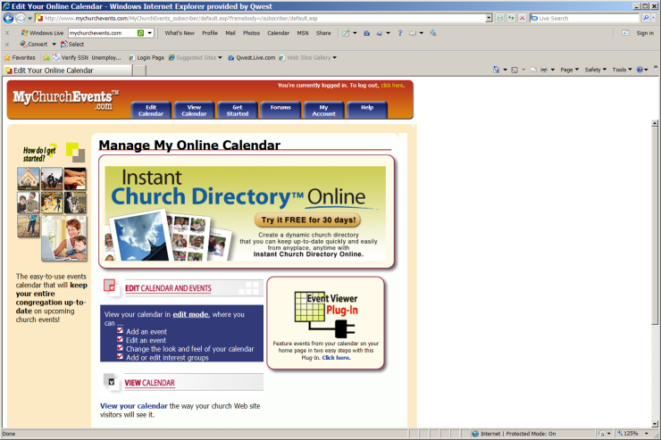 | Log into mychurchevents.com and enter the password. If you do not know the password,  Contact the Pastoral Staff to gain permission to receive the password. The password is restricted for control purposes.
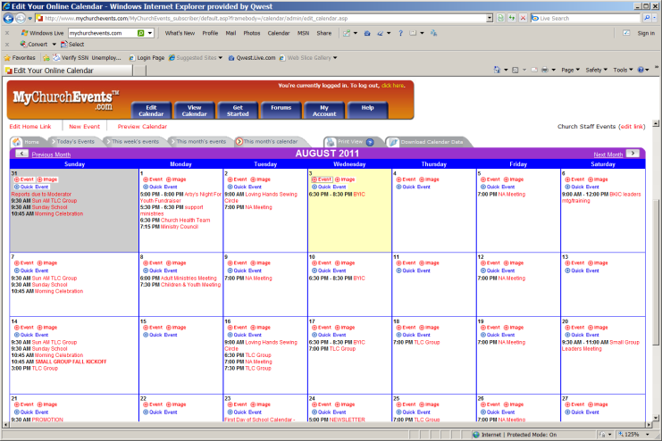 | Select “EDIT CALENDAR” tab, the first tab on the left.  Go to the day you wish to add an event.  Select the red “EVENT” link on the date square.
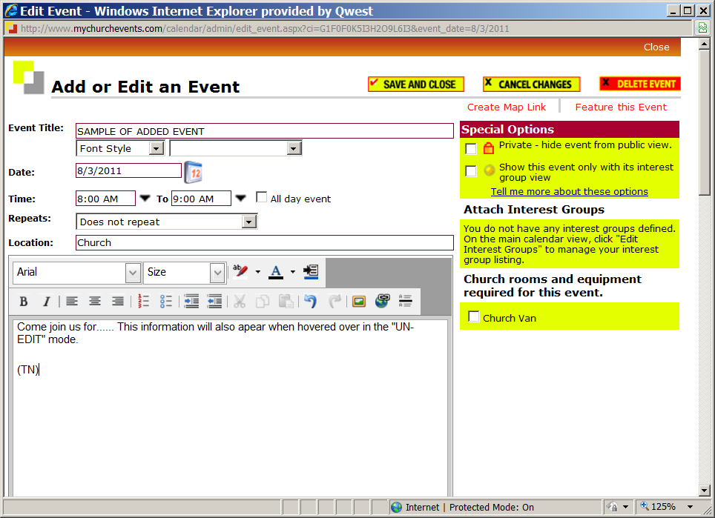 | This screen will pop up…  Fill in the event title  Time  Location  In the text box you can add information about the event.  YOU MUST PLACE YOUR INITIALS  In this text box even if you don’t add any additional comments. Failure to add you initials will risk the event being removed from the calendar. Select Save and close.
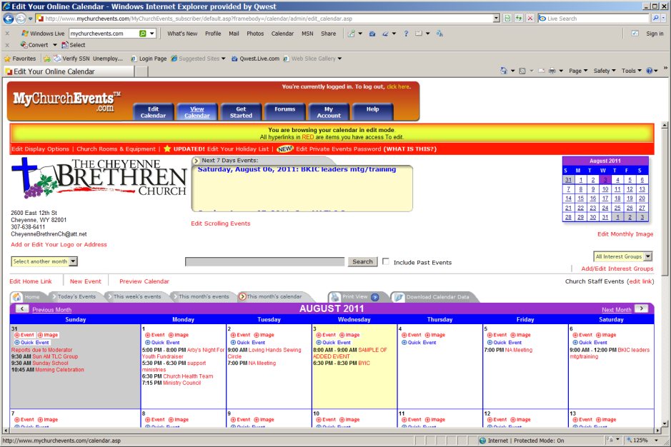 | Once you have saved and closed the previous screen, select  VIEW CALENDAR tab, second tab from the left.  This will bring you to the VIEW mode of the calendar which is what is posted on our church website.
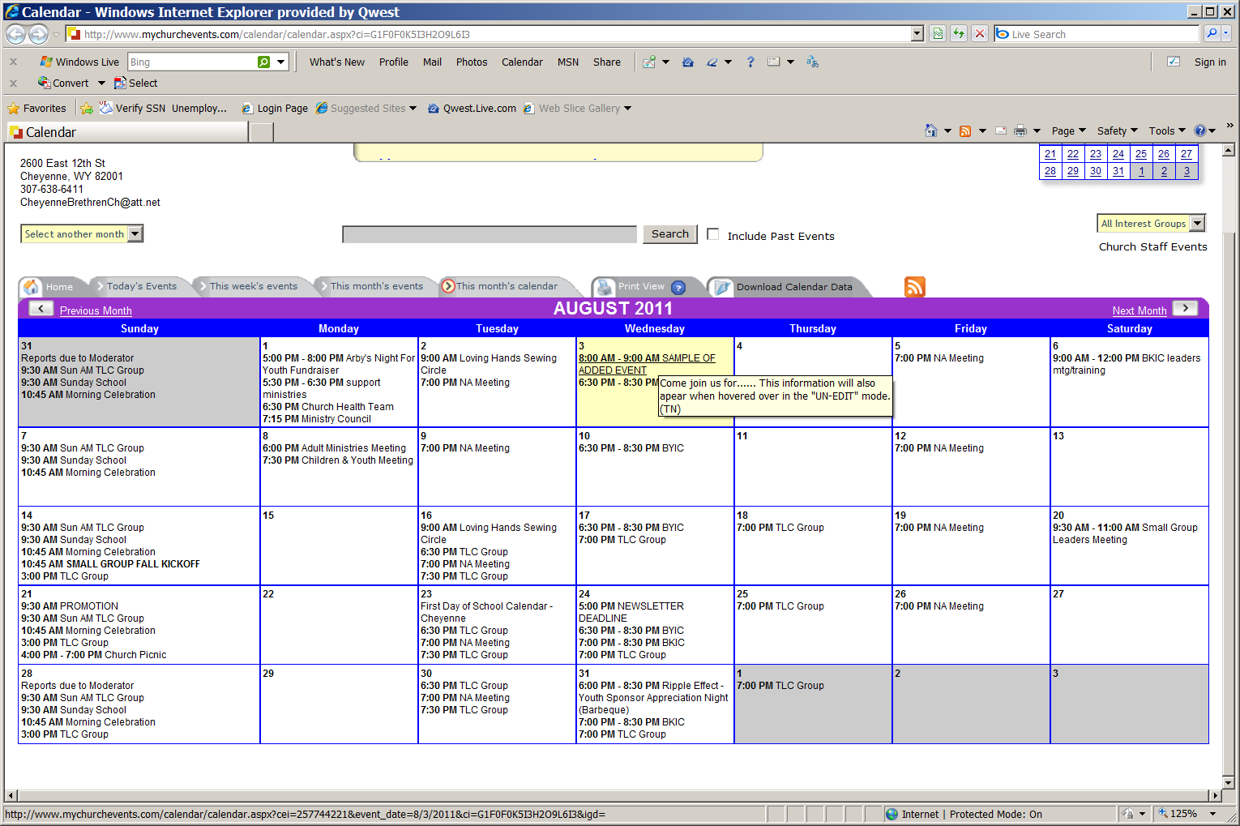 | Once in the VIEW mode you will notice all the red text is gone! Red text is only shown in the EDIT mode.  Hover over the newly added event.  Off to the side whatever you placed in the text box will now appear when hovered over the event. Initials will be seen as to who added the event. If no initials are placed on the events, the event may be deleted by the Social Media Specialist.
Questions??? | If you have any questions you may contact the Social Media Specialist or Pastoral Staff for answers.

P05-2: Child Care at Congregational Meetings

The following policy has been established to assure that the children of our church are cared for properly, that church property is adequately protected, and that adults attending church functions may be able to enjoy congregational activities.

- ALL CONGREGATIONAL MEETINGS AND EVENTS THAT INVOLVE THE ENTIRE CONGREGATION SHALL HAVE CHILD CARE PROVIDED
- Arrangement of child care shall be the responsibility of the individuals, group, or ministry hosting the activity or meeting.
- Child care must be secured two weeks prior to the event, to provide time to re-schedule or cancel the event if child care can not be secured.
- Those providing child care must be at least 16 years of age. Children 14- 16 may assist IF they are accompanied by an adult 18 years or older.
- One child care provider shall be available for every five children.
- All child care providers must be approved before the two week deadline by either the Nursery coordinator, the Ministry of Fellowship Coordinator, or a member of the Pastoral Staff
- Last minute substitutions of child care providers should be approved by one of the officers mentioned above.
- Child care providers may be paid or volunteer, with payment occurring through donations, church funds, or fees being charged to parents using the service. All funding methods must be announced along with the event if funding is expected during the event.

P05-3: Ministry Meeting Policy (08-01-11)

Frequency, Meeting Dates and Times: To assist in establishing meeting criteria for the Ministry Meetings of the Cheyenne Brethren Church.

Tasks: | Directions or Comments:
Meeting Frequency | To be established by the individual ministries of the church. (No less than every other month) Reports must be submitted to the Ministry Council for each month the ministry meets.
Meeting Dates | Each ministry will select their own meeting dates and times. Our current schedule is 1st Monday of the month, Support Ministries (every other month), Church Health Team, and Ministry Council meet. The 2nd Monday of the month, Adult Ministries and Children & Youth Ministries meet. ACCEPTATION TO THE RULE: In the event a holiday falls on the 1st Monday of the month, all ministry meetings will move down one week in the calendar schedule meaning the 2nd and 3rd Monday’s would be become ministry meeting dates.
Time of Meetings | To be established by the individual ministries of the church. Changing a meeting time or date must be reflected in the Master Church Calendar and be initialed by the poster of the event. Please use the Church calendar to prevent conflicts of meeting times as some ministry members may be required to attend multiple meetings.
Questions or Concerns | Contact the Church Moderator or Pastoral Staff with question or concerns about meeting schedules.

P05-4: Church Event Weather or Emergency Closing Policy (11-2014)

Any church event or meeting will be cancelled when there is an active Tornado warning or other community emergency advisement which would endanger attendees or make their attendance a violation of city ordinances dealing with community emergencies during the meeting time.

Any church event or meeting will be cancelled when there is a disruption of necessary basic services to the building, including, but not limited to heat, power, or water service.

Church events and meetings, NOT INCLUDING DAYTIME WORSHIP SERVICES, will be cancelled when any of the following numbered circumstances are known or forecasted to exist no more than 12 hours before the time of the meeting:
DAYTIME WORSHIP SERVICES will be cancelled when any TWO of the following numbered circumstances are known or forecasted to exist no more than 12 hours before the time of the service.

1) A winter travel advisory asking vehicles not to travel on local roads is in effect within city limits.
2) A wind chill advisory is in effect for the community and/or the wind chill temperature is in excess of -25°.
3) Snow accumulations exceed 12 inches in the 12 hours before the event.

Communication:

1) Such closings shall be announced through texting, email, voicemail, and posting on the church website and social media sites by the entity in charge of the event, or in the case of daytime worship services, the pastoral staff and the moderator.

2) A decision regarding cancellation must be made no less than 2 hours nor more than 12 hours before the event to permit communication of the cancellation and accurate information regarding the conditions that may exist at the time of the service or event.

3) Cancellation decisions will be made by ministry team leaders after informing Ministry Coordinators if possible. The person(s) deciding the cancellation are responsible for notifying all participants.

4) While all reasonable efforts to communicate with participants will be made, there is no inherent liability or responsibility for the church to communicate all closings to all possible participants.

P08-1: Usage of Donations (7-1-2012)

1) Donations to the Cheyenne Brethren Church are defined as:

- Monetary gifts, whether given by cash, check, credit card or electronic transfer
- Property of any kind, including food items
- Promises for provided services, if promised though any type of written document
That are given for the work and ministry of the Cheyenne brethren Church, or for the purposes of maintenance or fundraising for the Cheyenne Brethren Church

2) All donations to the Cheyenne brethren Church become the exclusive property of the Cheyenne Brethren Church, and the Cheyenne Brethren Church reserves the right to determine the usage and/or disposal of such items.

3) Items given for a particular purpose shall be used for that particular purpose, provided that A) that purpose has been defined by the Cheyenne Brethren Church prior to the donation and B) the donor releases the Cheyenne brethren Church to use these designated donations for purposes other than those designated if the designated purpose is fulfilled, or if the designated purpose has become invalid for a period of not less than 5 years, at which point those donation will be re-classified as undesignated.

4) Any donations of any kind donated for a specific purpose not solicited by the church will not be accepted until said donor initiated purpose has been approved by the Ministry Council.

5) The church may, at its sole discretion, permit donors of immediately perishable items (such as carry in dinner items) to take home portions not consumed at the event to which they were donated. This does not include items donated for the purpose of re-sale, such as fundraisers, bake sales, etc.

6) This policy will be distributed to the congregation on a regular basis, and any donation with a value in excess of $500.00 will require the donor to be presented with a copy of this policy at the time donation is received.

P12-1: Private Vehicles Used for Transportation of Minors

The Cheyenne Brethren Church permits individuals to use their private vehicles to transport minors to and from the church to an off-site function or destination under the following conditions:

- The driver holds a current and valid driver’s license, and the youth leadership has a copy of the license on file
- The vehicle being used is covered by current comprehensive vehicle insurance (including uninsured motorist, collision, bodily injury, and liability coverages), with the driver being the owner of the vehicle, listed as covered for the vehicle on the insurance card, or has written permission to drive the vehicle. A copy of the insurance card and the written permission (if needed) should be on file with the Youth leadership.
- The drive is notified and understands that the church is not primarily liable for any damage or injury during transportation, and that it is their private vehicle insurance that is the primary coverage.
- The driver of the vehicle must be a legal adult unless all passengers have signed waivers that their guardians have given permission for them to ride with a minor driver.

The Cheyenne Brethren Church has no responsibility for private transportation between the church and the residence of a minor.

P12-2: Housing of Minors and Leaders/Chaperones on Church Sponsored Activities

- No minor will be permitted to stay overnight at any activity sponsored by the Cheyenne Brethren Church without having obtained in advance a permission form from the parent or guardian.
- No minor shall be permitted to stay overnight in any hotel room or residence without at least one (1) adult in the room or the immediately adjoining room.
- Boys and Girls will have separate / divided housing.
- The purpose of Chaperones is to supervise minors in attendance. Therefore all adults will be expected to be housed with the minors attending, supervising minors of the same gender.
- Adults that are attending sponsored events may reside in their own room or space, but such housing arrangements will be at their own expense, will not excuse them from other supervisory responsibilities, and may cause the cancellation of an activity if there are insufficient numbers of adults available to provide housing supervision as defined above.
- The Youth leadership shall attempt to accommodate housing preferences; however, they also have the final authority in housing assignments.
- All persons, both minors and adults, will be expected to wear modest sleepwear that would not be inappropriate to be seen by the opposite sex or minors when sleeping.

