Historic Vessel Designs

Essential Question How can we learn about the history of a culture by studying ceramic vessels? How can we use shape, line, and color to represent a significant historical event in our own history?

Grade 3rd

Time 50 minutes

Art Concepts Shape, line, color, figure, ceramics, hieroglyph

Materials White paper (or printed worksheet; see template at end of lesson), pencil, eraser, colored pencils or markers
Optional: watercolor paints, paintbrush, cup for water, paper towels

Artworks in Focus Cylinder Vessel with Palace Scene, Maya, 740–800 by unknown artist
Vessel with Ballplayer and Dancers, Maya, 300-600 by unknown artist
Tripod Vessel with Supernatural Palace Scene and Cacao Tree, Maya, 750–850 by unknown artist
Vessel with Young Lord and Monkey, Maya, 600–800 by unknown artist

Talking about Art Have you ever used clay, or anything similar, to make a work of art? How did it feel to touch it? Do you know where clay comes from and what it is used for? Clay comes from the earth, and if you dig underground in different parts of the world you find different types of clay. Artists have been using clay to make vessels, such as vases, bowls, and cups, for thousands of years. When clay is heated at a very high temperature, or fired, it becomes hard and durable. This is an art form called ceramics. You probably have some ceramics around your house! We are going to focus on Maya vessels made in and around present-day Guatemala. Do you know where Guatemala is? It is a country in Central America just south of Mexico.

In the first millennium BCE, peoples speaking Mayan languages settled in agricultural villages across the Yucatan Peninsula. They began constructing monumental buildings, sculpting in various media, and creating durable containers out of fired clay. Ceramic vessels nourished Mayans in both life and death, holding food and drink for daily life as well as offerings in burials, ranging from the simplest graves to royal tombs.

After shaping the vessel and before firing it to make it hard and durable, the surface would be covered in slip, or mineral mixtures dissolved in water, to give the vessels added colors and textures. By the final centuries BCE, artists were engineering beautiful vases using only a few colors. The spectrum of slips on early pottery is limited to red, cream, and black, but often potters would experiment with different firing temperatures and environments to create surfaces that resulted in colors mixed together, like red with black accents.

Look closely at the overall shape and colors of Cylinder Vessel with Palace Scene. What do you notice about it? Now look at the forms painted on the outside of the object. Who might these figures be? During the period in which this vessel was made, well over 1,000 years ago, artists had developed a wide range of vessels that were painted with a variety of geometric and figural designs. These artists seem to have been sponsored by the royal courts of self-proclaimed divine rulers. Ceramics became the canvases of artists to create mythological scenes often dedicated to their patrons with hieroglyphic texts. Do you know what a hieroglyph is? A hieroglyph is when a picture is used to represent a word, syllable, or sound. It is a type of written language using pictures.

Now let’s take a look at Vessel with Ballplayer and Dancers, from a similar time period. What do you notice about the poses of the figures here? Painted vessels like this one tell us stories about the daily activities that Maya rulers participated in. Notice how all of the figures look as though they are moving, with their limbs reaching out in different directions. This particular scene represents a ballplayer and dancers.

What more can we learn from Maya vessels? When observing the details closely on Tripod Vessel with Supernatural Palace Scene and Cacao Tree, do you notice anything different about the figure on the left? It’s a monkey! There are several species of monkeys that are believed to have lived in the Maya region when these ceramics were made. Artists represented monkeys on many painted vessels because the Maya believed the creatures held spiritual meaning, thus often representing them as gods. Why do you think the artist chose these particular colors and patterns? What do you think they might represent? Colors often have symbolic meanings, which varied from culture to culture. Scholars think that for the Maya culture, the use of black might represent something supernatural, and that the part at the very top of these ceramics, below the lip, was reserved by some Maya artists for paintings of deities—that is, gods and goddesses.

Let’s look at this last Maya vessel, Vessel with Young Lord and Monkey. What do the shapes and lines remind you of? It is a cacao tree, which is where chocolate comes from! Cacao was an important crop in Maya culture, and some of these vessels may have been used for drinking a chocolate beverage. Isn’t it amazing how much we can learn about the history of a place and people by looking at such objects.

Making Art Drawing inspiration from the style of these Maya vessels, you will create a design for a vase that references an important moment in history. For example, you could represent the history of a group of people that doesn’t often get told, or choose a historical moment that you have learned about in class that is important to you. Think about telling a historical story that you would want preserved on a vase for thousands of years.

- Print out the attached worksheet (vessel outline) or copy the outlines onto a piece of paper.
- Use simple shapes and lines to illustrate a different part of your historical event inside the outline of the vessel. Think back to the way that the Maya artists used angular figures and simple colors to tell their stories.
- Similar to the way that the Maya artists added hieroglyphic symbols to their vessels to communicate a message, you could also add symbols to your vase to help you tell your story.
- If you have time, create a second design that shows the other side of your vase and tells a different part of the story, just like the vessels we looked at.
- Once you are happy with your design, you can use colored pencils or markers to add color, or you can use watercolors if you have them.

Reflection These questions can be writing or sharing and discussion prompts.

Share your artwork with someone. Which historical event did you choose to represent and how did you use shape, line, and color to tell the story?

Why is this historical event important to you? Write a story to accompany your ceramic vessel design.

Let’s look back at the figures on the Maya vessels. How did those artists use color, shape, line, and form to tell their stories?

Curriculum Connections California Arts Standards for Public Schools—Visual Arts

3.VA:Pr6: Investigate and explain how and where different cultures record and illustrate stories and history of life through art.
3.VA:Re7.1: Speculate about processes an artist uses to create a work of art. 3.VA:Re7.2: Determine messages communicated by an image. 3.VA:Re9: Evaluate an artwork based on given criteria.
History Social-Science Framework for California Public Schools
To incorporate these standards, teachers can specify that students represent a story from California’s history.
3.3.3: Students draw from historical and community resources to organize the sequence of local historical events and describe how each period of settlement left its mark on the land.
3.3.2: Students describe the American Indian nations in their local region long ago and in the recent past.

Worksheet
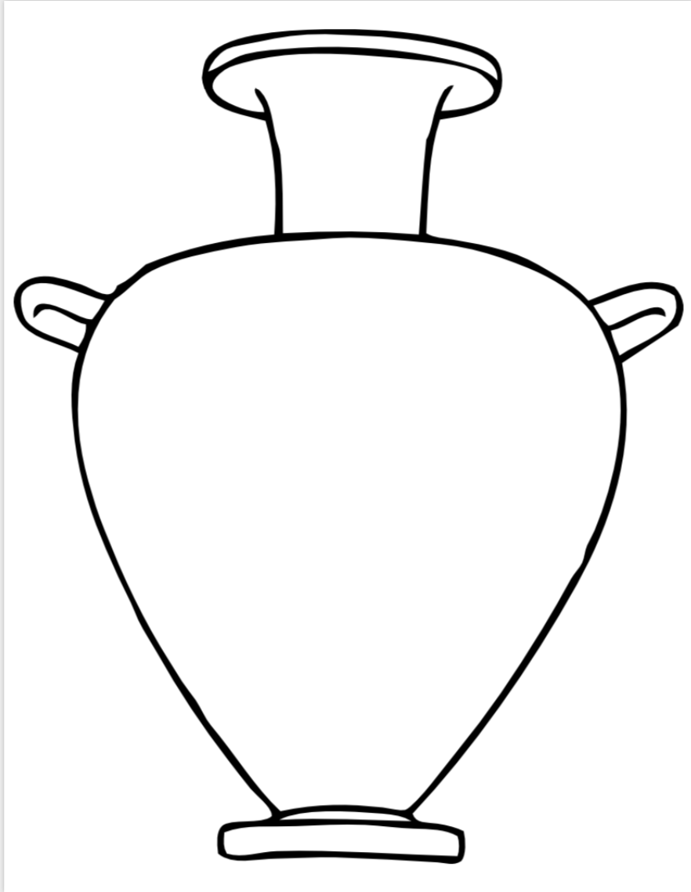

Prepared by Billie Rae Vinson with the Los Angeles County Museum of Art (LACMA) Education Department.

