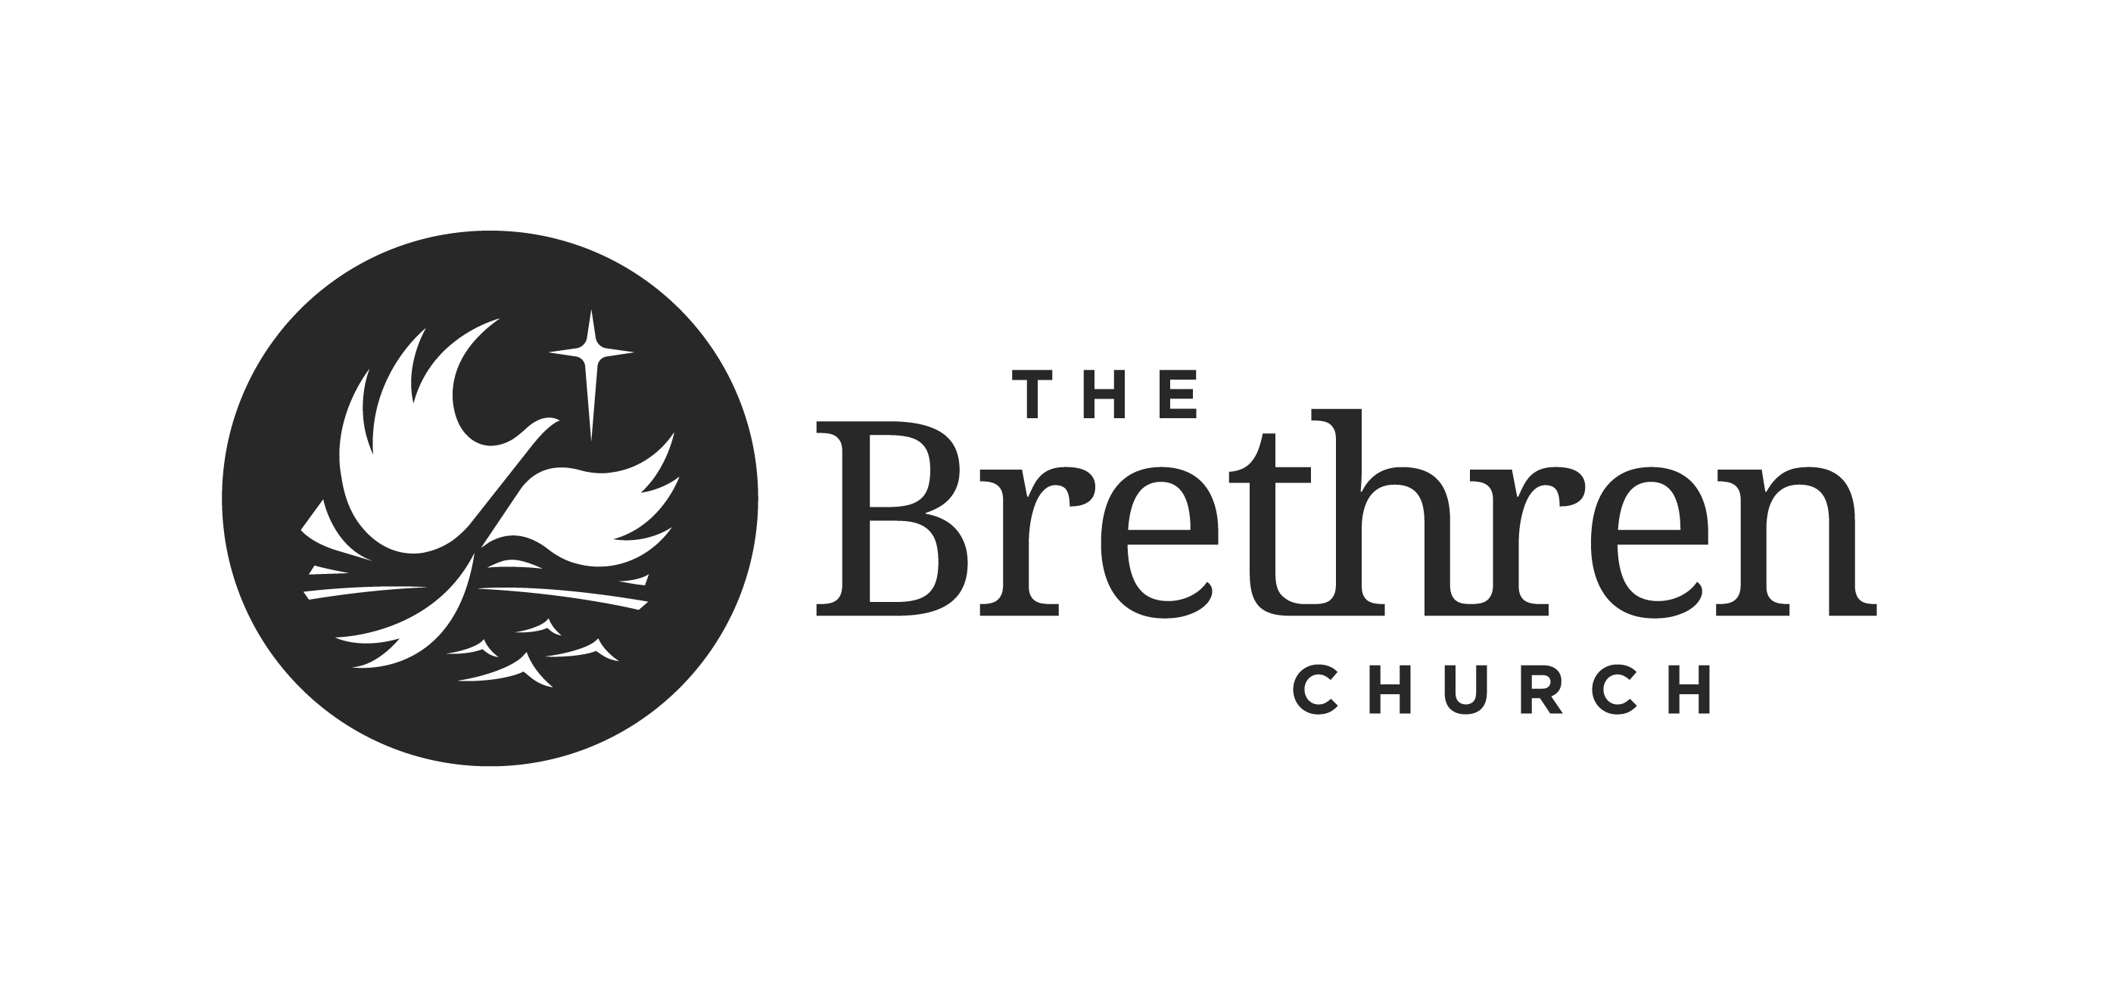

Manual of Commissioning Procedures

2022 Edition

Table of Contents

Purpose of Commissioning 3
Sequence of Events for Commissioning 3
Forms for Commissioning 4
Personal Information and Profile 4
Authorization for Commissioning 7
Readings for Commissioning 8
Required Readings 8
Recommended for Further Study 8

PURPOSE OF COMMISSIONING
- Commissioning is designed for individuals within a local church to be recognized by their congregation for a specific or special designated ministry. It is not for individuals serving as solo or lead pastor of a church. Solo or lead pastors are required to be licensed within six months of call or hire, and to complete all licensing requirements within two years of initial license.
- A commission is issued and overseen by the local church, with reporting of status to the Regional Leadership Team and through them to the National Board of Oversight.
- A commissioned individual who no longer holds membership in the commissioning church automatically forfeits their commission.
- A local church may remove the commission from an individual at any time through a congregational vote.

SEQUENCE OF EVENTS FOR COMMISSIONING

1. The local church chooses to call to commission for a Special Ministry
2. The candidate completes Commission: Personal Information and Profile
3. The local church examines the candidate and certifies that the candidate is acceptable to be commissioned.
4. The local church votes to commission the individual and notifies the Regional Leadership Team.
5. The local church conducts public recognition of commissioning for Special Ministry and notifies the Regional Leadership Team within 30 days.
6. The local church annually reports individuals commissioned to the Regional Leadership Team.
7. The National Board of Oversight is notified annually of persons who hold commission within the region.

NOTE: Commissioned persons are supervised by their local church. The list of commissioned individuals is reviewed annually by the Regional Leadership Team at regular intervals. If later a commissioned individual should seek ordination, they will need to pursue licensure, and following completion of the licensure process, proceed to pursue ordination.

BRETHREN CHURCH REGIONAL LEADERSHIP TEAMS
FORMS FOR COMMISSIONING, LICENSING AND ORDINATION

PERSONAL INFORMATION AND PROFILE

NOTE: A COMPLETE RESUME’ WITH PICTURE IS TO BE COMPLETED IN ADDITION TO THIS FORM

Date this profile was completed - -_____

Name _________________________________________ Date of Birth - - ___
Last first middle initial
Address (where to send correspondence)
________________________________________ ___________________________
(Street Address) (city)
_______ _________
(state) (zip code)

Telephone number: ________-_________-_______ (H) _______-________-______ (W)

Email: __________________@______________

- Current ministry position _____________________________________________

- Family Description: Single _____ Married _____ Divorced________ Widowed _____

Spouse’s name _______________________ Date Married ____/______/_______

Child(ren)’s name(s) ___________________________________________________

____________________________________________________________________

GENERAL THOUGHTS ABOUT MINISTRY
- What in your ministry has brought you the greatest level of satisfaction?

- What in your ministry has brought you the most frustration or disappointment?

- What do you hope to accomplish in your ministry?

CHRISTIAN EXPERIENCE and CALL
1. How long have you been a Christian? _______ years

a. Under what circumstances did you become a Christian?

b. When were you baptized? _- - (date)
in what church? ____________________________________________
by what method? ___________________________________________

c. How long have you been a member of The Brethren Church? __________ years

d. If you are married, is your spouse a member of The Brethren Church? Yes ____ or No ____

PERSONAL FINANCES
1. Do you have financial obligations and debts which may hinder your ministry? Yes or No

2. Do you make regular contributions to a retirement account? Yes or No

3. Do you have adequate life insurance to help cover your family’s financial Yes/No/Not sure
needs in the case of your death?

4. Do you have adequate medical insurance through your or your spouse’s
current employer? Yes or No

PASTORAL AND CONGREGATIONAL ETHICS STATEMENTS
1. I have read the current pastoral ethics statement and affirm its content. SEE REQUIRED READINGS ___ (initial if true)

2. I have read the current congregational ethics statements (1987 version) and affirm its content. SEE REQUIRED READINGS _____ (initial if true)

ETHICS
1, Have you ever been convicted of a felony or misdemeanor,
other than traffic offenses? Yes or No
If yes, please explain:

2. Has a formal complaint of ethical misconduct, ever been
filed against you? Yes or No

If yes, please explain and how the case was resolved:

Your Spiritual Gifts:
Please list key areas of giftedness Please list areas in which you do not feel
gifted
______________________________________ ______________________________

______________________________________ ______________________________

______________________________________ ______________________________

I Agree to a Criminal Background Check being performed ______________
(initial)

I AGREE TO ANY ADDITIONAL REQUIREMENTS BY THE LOCAL CHURCH ___________
(INITIAL)
AUTHORIZATION FOR COMMISSION

Completed by Local Church Issuing Call and signed by Candidate

Date: ________________________________

TO: The Regional Leadership Team of the ____________________________Region:

_______________________________________________________________ is a member in

good standing and full fellowship of the ______________________________________Brethren

Church located in _____________________________________________________________.

The church has called this candidate to be commissioned to the Special Ministry of

___________________________________________________________________. This commission

was issued at a congregational meeting on ____/______/_______/ (mm/dd/yyyy). The result of the

secret ballot vote was __________ affirmative and ____________ negative, with _________________

qualified voters present.

Signed (signed by at least three of the below):
Pastor: ______________________________________________________________________

Moderator: ___________________________________________________________________

Secretary: _____________________________________________________________________

Deacon(ess): __________________________________________________________________

Deacon(ess): __________________________________________________________________

Candidate:
I hereby indicate my desire to be examined for Commissioning for the above ministry.

Signature of Candidate: ____________________________________________ Date: _________
Instructions: Send one copy to RLT.

REQUIRED READINGS FOR COMMISSIONING

- Brethren Beliefs
- Brethren Positions on Social Issues
- Manual of Pastoral and Congregational Procedures
- Manual of Procedure
- Brethren Pastor’s Handbook

RECOMMENDED FOR FURTHER STUDY:

- Brethren Doctrine Intensive
- Brethren History Intensive
- Brethren Polity Intensive
- History of the Brethren Church by Albert Ronk
- Background and Development of Brethren Doctrines by Dale Stoffer
- A Brethren Witness for the 21st Century edited by Jason Barnhart and Bill Ludwig
- The Complete Writings of Alexander Mack by William Eberly

