E-Book Cover Design

Lesson 2

Basics of Kindle Cover Creator

You don't have to be a tech savvy graphic artist to create a compelling cover. I marvel at what is available free of charge on the web that one can learn to use in a few minutes. Sometimes I shake my head and wish I had these tools back in the day when I was working in advertising. I would spend days doing what I can do in a few keystrokes today.
One great tool for the indie publisher is the Kindle Cover Creator. It's so simple to use.
When you upload to Kindle you will include information about the title, subtitle and author of the book. The Kindle Cover Creator uses this information to get you started on creating a cover for your book. Just click the button that reads "Use Cover Creator" and you get this screen:

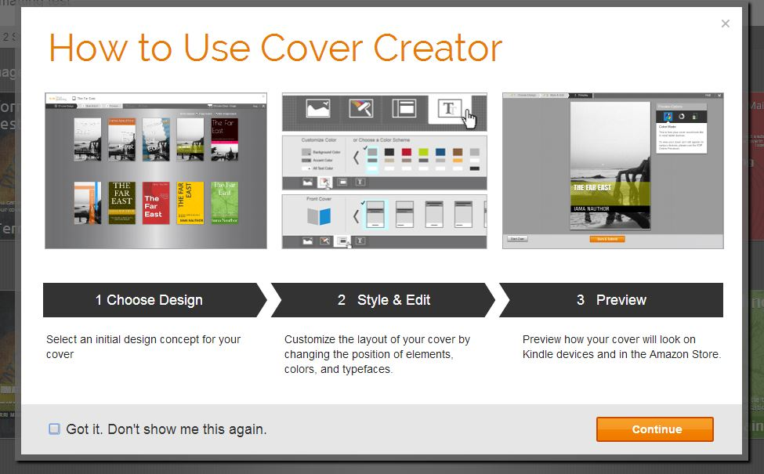

Just click "Continue" and you are taken to this screen:

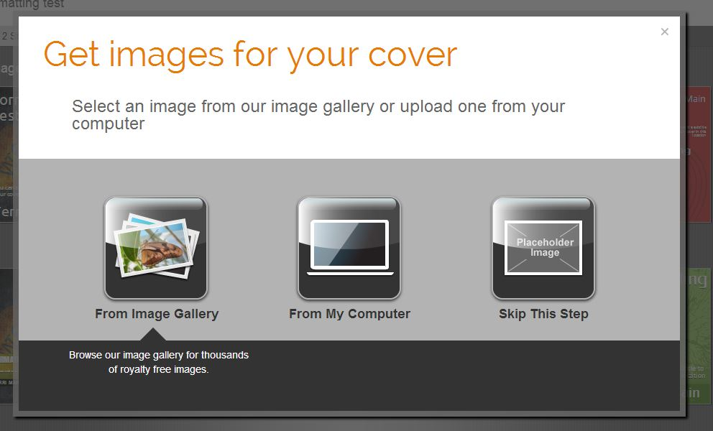

First you want to get an image or choose to not use an image. If you want to use an image, you can choose from the image gallery or from a folder on your computer. We are going to be using a picture I bought from Canstockphoto.com for $5.00.
I select my photo and get the following screen.

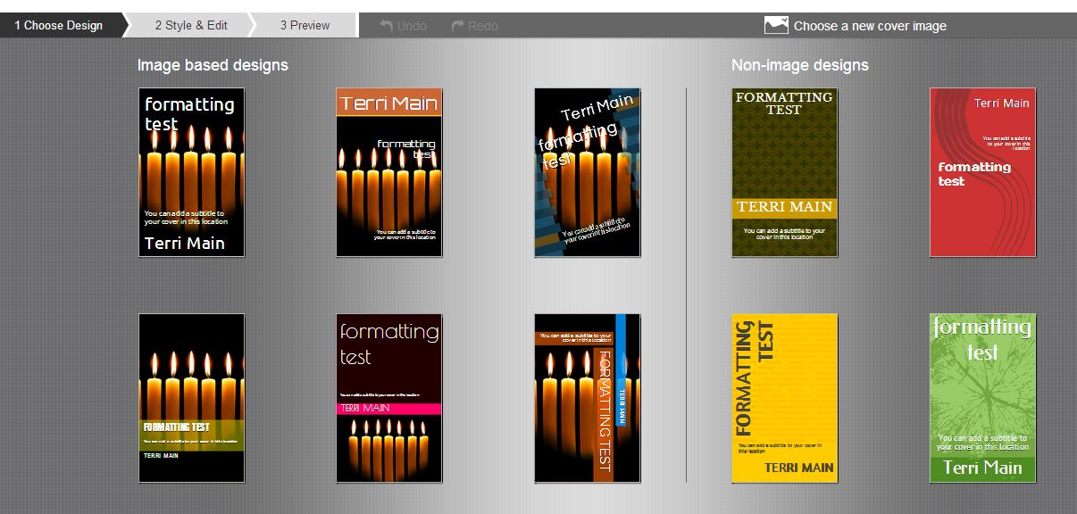

Now, I can choose one of these as the starting point for my design.

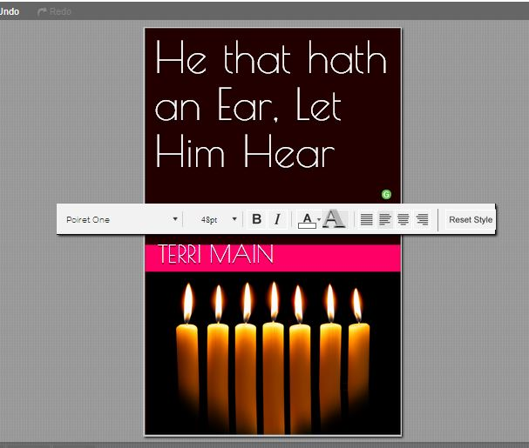

I decided to choose this one. However, want to change the styling on the title. I just click on the title and I get this toolbar. You notice it is just like a toolbar on your word processor. I can bold face, italicize, change the style and size of the font, color and adjust the alignment for center, right, left or full justification.

Now, I want to style the subtitle that was automatically inserted, too, but is covered by the text bar in this picture
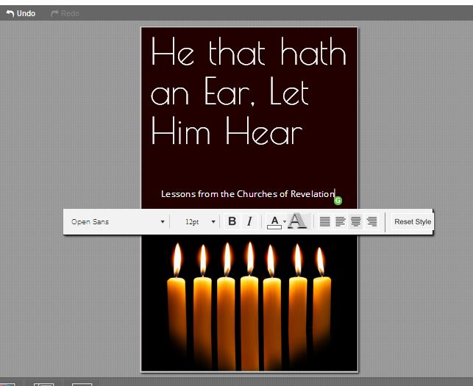
.
That looks okay to me, so I don't do any adjustment. Now, we have our final copy.

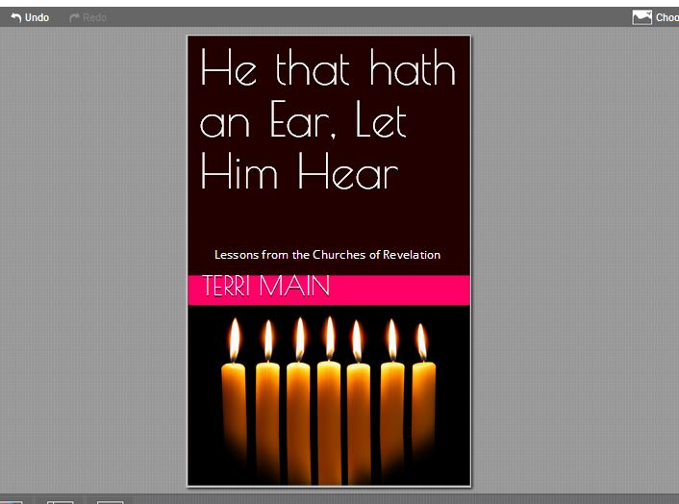

That is all there is too it. Now, we used mostly the default settings on this. In our next lesson we will learn how to customize everything from layout to color scheme to make your cover design truly yours.

