Date : 5th August 2012
Theme : Biblical values of GOD’s Kingdom
Topic : I am passionate about spiritual disciplines
Key verse : 1 Timothy 4:8
For physical training is of some value, but godliness has value for all
things, holding promise for both the present life and the life to come.

Review : VCDS
I am caught by the VISION
I am committed to CELL life
I am a DISCIPLE
I am passionate about Spirituality disciplines

I am passionate about spiritual disciplines because…
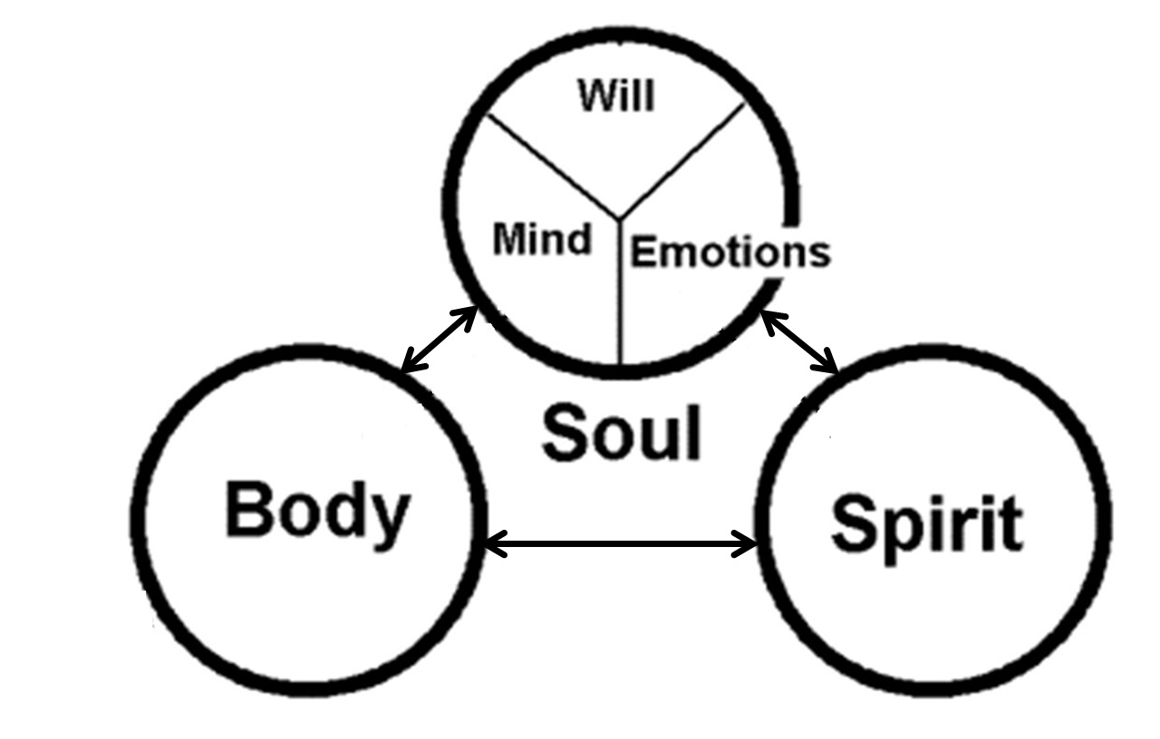

- I am designed to hear GOD’s voice

- I am body, soul, spirit. 1 Thessalonians 5:23(b)

- I long for a deeper walk with Jesus.

- To overcome ingrained habits of sin.
- without spiritual disciplines, my life …
…like the sea, waters toss up mire and dirt. Isaiah 57:20

- I make time / space for spiritual disciplines

- To practise elements of the WHEEL (contact with road, not pious exercises)

- Like a farmer tilling the ground before sowing.

- Like focusing to cross a ridge between 2 chasms.

- I benefit from taking personal responsibility 1 Timothy 4:8
(like athlete, weight-lifter, training for prize)

- Spiritual Disciplines lead to godliness which is profitable for eternity.

- Spiritual Disciplines build habits, for GOD to fill me with His grace

