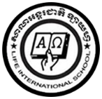**LIFE INTERNATIONAL SCHOOL**

KHMER SUBJECT FOR KSL

TEACHER : **CHEN SOTHARY**

**Name : …………………………………………………….**

1. **Learning the Khmer cons from ក to ង**

**ក ខ គ ឃ ង**

**…………….. ……………. …………….. …………….. ……………..**

**…………….. ……………. …………….. …………….. ……………..**

**…………….. ……………. …………….. …………….. ……………..**